Meeting Date | 21 April 2026 |  | Agenda Item
Name of Meeting | Workforce and OD Committee
Report Title | Workforce Report - NPTSSG
Report Author | Ceri Gimblett, Service Group Director NPTS
Report Sponsor | Deb Lewis, Chief Operating Officer
Presented by | Ceri Gimblett, Service Group Director NPTS  Sharron Price, Service Group Director NPTS
Freedom of Information | Open
Purpose of the Report | The purpose of the report is to provide an update on the following:  - Workforce performance against key metrics and associated actions  - Theatre sickness management update  - An overview of workforce risks and issues affecting NPTSSG  - Staff Survey progress and plans
Key Issues | The key issues relate to the following:  - Ongoing unavailability challenges across staff groups  - Staff Survey progress and plans  - Vacancies and associated risks  - Overview of main workforce risks
Specific Action Required  (please choose one only) | Information | Discussion |  | Assurance | Approval
Specific Action Required  (please choose one only) | ☒ | ☐ |  | ☒ | ☐
Recommendations | - ACKNOWLEDGE the Service Groups Workforce Metrics, Risks and Staff Survey plans.  - BE ASSURED of the actions being taken to ensure compliance with workforce metrics to support and improve the health and wellbeing of staff.

WORKFORCE REPORT - NPTSSG

- INTRODUCTION

This report will provide a workforce update on the following:

- Performance against key workforce metrics and associated action.
- Specific update on Theatres sickness absence management.
- An overview of workforce risks/issues affecting NPTSSG.
- Staff Survey progress and plans.

- BACKGROUND

2.1 Performance against key workforce metrics and associated action

Heatmap of key workforce metrics
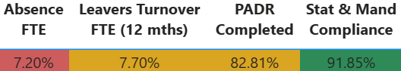

Sickness Absence
- Total absence across the Service Group for 02/26 was 7.20%, representing a slight improvement from 7.27% in 01/26 and 7.56% in 12/25.
- Over the past 12 months, in-month absence rates have remained within a relatively narrow range, fluctuating between 6.34% (05/25) and 7.56% (12/25).
- Long-term absence peaked at 5.58% in 07/25, but has since fallen to 4.18% in 02/26, the lowest rate recorded in the last 12 months.
- Short-term absence has varied between 1.62% (05/25) and 3.01% (02/26) over the same period.
- Across the previous 12 months, the main causes of absence were:
- Long-term absence: primarily Anxiety, Stress and Depression, followed by Musculo-Skeletal conditions.
- Short-term absence: primarily Anxiety, Stress and Depression, followed by Cough, Cold and Flu.
- In-month absence rates across the Service Group were below projected (forecast) levels up until 08/25.
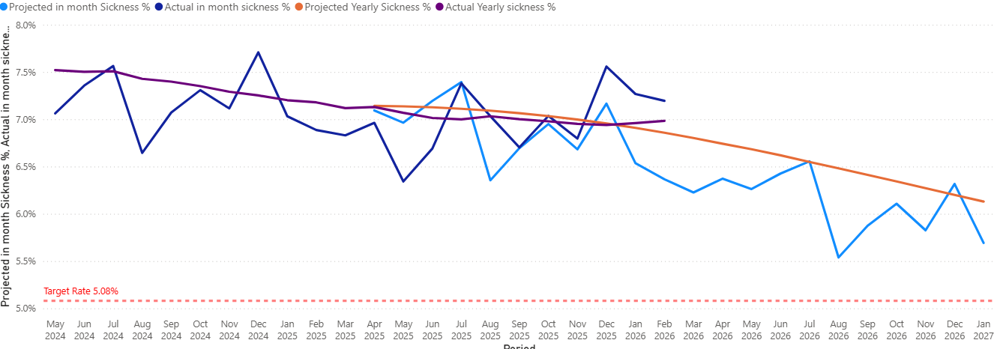
- In 08/25, actual in-month absence (7.03%) exceeded the projected rate (6.35%). In 09/25, the actual rate (6.70%) was in line with the projection. From 10/25 to 02/26, actual in-month rates have continued to exceed projected (forecasted) levels.

Actions taken in response to the above are detailed below.

Overarching Sickness Improvement Actions

Themes | Actions | Timescales
Leadership Engagement and Managerial Accountability | Strengthening Our Focus on Sickness Improvement:  - Clear messaging around sickness being a key priority  - Reinforcing the message that this is a key area that requires our collective attention and commitment.  - As leaders there is a vital role to play in shaping the environment our teams work in and by taking clear ownership of sickness performance, each leader has the power to make a real difference. | June 2025 Onwards
Sickness Management | - A planned quality improvement approach to sickness absence management which includes a comprehensive set of actions, grounded in best practice, to reduce sickness absence rates effectively.  - Monthly programme of audits for ‘Hot Spot Areas’.  - Absence Summits – undertaken in 10 ‘Hot Spot Areas’ These summits have been designed to enable a proactive approach to supporting both Long and Short-Term staff absence. The HR Business Partner and Operational HR Team work alongside the management team to ensure Long and Short-Term cases are being appropriately managed and progressed. The Summits also instigate Case Reviews which may require specialist advice input e.g., Occupational Health. | 09/25 Onwards
Key improvement actions relating to top 3 absence reasons | Specific actions taken for Anxiety, Stress and Depression are:  - Early contact – with a compassionate approach  - Regular contact / touch points during absence period  - Regular sickness review meetings with HR Ops Team  - Immediate support and signposting  - Tailored and flexible return to work plans  - Ongoing monitoring and touchpoints on return to work  - Occupational Health referral  - Stress risk assessment to be completed  - Referral and signpost to relevant support groups and wider support  Specific actions taken for Musculo-Skeletal are:  - Early contact – with a compassionate approach  - Regular contact / touch points during absence period  - Regular sickness review meetings  - Occupational Health referral  - Workplace adjustments applied where possible  - Tailored and flexible return to work plans  - Workplace risk assessment to be completed  - Support with attending physio or other recovery appointments  - Consider manual handling refresher training where appropriate  - Ongoing monitoring and touchpoints on return to work  Specific actions taken for Cough/Cold/Flu:  - Early contact – with a compassionate approach  - Regular contact / touch points during absence period  - Provide guidance on when it’s appropriate be in work vs. stay home  - Explore alternative options such as Homeworking if staff are well enough to work  - Monitor trends and action review prompts / escalate  - Occupational Health referral where appropriate  - Promotion of flu vaccine  - Promotion and education on IPC measures, e.g., handwashing | Ongoing
Staff Experience, Wellbeing and Retention | - Development of Staff Experience, Wellbeing & Retention Plans – The approach to developing the plans draws on the evidence and best practice contained within the Staff Health and Wellbeing – A Best Practice Guide for NHS Wales. Whilst the development of these plans was originally focussed on Perinatal, Theatres and Oncology and Haematology all Divisions have been asked to develop an initial draft plan by the end of March 2026. | Ongoing
Monitoring and Assurance | - Monthly Workforce Groups (Key Performance Indicators (KPI) are reviewed and plans agreed to improve performance if required)  - Audit / Workforce KPI Reports  - Monthly Roster Scrutiny Meetings  - Absence Summits/Audits  - Workforce Trackers presented at Wider Senior Leadership Team meetings. (sickness performance is specifically reviewed as part of this assurance and accountability process)  - Evaluation milestones to continually review if the actions are having a positive impact on reducing absence. | Ongoing
Education and Training | - Managers continue to have access to the Managing Attendance at Work Training and the Brilliant Basics Platform (interactive learning and education tool accessible 24/7).  - Support/coaching from HR Business Partner Team and HR Advisors.  - Workforce Touchpoint Sessions held 02/26 to further strengthen and standardise sickness absence management across the service group by:  - Improving compliance with Return-to-Work (RTW) recording, now a mandatory electronic requirement.  - Embedding consistent use of the Sickness Management Tracker, which has proven effective in hotspot areas. | Ongoing
Workforce Planning | - The HEIW Strategic Workforce Planning Toolkit has been used to develop Multi-Disciplinary Team (MDT) Workforce Plans across all Divisions so that services identify all opportunities to plan and design the workforce to maximise capacity and focus on effective workforce design (using the principles in the Staff Health and Wellbeing – A Best Practice Guide for NHS Wales) to support services in maximising staff availability. These workforce plans are subject to continual review. | Ongoing

2.1.2 Theatre Sickness Absence Management

Morriston Theatres

- Absence in Morriston Theatres as at 02/26 was 10.80% (in month), this has increased from 7.86% in 01/26.
- Long term absence rates peaked at 7.39% in 07/25, however rates have reduced to 5.28% in 02/26.
- Short term absence rates have ranged between 1.71% in 7/25 and 5.52% in 02/26. This rise in short term absence is mainly attributed to cough/cold, chest and respiratory infections which have all increased.
- The majority of absence during the previous 12 months, can be attributed to Anxiety, Stress and Depression and MSK Issues.
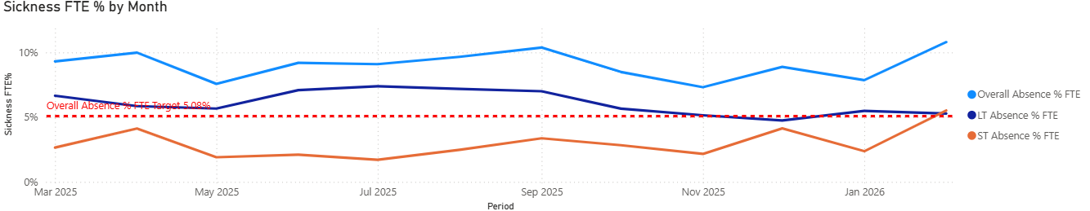

Neath Port Talbot Theatres (NPT)

- Absence in NPT Theatres as at 02/26 was 15.35% (in month), this has been an improvement since 12/25 where absence was 19.53%.
- Long term absence rates peaked at 17.52% in 11/25, however rates have reduced to 9.63% in 02/26.
- Short term absence rates have ranged between 0.96% in 07/25 and 5.72% in 02/26. The rise in short term absence is mainly attributed to Ear, Nose and Throat, Headache/Migraine, Cough, Cold & Flu and MSK issues.
- The majority of absence during the previous 12 months, can be attributed to Anxiety, Stress and Depression and musculoskeletal (MSK) Issues.

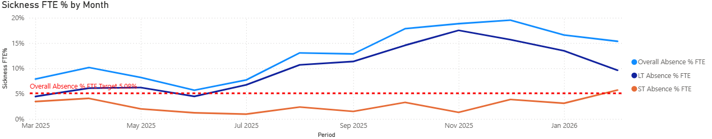

Singleton Theatres

- Absence in Singleton Theatres as at 02/26 was 6.71% (in month), this has been an improvement since 1/26 where absence was 8.34%.
- Long term absence rates peaked at 8.07% in 06/25, however rates have reduced to 4.41% in 02/26.
- Short term absence rates have ranged between 4.17% in 10/25 and 1.57% in 7/25 with absence rates as at 02/26 at 2.30%.
- The majority of absence during the previous 12 months, can be attributed to Anxiety, Stress and Depression and MSK Issues.

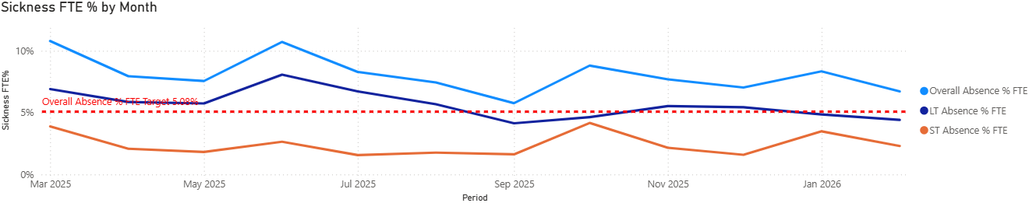
Specific Actions - Theatres

Sickness Management | Absence Summits have been established where discussion is generated around the sickness cases for both short and long term absences. The Deputy Head of Nursing for Theatres chair the meetings with HR support in attendance. Monthly Workforce Groups are then used to discuss and monitor hot spot areas and ensure compliance, with updates are also scheduled in Surgery Senior Management Team.  There is a robust Sickness Absence Tracker in place across theatres that has provided a previous audit with a high level of assurance that staff are being supported via the Managing Attendance at Work Policy. | Ongoing
Staff, Experience, Wellbeing & Retention | The Staff Experience, Wellbeing & Retention Plan for Theatre has been developed. This enables the service to positively act on some of the feedback from teams which was shared during the listening events. There has been significant progress made:  -Extensive staff engagement completed: 29 engagement events held over 40 hours, reaching nearly half of the Theatre workforce.  -Staff voices actively used: Anonymous feedback collected and shared with the Senior Team, informing early tangible actions.  -Project group established: Coproduction approach (members include team representatives, trade union representatives) to ensure the team voice continues to shape actions and priorities.  -Senior leadership commitment reinforced: Clear messaging from the Senior Management Team recognising staff contributions and committing to continued collaborative work. | Ongoing
Partnership Working | Trade Union Touch Points have been established to ensure engagement and partnership working across the Theatre Teams. We are receiving positive feedback from Trade Union Representatives about the work that is underway in Theatres, and these positive relationships are helping to support the case management of long term sickness and staff experience. | Ongoing

2.1.3 Performance Appraisal and Development Review (PADR)

NPTSSG overall PADR completion rates have increased over the last year from 77.86% in February 2025 to 82.81% in February 2026.

The Staff Experience, Wellbeing and Retention Plans for each Division will include actions to use the PADR process as an enabler to support patient safety and employee wellbeing. The improvement actions will also look at how the quality of PADRs in the service can be enhanced and ensure how the PADR process will provide valuable insight into the training and development needs of the workforce. In addition the Service Group are working with Learning and Development colleagues supporting the review of the current PADR system.

There is a recognition that specific improvement actions will continue to be needed to ensure the service complies with the Welsh Government target rate of 85%

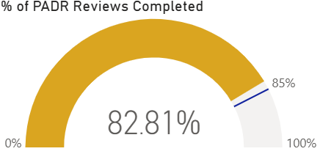

2.1.4 Mandatory Training

Mandatory training compliance across the Service Group exceeds the Welsh Government target rate of 85%. The rate as at 02/26 was 91.85%. Robust arrangements must be maintained to sustain this performance. All staff groups are above 90% compliance as at 02/26 with the exception of Medical Staff. There is continuous focus on improving Mandatory Training compliance within the Medical Staff Group (further increased to 80.48% in 02/26).

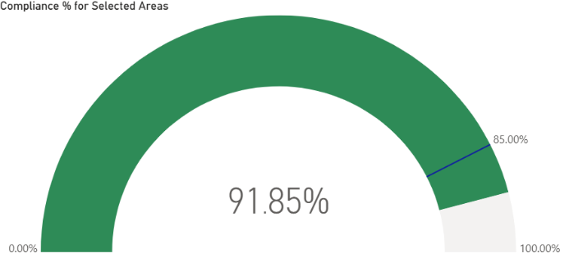

2.1.5 Turnover (all staff groups)

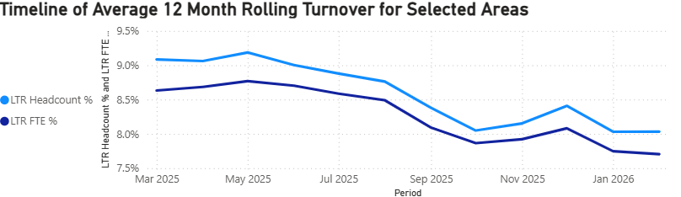

The service group has seen an improving trend in relation to turnover. The top three reasons for leaving between 03/25 and 02/26 have been Retirement Age, Voluntary Resignation -Relocation and Voluntary Resignation – Other/Not Known. The highest number of leavers have been between the age of 56-60.
The service group has highlighted to Divisions the importance of recording accurately the reason why staff leave our organisation as it is essential for understanding workforce trends, identifying retention challenges, and shaping our support for staff and services. In addition, the service continues to promote the use of Exit Interviews to provide critical intelligence to further inform staff experience and retention approaches. Retention and Career Development is also one of the themes within the Staff Experience, Wellbeing and Retention Plans.

2.1.6 Vacancies

All vacancies continue to be subject to the current Workforce Controls in place across the Health Board. The service group has asked all Divisions to review vacancies, in anticipation of an expected 5% workforce reduction on top of existing vacancies.
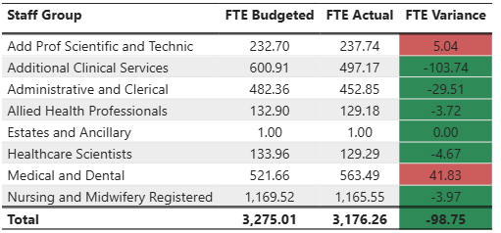

2.2 An overview of workforce risks and issues affecting NPTSSG

Workforce Risks/Issues

Medical Staff Recruitment Challenges | Recruitment challenges exist within the following specialties across the Service Group:  - Oncology  - Haematology  - Acute Paediatrics (Doctors in training posts)  - Obstetrics & Gynaecology  - Spinal  - Anaesthetics
Unavailability | High levels of sickness absence contribute to unavailability which impacts on the variable pay spend and service delivery. This applies to Medical, Nursing and Midwifery, Additional Clinical Services and the Administrative and Clerical Workforce.
Vacancies/Recruitment | Recruitment challenges and the need to reduce head count remains a challenge, the Service Group is working with colleagues to understand the implications on the headcount reduction.
Perinatal Service | The Service Group continues to actively respond to the requirements of both the Independent Review, Targeted Intervention status and workforce priorities which form part of the Perinatal Committee. For example, the Perinatal Leadership development Programme which is currently ongoing.  A recent inspection from HIW into the services, which was overall extremely positive. The previous lead inspector, who was also part of this team and the last two inspections, reflected that she had seen huge improvements, commenting that MDT team working was outstanding.

2.3 Staff Survey Update

The service group presented the Staff Survey Action Plan at Workforce and OD Committee in October 2025. It highlighted six key actions linked to the previous staff survey which are all complete.

The Service Group had a focus on the most recent staff survey throughout October to December 2025 with a final response rate of 10.2%. There were collective efforts in promoting and sharing the importance of completing the survey and whilst the target of 25% was not achieved it was more than double the response rate of the last survey.

The service group awaits the staff survey results which are expected from HEIW during March 2026. The service group will use the Staff Experience and Wellbeing Retention Project Framework and the Plans which are in development for each Division as a mechanism to respond to the feedback.
The Staff Experience, Wellbeing and Retention Plans use an improvement methodology encompassing professional body research, the HEIW Retention Framework and the Staff Health and Wellbeing – A Best Practice Guide for NHS Wales to support the development of the plans. The methodology is aligned with the strategic aims in the Health Board’s People Plan.
- GOVERNANCE AND RISK ISSUES

The Workforce Metrics, Risks and Staff Survey plans progress will continue to be monitored and evaluated through the Division’s Monthly Workforce Groups and the Divisional Performance Reviews.

From a risk perspective the impact of unavailability, the delay in recruiting to essential posts which has led to sickness is impacting on service delivery.

- FINANCIAL IMPLICATIONS

High absence levels above funded levels will result in variable pay usage to maintain service capacity and safeguard patient and service user care.

Although we are working to introduce the 21% fill rate on the nursing establishment (this is linked to level of overhead moving from current 26.5% to 21%), this will mean a level of variable pay is to be anticipated even if Sickness and Annual Leave are within funded levels.

Variable pay within Medical workforce remains a challenge for the Service Group specifically in our hard to recruit services namely Oncology and Haematology, which is having an impact on our financial position.

- RECOMMENDATION
ACKNOWLEDGE the Service Groups Workforce Metrics, Risks and Staff Survey Progress.
BE ASSURED of the actions being taken to ensure compliance with workforce metrics to support and improve the health and wellbeing of staff.

Governance and Assurance

Link to Enabling Objectives  (please choose) | Supporting better health and wellbeing by actively promoting and empowering people to live well in resilient communities
Link to Enabling Objectives  (please choose) | Partnerships for Improving Health and Wellbeing |  | ☐
Link to Enabling Objectives  (please choose) | Co-Production and Health Literacy |  | ☐
Link to Enabling Objectives  (please choose) | Digitally Enabled Health and Wellbeing |  | ☐
Link to Enabling Objectives  (please choose) | Deliver better care through excellent health and care services achieving the outcomes that matter most to people
Link to Enabling Objectives  (please choose) | Best Value Outcomes and High Quality Care |  | ☐
Link to Enabling Objectives  (please choose) | Partnerships for Care |  | ☐
Link to Enabling Objectives  (please choose) | Excellent Staff |  | ☒
Link to Enabling Objectives  (please choose) | Digitally Enabled Care |  | ☐
Link to Enabling Objectives  (please choose) | Outstanding Research, Innovation, Education and Learning |  | ☐
Health and Care Standards
(please choose) | Staying Healthy |  | ☐
(please choose) | Safe Care |  | ☐
(please choose) | Effective Care |  | ☐
(please choose) | Dignified Care |  | ☐
(please choose) | Timely Care |  | ☐
(please choose) | Individual Care |  | ☐
(please choose) | Staff and Resources |  | ☒
Quality, Safety and Patient Experience
Staff health and wellbeing has an impact on staff engagement and experience, and this in turn enables organisational productivity, individual performance and ultimately the quality of patient care and outcomes across the Service Group.
Financial Implications
High absence levels will result in variable pay usage in order to maintain the services capacity and safeguard patient care.
Legal Implications (including equality and diversity assessment)
Actions taken by the service will be required to comply with employment legislation.
Staffing Implications
Actions taken should contribute to improved employee availability and have a positive impact on staff health and wellbeing.
Long Term Implications (including the impact of the Well-being of Future Generations (Wales) Act 2015)
Developing and retaining a skilled workforce is a key objective of the Health Board and is a fundamental principle of the One Bay Way.
Improving population health is a key objective of the Health Board and the workforce plays a critical role in influencing the wellbeing of future generations.
Report History |  | None
Appendices |  | None

