Meeting Date | 21 April 2026 |  | Agenda Item |  | 2.3
Name of Meeting | Workforce and Organisation Development Committee
Report Title | Update on persistent recruitment and retention challenges within District Nursing
Report Author | Ruth George, Human Resources Business Partner
Report Sponsor | Tina Ricketts, Executive Director of Workforce and Organisational Development
Presented by | Emily Davies, Interim Group Nurse Director/Ruth George, Human Resources Business Partner
Freedom of Information | Open
Purpose of the Report | The purpose of this report is to provide the Committee with:  - The current recruitment and retention position within the District Nursing service  - Key workforce risks and mitigations  - Progress against recruitment and retention actions
Key Issues | This report summarises the current position and actions in relation to persistent recruitment and retention challenges within District Nursing.  The District Nursing service has a funded establishment of 328 WTE and operates across eight cluster teams, delivering services seven days a week. Vacancy levels remain low, and current registered nursing over‑establishment (6 WTE) reflects temporary student streamlining and maternity leave cover arrangements. Turnover has shown sustained improvement since mid‑2024, indicating increasing workforce stability, with attrition primarily driven by predictable factors such as retirement and career progression.  Key workforce risks include retirement‑driven attrition, sickness absence impacting service capacity, workforce pressures linked to increasing patient acuity and demand, and financial pressures associated with variable pay and temporary staffing. These risks are well understood and are actively managed through established governance arrangements.  A range of recruitment, retention, and sickness absence actions are in place.  These include:  - centralised recruitment processes  - role diversification, Band 4 development, and internal progression pathways  - leadership development  - professional advocacy and wellbeing support  - routine workforce assurance meetings, and targeted absence management interventions.  Substantive pay remains underspent year‑to‑date; however, variable pay continues to present a financial pressure, predominantly linked to sickness absence. Actions to reduce absence and associated costs are in place and are monitored through workforce and financial governance arrangements.
Specific Action Required  (please choose one only) | Information | Discussion | Assurance | Approval
Specific Action Required  (please choose one only) | ☒ | ☐ | ☒ | ☐
Recommendations | Members are asked to:  - BE ASSURED of the recruitment and retention position within District Nursing and the actions being taken to address any challenges.

UPDATE ON THE PERSISTENT RECRUITMENT AND RETENTION CHALLENGES WITHIN THE DISTRICT NURSING SERVICE

1 INTRODUCTION
This report provides the Workforce & Organisation Development Committee with an update on the persistent recruitment and retention challenges within the District Nursing service, including current workforce position, emerging risks, and mitigating actions.

- BACKGROUND

  - District Nursing Services Overview
District Nursing is a critical component of SBUHB’s community care model, supporting admission avoidance, early discharge, long-term condition management, prevention, and end-of-life care. Workforce sustainability is therefore fundamental to service delivery and to the Welsh Government’s and Health Board’s strategic ambition to shift delivery of care closer to home.
Nationally, District Nursing services face sustained workforce pressures arising from demographic change, increasing demand, and rising patient acuity. These pressures are evident locally and require continued oversight through workforce planning and governance arrangements.
District Nursing services are delivered by community registered nurses, and health care support workers based within eight cluster teams, operating seven days a week across the SBUHB geographical footprint. The service promotes person-centred, coordinated care, and supports independence wherever possible.
The current funded establishment, based on data extracted from the workforce business intelligence dashboard is 328 FTE, broken down as follows:
FTE | Staff Group
121 | Additional Clinical Services
15 | Admin and Clerical
192 | Registered Nursing

Financially, substantive pay within the service remains underspent year to date; however, variable pay continues to present a financial pressure. Reducing sickness absence and variable pay remains a priority and is subject to ongoing monitoring through workforce governance arrangements.
The Service Group presented to the Workforce &OD Committee in February 2026 regarding key workforce metric performance, including on-going and planned actions to reduce sickness absence and variable pay in hot spots areas such as District Nursing. An external review of District Nursing services, as part of a wider community services review, was concluded in March 2026. This identified opportunities to strengthen service sustainability and capacity across the community teams. Recommendations are currently under review by the Service Group for implementation.
2.2 Recruitment Challenges
Recruitment challenges reflect national trends and include:
  - Limited entry pipeline into district nursing
  - Competition from acute and specialist roles
  - Requirement for specialist skills, autonomy, and leadership
  - Variable access to post-registration education
  - Lone working and geographical coverage
  - Financial constraints
Despite these challenges, vacancy levels remain low against funded establishment. The current over-establishment of registered nurses (6 FTE) reflects student streamliners and maternity leave cover and is partially offset by vacancies in additional clinical services roles.
2.2.1 District Nursing Establishment Control
Data from Workforce Dashboard (March 2026):

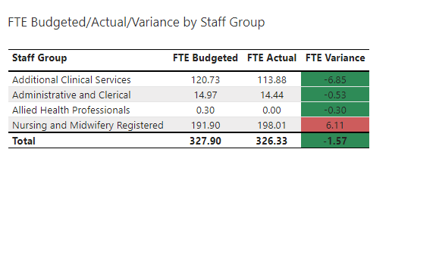
To mitigate these challenges, the service has strengthened skill-mix through new Band 4 roles and a “grow your own” approach. Appointments have been made mainly from within existing workforce, with some staff now undertaking registered nurse training. Expanding health care support worker roles is also helping to release registered nurse capacity to manage increasing clinical complexity. Further role diversification including advanced and specialist roles is being explored.
To attract new staff, the service takes a proactive approach to recruitment, including careers events, support for student streamliners, and promotion of opportunities across community teams. Messaging focuses on MDT working, community-based practice, and a positive, person-centred culture.

Actions in place to support recruitment, include:
- All vacancies continue to be subject to the current enhanced workforce controls in place across the Health Board.
- Work is ongoing for nurse leaders to review current establishments in line with the Health Board requirements and the impact on any service risks.
- Strategic workforce planning events held for nursing leaders and service workforce plans in place.
- Continue to seek alternative ways to fill vacancies through role redesign, skill mixing, rotation, pooled resource, and opportunities to develop new roles.
- Weekly vacancy control scrutiny panels.
- Fixed term contract and secondment quarterly review.
- Recruitment update reports shared on a monthly basis from data provided from NWSSP recruitment services.
- Central recruitment process for all eight cluster District Nursing teams to improve recruitment experience, time to hire and release clinical capacity of leaders.
- Recruitment webinars/career open days
- Flexible working arrangements

2.2.2 Recruitment Action Plan Progress
Actions | Lead | By When | Status
Strategic Workforce planning training for all Senior Nurse Leaders and workforce plans in place. | Group Nurse Director | 06/25 | Complete - 2026 plans to be reviewed and refreshed in line with Health Board requirements and impact of service risks.
Review fixed term contracts and secondments. | Nurse Leaders/ HRBP | 06–07/25 | Complete -On-going quarterly review.
Swansea University Community Nursing Open Day | Nurse Leaders | 02/26 | Complete – open day held on 17 Feb 26.
Senior Nurse Leader Workforce Assurance meeting with HRBP | Group Nurse Director/HRBP | 03/26 | Complete 03/26 – on-going monthly

2.3 Retention Challenges
2.3.1 Turnover
Twelve-month rolling turnover peaked in early 2024 and has shown sustained improvement since mid-2024, continuing into early 2026. This indicates increasing workforce stability and suggests that recent workforce interventions are having a positive impact. Continued monitoring is required to ensure this improvement is sustained.

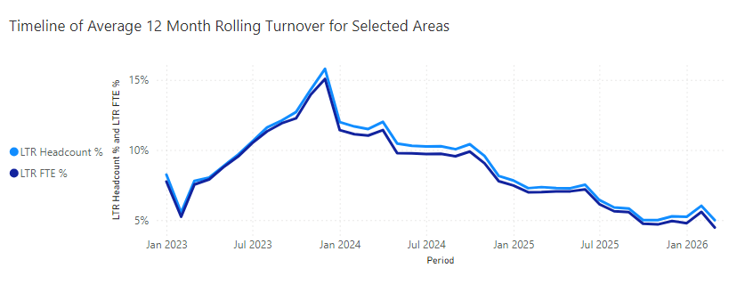

2.3.2 Reasons for Leaving
Leavers within District Nursing services are primarily driven by:
  - Retirement (including flexible and ill-health retirement)
  - Voluntary resignation for other unknown
  - Voluntary resignation due to promotion
Promotion-related exits highlight the importance of internal career pathways to retain talent within the organisation and the current recruitment processes in relation to external recruitment. Service teams have been asked to record reasons for leaving consistently and accurately. This improves understanding of workforce trends, helps identify retention issues, and informs targeted support. The service also continues to promote exit interviews to strengthen insight into staff experience and to shape retention approaches.

Numbers of Leavers by Reason for District Nursing

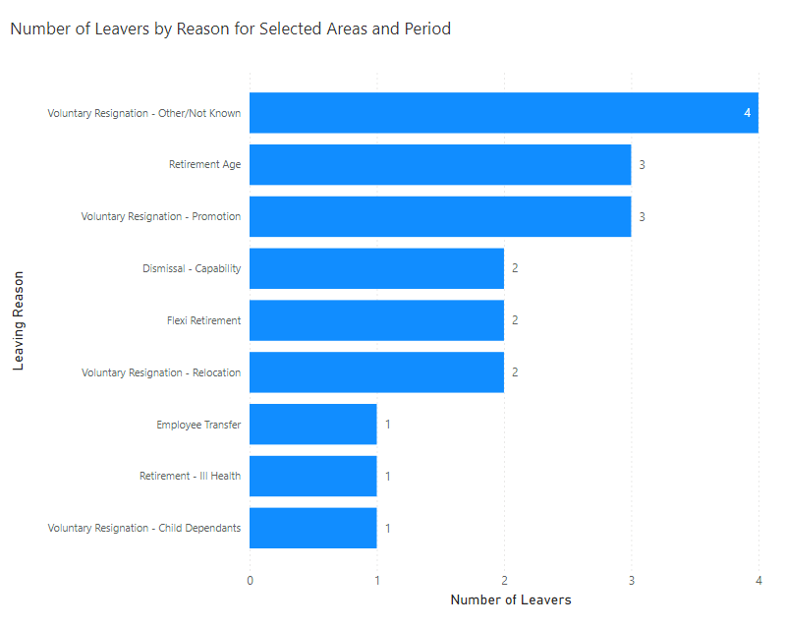
2.3.3 Age Profile
The highest proportion of leavers are aged 56–60 for Registered Nursing, confirming a predictable retirement-driven attrition risk. The overall workforce age profile shows a strong and experienced mid-career workforce, alongside a sizeable cohort approaching retirement age. This presents a medium-term risk of loss of experience without effective succession planning.
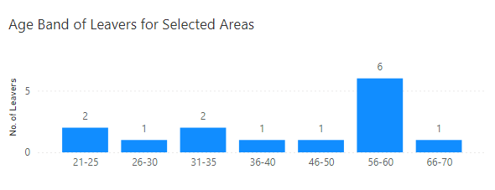

District Nursing Service Age Profile
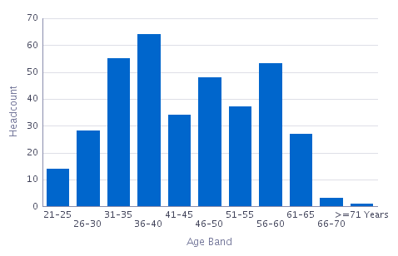
Actions in place to support retention, include:
- Alignment with local and national nursing workforce and retention strategies.
- Local workforce planning and regular review of establishment and skill mix.
- Development of Band 4 and internal progression pathways.
- Use of workforce and workload tools to support safer staffing
- Initiatives to promote staff wellbeing, flexible working, and retention of experienced staff.
- The District Nursing Service was proud to appoint Swansea Bay’s first Professional Nurse Advocate (PNA). This role has provided vital professional guidance and wellbeing support to District Nursing teams, helping to strengthen and sustain the workforce. Building on this success, the PNA model has since been extended to other services, including Sexual Health and Specialist Palliative Care, ensuring wider access to this important support.
- To further enhance accessibility, a Service Group Professional Advocate Hub site has been developed, providing a central, easily accessible resource for staff across District Nursing and the wider service group.
- Well-being rooms for staff.

2.3.4 Retention Action Plan Progress
Actions | Lead | By When | Status
Pulse surveys rolled out across District Nursing Cluster Teams | Head of Nursing/HRBP |  | Complete – Pulse surveys undertaken in eight cluster teams throughout 2025. Findings feedback and service improvement plans being implemented.
Implement Absence Summit meeting to review sickness absence and compliance within District Nursing. | Nurse Leaders/ HRBP | 07/25 | Complete -On-going monthly.
Implement Well-being plan for District Nursing Services | HRBP/Nurse Leaders | 10/25 | Complete
Develop and implement District Nursing Intranet Hub Site. | Head of Nursing | 06/25 | Complete
Develop Leadership Pathway for Band 6 and 7 Nurse Leaders | Group Nurse Director/Head of Nursing | 07/26 | In progress
Analyse Exit questionnaire data and produce quarterly report for the service group. | HRBP | 07/25 | Completed – reports produced on a quarterly basis for
Set up well-being rooms for staff use | Head of Nursing | 03/26 | Completed – well-being rooms set up in Gorseinon and Cimla Hospitals March 26
Student streamlining induction day | Head of Nursing | 03/26 | Completed 03/26
Sickness deep dive for District Nursing | HRBP | 01/26 | Completed 01/26
Sickness audits for District Nursing Cluster Teams | Group Service Director/HRBP | From 10/25 | Completed and feedback provided 02/26. Follow up reviews to be undertaken from 08/26
Senior Nursing Leadership structure to be reviewed in line with HB Organising for Success OCP | Group Nurse Director | 09/26 | In progress

- GOVERNANCE AND RISK ISSUES

District Nursing workforce risks are understood and are actively managed through established governance arrangements. Turnover trends are improving, with attrition largely driven by predictable factors such as retirement and career progression. Recruitment remains effective and vacancy levels are low against funded establishment.
Mitigating actions are aligned to local and national strategy and local workforce plans, with ongoing monitoring and escalation providing assurance.
The following workforce risks are highlighted:
- Service risk: Reduced capacity to meet demand and support community-based care models.
- Workforce risk: Retirement-driven attrition, sickness absence, and skill-mix pressures.
- Quality and safety risk: Impact on continuity of care, staff resilience, and patient experience
- Financial risk: Increased reliance on temporary staffing and variable pay
- Strategic risk: Reduced ability to deliver national policy commitments.
These risks are consistent with national findings and are currently reflected on the Risk Register.

From a risk perspective the impact of unavailability and specifically sickness can impact on service delivery.

4 FINANCIAL IMPLICATIONS
Financially substantive pay within the service remains underspent year-to-date; however, variable pay costs continue to present a financial pressure. Reducing sickness absence and variable pay remains a priority and is subject to ongoing monitoring through workforce governance arrangements.
Recruitment and retention pressures increase the risk of reliance on temporary staffing, with associated cost pressures. Further assurance on budget impact and mitigating actions will continue to be provided in conjunction with Finance.
5 RECOMMENDATIONS
The Workforce & OD Committee is asked to:
- BE ASSURED of the current recruitment and retention position within the District Nursing service, and of the actions being taken to address identified challenges.

Governance and Assurance
Link to Enabling Objectives  (please choose) | Supporting better health and wellbeing by actively promoting and empowering people to live well in resilient communities
Link to Enabling Objectives  (please choose) | Partnerships for Improving Health and Wellbeing |  | ☐
Link to Enabling Objectives  (please choose) | Co-Production and Health Literacy |  | ☐
Link to Enabling Objectives  (please choose) | Digitally Enabled Health and Wellbeing |  | ☐
Link to Enabling Objectives  (please choose) | Deliver better care through excellent health and care services achieving the outcomes that matter most to people
Link to Enabling Objectives  (please choose) | Best Value Outcomes and High-Quality Care |  | ☐
Link to Enabling Objectives  (please choose) | Partnerships for Care |  | ☐
Link to Enabling Objectives  (please choose) | Excellent Staff |  | ☒
Link to Enabling Objectives  (please choose) | Digitally Enabled Care |  | ☐
Link to Enabling Objectives  (please choose) | Outstanding Research, Innovation, Education and Learning |  | ☐
Health and Care Standards
(please choose) | Staying Healthy |  | ☐
(please choose) | Safe Care |  | ☐
(please choose) | Effective Care |  | ☐
(please choose) | Dignified Care |  | ☐
(please choose) | Timely Care |  | ☐
(please choose) | Individual Care |  | ☐
(please choose) | Staff and Resources |  | ☒
Quality, Safety and Patient Experience
Staff recruitment, retention, health, and wellbeing have an impact on staff engagement and experience, and this in turn enables organisational productivity, individual performance and ultimately the quality of patient care and outcomes across the Service Group.
Financial Implications
Substantive pay remains underspent year-to-date; however, variable pay continues to present financial pressure. Controls focus on reducing sickness absence and variable pay, with ongoing monitoring through workforce governance.

Legal Implications (including equality and diversity assessment)
Actions taken by the service will be required to comply with employment legislation.
Staffing Implications
Actions taken should contribute to improved employee availability and have a positive impact on staff health and wellbeing.

Long Term Implications (including the impact of the Well-being of Future Generations (Wales) Act 2015)
Recruiting, developing, and retaining a skilled workforce is a key objective of the Health Board and is a fundamental principle of the One Bay Way.
Improving population health is a key objective of the Health Board and the workforce plays a critical role in influencing the wellbeing of future generations.
Report History |  | N/a
Appendices |  | N/a

