Meeting Date | 21 April 2026 |  | Agenda Item |  |  | 2.4
Name of Meeting | Workforce and OD Committee
Report Title | Workforce Report – MH&LD
Report Author | Dermot Nolan, Interim Service Group Director Mental Health and Learning Disabilities
Report Sponsor | Deb Lewis, Chief Operating Officer / Executive Director of Primary Care & Mental Health
Presented by | Dermot Nolan, Interim Service Group Director Mental Health and Learning Disabilities
Freedom of Information | Open
Purpose of the Report | The purpose of the report is to provide an update on the following areas, originally outlined on 11th December 2025:  - Workforce performance against key metrics and associated actions  - An overview of workforce risks and issues affecting MH&LD  - Staff Survey Action Plan Progress
Key Issues | The key issues relate to the following:  - Ongoing unavailability challenges across staff groups  - Engagement in Staff Survey for Service Group  - Establishment and vacancies impact based on underlying deficit allocation.  - Overview of main workforce risks
Specific Action Required  (please choose one only) | Information | Discussion |  | Assurance | Approval
Specific Action Required  (please choose one only) | ☒ | ☐ |  | ☒ | ☐
Recommendations | - ACKNOWLEDGE the Service Groups Workforce Metrics, Risks and Staff Survey Progress.  - BE ASSURED of the actions being taken to ensure compliance with workforce metrics to support and improve the health and wellbeing of staff.

WORKFORCE REPORT
Mental Health and Learning Disabilities

- INTRODUCTION

This report will provide a workforce update on the following:

- Performance against key workforce metrics and associated action
- An overview of workforce risks/issues affecting MH&LD
- Staff Survey Action Plan Progress

- BACKGROUND

2.1 Performance against key workforce metrics and associated action

In December 2025 we reported our metrics for October 2025 were:

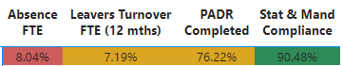

In February 2026 our metrics are as follows:

Sickness Absence

Overall Sickness absence for the Service Group continued to rise from October 2025 to 9.67% in December 2026. With a continued focus on each sickness absence improvement in reduction commenced in January 2026 to 8.26% in February 2026

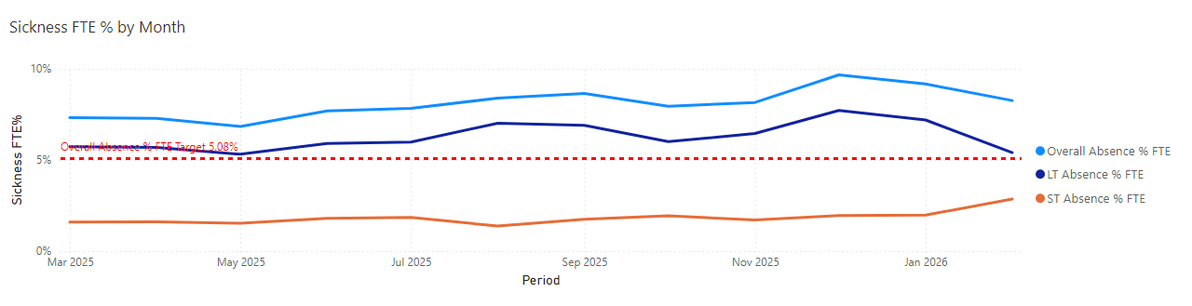

Overall total absent days by total employees amounted to 4,227 workdays lost during October 2025, ranging between 120 to 188 absences per day.

In February 2026 total absent days by total employees improved to 1746 workdays lost, ranging between 144 to 164 absences per day.

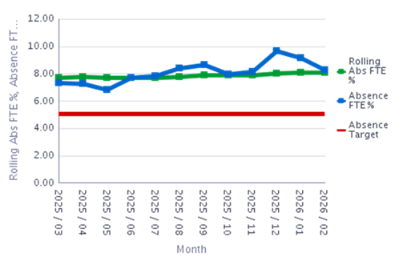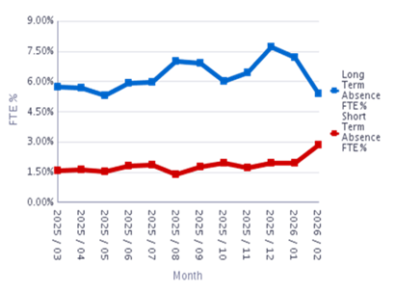

Long term absence decreased to 5.41% in February 2026. Short term absence continued to increase to 2.85% in February 2026 and remains an area of pressure for variable pay.

The Directorate’s short-term and long-term absences for February 2026 were as follows:

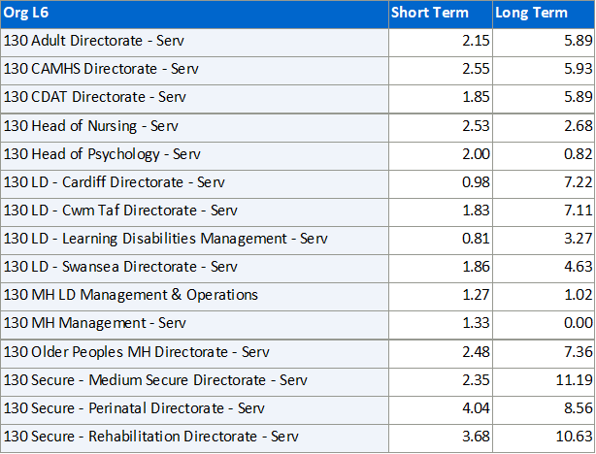

A Service Group sickness summit held in March 2026 highlighted that of ten areas identified as being consistently above 11% absence over a rolling 12 months, with a minimum of 20 staff for audits, 6 areas had made substantial improvement and 4 will no longer require additional focus within this summit.
Follow up audits have been undertaken in these areas. The sickness summit enabled our managers to share learning on approaches that have led to a reduction in absence in their areas. A focus on the improvement achieved will be shared with the Health Board within both Gwelfor ward and Suite 2.

Monday has remained the highest day of absence with a steady reduction through the week, rising again on Sunday. The highest level of absence has been between 0 and 1 days, with absences between 28 days and 6 months the next highest area. This is illustrated in the February data below.

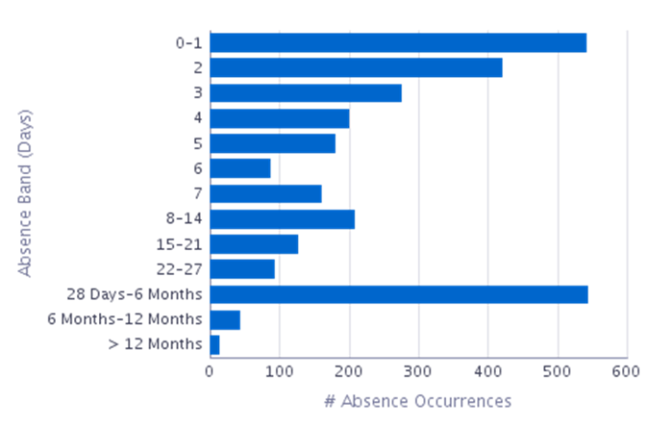 | 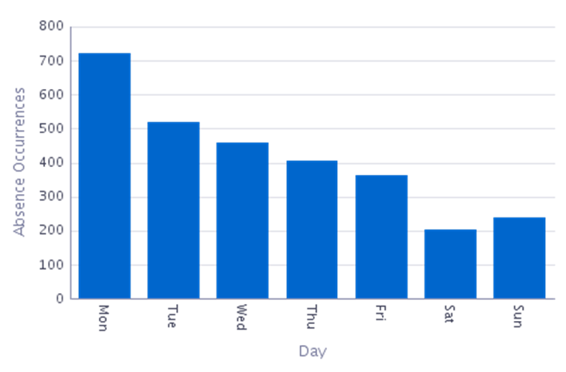
The three main reasons for sickness absence within the Service Group have not changed since October 2025. The figures for February 2026 are below, notably absences for Cold, Cough and Flu have declined, but Anxiety /Stress remains at the same level of pressure:

Absence Reason | Grand Total
S10 Anxiety/stress/depression/other psychiatric illnesses | 111
S13 Cold, Cough, Flu - Influenza | 36
S25 Gastrointestinal problems | 54

The TRIM support continues to be widely shared across the Service Group and a new TRIM manager is currently being sourced.

Managers are reminded to utilise Occupational Health and Wellbeing for staff who are absent, along with other mechanisms available. The staff counsellor within the Service Group is unfortunately absent and this is impacting on the opportunity for group work to support wellbeing and individual access to counselling support.

Absence rates within nursing and additional clinical services staff have remained high throughout the year. The absence rate for February by staff group is below.

In-month absence rates across the Service Group have been below the projected (forecasted) rate.

February 2026 in month absence rates have exceeded the projected (forecasted) rates.

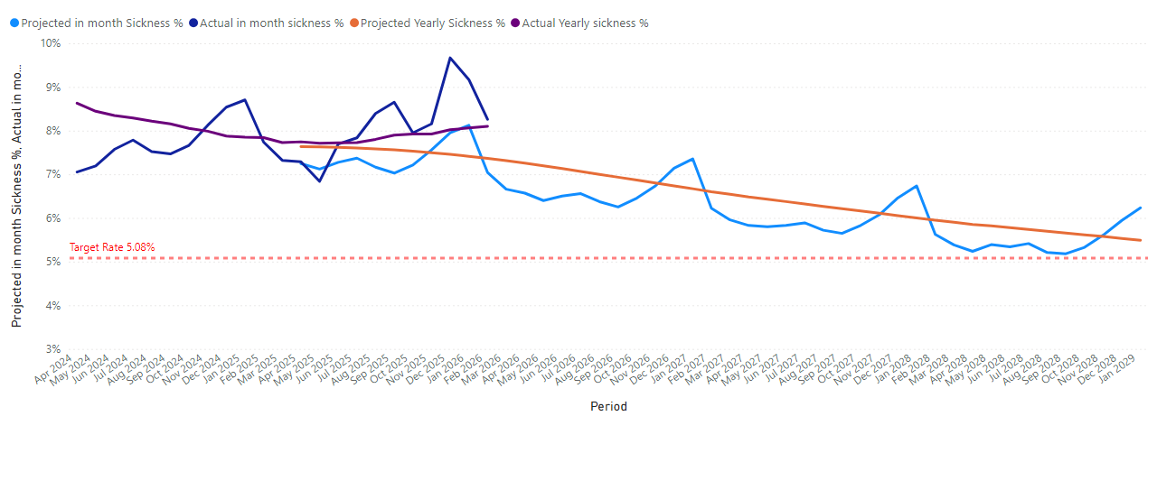

To address these issues the following actions are continuing:

Overarching Sickness Improvement Actions

MH&LD Managing attendance at work action plan is attached, and we have summarised below the key themes.

Themes | Actions
Leadership Engagement and Managerial Accountability | Strengthening Our Focus on Sickness Improvement:  - Clear messaging around sickness being a key priority.  - Reinforcing the message that this is a key area that requires our collective attention and commitment.  - As leaders there is a vital role to play in shaping the environment our teams work in and by taking clear ownership of sickness performance, each leader has the power to make a real difference.
Sickness Management | - Programme of audits for ‘Hot Spot Areas’ took place between 09/25 and 01/26 with a re-audit programme held between 01/26 and 03/26.  - Absence Reviews – undertaken in 10 ‘Hot Spot Areas’ These reviews have been designed to enable a proactive approach to supporting both long and short-term staff absence. The HR Business Partner Team and Operational HR Team work alongside the management team to ensure long and short-term cases are being appropriately managed and progressed. The meeting also initiates case reviews, which may require specialist advice input e.g., Occupational Health.
Key improvement actions relating to stress and anxiety | Specific actions taken for anxiety, stress and depression are:  - Early contact – with a compassionate approach  - Regular contact / touch points during absence period  - Regular sickness review meetings with HR Ops Team  - Immediate support and signposting  - Tailored and flexible return to work plans  - Ongoing monitoring and touchpoints on return to work  - Occupational Health referral  - Stress risk assessment to be completed.  - Referral and signpost to relevant support groups and wider support
Staff Experience, Wellbeing and Retention | Development of staff experience, wellbeing & retention plans draws on the evidence and best practice contained within the Staff Health and Wellbeing – A Best Practice Guide for NHS Wales.
Monitoring and Assurance | - Monthly workforce groups (KPIs are reviewed and plans agreed to improve performance if required)  - Audit / workforce KPI Reports  - Monthly roster scrutiny meetings  - Absence summits/audits  - Business assurance and accountability meeting (sickness performance is specifically reviewed as part of this assurance and accountability process)
Education and Training | - Managers continue to have access to the “Managing Attendance at Work” training and the Brilliant Basics platform (interactive learning and education tool accessible 24/7).  - Support/coaching from HR Business Partner Team and HR Advisors.
Workforce Planning | - The HEIW Strategic Workforce Planning Toolkit has been used to develop MDT Workforce Plans across all Divisions so that services identify all opportunities to plan and design the workforce to maximise capacity and focus on effective workforce design (using the principles in the Staff Health and Wellbeing – A Best Practice Guide for NHS Wales) to support services in maximising staff availability. These workforce plans are subject to continual review.

Personal Development Reviews (PADR)

The target set for PADR compliance and Statutory Mandatory training is 85%.

PADR compliance has increased from 76.18% on 31st October 2025 to 76.6% on 28th February 2026. Managers are reminded to arrange to meet with staff who still require a PDR and Managers must take responsibility for ensuring they have rolling plans in place to meet with staff and that they are recorded on ESR. Training on how to conduct a meaningful PADR is available to be booked on with Learning and Development each month.

25 areas out of 138 areas in the Service Group are in the red. Managers are reminded that reviews can be completed over teams. 420 staff currently are out of compliance for completing a PADR.

There has been an increase in three staff groups compliance since October 2025. Staff groups highlighted in red are below target. All Managers have been directed to ensure there is a plan for reviews to be scheduled and to include a check in with their staff wellbeing.

Progress plans are reviewed in Divisional Meeting, Nurse Workforce, Board and Senior Team Meetings.

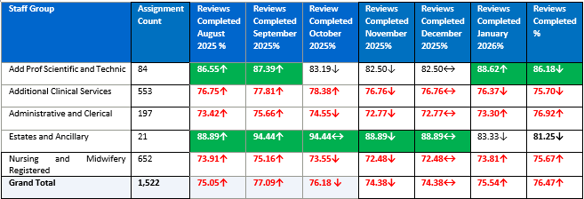

The following areas need to focus on planning PADRs to engage with staff. (please note only those with 10+ staff have been included). Please note this was the status on 28th February 2026)

The following areas with 10+ staff are thanked for engaging with staff and being on or above target.

Mandatory Training
Mandatory training has continued to improve from 90.34% on 31st October 2025 and is currently on 28th February 2026 at 90.88%. Staff groups with the exception of medical staff and ancillary staff are above target.

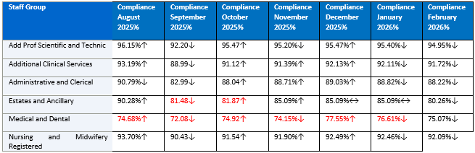

Staff that are not compliant are reminded that this is a contractual requirement and that they be provided with a deadline to ensure completion of their mandatory training, it is a contractual requirement. It needs to be reinforced that mandatory training can be accessed from home.

This is reinforced within PADR’s and non-compliance will result in staff not going through a pay progression point. A particular focus is being driven for our medical staff and those not in compliance are having study leave declined. Progress plans are reviewed in Divisional Meeting, Nurse Workforce, Medical Workforce, Board and Senior Team Meetings.

With the exception of three areas that are 2% to 5% or less below target, all Directorates achieved or exceeded the Mandatory training compliance target:

With regards to specific competencies the Service Group is above target in all competencies apart from three highlighted yellow in the table below where the compliance is 2 to 3% lower than target.

Vacancies / Turnover

Unfilled Vacancies February 2026

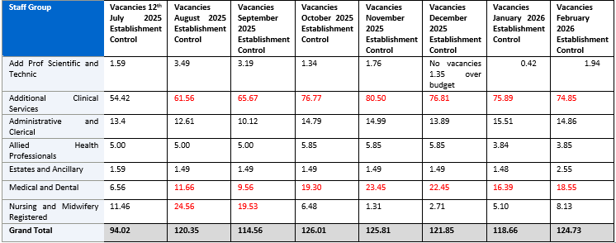

There are 124.73 vacancies within MH&LD, the main pressures within the group remain for Medical (18.55) and Additional Clinical Services (74.85) which is contributing to variable pay usage.

Additional processes have been implemented in line with the health board decision to delay appointment to posts which has resulted in posts scheduled for shortlisting, interview and appointment being removed from recruitment.
Managers have or are now working through three criteria, external funded, Nurse Staffing Act principles and business critical for posts to be reinstated within recruitment, however there is a risk that applicants will not reapply to the health board. The deployment of staff internally is being utilised to reduce variable pay and service pressures where areas have gaps.

Turnover

Turnover for the Service Group has reduced from 7.61% as of 31st October 2025 to 7.09% headcount on 28th February 2026. The main reason for leaving remains age retirement.

Registered Nursing and Additional Clinical staff are the main staff group for leavers due to age profile, albeit a number of staff are returning to work under the retire and return scheme and supported with flexibility arrangements.

Exit questionnaires and interviews are available for all staff within the group and responses are monitored.

Staff Group | Headcount July 2025 | Headcount August 2025 | Headcount September 2025 | Headcount October 2025 | Headcount December 2025 | Headcount January 2026 | Headcount February 2026
Add Prof Scientific and Technic | 9.69%↑ | 8.77%↓ | 7.89%↓ | 6.90%↓ | 5.11%↓ | 4.27%↓ | 6.03%↑
Additional Clinical Services | 8.15%↓ | 7.28%↓ | 6.95%↓ | 6.98%↑ | 6.99%↑ | 7.28%↑ | 7.40%↑
Administrative and Clerical | 12.17%↑ | 11.74%↓ | 10.87%↓ | 11.79%↑ | 10.20%↓ | 10.34%↑ | 10.31%↓
Estates and Ancillary | 10.81%↔ | 10.81%↔ | 10.81%↔ | 0.00% | 0.00% | 0.00% | 0.00%
Medical and Dental | 15.17%↑ | 16.90%↑ | 15.28%↓ | 17.93%↑ | 13.79%↓ | 12.16%↓ | 16.00%↑
Nursing and Midwifery Registered | 6.71%↑ | 6.86%↑ | 6.68%↓ | 6.29%↓ | 6.12%↓ | 5.96%↓ | 5.49%↓

Staff Turnover – Mental Health and Learning Disabilities March 2025 to February 2026

The four main reasons for staff leaving by staff group are indicated in the table below together with the overall total leavers for the last 12 months by staff group.

2.2 An overview of workforce risks and issues affecting MH&LD

This table is a summary of all MH&LD risks.

Mental Health & Learning Disabilities Risks Rated 16 plus
Type | Mental Health and Learning Disabilities Delivery Unit October 25 | Mental Health and Learning Disabilities Delivery Unit March 26
Compliance with legislation and Statutory/regulatory inspections | 1 | 1
Environment, Estates and Infrastructure | 11 | 12
Financial Management | 2 | 2
Governance and Assurance | 4 | 6
Patient Safety | 1 | 2
Sustainable Services | 9 | 8
Workforce & OD | 9 | 9
Grand Total | 37 | 40

This table is a focus on risks that affect our workforce.
ID | Title | Opened | Rating (current) | Adequacy of Controls
4210 | Environmental Constraints of existing MBU | 16/06/2025 | 20 | Adequate
4148 | Inadequate Seclusion Facilities at Caswell Clinic | 07/04/2022 | 20 | Inadequate
3962 | Mental Health Site Security Issues (Cefn Coed & Garngoch) | 05/11/2024 | 20 | Inadequate
3226 | Ward F Seclusion Facility Non-Compliant with Standards | 09/12/2022 | 20 | Adequate
3981 | Environmental Concerns YYC | 12/11/2024 | 16 | Inadequate
4156 | Inadequate Estates Maintenance and Infrastructure at Caswell Clinic | 18/07/2023 | 16 | Inadequate
4195 | Inadequate Estates Maintenance and Infrastructure at Taith Newydd | 04/06/2025 | 16 | Inadequate
2026 | LD - Estates Responsibilities/Units not fit for purpose | 20/08/2019 | 16 | Adequate
4149 | Outdated and Inadequate Seclusion Suite Design (Penarth Ward) | 07/04/2022 | 16 | Inadequate
3346 | Inadequate establishment and staff in post to comply with Part 1A&B MHM and timely patient care | 04/05/2023 | 16 | Adequate
4181 | Limited acute liaison nursing roles across the service group and commissioning HBs | 16/05/2025 | 16 | Adequate
3406 | Overoccupancy in adult acute mental health services/Adult patients on older persons MH wards | 07/06/2023 | 16 | Inadequate
3214 | Clinical Risk - Typing Backlog for consultants and in CMHT's due to workload and lack of workforce capacity | 24/11/2022 | 20 | Inadequate
3407 | Deficits in administrative cover across adult mental health services | 07/06/2023 | 20 | Inadequate
3628 | MH & LD Nursing workforce/Safe Staffing levels in accordance with the Nurse Staffing Act | 12/01/2024 | 20 | Inadequate
3275 | Cefn Coed Hospital wards night staffing | 22/02/2023 | 16 | Inadequate
4183 | Insufficient medical cover for inpatient wards for adult mental health Tawe Clinic | 19/05/2025 | 16 | Adequate
1048 | Medical Cover SG Wide/Psychiatric Cover on CCH Site | 07/11/2016 | 16 | Inadequate
1581 | No funded SLT for Mental Health services across SBUHB | 20/06/2018 | 16 | Inadequate
4253 | Psychology - Significant workforce gaps and resource issues impacting quality of care/treatment/MDT risk management | 08/08/2025 | 16 | Adequate
4200 | Rowan ward functioning as a stand alone ward in Taith Newydd | 05/06/2025 | 16 | Inadequate

Some of these risks are being worked through as part of the modernisation and transformation work. In addition, the work around Nurse Staffing requirements will also address a number of these risks if these can be supported.

2.3 Staff Survey Action Plan Progress

The service group identified the following key actions following receipt of the staff Survey date from the Staff Survey in 2024. Our engagement score was 73.5% and 227 staff (14.7% completed the survey)

The following table summarised results against the 10 question themes for MH&LD for 2024:
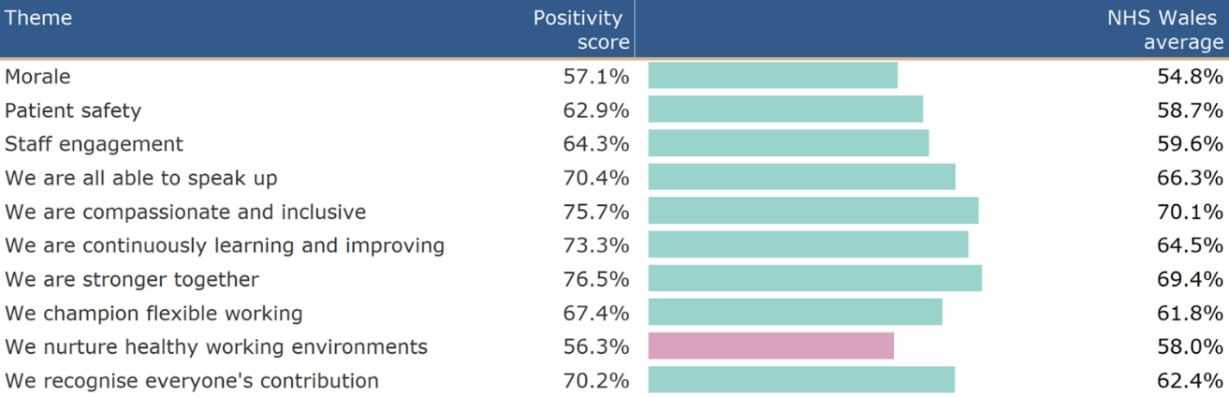

We developed short and medium term goals which are outlined below.

Short-term goals
Leadership, Engagement and Accountability at SMT/Divisional/Directorate Level.
Our 3 key areas of focus include:
- Leadership & Management
Staff are accessing Brilliant Basics, being supported to access education and clinical leadership opportunities and development. Use of Rdial
- Speaking Up Safely / Raising concerns
This has been picked up in Divisional Meetings and then reported into Quality & Safety on a monthly meeting. All staff have been provided with Webinar and information regarding how to speak and raise concerns.
- Values & Behaviours
Active Equality Group in place to ensure inclusion of all staff, embedding values in all aspects of work. The service group also established a Disability Staff Network which has now been rolled out across the Health Board.
- Healthy Working Environments
Changes to the current Estate are being undertaken as part of transformation work.
Sickness Audits have commenced and action plans are in place to address wellbeing of staff, use of TRIM, staff counsellor.

We are continuing to promote Workforce Strategies focussing on retention.
Divisions are taking a collective and compassionate leadership approach to developing local plans.

We are embarking on transformation of services, which is involving representatives from local teams as well as managers and Trade Union Representatives to develop plans.

Each Division is focusing on a communication and engagement strategy.

We are continuing to develop a talent pathway through the “Grow your own” ethos for MH&LD.

We benchmarked results against 2023 survey to assess improvements.

Medium-term goal
To identify leadership, management (including compassionate leadership) and professional development needs and plans as part of MH&LD PADRs to inform MH&LD development plan.

Benchmarking results against 2025 survey to assess improvements and highlight areas for further improvement which will form the medium-term goals.
Implement training and education to enhance use of digital systems within MH&LD
Alignment to IMTP and 7 people aims set out in SBU People Strategy.

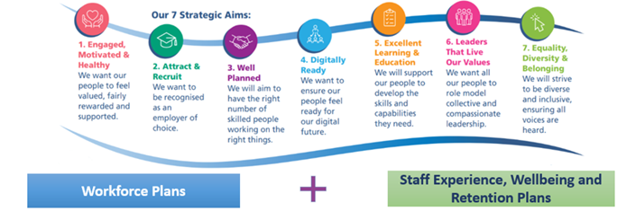

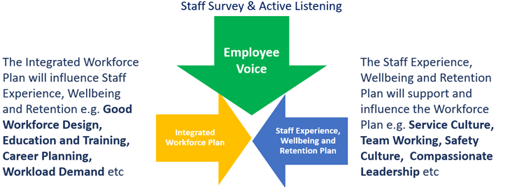

Key Actions/ Milestones leading up to 2025 staff survey
Actions/ Milestones | Lead | By When | Status
Nominate SG leads to access staff survey results via dashboard. | DN | 03/25 | Complete
Share 3 key areas of focus for the Health Board along with Divisional level staff survey results highlighting the specific themes for MH&LD | DN | 05/25 | Complete
Management teams to discuss the results and to agree how they will shape local Divisional Staff Survey Plans. | Divisional Leads | 05/25 | Complete
Utilise the “Meet the Senior Team” quarterly briefing to share overarching and Divisional results and actions planned. In addition highlight the launch of the 2025 survey | SMT | 06/25 | Complete
Divisional Staff Survey Plan to be shared during Divisional and Directorate Meetings | Divisional Leads | 06/25 | Complete
Progress update on Divisional Staff Survey Plan to be reported during SMT ahead of the launch of the 2025 Staff Survey (Oct 25). | Divisional Leads | 09/25 | Ongoing

Current Progress with the 2025 Staff Survey

The current survey closed on 1st December 2025, the response rate was 22.9% 427 staff completed the survey within MH&LD.

This was an improvement on staff participation since 2024 albeit the engagement score has reduced slightly to 72.2%. The detailed response will be worked through and the action plan in place based on 2024 data updated.

Healthy working environments remain a key focus for the service group.

Theme | Positivity score |  | Benchmark | Variance
We are stronger together | 74.6% |  | 68.7% | ▲ 5.89 pp
We are compassionate and inclusive | 74.4% |  | 69.6% | ▲ 4.77 pp
We are all able to speak up | 69.8% |  | 65.6% | ▲ 4.21 pp
We are continuously learning and improving | 68.4% |  | 63.1% | ▲ 5.30 pp
We recognise everyone's contribution | 68.2% |  | 61.2% | ▲ 6.98 pp
We champion flexible working | 68.2% |  | 60.8% | ▲ 7.33 pp
Patient safety | 62.5% |  | 59.7% | ▲ 2.77 pp
Staff engagement | 62.5% |  | 57.7% | ▲ 4.76 pp
Morale | 56.9% |  | 53.7% | ▲ 3.23 pp
We nurture healthy working environments | 54.7% |  | 56.5% | ▼ -1.79 pp

- GOVERNANCE AND RISK ISSUES

The Workforce Metrics, Risks and Staff Survey Progress will continue to be monitored and evaluated through the Division’s Monthly Workforce Groups, Nurse Workforce, Medical Workforce, Board and SMT.

Violence & Aggression Incidents In MH&LD- April 1st 2025 to March 31st 2026.
This looks at Datix under the following categories.
• Aggressive/threatening behaviour
• Inappropriate behaviour / attitude
• Patient clinically challenging behaviour
• Physical assault (physical contact)
• Sexual (inappropriate) behaviour
• Verbal assault (gender/sexual orientation)
• Verbal assault (racial abuse)
• Verbal assault (swearing etc.)

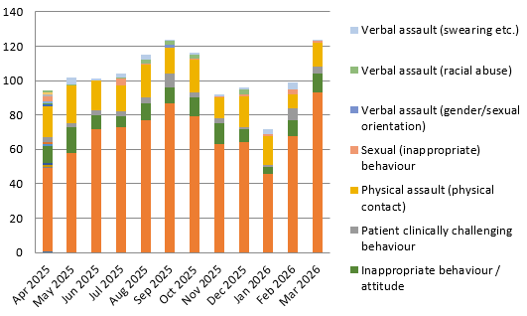

The graph below shows the incidents in the wards and community teams.

Please note locations are those incidents not located to teams but to areas such as carparks or patients’ homes.

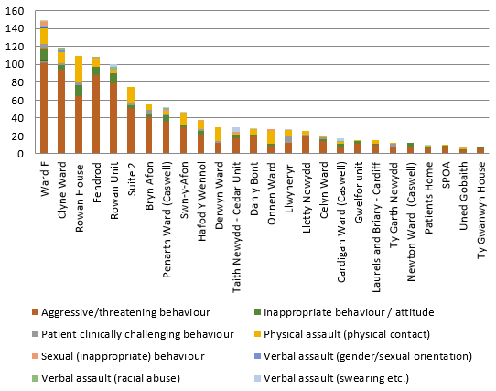

The final graph shows who was impacted by the incident.

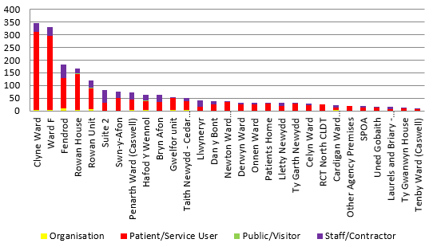

Self-Harm
The graph shows self-harm incidents which are stressful for staff to manage shown by location. This does not include self-harm leading to suicide as these would be classed as death of a patient seen by mental health services.

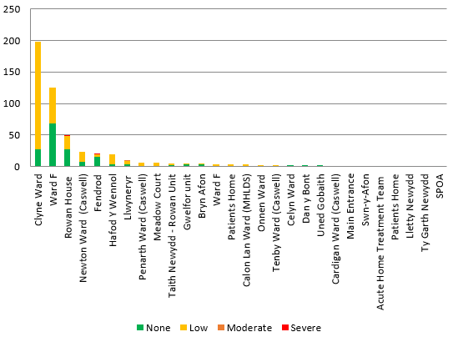

Management of ER cases also impacts on sickness levels and availability of staff. Currently we have the following number of cases.

Type | Number of Cases
Disciplinary | 28
Respect and Resolution | 7
Professional concerns (Safeguarding Process) | 2 not in other processes
Appeal (all policies) | 2

- FINANCIAL IMPLICATIONS

Unavailability of staff above funded levels results in variable pay usage to maintain service capacity and safeguard patient and service user care.

Nurse staffing act principles are currently being reviewed within all our inpatient areas. It is anticipated that it will identify that we are insufficiently staffed which contributes to additional variable pay.

- RECOMMENDATION
- ACKNOWLEDGE the Service Groups Update on Workforce Metrics, Risks and Staff Survey details.
- BE ASSURED of the actions being taken to ensure compliance with workforce metrics to support and improve the health and wellbeing of staff.

Governance and Assurance
Link to Enabling Objectives  (please choose) | Supporting better health and wellbeing by actively promoting and empowering people to live well in resilient communities
Link to Enabling Objectives  (please choose) | Partnerships for Improving Health and Wellbeing |  | ☐
Link to Enabling Objectives  (please choose) | Co-Production and Health Literacy |  | ☐
Link to Enabling Objectives  (please choose) | Digitally Enabled Health and Wellbeing |  | ☐
Link to Enabling Objectives  (please choose) | Deliver better care through excellent health and care services achieving the outcomes that matter most to people
Link to Enabling Objectives  (please choose) | Best Value Outcomes and High Quality Care |  | ☐
Link to Enabling Objectives  (please choose) | Partnerships for Care |  | ☐
Link to Enabling Objectives  (please choose) | Excellent Staff |  | ☒
Link to Enabling Objectives  (please choose) | Digitally Enabled Care |  | ☐
Link to Enabling Objectives  (please choose) | Outstanding Research, Innovation, Education and Learning |  | ☐
Health and Care Standards
(please choose) | Staying Healthy |  | ☐
(please choose) | Safe Care |  | ☐
(please choose) | Effective Care |  | ☐
(please choose) | Dignified Care |  | ☐
(please choose) | Timely Care |  | ☐
(please choose) | Individual Care |  | ☐
(please choose) | Staff and Resources |  | ☒
Quality, Safety and Patient Experience
Staff health and wellbeing has an impact on staff engagement and experience, and this in turn enables organisational productivity, individual performance and ultimately the quality of patient care and outcomes across the Service Group.
Financial Implications
High absence levels will result in variable pay usage in order to maintain the services capacity and safeguard patient care.
Legal Implications (including equality and diversity assessment)
Actions taken by the service will be required to comply with employment legislation.
Staffing Implications
Actions taken should contribute to improved employee availability and have a positive impact on staff health and wellbeing.
Long Term Implications (including the impact of the Well-being of Future Generations (Wales) Act 2015)
Developing and retaining a skilled workforce is a key objective of the Health Board and is a fundamental principle of the One Bay Way.
Improving population health is a key objective of the Health Board and the workforce plays a critical role in influencing the wellbeing of future generations.
Report History |  | None
Appendices |  | Managing Attendance at Work Improvement Plan

