Meeting Date | 21 April 2026 |  | Agenda Item |  | 3.2
Name of Meeting | Workforce and OD Committee
Report Title | Organised for Success Programme Update
Report Author | Tina Ricketts, Director of Workforce & OD & Dr Matt Lewis, Programme Lead
Report Sponsor | Tina Ricketts, Director of Workforce & OD
Presented by | Tina Ricketts, Director of Workforce & OD
Freedom of Information | Open
Purpose of the Report | This report updates the Board on the progress of the Organised for Success programme. The current status of the programme is as follows:
  Phase | Description | Status
  A | Executive Portfolios | Stage 1 completed
  B | Deputy/ Tier 2 Management Structure | In progress
  C | The Establishment of a Delivery Unit | In progress
  D | Joint Posts across the Regional Partnership | Not started
  E | The establishment of a new care group structure | In progress
  F | A review of the care group leadership structure – confirming the Triumvirate Leadership model (e.g. operationally led or clinically led) | In progress
  G | A review of the number of divisions or directorates within each new care group to ensure spans of control are reasonable and equitable. This will include a review of the specialities and services managed under each of the care groups to ensure they are organised in the best way for our patients | In planning
  H | A review of the number of management layers within the new care groups with the aim to have a maximum of 6 layers, where appropriate, from Board to front line staff with a focus for this programme on the top 4 layers (Tri, Division, Directorate, speciality/ service) | In planning
  I | A review of the wraparound support for each new care group (e.g. HRBP, Finance BP) to ensure this is reasonable and equitable | Not started
  J | A review of corporate functions sitting in/ out of care groups to ascertain the most appropriate design of the function (e.g. hub and spoke, centralised) | Not Started
Key Issues | General Update  Progress continues across the Organised for Success Programme, with specific focus on engagement and planning in the following key areas:  Phase 1; Stage C: Establishment of Delivery Unit (PHASE 1)  Initial review of staff in scope conducted  Staff survey to understand capability and capacity completed (see appendix 1 for initial analysis)  Interim Business Intelligence/ Performance leadership position recruited  Executive and Service Group Tri timeout planned for 15th April to ensure alignment on the functions of the delivery unit and leadership model for the Care Groups  Phase 2; Stages F-H: Care Group leadership model, structure and management de-layering  - Engagement with executives and current Service Group Directors concluded that there is not a consensus on whether to complete the above stages sequentially or concurrently.  - Decision taken within the Programme Team to run sequentially.  - Engagement Document finalised and launched NLT 27th April.  - Establishment of ‘Ready Groups’, which will be vital to informing and monitoring Gateway criteria:  - People Ready Group  - System Ready Group  - Estates (Infrastructure) Ready Group
Specific Action Required  (please choose one only) | Information | Discussion | Assurance | Approval
Specific Action Required  (please choose one only) | ☒ | ☒ | ☒ | ☐
Recommendations | The Committee is asked to consider the Organised for Success Programme update, which is provided for assurance.

Organised for Success Programme Update – April 2026

- Introduction/ Background
The Organised for Success programme has been set up to support us to be organised in the most effective way to delivery in year and medium terms improvements. The programme is a key enabler in the delivery of the savings benefit associated with headcount reduction (as identified by the Recovery and Sustainability Board), which will include a management restructure of our clinical services and corporate functions.
This programme of work will review executive portfolios, service group structures and management spans of control and will make recommendations on how we organise ourselves for success. The programme will also bring together our PMO, transformation, business intelligence, performance and improvement capability through the establishment of a Delivery Unit.
- Terms of Reference
The terms of reference of the programme were approved by the Board in January 2026. The governance structure for the programme is set out in the diagram below. The Formal Executive Team Meeting is the Steering Group for the programme with key decisions being made by the Board.
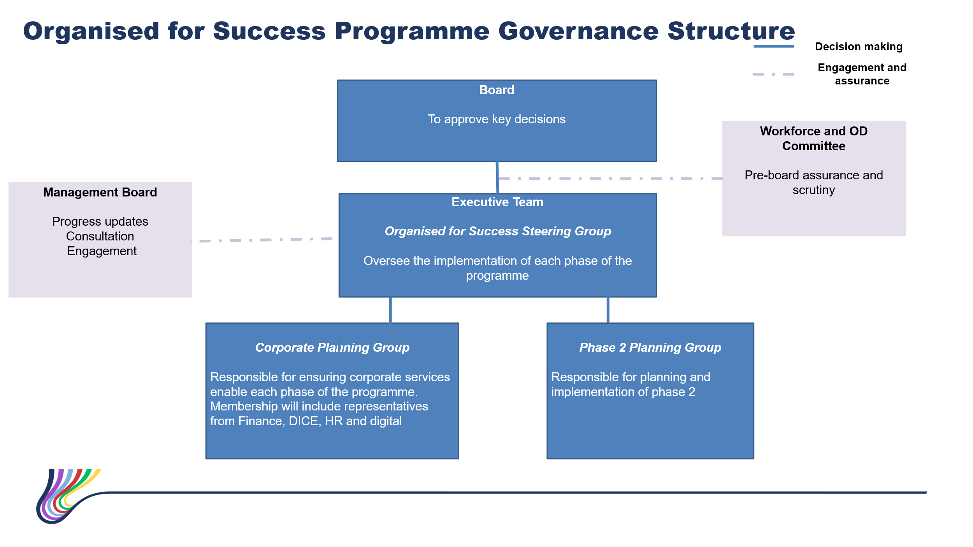
- Executive Portfolios
The review of the executive team portfolios has been completed.

The portfolios may be subject to further review following recent changes within the executive team as we appoint to a substantive Director of Finance, Medical
Director, Director of Public Health and to an Interim Deputy Chief Executive Officer.
- Executive Team Deputy Structure
Meetings are taking place with each executive team director to review their deputy structure in response to the changes to executive team portfolios.
This work will be completed by 30th June 2026.
- Central Delivery Unit
Progress is being made toward the development of the Delivery Unit (DU), with a continued focus on understanding current capability, preparing for transition, and finalising leadership arrangements.
Initial staff scoping has been completed, identifying functions and roles in scope for transition into the Delivery Unit. Following this a staff capability and capacity survey was launched and closed on 6 April, with results detailed in appendix 1.
Preparation and planning is being undertaken for an Executive ‘Organised for Success’ Timeout on 15th April, focusing on the function of the delivery unit, and the first tranche of staff transfers.
In support of this structure, three key leadership roles have been identified:
- Interim Director of Transformation & Delivery (Indicative VSM): A newly created role, that will oversee the establishment of the Delivery Unit, lead the initial “transition”, and subsequently head the DU. The postholder will initially be accountable to the Chief Executive Officer.
- Interim Director of Performance & BI (Indicative Band 9): The new job description has been advertised and successfully appointed to. The successful candidate is planned to commence their interim employment on 13th April.
- Interim Head of PMO (Indicative Band 8D): The new job description has been developed, has been evaluated and is being progressed to be advertised internally during April.

Phase 1 will be completed once all identified in-scope staff have been transitioned into the virtual Delivery unit. Phase 2, which will involve
- Permanent leadership structure
- Permanent executive lead
- Future design and structure of the delivery unit and associated workforce model

- Proposed Care Group Structure
The proposed Care Group Structure, with one name change (Integrated Community Services Care Group) was approved by the Board on 29th January 2026.
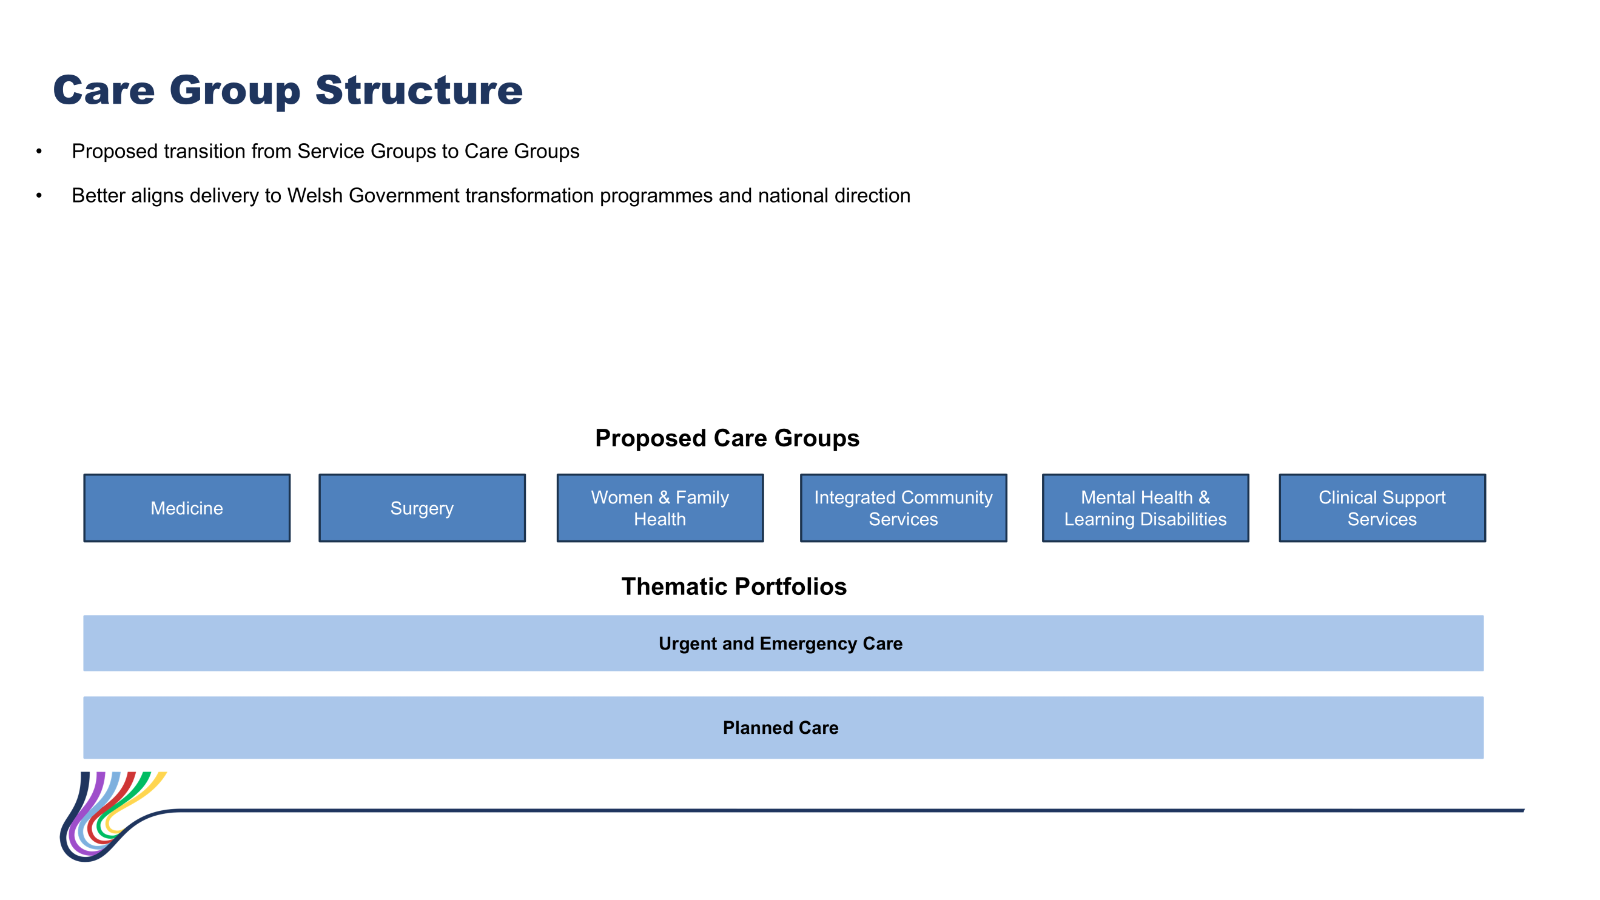
Engagement with Executive Directors and current Service Group Directors has concluded that there is not yet consensus on whether Stages F–H (leadership model; structure; de-layering) should be progressed sequentially or concurrently. Further alignment is required. The 15 April timeout, with Service Group Directors joining for the second hour, will:
- Agree a shared definition, role, and function of Operational Leadership vs Clinical Leadership.
- Confirm the sequence and timeline for Phases F–H engagement and decision‑making.

Engagement Planning
- The Phase 2F Engagement Document will be finalised and launched no later than 27 April.
- Materials will include:
  - Leadership model options
- The Phase 2G-H Engagement will be planned alongside Phase 2F engagement and launched following recruitment to Care Group Leadership to support governance, assurance and programme delivery for all future O4S phases, three cross‑organisational Ready Groups are being established:
- People Ready Group
- System Ready Group
- Estates (Infrastructure) Ready Group
These groups will:
- Provide senior oversight and challenge
- Support development of Gateway criteria
- Monitor readiness for major implementation steps
- Ensure the programme’s sequencing is both safe and deliverable

- Key Risks
The Committee should be aware of the following risks:
Key Risks | Current risk rating | Mitigating Actions | Risk Owner
There is a risk that the implementation of the programme will be delayed due to lack of programme management capacity | 8 | Programme Lead appointed and commenced full-time on 2nd January 2026 | Director of Workforce & OD
There is a risk that the challenging timelines of the programme will not be met due to senior colleagues not seeing this programme as a priority/ not releasing the required resource | 12 | The resourcing of the programme will be overseen by the Steering Group.  The establishment of a central delivery unit has been incorporated in phase 1 of the programme. This will be responsible for ensuring that all key HB programmes are adequately resourced. | Director of Workforce & OD
There is a risk that the operational performance of the Health Board is negatively impacted as colleagues become distracted with the programme/ associated organisational change processes | 12 | Operational performance will be overseen by the central delivery unit. The establishment of a delivery unit has been incorporated in phase 1 of the programme.  Gateways are being developed for each phase of the programme so that a decision can be made on whether we are in a position to “go” safely. The criteria for each gateway will be shared with the Board for approval. | Chief Operating Officer  Programme Lead
The programme will require a restructure of our budgets and corporate systems (e.g. the Electronic Staff Record System). There is a risk that this may limit the capacity of the corporate teams to work on other priorities. | 12 | Three ready groups have been set up with one focused on the restructure of our budgets and corporate systems. Regular updates on progress will be provided to the Steering Group. The impact on other priorities will be managed through the delivery unit. | Programme Lead

- Next Steps
The programme lead’s priorities are as follows:
- Finalise and publish updated Executive Team job descriptions Complete the revisions to Executive Team job descriptions to reflect the updated portfolios (Phase 1; Stage A) and prepare for evaluation where required.
- Progress the Delivery Unit establishment and engagement alongside the Task and Finish Group
Complete preparation for Tranche 1 transition. Begin development of the Delivery Unit work plan aligned to Annual Plan priorities. Continue recruitment and onboarding of interim leadership roles.

- Support the preparation and execution of Phase 2F engagement
Complete Executive alignment session on 15 April. Publish Engagement Document (by 27 April at latest), open for 2-weeks. Formal Exec’s to review engagement outcome and provide recommendation to Board on the preferred Leadership model.
- Ready Groups
Confirm membership and begin initial work on Gateway criteria. Align readiness assessments to the September 2026 Care Group go‑live ambition.

- Recommendations
The Workforce & OD Committee is asked to consider the progress outlined in this update and take assurance from the programme’s continued advancement against key milestones.
Governance and Assurance

Link to Enabling Objectives  (please choose) | Supporting better health and wellbeing by actively promoting and empowering people to live well in resilient communities
Link to Enabling Objectives  (please choose) | Partnerships for Improving Health and Wellbeing |  | ☐
Link to Enabling Objectives  (please choose) | Co-Production and Health Literacy |  | ☐
Link to Enabling Objectives  (please choose) | Digitally Enabled Health and Wellbeing |  | ☐
Link to Enabling Objectives  (please choose) | Deliver better care through excellent health and care services achieving the outcomes that matter most to people
Link to Enabling Objectives  (please choose) | Best Value Outcomes and High-Quality Care |  | ☒
Link to Enabling Objectives  (please choose) | Partnerships for Care |  | ☐
Link to Enabling Objectives  (please choose) | Excellent Staff |  | ☒
Link to Enabling Objectives  (please choose) | Digitally Enabled Care |  | ☐
Link to Enabling Objectives  (please choose) | Outstanding Research, Innovation, Education and Learning |  | ☐
Health and Care Standards
(please choose) | Staying Healthy |  | ☐
(please choose) | Safe Care |  | ☐
(please choose) | Effective Care |  | ☐
(please choose) | Dignified Care |  | ☐
(please choose) | Timely Care |  | ☐
(please choose) | Individual Care |  | ☐
(please choose) | Staff and Resources |  | ☒
Quality, Safety and Patient Experience
The aim of phase 2 of the programme is to structure our services to improve patient experience. Currently services are structured on a geographical basis.
Financial Implications
The financial savings from the programme have not yet been quantified as we are still working through potential scenarios including the impact of the pay protection policy.
Legal Implications (including equality and diversity assessment)
An equality and diversity impact assessment will be completed for phase 2.
Staffing Implications
The aim of the programme is to see a reduction in management tiers and equity in spans of control where possible. Staffing implications are still being scoped.
Long Term Implications (including the impact of the Well-being of Future Generations (Wales) Act 2015)
As set out in the report.
Report History |  | Not applicable
Appendices |  | 1.Summary of skills questionnaire for Delivery Unit

