Meeting Date | 21 April 2026 |  | Agenda Item |  |  | 3.6
Name of Meeting | Workforce and OD Committee
Report Title | The 2025 NHS Wales Staff Survey Results
Report Author | Julie Lloyd, Head of Culture, OD & Staff Experience  Dan Blyth, Leadership and OD Lead
Report Sponsor | Tina Ricketts, Director of Workforce and OD
Presented by | Julie Lloyd, Head of Culture, OD & Staff Experience
Freedom of Information | Open
Purpose of the Report | The purpose of this paper is to share the initial findings of the 2025 NHS Wales Staff Survey summarising areas of strength, identifying priority areas for improvement.
Key Issues | The 2025 NHS Wales Staff Survey ran from 6th October to 1st December 2025 and was again facilitated by Health Education and Improvement Wales (HEIW).  Our participation rate saw a positive improvement on last year at 19.1% or 2,954 responses (compared with 12.9% in 2024, an increase of 6%) however was much lower than the national rate of 30%. Disappointedly, the survey results show a 0.9% decline in the engagement score this year, dropping to 70.3% from 71.2% in 2024 (acknowledging that there has been a drop in the engagement score across NHS Wales, our engagement score is lower than the national average overall and in 5 of the 7 engagement questions).  A copy of the full paginated report of quantitative results for Swansea Bay University Health Board is provided in appendix 1. Qualitative data release from the open text comments have been delayed due to Welsh translation requirements and gaps in information on paper-based returns resulting in challenges in being able to match to organisations. An announcement on the issuing of the free text data to organisations is due by the end of March 2026.  The initial quantitative results highlight our top 3 areas for improvement are:  - We nurture healthy working environments  - Staff Engagement  - We are compassionate and inclusive with links to we are all able to speak up  The annual survey provides a critical source of insight into staff experience across NHS Wales. The quantitative results for Swansea Bay indicate strong performance in compassionate patient care and teamwork but also highlight substantial deterioration in perceptions around staffing levels, engagement, and psychological safety.  These findings require a call to action across the Health Board to increase the participation rate to over 30% this year and to involve colleagues in the improvements to our working environments.
Specific Action Required  (please choose one only) | Information | Discussion |  | Assurance | Approval
Specific Action Required  (please choose one only) | ☐ | ☐ |  | ☒ | ☐
Recommendations | Members are asked to:  - RECEIVE the initial results of the NHS Wales Staff Survey 2025 for Swansea Bay University Health Board and the recommended top three priorities for improvement for 2026-7.  - BE ASSURED by the actions and timescales set out as part of next steps and appendix two.

THE 2025 NHS WALES STAFF SURVEY RESULTS

- INTRODUCTION
The purpose of this paper is to share the findings of the 2025 NHS Wales Staff Survey for Swansea Bay UHB, summarising areas of strength and priority areas for improvement.

- BACKGROUND

The 2025 NHS Wales Staff Survey ran from 6 October to 1 December 2025 and was again led by Health Education and Improvement Wales (HEIW).
Our participation rate saw a positive improvement on last year at 19.1% or 2,954 responses (compared with 12.9% in 2024, an increase of 6%) however, was lower than the national rate of 30%. Survey results show a 0.9% decline in the engagement score this year, dropping to 70.3% from 71.2% in 2024 (acknowledging that there has been a drop in the engagement score across NHS Wales, our engagement scores are lower than the national average overall and in 5 of the 7 engagement questions). This is visually summarised in table 1 below, benchmarked with the NHS Wales average across both positivity and negativity scores.
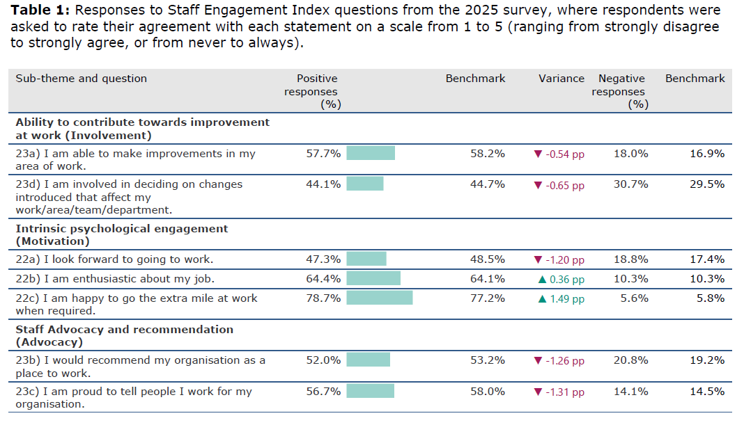Health Education and Improvement Wales have developed an accessible dashboard for colleagues to use this year, which has had some positive updates from previous years. The dashboard has functionality to provide paginated reports and for anyone to request access from Health Board local Staff Survey Leads, supporting increased accessibility and transparency. A copy of the full paginated report providing the quantitative results for Swansea Bay University Health Board is provided in appendix one.
The annual survey provides a critical source of insight into staff experience across NHS Wales. Results for Swansea Bay indicate strong performance in compassionate patient care and teamwork, but also highlight substantial deterioration in staffing levels, engagement, and psychological safety.

These findings require a call to action across the Health Board to increase the participation rate to over 30% this year and to involve colleagues in the improvements to our working environments.

  - Key Findings

HEIW’s reporting mechanism group together a ‘positivity score’ across the 10 overarching question themes which are shown below in Table 2. Positivity scores are taken from responses that answer in the affirmative. The benchmark displayed is the NHS Wales Average.

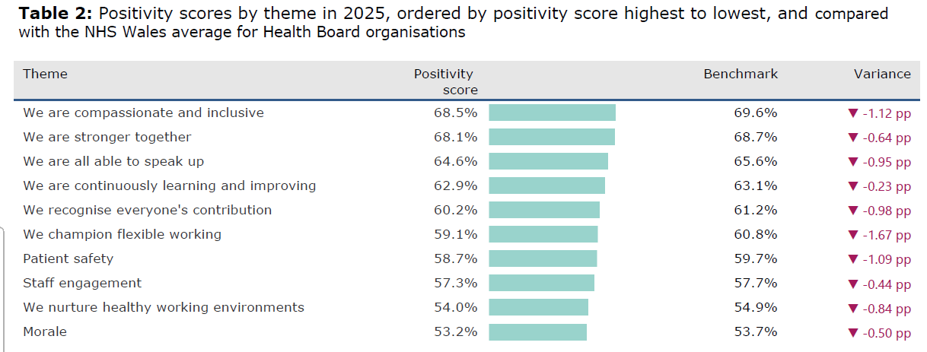
The results present a picture of an organisation with strong foundations at team level but facing significant and growing pressures at organisational level. Staff continue to report exceptionally high standards of compassionate patient care, with scores consistently above 80% across key measures of kindness, compassion and responsiveness. This demonstrates that, despite operational challenges, colleagues remain deeply committed to delivering high quality, person-centred care.
Teamworking similarly remains a major strength. Staff describe positive relationships with colleagues and a strong sense of mutual support, which helps them manage the pressures they face. These strengths are reinforced by steady improvements in line management behaviours. More staff now report that their manager understands the problems they face (67.7% to 68.9%), takes action to help resolve issues (65.8% to 66.9%), encourages them at work (70.0% to 70.8%) and values their contribution (70.2% to 71.0%). While these changes are modest year on year, they demonstrate a consistent strengthening of everyday communication and support within teams.
Set against these positive foundations, the survey also highlights several areas of significant concern. The most prominent relates to staffing levels and workload. The question asking whether there are “enough staff to do the job properly” experienced the sharpest decline across the entire survey, reflecting the scale of pressure currently experienced by teams. Staff also reported worsening access to necessary supplies and equipment and expressed declining confidence that the organisation takes effective action on wellbeing. Together, these shifts indicate a growing sense of unsustainable demand and operational strain.
This operational pressure appears closely linked to a decline in staff engagement and organisational confidence. As summarised in table 1, key measures such as recommending the organisation as a place to work, pride in working for the organisation, and looking forward to going to work all fell significantly. Particularly notable is the fall in staff feeling involved in decisions about change - from 48.3% to 44.1% - one of the largest declines in the survey.
The survey also identifies important concerns relating to inclusion, belonging and psychological safety. Scores for questions relating to diversity, equality and respect/civility all declined, with the diversity, inclusion and equality theme falling from 63.0% to 59.9%. Staff also reported high levels of negative behaviours: 27.8% experienced harassment from patients or the public, around 20% experienced harassment from colleagues, and 7.5% reported discrimination from a manager. Reports of unwanted sexual behaviour remain concerning, with 11.5% reporting incidents from patients and around 5% from colleagues. This is important to note given the issuing of the Worker Protection Act legislation in the last 18-months. These figures as a whole highlight a need for health board wide action to strengthen dignity, respect and safety.
2.2 Progress against top 3 priorities 2024
Progress against the organisation’s top three priority areas from the 2024 National Staff Survey presents a mixed picture, with improvements visible at team level but reporting to be deteriorating at an organisational level which indicates further focus is needed, particularly in the communication of meaningful action taken.
- Leadership & Management
The priority area of Leadership and Management continues to show incremental but consistent improvement in day-to-day line management behaviours. Several indicators improved in the last 12 months: more staff reported that their manager understands their problems (67.7% to 68.9%), takes effective action to help resolve issues (65.8% to 66.9%), encourages them at work (70.0% to 70.8%) and values their contribution (70.2% to 71.0%). These gains suggest stronger local communication, relational leadership and problem solving within teams. The proportion of staff who feel involved in decisions about change dropped sharply from 48.3% to 44.1% (a fall of 4.22 percentage points), indicating reduced visibility, reach and connection from senior leadership. Overall, results confirm leadership progress is therefore strongest at team level, while wider organisational communication and engagement require further attention.
- Speaking Up Safely / Raising concerns
The Speaking Up and Safety priority demonstrates a similarly mixed pattern. Encouragement to report errors or near misses increased slightly (75.7% to 76.6%), and more staff received feedback on actions taken after incidents (47.8% to 49.7%). These improvements indicate that the operational aspects of incident reporting and learning are strengthening. However, staff feel marginally less safe to speak up when they have concerns (falling from 56.5% to 55.4%) and less confident that the organisation would act on concerns raised (42.0% to 39.6%). This suggests that while the mechanisms for reporting are improving, overall psychological safety and trust in organisational follow-through remain areas of concern.
- Values & Behaviours
The final priority area, Values, Behaviour and Culture, has deteriorated further since last year and is the least improved area of the three. The Diversity and Equality theme declined from 63.0% in 2024 to 59.9% in 2025, and kindness and respect indicators fell by up to 2.05%. Staff also continue to report high levels of poor behaviours: 27.8% experienced harassment from patients or the public, around 20% experienced harassment from colleagues and 7.5% reported discrimination from a manager. As referenced previously, unwanted sexual behaviour was reported by 11.5% of staff from patients and approximately 5% from colleagues. These findings highlight ongoing cultural challenges around inclusion, dignity, respect and behavioural norms that are outside of both legislation and what we advocate through our organisational values and behaviours, highlighting the need health board wide action.
In summary, the progress against last year’s priorities shows that while team level support continues to strengthen, the organisational level perception highlights the need for improvements relating to trust, involvement, psychological safety and culture.
2.3 Top Areas of focus for 2026/2027
There is currently a delay in the qualitative data release from the open text comments due to Welsh translation requirements and gaps in information on paper-based returns resulting in challenges in being able to match to organisations. An announcement on the timeframe for the issuing of the free text data to organisations is due by the end of March 2026.
In spite of this, the quantitative survey results have recently been supplemented through feedback shared by Trade Union Partners with Board Members at March’s Health Board Partnership Forum. This combined intelligence indicates the following areas recommended for focus and organisational action over the next year.
- We Nurture Healthy Working Environments
Stabilise perception of workforce capacity and reduce workload pressures.
The first priority area of focus is around addressing disparities of perception around staffing levels and workload (i.e. data around variable pay vs lived experience on the ground), which is reported as the most significant concern for staff. The steep decline in staff feeling there are enough colleagues to do their job properly (34.8% in 2024 to 29.8% in 2025) highlights this disparity and the growing operational pressure, increased risk of burnout, and potential impact on patient experience/care. This is further compounded by reduced confidence in access to the equipment and resources required to work effectively and declining perceptions of organisational support for wellbeing.
2. Staff Engagement
Rebuild organisational trust by improving engagement and staff involvement in change.
The second priority area relates to rebuilding organisational trust, engagement and involvement. Several engagement-related measures have deteriorated, with fewer staff recommending the organisation as a place to work, fewer expressing pride in their role, and fewer looking forward to coming to work. Particularly notable is the fall in staff involvement in decisions about change, declining from 48.3% to 44.1%. This suggests a weakening sense of influence and connection to organisational direction, which may undermine the Health Board’s ability to deliver improvement and transformation at pace under Organised for Success.
3. We are compassionate and inclusive with links to we are all able to speak up
Transform cultural safety, ensuring dignity, inclusion and respect are consistently upheld.
The third priority area is the need to strengthen cultural safety, inclusion and behavioural expectations. The declines in results relating to questions around equality, respect and belonging highlighted earlier, along with high levels of harassment, discrimination and unwanted sexual behaviour, indicate a cultural environment that does not consistently support psychological safety or uphold expected standards of behaviour outlined in our organisational values and behaviour framework. These issues present risks to staff wellbeing, organisational reputation and compliance with equality and safeguarding responsibilities, and require coordinated action across all service areas.
2.4 Next Steps
Together, the three areas outlined in section 2.3 represent the most urgent organisational priorities for the coming year. Improvements will require visible senior sponsorship, consistent, continual communication, collaborative problem-solving/engagement with staff, and strengthened accountability for delivering change across services.
In line with this, it was suggested at March’s Health Board Partnership Forum that a joint workshop between the Board and Trade Union Partners is held in April 2026 to collectively identify solutions that would support inform an overarching Action Plan for improvement.
In addition, further steps and timescales have been set out in appendix 2.
Lastly, whilst results will be made available, there will be no national Staff Survey findings or analysis report published until after the 2026 elections.
3. GOVERNANCE AND RISK ISSUES

- Accountability and Monitoring: As with last year, each Service Group/Corporate Directorate will need to ensure that they have ownership of their data and identify their top 3 priorities for delivery to inform local action plans. All have nominated leads to do this and those leads will be sent the link to register for access to the new survey data dashboard.
- Dilution of Impact: There is the risk of action plan/scrutiny fatigue and dilution of impact having both an overarching Health Board-wide Action Plan, plus separate Service Group action plans to monitor and report on. In addition, meaningful action may be difficult to evidence as we embark on Organised for Success, resulting in movement of some services.
- Data Limitations: Whilst there has been a positive increase in engagement and up-take in the National Staff Survey for 2025, the response rate remains lower than the target of 25% for Swansea Bay. To mitigate and ensure validity and reliability in conclusions drawn, the national staff survey data has been considered along-side other workforce intelligence, such as matters raised by Trade Unions, as well as ER and Speaking Up data.
- Organisational climate/financial challenge: Some priorities may be difficult to positively address whilst we continue to need to make significant financial savings and take forward transformation at pace. Working in partnership with the Directorate of Insight Communication and Engagement (DICE) around the language and messaging will be essential.

- FINANCIAL IMPLICATIONS
There are no financial implications.

- RECOMMENDATION
Members are asked to:
- RECEIVE the results of the NHS Wales Staff Survey 2025 for Swansea Bay University Health Board and the recommended top three priorities for improvement for 2026-7.
- BE ASSURED by the actions and timescales set out as part of next steps and appendix two.

Governance and Assurance

Link to Enabling Objectives  (please choose) | Supporting better health and wellbeing by actively promoting and empowering people to live well in resilient communities
Link to Enabling Objectives  (please choose) | Partnerships for Improving Health and Wellbeing |  | ☒
Link to Enabling Objectives  (please choose) | Co-Production and Health Literacy |  | ☐
Link to Enabling Objectives  (please choose) | Digitally Enabled Health and Wellbeing |  | ☐
Link to Enabling Objectives  (please choose) | Deliver better care through excellent health and care services achieving the outcomes that matter most to people
Link to Enabling Objectives  (please choose) | Best Value Outcomes and High Quality Care |  | ☐
Link to Enabling Objectives  (please choose) | Partnerships for Care |  | ☐
Link to Enabling Objectives  (please choose) | Excellent Staff |  | ☒
Link to Enabling Objectives  (please choose) | Digitally Enabled Care |  | ☐
Link to Enabling Objectives  (please choose) | Outstanding Research, Innovation, Education and Learning |  | ☐
Health and Care Standards
(please choose) | Staying Healthy |  | ☐
(please choose) | Safe Care |  | ☐
(please choose) | Effective Care |  | ☐
(please choose) | Dignified Care |  | ☐
(please choose) | Timely Care |  | ☐
(please choose) | Individual Care |  | ☐
(please choose) | Staff and Resources |  | ☒
Quality, Safety and Patient Experience
The NHS Wales Staff Survey is endorsed by Welsh Government and the National Partnership Forum. It measures staff experience and engagement across NHS Wales, enabling benchmarking and identifying areas for improvement.
A strong correlation exists between patient and staff experience. The national survey provides valuable feedback to help us listen, learn, and take action for improvement.
Financial Implications
There are no financial implications.
Legal Implications (including equality and diversity assessment)
Ensure compliance with GDPR Regulations. This will be supported / addressed by HEIW. Demographic and equality data is gathered as part of the survey to support inform progress and delivery against national and local Equality Standards, Frameworks and legislation.
Staffing Implications
There is the need for Service Groups and Corporate Directorates to nominate leads they would like to have access to the national survey results dashboard to inform local priorities and development of action plans. Capacity within services to enable this a risk.
There will be the need to implement changes and improvements based on the feedback received, which may differ across areas, however actions/changes aim to impact staff positively.
Communication and engagement is key to maintain engagement and demonstrate meaningful change has taken place. This may be difficult to demonstrate as we progress with organisational transformation through Organised for Success.
Long Term Implications (including the impact of the Well-being of Future Generations (Wales) Act 2015)
Survey analysis enables benchmarking and informs future workforce development planning.
Specific questions address the 7 core areas of staff engagement and experience, including Wellbeing. Results will help refine and prioritise our People Aims and associated workstreams.
Report History |  | Presented to Management Board, 15 October 2025 – NHS Wales Staff Survey 2025  Presented to Executive Team, March 2026 - NHS Wales Staff Survey 2025 – Summary, Key Findings & Priority Actions  Presented to Board, March 2026 - NHS Wales Staff Survey 2025 – Summary, Key Findings & Priority Actions  Presented to Health Board Partnership Forum, March 2026 - NHS Wales Staff Survey 2025 – Summary, Key Findings & Priority Actions
Appendices |  | Appendix 1 – Swansea Bay UHB Paginated Report, 2025 NHS Wales Staff Survey  Appendix 2 – 2025 NHS Wales Staff Survey Results -Next Steps and Timelines

