10. Workforce Updates and Actions
This section of the report provides further detail on key workforce measures. Caveats and Limitations (C&L) detailed beneath data in each section.
Staff sickness rates - Percentage of sickness absence rate of staff (two metrics provided, ‘rolling 12 month’ and ‘in month’)  Sickness absence target – 5.5% | % of full time equivalent (FTE) days lost to sickness absence  Caveat & Limitations;- Report generated July 2024, within SBUHB (Performance Team) for substantive and FTC employee types. Data source – ESR. Target of 5.5% added as blue line
Current Performance
- Health Board total for in month sickness absence for June 2024 has increased slightly from the last reporting period to 7.15% (compared to 6.70% March 24).
- Anxiety/stress related absence remained the highest reason for long term absence, with MSK remaining second. This is consistent across NHS Wales and is a long-term pattern.
- In June, we identified a slight decrease in absences across MH&LD compared to the previous reporting period (7.73% in June 24 compared with 8.04% in March 24). NPT/SG and PCT absence rate remain consistent since the last reporting
- In June 24, we identified a slight increase in absences in Morriston in comparison with the last reporting period – June 24 6.18% compared to March 24 5.80%
- Long term absence has increased since the last reporting period (4.44% in June 24 compared to 4.13% in March 24). Short term absence has decreased slightly since the last reporting period (2.22% in June 24 compared to 2.02% March 24)

Actions for Next Period
General
Current focus on areas with high absences rates, examples of initiatives to support our employees:
- Piloting Tailored Adjustments training for managers to increase experience of using these to flexibly support staff to remain in work/return to work
- Wellbeing resource pack – physical and electronic copies available – includes new starter feedback questionnaires
- Case conference training for leaders in partnership with OH is continuing.
- Service group sickness absence reduction plans remain in place.
- The corporate BP role will be appointed to begin to review improvement opportunities.

Occupational Health and Staff Health and Wellbeing
The services continue to develop high quality multi-disciplinary interventions to contribute to an engaged, motivated and healthy workforce.
- SBU OH&WB Lead has contributed to the WG tripartite group to develop All Wales OH Standards and KPI’s with monitoring to WG from June 2024
- Team contributed to the HEIW Wellbeing Best Practice Guide; planning the roll out of this across the organisation with HR BP’s
- Nurse training being undertaken with diabetes Lead Nurse and smoking cessation lead in order to deliver staff health checks – to commence June 2024
- Commenced menstruation awareness training in May for managers to aid management at work; dates planned for the next 3 months
- HB wide OH Nurse Skin surveillance training commencing June 2024 for identified ‘responsible persons’

Mandatory & Statutory Training-  Percentage compliance for all completed Level 1 competencies within the Core Skills and Training Framework by organisation  Mandatory & Statutory Training target – 85% | % of compliance (Headcount) with Core Skills and Training Framework  C&L;- Report generated July 2024, within SBUHB (Performance Team) for substantive and FTC employees. Data source – ESR (OLM Module). Accuracy levels subject to local maintenance and validation standards. Target of 85% added as blue line
Current Performance
- Health Board Statutory and Mandatory Training compliance rates as of 30th June 2024 are:
90.59% - 10 CSTF (Core Skills Training Framework) competencies as reported to Welsh Government (The Welsh Government target is 85%).
89.06% - *15 core competencies (including the 10 CSTF and *5 additional competencies required by SBUHB)
- Medical & Dental staff Group remain the lowest performing area with 61.42% compliance.
- Compliance figures (*15 core competencies) per Service Group - MH&LD 90.57%, PCCT 92.98%, Morriston 85.60%, Finance & Estates 87.86%, NPTS 91.03%

Actions for Next Period
- Subscription to Learning Certification and Enrolment onto Statutory/Mandatory Courses (E-Learning) – User issues identified are being supported on a case-by-case basis via Action Point and from direct contact. This has been the case over a number of months and continues to be the case going forward.
- NPTS - The focus on improving Mandatory Training compliance within the Medical Staff group is ongoing
MH&LD - Clinical Directors & Directorate Managers to work together to focus on improvement of mandatory training for Medical staff which has decreased in month to 73.15% in month based on the compliance information that has been circulated
Vacancies  Medical and Nursing and Midwifery | Vacancies (FTE) Feb 24 to Apr 24  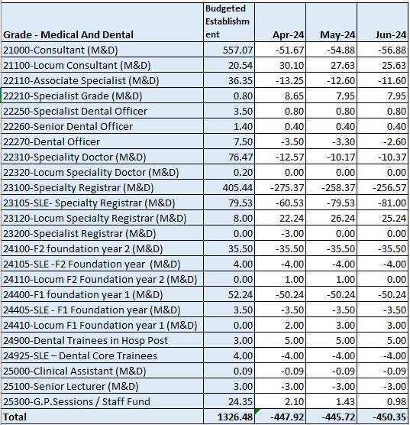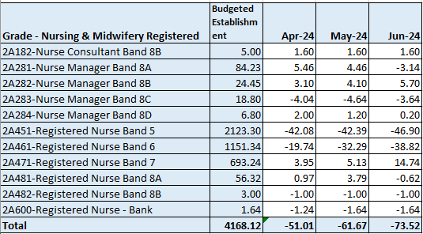  C&L;- Report generated 23 May 2024, within SBUHB (ESR Team), using currently available methodology. Data source – ESR (Workforce) and General Ledger (Finance). We compare the SIP v’s the finance ledger, appreciating limitations on accuracy in some areas. Accuracy levels are subject to local validation practices based on budget holders intelligence. N.B. a 12 month project (ESR Establishment control) has commenced which will harmonise vacancy data including Grade detail shown above.
Current Performance
- M&D vacancies have reduced by circa 38 WTE since February. It is worth noting that SLE doctors (those for whom we hold allocated budget, but do not employ the individuals to offset against the financial position) are inflating the vacancy data at present. The Establishment Control Project is exploring this issue in the context of data cleansing and delivery in order to clarify the position. The project is anticipated for completion in September.
- NMC vacancies have stabilised in the last quarter. A steady stream of overseas nurses completing OSCE training and becoming employed by SBUHB as well as our regular intake of newly qualified nurses via the streamlining process continues to assist with Band 5 nursing vacancies.
- Band 6 vacancies have increased recently by approx. 19 WTE since April 24
Actions for Next Period
- Overseas Nurse recruitment continues but is now more targeted in specialist areas i.e Mental Health, Midwifery. New July arrivals currently undergoing OSCE preparation training
- Pre-employment checks for the cohort of circa 150 newly qualified nurses (NQNs) due to qualify in September 24 commencing on receipt of final confirmed list of recruits from NWSSP and onboarding will be supported by Central Resourcing team.
- Central Resourcing team continues to support targeted recruitment of UK domicile nurses to specific areas that have hard to fill vacancies i.e ED.
- The Medical HR Team will continue to support the services to identify recruitment options to drive down variable pay and alleviate some of the agency spend.

Recruitment  Metrics provided by NWSSP. Comparison with all-Wales benchmarking  Target 44 days | 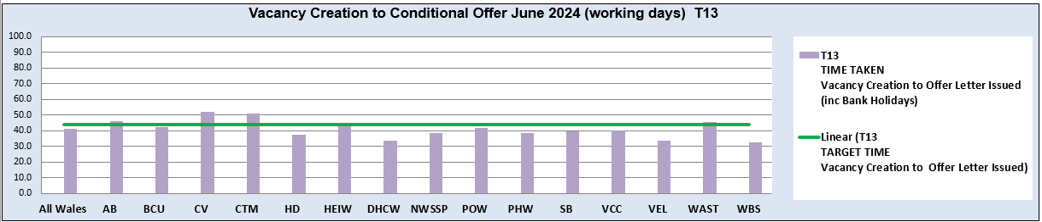  C&L;- Report generated May 2024, by NWSSP (Recruitment). Data source – TRAC system. Outliers are excluded. This is day to day vacancy management. Data excludes outliers.
Current Performance
- Swansea Bay UHB overall performance continues to be on target in June 24, and our monthly average over the last 12 months remains in target. In addition our performance for conditional offer to ready for start date start date was 19 days, which remains well below the set target of 27 days.
- The Central Resourcing Team continue to focus efforts on the recruitment of acute ward based HCSW’s and Band 5 nurses as well as providing support to specific difficult to recruit to posts and vacancy gap has closed significantly evidenced by significant reduction in nurse temporary agency spend.
- Current KPI’s (June 24) comparing SBUHB average time to hire vs the CRT on HCSW recruitment is 57 days vs 47 days based on average time taken from vacancy creation to ready to start.
- In collaboration with NWSSP, we have been supporting the wider HB by trying to ‘chase’ outstanding actions on vacancies / pre-employment checks with applicants, in an effort to reduce the overall HB time to hire further, this has shown further improvements since the last report.

Medical Recruitment

- 288 Health Board substantive & fixed term medical appointments, which includes 66 Consultant posts, undertaking end-to-end recruitment during the period 1.4.23 – 31.3.24.
- Medical HR Team continue to focus on the recruitment of hard to recruit to posts, working closely with the relevant service groups.
- Continuing to offer high level pastoral care for international doctors relocating to the UK.
- Welsh Government have advised that Swansea Bay are an anomaly when it comes to international recruitment of doctors as all other Health Boards in Wales are unsuccessful at Junior and Senior Clinical Fellow levels.
- Medical HR has two dedicated overseas champions.
- 141 clinical attachment placements approved during the period 1.4.23 – 31.3.24, with potential for these to move into a Junior/Senior Clinical Fellow post.
Actions for Next Period
- HRBP’s continue to discuss with Service Groups opportunities to reducing the lag between the date termination of posts are being requested versus date a TRAC entry was initiated.
- The Central Resourcing Team will continue focusing on the recruitment of B5 nurses, B2 ward based HCSW’s and assisting in overseas nurse recruitment. In addition, they are assisting in the recruitment of newly qualified nurses, via the all Wales Student Streamlining process. As well as specific identified hard to recruit to posts.
- In collaboration with NWSSP, we will continue supporting the wider HB by trying to ‘chase’ outstanding actions on vacancies / pre-employment checks with applicants, in an effort to further reduce the overall HB time to hire.

Medical Recruitment
- Will continue to recruit overseas doctors on a post-by-post basis.
- Will continue to support the services for their hard to recruit to posts, looking at working with Agencies to support permanent recruitment in these hard to fill areas.
- Will continue to recruit SAS doctors to support through Portfolio Pathway (formerly CESR)
- Bid submitted to Welsh Government for funding for to aid international recruitment awaiting outcome

Turnover  % turnover by occupational group | Period Turnover Rate (Swansea Bay) – 01 Jul 2023 – 30 Jun 2024  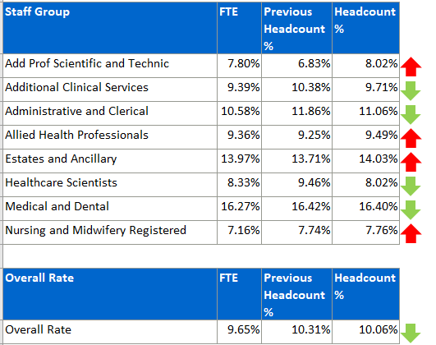  C&L;- Report generated July 2024, within SBUHB (ESR Team). Data source – ESR (Workforce). Small risk of margin of error due to late communication of terminations. Report excludes Bank, Locum, Honorary & Widow/Widower, Junior M&D staff. Internal movement not included – measure is about leaving Swansea Bay UHB.
Current Performance
- Organisationally our turnover has decreased marginally in this reporting period (from 10.31% to 10.06%).
- It is important to recognise that this is reporting on a 12 month rolling period of turnover.
- Medical and Dental appears as the highest turnover at 16.40%, however it is important to note that expected spikes in activity created by seasonal SLE turnover which will lead to elevated M&D levels overall.
- Estates and Ancillary remains the second highest area, and has seen a further increase in this reporting period.
Other than Add Prof Scientific & Technical which saw a circa 1% increase in reporting period, categories are either relatively stable.

Actions for Next Period
- HEIW self-assessment nurse retention tool to be finalised and submitted to HEIW
- Health Board overall retention plan has been drafted and will be shared across appropriate forums/committees for approval
- Retention Lead continues to work closely with Workforce BP’s in order to identify and advance local retention plans

PADR  % staff who have a current PADR review recorded  PADR target – 85% | % of staff (Headcount) who have had a PADR in previous 12 months  C&L;- Report generated May 2024, within SBUHB (Performance Team). Data source – ESR (OLM Module). Accuracy levels subject to local maintenance and validation standards. Target of 85% added as blue line.
Current Performance
- Staff who have had a Personal Appraisal and Development Review (PADR) as of 30th June 2024 is 72%, this is a slight but steady increase from Apr 2024.
- In the past two months 22 staff have attended 130 PADR - Personal Appraisal Review for Managers the Learning and a further 14 staff have attended 130 MP PADR via Managers Pathway. The Education Team signpost colleagues to SBU ESR - ESR User Guides SharePoint Page for resources on how enter PADR Dates in ESR.
- Compliance figures per Service Group (excluding Medical and Dental Staff) – MH&LD 74%, NPTS 75%, PCCT 84%, Morriston 72%, Finance and Estates 61%
Actions Planned for Next Period
- Supporting activity outlined in previous reports continues, Service Groups continue to focus on highlighting areas for focus.
- NPTS - PADR Deep Dive underway to understand how the quality of PADR’s can be improved. Hot Spot areas are Maternity/Children Services. PADR’s are being used as an enabler to support Quality and Safety Strategy.
MH&LD - Plans to be put in place to identify dedicated time to meet with all staff for objectives and development and to prioritise the 466 staff that have not received a PADR and ensure ESR records are updated.
Operational Casework  Number of current operational cases. | C&L;- Report generated May 2024, within SBUHB (Workforce Digital). Data source – ER Tracker. Accuracy levels subject to local maintenance and validation standards.
Current Performance
- No. of open Formal Disciplinaries since the last reporting period have decreased from 53 to 40 open cases
- Number of Formal requests for Resolution has reduced to 22
- Suspensions, since the last reporting period have increased to 12, some of the cases have been resolved, additional suspensions have taken place
- ET’s remain at 3 (previous claims have been closed and new claims received)
Actions for Next Period
- A number of actions are on-going in line with the Best Practice Review
- 3 workshops have taken place to date in partnership with our Trade Unions facilitated by HEIW and SBUHB covering the following: Employee Investigations – Avoiding Employee Harm.
- We have successfully launched the Management Review document, to replace the initial assessment, which allows us to determine the most appropriate course of action at an early stage with the intention to resolve cases informally where possible – education and training ongoing with HR and leaders, this is being embedded and continually reviewed
- Suspension Guidance for leaders and employees has been shared for comment with the aim of supporting both groups and clarifying the process
- We are in the process of documenting and recording the number of informal resolutions (both Disciplinary and Respect & Resolution)

