Meeting Date | 14 August 2025 |  | Agenda Item |  |  | 4.6
Name of Meeting | Workforce and OD Committee
Report Title | Job Planning Progress Report
Report Author | Liz Wonnacott, Head of Service – Medical Director
Report Sponsor | Dr Richard Evans, Executive Medical Director
Presented by | Dr Raj Krishnan, Deputy Medical Director
Freedom of Information | Open
Purpose of the Report | The purpose of the report is to set out the progress to improve job planning compliance within the health board, as well as the completion of the internal audit recommendations.
Key Issues | - Job planning was established as a critical part of the Consultant Contract following an amendment in 2003;  - There are a number of risks if job planning is not undertaken effectively, the most significant being that the clinical workforce not being used correctly to provide safe and effective care;  - An internal audit was commissioned to review job planning and provide a baseline for the improvements needed;  - An improvement in job planning compliance from 20% in April 2024 to 98% for March 2025 was achieved;  - Focus is now being given to maintaining the compliance percentage as well improving the quality of job plans.
Specific Action Required  (please choose one only) | Information | Discussion |  | Assurance | Approval
Specific Action Required  (please choose one only) | ☐ | ☐ |  | ☒ | ☐
Recommendations | Members are asked to:  - TAKE ASSURANCE that compliance with job planning improved from 20% in April 2024 to 98% compliance at the end of the financial year;  - TAKE ASSURANCE that progress has been maintained with compliance at 94% in July 2025;  - TAKE ASSURANCE the health board is now compliant with the Welsh Government target of more than 90% of consultants to have a current job plan by September 2025;  - TAKE ASSURANCE that 15 of the 21 internal recommendations have been closed and there are plans in place for the remaining six to be delivered by autumn 2025;  - TAKE ASSURANCE that focus is now being given to improving the quality of job plans.
JOB PLANNING PROGRESS REPORT

- INTRODUCTION
The purpose of the report is to set out the progress to improve job planning compliance within the health board, as well as the completion of the internal audit recommendations.

- BACKGROUND
Job planning is the process by which consultants agree their duties, responsibilities and outcomes for the coming year to meet the requirements of their role. It was established as a critical part of the Consultant Contract in Wales 2003.

Each job plan sets out the direct clinical care (DCC) sessions, in which patient care is provided, and supporting professional activities (SPA) sessions, such as carrying out appraisals, honorary contracts and clinical supervisor roles, a doctor will undertake over the following year. It also sets out the agreed service outcomes and the role the consultant will have in delivering these.

Job plans have a duration of 12 months, after which they are to be reviewed. This ensures they continue to meet the demands of the service and the consultant. Within Swansea Bay, job planning is undertaken using the electronic system Allocate.

The health board has a vision to be a high quality, clinically-led organisation. There are a number of risks to this if job planning is not undertaken effectively, the most significant being that the clinical workforce not being used correctly to provide safe and effective care. There is also the risk that the health board will not fill its contractual duties in relation to job planning and consultants may be incorrectly paid.

- GOVERNANCE AND RISK ISSUES
The work to improve compliance with job planning commenced in April 2024 following a limited assurance internal audit, for which a comprehensive action plan was shared with both the Workforce and OD and Audit committees.

At this point in time, only 20% of the consultant workforce had a current job plan on the Allocate system. While some had a paper-based one, for the others, their job plans were out of date. This had both financial and service implications as in some instances, consultants were working more sessions that in their job plan, while others were working less.

The focus for the last 12 months has been to improve compliance with job planning and ensure every consultant has a current job plan on Allocate. Alongside this was a requirement by Welsh Government in the NHS Planning Framework for 2025-26 that health boards would:

Ensure effective implementation of job planning policy, to include ensuring that > 90% of all Consultants always have an agreed job plan in place by 30 September 2025.

Significant progress was made throughout the year, with the health board delivering 98% compliance on 31st March 2025.

To achieve this Medical HR (human resources) and the Job Planning Manager have worked with specialities to identify the barriers to job planning, undertaking deep dives to highlight the areas which need targeted support.

One of the key actions has been for Medical HR to work with specialities with high numbers of doctors, particularly where the majority of job plans were paper-based, to help upload these onto the system. Another has been, along with the Job Planning Manager, to provide advice and support to equip the service managers and clinical leads/directors with the tools to undertake the process, as for some, this will be new. Examples of this include:

- Vascular – at the start of the process, there were no job plans on Allocate as the service were unclear whether the complexity of the job plans would lend itself to the system. All job plans have now been added as annualised jobs, through the support of Medical HR, and training provided so the service can manage the process itself once the job plans reach their end date;
- Emergency department – the entire department had paper-based job plans therefore support and training was given to add and amend job plans on Allocate. All consultants now have an electronic job plan, with the department able to amend or add any as needed;
- Care of the Elderly – at the start of the process, all the job plans within the department had expired – through training by Medical HR, this has now been resolved on Allocate.

Alongside this was the directive by the Deputy Executive Medical Director that no new or replacement posts are approved by the clinical vacancy panel unless the department is fully job planned. Once approved for advert, Medical HR upload to Allocate the job plan set out in the job description in readiness for the successful candidate to start, with a caveat that this is reviewed by the service manager and clinical lead/director with the doctor after six months to ensure the content meets the needs of the service and their own personal outcomes. This should be standard practice for all newly appointed consultants to ensure the job plan is correct, and reminders are issued to the service groups.

A job planning study day took place in January 2025, attended by around 100 service managers, clinical leads and clinical directors. In the first half of the day, attendees heard from external speakers such as Welsh Government setting out progress on the national job planning guidance, and Allocate as to the potential the system has to give the job planning process meaning. The afternoon was based on interactive sessions, with attendees given scenarios to discuss how they would approach situations to have a successful job planning meeting. The feedback from the session was positive as set out below:

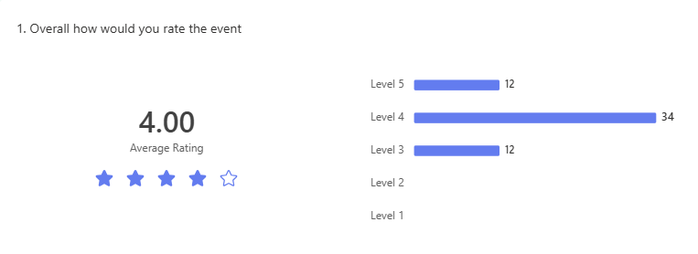

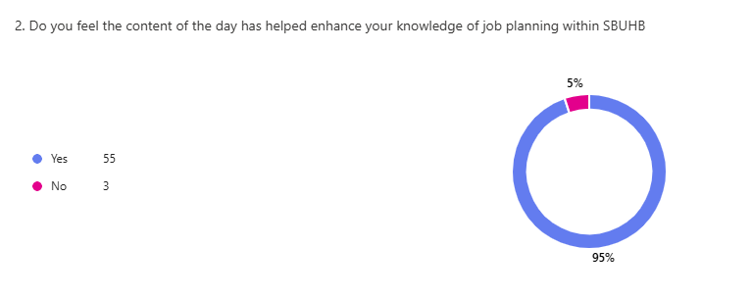

It is important that compliance is maintained, and the position reported in July 2025 being 94%. 100% will never be possible due to the turnover of staff. The Medical HR team and Job Planning Manager will continue to support areas as needed, particularly any identified as hotspots, of which there currently are none, and each the service managers are sent reminders of job plans nearing their expiry dates.

In terms of the internal audit recommendations, good progress has been made on these, with 15 of the 21 closed. The remaining six are currently overdue, but this is due to the fact they refer to the quality detail of the job plans. Initially it has been hoped to address quantity and quality of job planning at the same time, but the focus for 2024-25 in the end needed to be ensuring all doctors had a current job plan.

The remaining internal audit actions are set out below. Medical HR are in the process of running the relevant reports to identify any gaps and compile the relevant evidence to demonstrate completion, with the aim of closing these by autumn 2025. In order for these to be addressed, all job plans needed to be on Allocate so all services were working in a consistent way to enable Medical HR to put in place the required processes. Reports can now be run to demonstrate progress.

The health board should run an Allocate exception report to identify instances where personal outcomes are not included and escalate where necessary.
Directorate / Service Managers should periodically review those consultants with a 7:3 DCC:SPA split and the reasonableness for the continuation of such.
Reporting should be undertaken to confirm compliance with quality improvement priority requirement.
The health board should investigate inconsistencies in the intensity bandings for the same field/speciality.
The health board should run an Allocate exception report to identify intensity bandings per the job plans and compare to the intensity banding paid and investigate any anomalies.
The health board should quantify, report and escalate any under/overpayments identified.

The focus for 2025-26 is to improve the quality of job plans, as well as maintaining the compliance level, in order to standardise consultant job planning across the health board and lead to consistency in roles, responsibilities, and working hours, including DCC/SPA splits and justification of more than two SPAs. This will ensure job plans are fair, transparent and reflect the skills and expertise of the consultants.

One of the first areas to be addressed is the use of ‘other’ as a descriptor. For each DCC/SPA session a consultant undertakes, there has to be an activity description, such as theatre time, outpatient clinic or patient related administration. However, there is currently an option to select ‘other’, and without any notes included to explain what this entails, an accurate picture of the activities being undertaken cannot be formed. As such, specialities are now providing to Medical HR the activities they class as ‘other’ to be included in the options as an alternative. This will be a work in progress across the year as the job plans are renewed.

Baseline assessments meetings took place in June and July 2025, with each speciality asked to complete a template setting out their current position against a number of areas:
- Total number of consultants;
- Current compliance level;
- Number of job plans in discussion;
- Any inaccuracies between ESR (electronic staff record) and salary payments;
- Whether the agreed job plan supports the workload of each consultant;
- Process of demand and capacity planning.

The sessions comprised an all-day meeting in each of the services groups, to which the service manager and clinical lead/director were asked to attend in half-day group slots to present their baseline assessment. The purpose of these was to work with the services to improve the content of the job plans, taking opportunities to identify areas of challenge or in need of improvement, and to learn from others any areas of best practice.

The themes highlighted during the assessments are now being collated to identify common challenges across all or the majority of specialities and identify actions to address these, such as:
- User friendly documents and tools for job planning and digital tools for monitoring.
- Training and support for clinical leaders and managers to successfully implement and manage job planning.
- Enhanced support for areas with specific challenges and/or issues.

The sessions will also highlight any hotspot areas to prioritise and set the foundations to move towards team job planning.

The third piece of work underway is exploring the potential to implement the demand and capacity module on Allocate. If successful, it will align workforce capacity with service demand to identify gaps and opportunities for efficiencies. Initial meetings have taken place to understand more how the module works and led to dermatology being identified as a potential pilot site. This is in the process of being taken forward. No other health board is currently using this function so Swansea Bay could be the first to implement it.

The work to improve job planning is overseen by the Job Planning Governance Group, chaired by the Deputy Medical Director. This meets on a monthly basis to monitor progress against compliance, internal audit recommendations, risks and hotspot areas, agreeing mitigating actions. It will also now monitor the work to improve job plan quality and agree the next steps as each phase is completed.

While Medical HR and the Job Planning Manager can provide support, delivery of the work needed has to be led through the service groups. A dashboard is in place on the intranet for service groups and specialities to see at a glance their compliance rates and issues will be escalated through the Medical Workforce Group, where job planning is a standing agenda item.

While the end objective is to have high quality job plans which align with demand capacity, it is important that consultants maintain a current job plan, and support will continue to ensure both the quantity and quality of up-to-date job plans.

- FINANCIAL IMPLICATIONS
There are no financial implications associated with this report.

- RECOMMENDATION
Members are asked to:
- TAKE ASSURANCE that compliance with job planning improved from 20% in April 2024 to 98% compliance at the end of the financial year;
- TAKE ASSURANCE that progress has been maintained with compliance at 94% in July 2025;
- TAKE ASSURANCE the health board is now compliant with the Welsh Government target of more than 90% of consultants to have a current job plan by September 2025;
- TAKE ASSURANCE that 15 of the 21 internal recommendations have been closed and there are plans in place for the remaining six to be delivered by autumn 2025;
- TAKE ASSURANCE that focus is now being given to improving the quality of job plans.

Governance and Assurance
Link to Enabling Objectives  (please choose) | Supporting better health and wellbeing by actively promoting and empowering people to live well in resilient communities
Link to Enabling Objectives  (please choose) | Partnerships for Improving Health and Wellbeing |  | ☒
Link to Enabling Objectives  (please choose) | Co-Production and Health Literacy |  | ☐
Link to Enabling Objectives  (please choose) | Digitally Enabled Health and Wellbeing |  | ☐
Link to Enabling Objectives  (please choose) | Deliver better care through excellent health and care services achieving the outcomes that matter most to people
Link to Enabling Objectives  (please choose) | Best Value Outcomes and High Quality Care |  | ☐
Link to Enabling Objectives  (please choose) | Partnerships for Care |  | ☐
Link to Enabling Objectives  (please choose) | Excellent Staff |  | ☒
Link to Enabling Objectives  (please choose) | Digitally Enabled Care |  | ☐
Link to Enabling Objectives  (please choose) | Outstanding Research, Innovation, Education and Learning |  | ☐
Health and Care Standards
(please choose) | Staying Healthy |  | ☐
(please choose) | Safe Care |  | ☐
(please choose) | Effective Care |  | ☐
(please choose) | Dignified Care |  | ☐
(please choose) | Timely Care |  | ☐
(please choose) | Individual Care |  | ☐
(please choose) | Staff and Resources |  | ☒
Quality, Safety and Patient Experience
High quality, robust job plans will ensure the clinical workforce is being used correctly to provide safe and effective care which will result in better patient experience and more effective services.
Financial Implications
There are no financial implications. However consideration is needed as to the level of resources to support job planning in the longer-term..
Legal Implications (including equality and diversity assessment)
The health board has contractual duties in relation to job planning and consultants as part of the Consultant Contract 2003.
Staffing Implications
There are no staffing implications.
Long Term Implications (including the impact of the Well-being of Future Generations (Wales) Act 2015)
The health board has a vision to be a high quality, clinically-led organisation and compliant job planning is a key component to this.
Report History |  | Bi-annual report to the Workforce and OD Committee
Appendices |  | No appendices

