

HEALTH BOARD RISK REGISTER
November 2024
WORKFORCE & OD COMMITTEE RISKS

Datix ID Number: 843  Health & Care Standard: |  |  | HBR Ref Number: 3  Risk Target Date: 31/03/2025 | Current Risk Rating  4 x 5 = 20
Objective: The Health Board is a great place to work where staff feel valued and work together towards a common goal |  | BAF Ref: 5 | Director Lead: Sarah Jenkins, Interim Director of Workforce and OD  Assuring Committee: Workforce & OD Committee
Risk: Recruitment of consultant medical & dental staff in hard to fill roles.  Due to national shortages, there is a risk that that the health board will be unable to recruit consultant medical & dental staff into particular hard to fill roles which may result in difficulties fulfilling rotas on all sites, and adverse impact upon patient safety, service provision, quality and financial matters. |  |  | Date last reviewed: November 2024
Risk Rating  (consequence x likelihood):  Initial: 5 x 4 = 20  Current: 4 x 5 =20  Target: 4 x 3 = 12 | 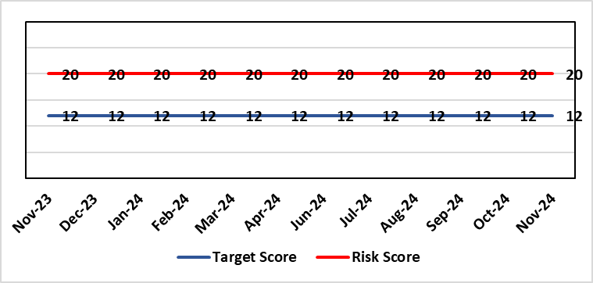 |  | Rationale for current score:  National shortages of numbers in some areas can lead to:  - Inability to recruit sufficient numbers of trainees to fulfil rotas on all sites  - Inability to attract non training grades to complete rotas  - Inability to fill Consultant grade posts in some specialties with adverse effects on patient safety and employer relations. Inability to recruit sufficient registered nursing staff.  - The situation has improved around the recruitment of junior staff but there are many hard to fill consultant posts which impact on the ability to run services which impacts patient care.
Level of Control  = 70% |  |  | Rationale for target score:  This remains a challenge and is also a national problem.
Date added to the HB risk register
April 2012
Controls (What are we currently doing about the risk?) |  |  | Mitigating actions (What more should we do?)
- Regular monitoring of recruitment position with reports to Executive Team and Board via Medical Director and Medical Workforce Board.  - Specialty based local workforce boards established to monitor and control specific issues. The HB Workforce & OD Committee will seek assurance of medical workforce plans to maintain services.  - Engagement of the Deanery about recruitment position.  - Weekly workforce delivery meetings with CEO to review progress against critical medical and clinical posts  - Working with specialist agency and head hunters to improve chances to fill hard to recruit posts  - Working with a marketing agency to develop a branding and attraction campaign for the health board.  - Consideration of the RPO (Recruitment Process Outsourcing) model.  - Implemented the CESR (Certificate of Eligibility for Specialist Registration) framework to grow your own consultants  - Revised Consultant Development Programme launched on 10th October 2024, sponsored by the Medical Director. 28 Consultants have registered and 15 have attended to date, across modules 1 & 2. |  |  | Action |  | Lead | Deadline
 |  |  | Medical training initiatives pursued in a number of specialties to ease junior doctor recruitment |  | Director W&OD | 31/03/2025
 |  |  | The Medical Workforce Board continues to monitor recruitment and junior doctor’s rotas. |  | Director W&OD | 31/03/2025
 |  |  | Continue to recruit internationally. |  | Director W&OD | 31/03/2025
 |  |  | Continue to work with head hunters |  | Director W&OD | 31/03/2025
Assurances (How do we know if the things we are doing are having an impact?)  - General situation monitored through W&OD Committee  - Communication with Deanery  - Recruitment campaigns  - Monitoring by Executive Teams and specialty based local workforce boards  - Workforce planning and deployment taskforce meetings with service groups  - Weekly workforce delivery meetings with CEO as above |  |  | Gaps in assurance (What additional assurances should we seek?)  Locum cover  Adequate supply of doctors who can work in this country  Ability to flexibly deploy doctors in training.  Dedicated work between workforce and finance to review and confirm budgeted medical workforce establishment by service group to confirm SIP and vacancy factor.
Additional Comments / Progress Notes
30/11/2024: No further updates at this stage the position remains as described.

Datix ID Number: 1759  Health & Care Standard: |  |  | HBR Ref Number: 51  Risk Target Date: TBC | Current Risk Rating  4 x 3 = 12
Objective: Care is high quality, safe, efficient, and delivers the best possible outcomes for people |  | BAF Ref: 2.1 | Director Lead: Hazel Powell, Executive Director of Nursing  Assuring Committee: Workforce & OD Committee
Risk: Non Compliance with Nurse Staffing Levels Act (2016) – Section 25B Wards  The Nurse Staffing Levels (Wales) Act 2016 (NSLWA) legally requires the health board to make provision for appropriate nurse staffing levels within their nursing services. In accordance with section 25B, there is a duty to calculate nurse staffing levels in adult and paediatric acute medical and surgical inpatient wards. There is a risk we may not meet these requirements fully due to increased acuity, unplanned staff absence and vacancies. The potential impact of this maybe non-compliance with the ‘Act’, poor patient outcomes and experience, and suspension of services. |  |  | Date last reviewed: November 2024
Risk Rating  (consequence x likelihood):  Initial: 4 x 4 = 16  Current: 4 x 3 = 12  Target 3 x 2 = 9 | 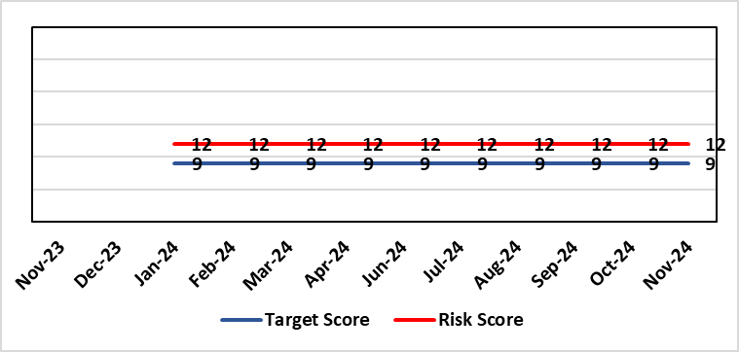 |  | Rationale for current score:  - The scope of the risk has been reviewed to disaggregate the 25B reportable wards as part of the NSLWA to enable clearer identification of risk of non-compliance with the’ Act’ from the aggregated risk across all nurse staffing areas of inadequate staffing levels previously scored 20.  - There has been a steady decline in the number of vacancies across the 25B wards as a result of successful international recruitment and student streamlining  - The Service Group risk assessments for 25B wards reported at the NMSSAIG (Oct 2024) are as follows:  - Morriston Service Group – 9 (unchanged)  - NPTSSG – 9 (unchanged)  - Paediatrics: In-patient wards – 12 (reduced from 16)
Level of Control  = |  |  | Rationale for target score:  - The health board has the required structures and processes in place to provide reassurance to the Board that SBUHB is compliant under the Act and as such are allocating resources accordingly.  - Health boards are duty bound to take all reasonable steps to maintain nurse staffing levels.  - Ward skill mix, recruitment and induction plans impacting on ward  - Projected continued decrease in vacancies by end of 2024.
Date added to the HB risk register
November 2018
Scope Refreshed:
January 2024
Controls (What are we currently doing about the risk?) |  |  | Mitigating actions (What more should we do?)
- The designated person as part of the requirements of the ‘Act’ is the Executive Director of Nursing & Patient Experience  - The responsibility for decisions relating to the maintenance of the nurse staffing level rests with the health board is based on evidence provided by, and the professional opinions of the Executive Directors with the portfolios of Nursing, Finance, Workforce, and Operations  - Bi-annual calculations undertaken across all Section 25B wards using the triangulated methodology which Service Groups formally present at Executive led scrutiny panels with representation from Nursing, Workforce and Digital and Finance Colleagues.  - The Ward Sister / Charge Nurse, Senior Nurses and Group Nurse Director continuously assess the situation and keep the designated person formally apprised  - The health board has representation at the All-Wales Nurse Staffing Group and its sub groups to ensure the organisation is aware of national updates  - The Board receive a bi-annual report - May (agreed Once for Wales) and November (mandatory). The final 3 yearly mandatory paper was submitted to Welsh Government 7th October 2024. The next mandatory paper will be presented to Board 28th November 2024.  - Workforce planning & redesign, training and development. Recruitment and retention continues. HB Workforce Group has been set up and links to HEIW Retention Work stream, HB representatives on HEIW Group are Associate Head of HR, Recruitment and Retention Manager and Matron, Corporate Recruitment. Workforce plans have been developed by Service Group Nurse Directors and each Service Group agrees staffing, with consideration of all reasonable steps to maintain the nurse staffing level  - Work assessing the impact of the 'Team around the Person' continues on a HB and All Wales basis.  - Rostering Policy - the Service Groups have a robust roster scrutiny process that is undertaken to ensure roster efficiency and appropriate utilisation of temporary staff.  - The health board has a nursing retention plan and actively supports the Retire and Return policy.  - SafeCare has been implemented, the All Wales SOP remains a working document as understanding evolves.  - Service Groups continue daily staffing huddles and daily staffing tool and escalate as appropriate. |  |  | Action |  | Lead | Deadline
 |  |  | Student Streamlining and Overseas recruitment |  | Executive Director of Nursing | 31/12/2024  Monthly ongoing
 |  |  | Review of workforce, consider more diverse skill mix, including development of Band 3 and Band 4 roles. Bi-annual re-calculations of inpatient wards have resulted in the addition of Band 3 and 4 roles within the NSA templates. These posts are being recruited into, there is a need for training and supervision for these new posts. Development of Service Group workforce plans to support an overall Corporate Workforce Plan. |  | Executive Director of Nursing | 31/12/2024
Assurances (How do we know if the things we are doing are having an impact?)  - Ongoing robust recruitment and retention plans in place to reduce vacancies in key clinical areas.  - Accurate reporting of acuity data and governance around sign off.  - Agreed establishments are funded.  - E-Rostering implemented and roster scrutiny undertaken, ensuring effective staff allocation.  - All Wales Templates are visible informing patients/visitors of planned roster on all Section 25B wards. Service Groups have access to the All Wales Nurse Staffing Programme documents via NHS Wales Executive webpage.  - Bi-annual Board reports, provide assurance and outline compliance and any key risks, submitted in November and May each year, with final three yearly report to Welsh Government due and submitted October 2024.  - The Health Board Nursing and Midwifery Safe Staffing Assurance Group (renamed October 2024) (formally the Nurse Staffing Act Steering Group, amended July 2023) meets on a bi-monthly basis, ensuring risks from all Service Groups are presented, discussed and escalated as appropriate at each meeting. This group is chaired by an Associate Director of Nursing and reports to Nursing and Midwifery Group (formally Nursing and Midwifery Board, amended October 2024), and the Workforce & OD Committee.  - Service Group risk assessments have been updated and disaggregated into 25B and 25A areas to enable clear risk assessment and escalation of specific risks to ensure robust governance and risk assurance  - There is a clear process for scrutiny during bi-annual re-calculations and at any other time when wards require a re-calculation, for example: change to ward purpose, increased bed numbers or increase patient acuity  - SafeCare system has been implemented. Support given to help embed the system into everyday use. Use of SafeCare linked to daily staffing huddles.  - Historical information and all reporting templates available on a share drive |  |  | Gaps in assurance (What additional assurances should we seek?)  - Issue remains regarding Information Technology barriers around the capture of data required for the Act on an All- Wales and Health Board basis. All Wales work with Allocate (Safecare) to improve reporting capabilities of Safecare, via a dashboard continued to progress, SBU is pilot site for testing. Update to Allocate system received, working with rostering team and BCU NSA Lead to check accuracy of reporting.  - Ongoing work across Wales to ensure IT systems are compatible with each other for operational and reporting purposes.
Additional Comments / Progress Notes
Section 25B wards covered by this risk:
NPTSSG |  | Morriston Service Group
Ward 2, Ward 4, Ward 12, Ward A, Ward E  Paediatric: Ward M and Oakwood Ward |  | Ward G, H, W and Clydach Ward  Ward C, Cyril Evans Ward, Dan Danino Ward  Powys Ward, Tempest Ward, Cardigan Ward  Ward K, L, R, T and Pembroke Ward  Ward D, F, J, S and Gowers Ward
For information – 25A areas not covered by this risk include (These are managed within Service Groups and would be escalate for Executive consideration as appropriate).
Morriston Service Group | NPTSSG | Mental Health & Learning Disabilities | Community Areas
Critical care areas – GITU, CITU, Tempest Burns & CCU  Short stay and assessment areas  Ward E (Area for Clinically Optimised Patients over the age of 65 years)  SAU, SSSU, CSSU, Plastic Surgery Treatment Centre  Emergency Department | Neonates  Theatres  Ward B, C, D & Neuro Rehab NPTH  Ward 8 & 11 SH  Midwifery | Mental Health, Forensic Psychiatry and Learning Disabilities | District Nursing  Health Visiting  Gorseinon Hospital  Ty Olwen

23.10.2024: Risk will be reviewed and updated following the Nursing and Midwifery Safe Staffing Assurance Group meeting on 30.10.2024
30.10.2024: Reduction in the Paediatric risk score from 16 to 12 recorded due to the introduction of band 6 development posts and the successful recruitment of RN’s and Internationally Educated Nurses. The overall corporate score remains unchanged at this time but will be reconsidered at the next meeting in December 2024.

Datix ID Number: TBC  Health Care Standards: |  |  | HBR Ref Number: 102  Risk Target Date: TBC |  | Current Risk Rating  4 x 4 = 16
Objective: Maternity Services |  | BAF Ref: 2.8 | Director Lead: Hazel Powell, Executive Director of Nursing  Assuring Committee: Quality & Safety Committee  For Information: Workforce & OD Committee
Risk: Inability for maintaining Birthrate Plus ® complaint rosters  Birthrate Plus® enables health boards to calculate their midwifery staffing requirements based on their specific activity, case mix, demographics and skill mix.  There is a risk non-compliance with roster templates due to increased acuity, unplanned staff absence and vacancies. The potential impact of this may be reduced staffing levels against the agreed Birthrate Plus ®, staffing template resulting in poor patient outcomes and experience, and potential suspension of services. |  |  | Date last reviewed: November 2024
Rationale for current score:
The vacancy position has improved for Band 5 & 6 registered staff – there are no vacancies. The risk was reduced from 25 to 20 initially and on further assessment is being reduced to 16. Whilst the service is now over-established with registered midwives, the score will be moderate (16) due to unregistered vacancies (which will concluded in September following job evaluation and new JD’s to support the unregistered workforce) and unavailability (due to parenting leave, mandated study leave and sickness). There are improved numbers of registered midwives per shift with most shifts achieving the required 14 midwives. Additional staff in AAU have been put in place to ensure two on duty at all times in line with the RCOG Good Practice Guidelines for Maternity Triage.
Risk Rating  (consequence x likelihood):  Initial: 4 x 5 = 20  Current: 4 x 4 = 16  Target: 4 x 4 = 12 | 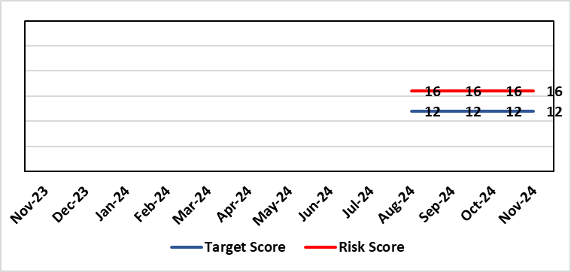
Level of Control  = |  |  | Rationale for target score:  It is intended through resolution of the unregistered job evaluation process and the recruitment of new unregistered workforce that the unavailability position will improve. Further, on review of the community Intrapartum pathways being re-established that the acuity on the Singleton site will lessen as women have all options for birth open to them and that via risk assessment women will be enabled to birth in the right settings.  Projected decrease in unregistered vacancies by end of 2024.
Date added to the risk register
11/09/2024
Controls (What are we currently doing about the risk?) |  |  | Mitigating actions (What more should we do?)
- The Health board has put the following controls in place:  - Service Group Nurse Director chairs fortnightly roster scrutiny meetings to ensure effective deployment of staff.  - All midwives are working at the hours they require up to full time.  - Specialist midwives and management redeployed to support clinical care as required  - Birth rate plus Intrapartum acuity tool completed 4 hourly to guide safe service provision and escalation  - Escalation meeting held daily during the week to review rotas and reallocate staff as required chaired by Head of Midwifery  - Escalation guidelines in place to support actions during periods of increased acuity  - Morning safety huddle for community midwifery teams  - Morning safety huddle for obstetric unit generates RAG-rated daily acuity and shares this with the Service Group for its daily meeting.  - Additional shifts offered via Bank, additional hours and overtime at enhanced rates  - Utilisation of off-contract midwifery agency authorised by Executive Director of Nursing  - Open advert for recruitment on TRAC (recruitment system)  - On-Call Manager Rota in place.  - International recruitment campaign initiated with MEDACS.  - Offer of additional support worker shifts particularly in the postnatal area for additional support for women  - Maternity Care Assistance (MCA) role in place to support Midwives in providing care in women and their families.  - Regular communication with stakeholders includes: Early warnings to Welsh Government; Verbal and formal communication with Llais; Internal communications on home births, RCM updates; weekly staff briefings and bulletins.  - Maternity Services Improvement & Assurance Board continue, meeting fortnightly, chaired by NPTS Nurse Director. This is reported into the Midwifery & Neonatal Service Performance Board in place chaired by EDON |  |  | Action | Lead |  | Deadline
 |  |  | Seventeen newly qualified midwives through streamlining to commence employment from October 2024 onwards. Expect all to be in post by December 2024. | HOM |  | 31/12/2024
 |  |  | Business case to support implementation of BSOTS (Birmingham Symptom Specific Obstetric Triage System) in the Ante Natal Assessment Unit to be developed. The service plans to implement a new AAU pathway and documentation process. | DHOM |  | 31/10/2024
 |  |  | Recruitment of 6.27 WTE (whole time equivalent) Band 2 HCA (health care assistant) positions at Singleton: will commence on completion of job matching of current workforce into band 3 posts following job evaluation implementation plan expected end of September | HOM |  | 30/09/2024  New date for completion to be advised on completion of band 3 competency assessment
Assurances (How do we know if the things we are doing are having an impact?)  The following assurance mechanisms in place currently:  Birth-rate Plus Intrapartum acuity tool completed 4 hourly  X3 weekly look ahead of rosters to alert and mitigate against unexpected staff absence  Daily staff safety briefings chaired by Head of Midwifery which considers sickness & other absences and daily review of safety and quality outcomes.  The Group Head of Quality Safety & Risk is supporting daily oversight of Datix incidents. The following red flag events are monitored:  • Delayed or cancelled elective caesarean sections;  • Missed or delayed care incidents;  • Delayed or cancelled induction of labour;  • Delay of 2 hours or more between admission for induction of labour and beginning of process;  • Delay of 30 minute or more between presentation and triage.  Birthrate Plus planned roster assessment Oct 2023 complaint – 3-year cycle of external assessment. |  |  | Gaps in assurance (What additional assurances should we seek?)
Additional Comments / Progress Notes
20/08/2024: Gateway review in place in relation to reinstatement of community services, recruitment of band 7 community team leaders completed. Paper being presented to Management Board 05.09.2024. Initial issues raised by staff side for job evaluation and approved job descriptions with competency frameworks for the un-registered workforce agreed and approved. Implementation plan in place expected to complete end of September
Recruitment of Band 2 HCA (health care assistant) positions at Singleton was suspended pending the outcome of the job evaluation. On completion of the implementation plan the 6.27 whole time equivalent band 2 Health Care Support Workers will commence.
10/10/2024: Implementation of BSOT to commence in October 2024 following completion of a complex implementation framework which includes Job Planning for Obstetric cover and the arrangement of appropriate safe waiting areas for women on the three escalation pathways for review.

Datix ID Number: TBC  Health Care Standards: |  |  | HBR Ref Number: 103  Risk Target Date: 31/10/2024 |  | Current Risk Rating  4 x 4 = 16
Objective: Maternity Services |  | BAF Ref: 2.8 | Director Lead: Hazel Powell, Executive Director of Nursing  Assuring Committee: Quality & Safety Committee  For Information: Workforce & OD Committee
Risk: High Quality Choices in Place of Birth  There is a risk of not being able to provide high quality choices in place of birth (via appropriately staffed and resourced community midwifery teams, the freestanding midwifery unit at Neath Port Talbot Hospital, the alongside midwifery unit and obstetric unit at Singleton Hospital). The potential impact of this is poor patient experience and birth outcomes, poor staff morale and increased attrition of community midwives, increased acuity within obstetric services at Singleton Hospital, and the reduction of services could impact on organisational reputation. |  |  | Date last reviewed: November 2024
Rationale for current score:
Womens birth choices have been limited resulting in women choosing to freebirth, employ private midwives or transfer their care to neighbouring Health Boards to support their birth choice.
The service has experienced increased complaints and enquiries from women seeking support for intrapartum community pathways of care
Community Intrapartum services had been suspended (these were recently reinstated 21/10/2024)
Risk Rating  (consequence x likelihood):  Initial: 4 x 4 = 16  Current: 4 x 4 = 16  Target: 4 x 3 = 12 |  |  | Rationale for target score:  Re-instatement of community Intrapartum pathways of care.  Increased positivity of women’s experience and choice for birth
Level of Control
=
Date added to the risk register
11/09/2024
Controls (What are we currently doing about the risk?) |  |  | Mitigating actions (What more should we do?)
The Health board has put the following controls in place:  - Maternity and Neonatal Assurance Boards Chaired by the NPTSSG Group Nurse Director  - Senior Leadership Team Weekly Meeting  - Morning safety huddle for community midwifery teams  - Ongoing assurance and monitoring of complaints or concerns identified by the women  - ‘Transfer Meeting’ to review cases of women transferring from the NPT Birth Centre or Home into the Obstetric Unit at Singleton Hospital to assess any learning or improvements to be made  - Maternity Services Improvement & Assurance Board continue, meeting fortnightly, chaired by NPTS Nurse Director. This is reported into the Midwifery & Neonatal Service Performance Board in place chaired by EDON |  |  | Action | Lead |  | Deadline
 |  |  | Gateway review in place in relation to reinstatement of community services. Paper to go to Management Board. | CDoM |  | Completed (See Notes)
Assurances (How do we know if the things we are doing are having an impact?)  The Group Head of Quality Safety & Risk is supporting daily oversight of Datix incidents. The following red flag events are monitored:  - Inability to provide choice for place of birth  - Delayed transfer to the Obstetric Unit  - Adverse outcomes as a result of place of birth outside of the Obstetric Unit |  |  | Gaps in assurance (What additional assurances should we seek?)
Additional Comments / Progress Notes
20/08/2024: A measured re introduction of community Intrapartum pathways has been completed with the 6 safety gateways s having been met. These include:
• Stable clinical establishment
• Clinical leadership, appointment of 8 Community Team Managers (band 7)
• Midwifery proficiency assessment
• Environmental and operational assurance
• Phased reopening of the FMU, prior to home birth services
• A sustainable solution for the managing the obstetric unit at times of high acuity (Managed as part of the Obstetric Unit OCP)

A paper is going to Board on the 5th September the outcome from which may alter the scoring of this risk.
The paper outlines new risk of continued closure of the pathways for women that previous risk scoring did not capture. These include:
• A disaffected workforce unable to work to licence.
• Staff in post unable to support women’s choices for birth and underutilisation of their skill set
• Staff employed specifically to operationalise community midwifery services not able to fulfil their job descriptions and contract of employment
• An increase in complaints relating to community intrapartum care
• Increase in women choosing freebirth or to employ independent midwives to support their birth choices
• Women choices to transfer care to neighbouring HB’s to achieve their birth choices
• Reputational damage of not offering full birth choices to the population of Swansea Bay
10/10/2024 Birth Centre re-opened on 16th September. Community Home Birth pathways due to commence on the 21st October 2024.
18/11/2024: Community home birth pathways recommenced 21/10/2024.

Risk Score Calculation

For each risk identified, the LIKELIHOOD & CONSEQUENCE mechanism will be utilised. Essentially this examines each of the risks and attempts to assess the likelihood of the event occurring (PROBABILITY) and the effect it could have on the Health Board (IMPACT). This process ensures that the Health Board will be focusing on those risks which require immediate attention rather than spending time on areas which are, relatively, a lower priority.

