Appendix 3: Swansea Bay Graduate Scheme

Programme Structure
During the programme, we work closely with graduate trainees to tailor their experiences and explore the endless possibilities that Swansea Bay as part of NHS Wales and the wider Public Service Wales have to offer. Challenging placements in each Service Group during the first year provide experiential learning opportunities that introduce and develop practical management and leadership skills.
Depending on their existing degree qualification, graduates complete a level 5 qualification in business, project management or leadership and management. Supported by action learning sets; individual coaching and mentoring our graduates are able to assimilate their experiences and determine which areas of the organisation they are drawn to.

During the second year, they complete fewer longer placements, tailored to their interests including the potential to work with local authority partners such as housing; third sector; social services; education; police and ambulance services.

Since its inception in 2016, the Graduate Gateway Programme has welcomed 24 graduate trainee managers. Each cohort has welcomed people with protected characteristics, and has offered a mix of internal and external candidates.

At a glance: Cohort 4 current graduate trainees (June 2022-June 2024)
As part of their induction, graduate trainees prepare a short biography that they present to their upcoming placement manager. Below are the biographies of the current cohort participants.

Alex McNamara
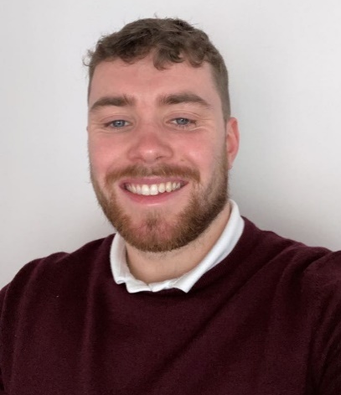
My name is Alex, I am a 22-year-old graduate of Cardiff University who is currently living in the Swansea Valley area and I am also a fluent Welsh speaker.
I decided to apply for the Graduate Gateway Programme because a career in the NHS provides a unique opportunity to work within a fast paced and dynamic working environment surrounded by highly skilled and experienced colleagues.
The experiences gained through the programme will allow me to really develop my managerial capabilities and skills as well as contribute to creating the best possible healthcare environment for the surrounding communities at large. I’m excited to see what opportunities, challenges, and experiences lay ahead.

Connie Bush
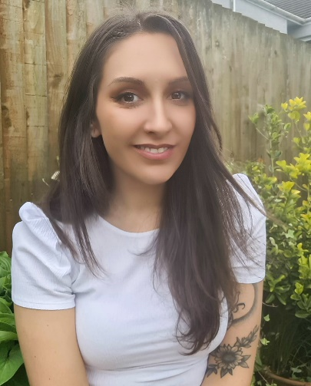
Hello, I’m Connie and I’m from a small Welsh village on the edge of the Brecon Beacons. In 2016, I graduated from The University of Wales, Trinity St. David with a BSc Degree in Health and Nutrition. The past 5 years I have worked in Dietetics within SBUHB. Two of these years were spent in Primary Care – working in Neath Port Talbot Hospital and within the local community. The past 3 years I have worked within Pulmonary Rehabilitation, delivering education for patients with lung conditions and more recently, Long-COVID.
From working in the NHS and also from being on the other side, as a patient, I know how lucky we are to have the NHS. I appreciate how important it is to have great leaders to inspire change, engage the team and lead with compassion, to deliver the best results for our patients. I aim to be one of these leaders and to make positive change and that is why I applied for The Graduate Gateway Programme. I was drawn to the opportunity to learn and grow with placements in areas which are new to me and face new challenges. I look forward to the opportunities the programme will bring.

Daniel Williams
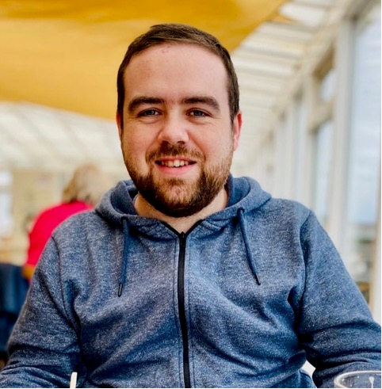
Hello everyone, my name is Daniel Williams, and I am one of the new Graduate Trainee Managers in Cohort 4. I am 29 years old and I live in Brecon with my girlfriend, our daughter and our dog.
I graduated from the University of South Wales with first class honours in Psychology in 2020, and have since worked as a Mental Health & Wellbeing Coach, until this opportunity presented itself. I am incredibly excited to be joining the team at Swansea Bay University Health Board, and I look forward to learning from a range of different people.
There are many reasons why I applied for the Graduate Gateway Programme. Firstly, I see it as an incredible opportunity to step into a career where my main overarching task, is to positively help people, which is something I am very passionate about. The Graduate Gateway Programme is also an exciting opportunity that will facilitate me meeting a diverse group of individuals from a wide range of different fields, which I am excited to work compassionately with, and I look forward to learning from and contributing positively to your various programmes of work.”

Ethan Bates
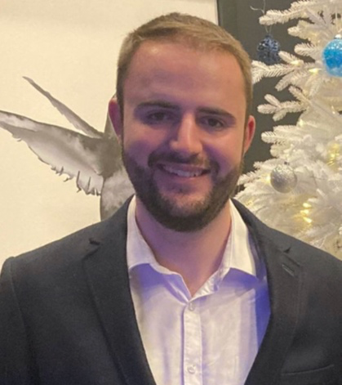
Hello, my name is Ethan I am a 24-year-old graduate from Swansea University where I studied my Bachelor’s degree in Chemical Engineering before moving on to my Masters in business management last year.
I live in a small village just outside Cowbridge with my parents. I’ve always wanted to work in healthcare having a long family history of relatives working within the NHS. I am currently employed by East Kent Hospitals Foundation Trust, working remotely, helping to manage the backlog of patients awaiting treatment, created by the pandemic.
I applied for the graduate gateway program because I believe it’s a great opportunity to experience every aspect of healthcare management and to develop my skills alongside experienced professionals. I am excited about what the next two years will bring and cannot wait to get stuck in alongside my new colleagues.

Hannah Thomas
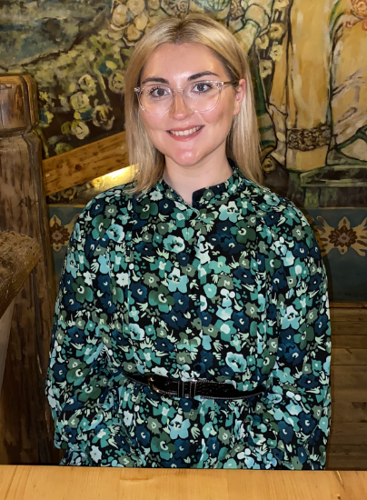
Hello I’m Hannah, I’m 23, and live with my mother, brother, boyfriend Liam, and Ollie our pug x Jack Russell.
I graduated last year from the University of Wales Trinity Saint David Business School, after receiving a 1st class honour in BA Business and Management.
I have always known that I wanted a career where I am able to help others and make a difference. I have worked as a waitress, shift coordinator and a teaching assistant and most recently as a GP practice receptionist. It was challenging at times but really opened my eyes to the NHS.
I was drawn to the Programme by the chance of progression within the health board and being able to do that through helping the public. I am a Welsh speaker, and look forward to strengthening this skill and helping colleagues and service users.
Cohort 3 have all expressed how great the programme is, and described it as having the “golden ticket”. I am excited to have my “golden ticket” and look forward to developing myself professionally and personally within a forever-changing environment. I am delighted to have been given this opportunity and cannot wait to see where it will take me and my colleagues.

Graduate Trainee Manager Julie Rafferty
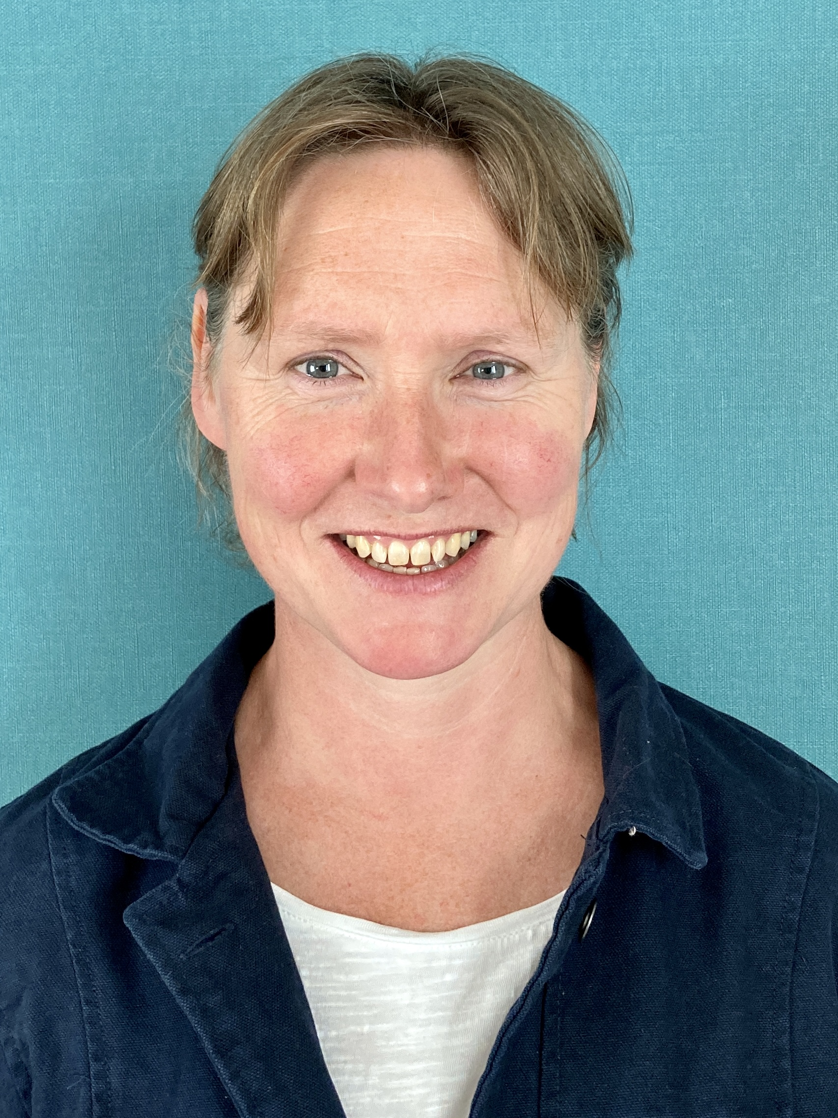
Hello Everyone; My name is Julie and I am very much looking forward to joining some of you on placement in the near future. My background is in healthcare and I have worked as a senior staff nurse all over the UK and also Australia.
I qualified in Glasgow 2001 where I worked in the acute/chronic renal unit which was a very busy tertiary critical care unit. I then travelled to Australia and worked with a lovely team on the renal transplant unit. On my return to the UK I worked in Southmead Hospital, Bristol, in the recovery unit. This was a great experience. I have now settled in Swansea where I work at SDMU, the surgical admissions unit in Morriston Hospital. I have worked here since its inception twelve years ago and I am long-standing and valued member of the clinical team.

Some success stories of graduate alumni:
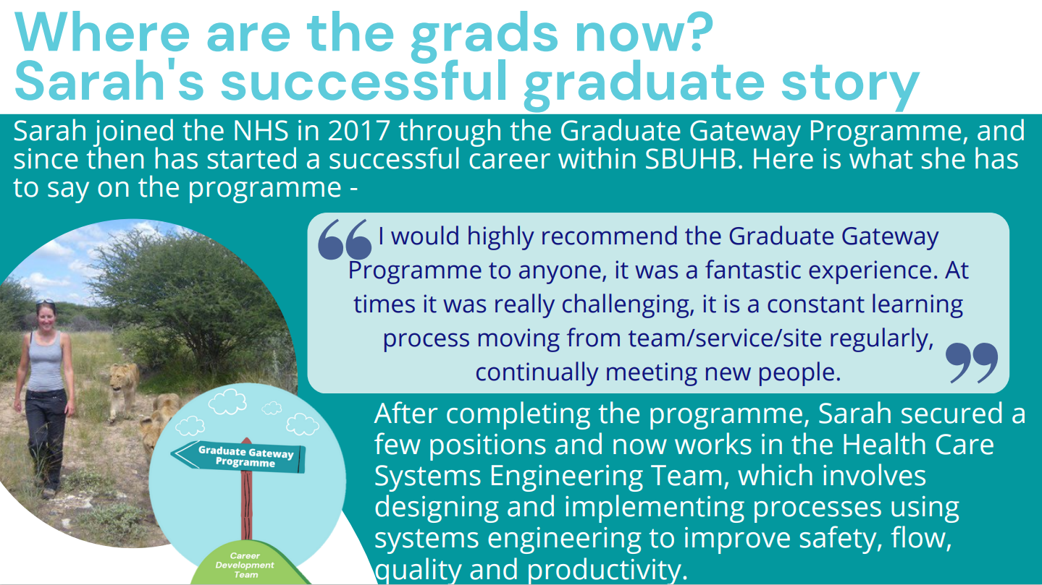

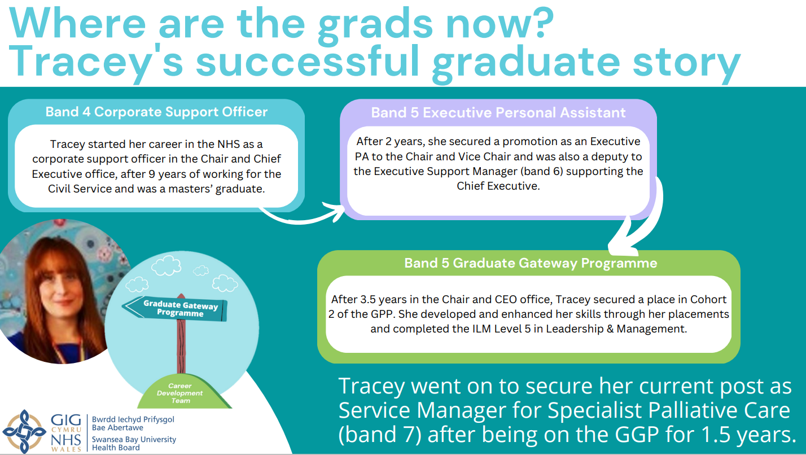

Information on other graduate alumni:
Cohort 1 (Graduated in 2018)
- Megan Protheroe – Head of Performance, Finance
- Ricky Morgan – Assistant Head of Operations, MH&LD
- Ruth Tovey – Head of Strategic Planning, Strategy

Cohort 2 (Graduated in 2021)
- Anthony Bullock – Deputy Cluster Development and Planning manager, PCCT
- Becky Jones – Maternity Service Manager, Singleton Hospital
- Jordan Tucker – Directorate Manager, MH&LD
- Katie Hollingworth -- Directorate Manager, MH&LD
- Nia Angharad Leather -- Graduate and Internships Manager, WOD

Cohort 3 (Graduating in May 2023 – some have already secured roles)
- Alisha Ramji – Acute Medicine and Emergency Care Service Manager
- Ella Foreman – Service Manager Surgery
- Lisa James – Appointed to HEIW
- Sam Jenkins – Service Manager, Haematology Cancer Services

