10. Workforce Updates and Actions
This section of the report provides further detail on key workforce measures. Caveats and Limitations (C&L) detailed beneath data in each section.
Staff sickness rates - Percentage of sickness absence rate of staff (two metrics provided, ‘rolling 12 month’ and ‘in month’)  Sickness absence target – 5.5% | % of full time equivalent (FTE) days lost to sickness absence  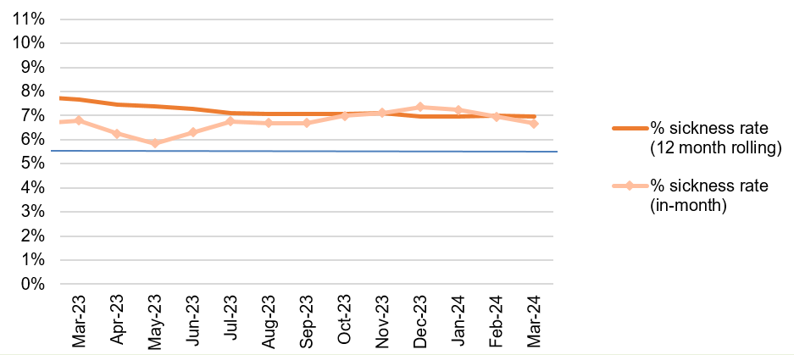  Caveat & Limitations;- Report generated May 2024, within SBUHB (Performance Team) for substantive and FTC employee types. Data source – ESR. Target of 5.5% added as blue line
Current Performance
- Health Board total for in month sickness absence for March 2024 has decreased slightly from the last reporting period to 6.67% (compared to 7.23% January 24 and 7.35% Dec 23).
- In January, absences relating to ‘Cold, Cough, Flu’ reduced to 712 and have further reduced to 529 as we enter Spring which is in line with seasonal trends.
- Anxiety/stress related absence remained the highest reason for long term absence, with MSK remaining second. This is consistent across NHS Wales and is a long-term pattern.
- In March, we identified a slight increase in absences across MH&LD compared to the previous reporting period (8.04% in March 24 compared to 7.70% in Jan). NPT/SG and PCT absence rate remain consistent since the last reporting
- In March 24, we identified a significant decrease in absences in Morriston in comparison with the last reporting period – January 24 7.31%, March 24 5.78%
- Long term absence has reduced since the last reporting period (4.82% January 24 compared to 3.70% in March 24). Short term absence has increased slightly since the last reporting period (2.67% January 24, 2.97% March 24)

Actions for Next Period
General
Current focus on areas with high absences rates, examples of initiatives to support our employees:
- Piloting Tailored Adjustments training for managers to increase experience of using these to flexibly support staff to remain in work/return to work
- Wellbeing resource pack – physical and electronic copies available – includes new starter feedback questionnaires
- Case conference training for leaders in partnership with OH
- The HRBPs leading on the initiatives listed above are working together to share best practice with the intention to deploy initiatives across the HB
- Managing Attendance at Work stand-alone training module has been developed along with ‘how to’ guides which will be available centrally. Training attendance will be recorded on ESR.

Occupational Health and Staff Health and Wellbeing
The services continue to develop high quality multi-disciplinary interventions to contribute to an engaged, motivated and healthy workforce.
- SBU OH&WB Lead has contributed to the WG tripartite group to develop All Wales OH Standards and KPI’s with monitoring to WG from June 2024
- Team contributed to the HEIW Wellbeing Best Practice Guide; planning the roll out of this across the organisation with HR BP’s
- Nurse training being undertaken with diabetes Lead Nurse and smoking cessation lead in order to deliver staff health checks – to commence June 2024
- Commenced menstruation awareness training in May for managers to aid management at work; dates planned for the next 3 months
- HB wide OH Nurse Skin surveillance training commencing June 2024 for identified ‘responsible persons’

Mandatory & Statutory Training-  Percentage compliance for all completed Level 1 competencies within the Core Skills and Training Framework by organisation  Mandatory & Statutory Training target – 85% | % of compliance (Headcount) with Core Skills and Training Framework  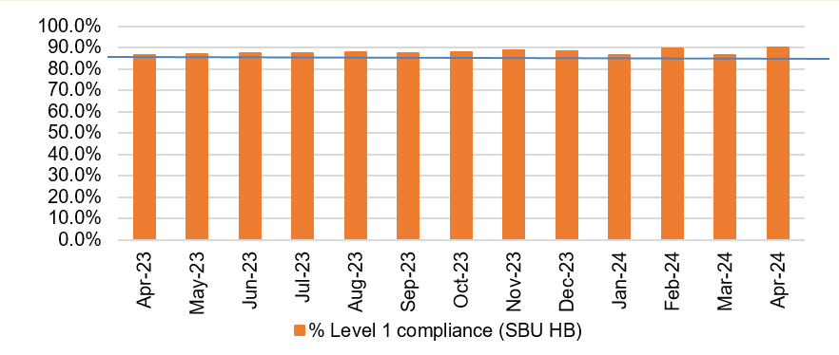  C&L;- Report generated May 2024, within SBUHB (Performance Team) for substantive and FTC employees. Data source – ESR (OLM Module). Accuracy levels subject to local maintenance and validation standards. Target of 85% added as blue line
Current Performance
- Health Board Statutory and Mandatory Training compliance rates as of 30th April 2024 are:
89.83% - 10 CSTF (Core Skills Training Framework) competencies as reported to Welsh Government (The Welsh Government target is 85%).
88.58% - *15 core competencies (including the 10 CSTF and *5 additional competencies required by SBUHB)
- Medical & Dental staff Group remain the lowest performing area with 60.86% compliance.
- Compliance figures (*15 core competencies) per Service Group - MH&LD 90.04%, PCCT 92.91%, Morriston 84.29%, Finance & Estates 87.64%, NPTS 90.27%

Actions for Next Period
- Subscription to Learning Certification and Enrolment onto Statutory/Mandatory Courses (E-Learning) – User issues identified are being supported on a case-by-case basis via Action Point and from direct contact. This has been the case over a number of months and continues to be the case going forward.

Vacancies  Medical and Nursing and Midwifery | Vacancies (FTE) Feb 24 to Apr 24  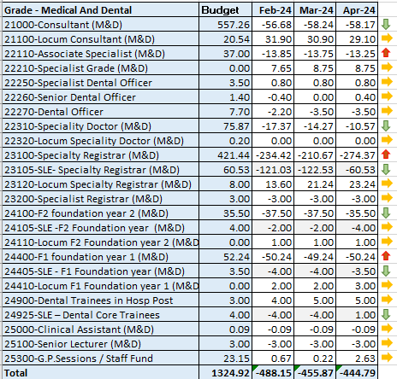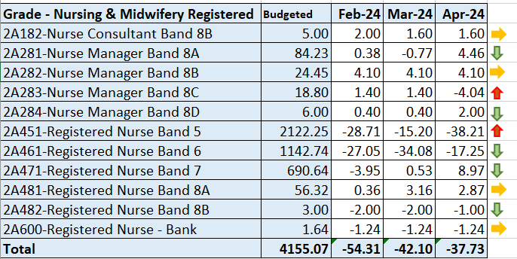  C&L;- Report generated 23 May 2024, within SBUHB (ESR Team), using currently available methodology. Data source – ESR (Workforce) and General Ledger (Finance). We compare the SIP v’s the finance ledger, appreciating limitations on accuracy in some areas. Accuracy levels are subject to local validation practices based on budget holders intelligence. N.B. a 12 month project (ESR Establishment control) has commenced which will harmonise vacancy data including Grade detail shown above.
Current Performance
- M&D vacancies have reduced by 43.36 WTE since February. It is worth noting that SLE doctors (those for whom we hold allocated budget, but do not employ the individuals to offset against the financial position) are inflating the vacancy data at present. The Establishment Control Project is exploring this issue in the context of data cleansing and delivery in order to clarify the position. The project is anticipated for completion in September.
- The recruitment of Junior/Senior Clinical Fellow vacancies in certain areas has increased to support the recruitment challenges of other grades which has assisted in reduced agency costs.
- NMC vacancies have fluctuated somewhat which is partly a result of the budgeted WTE being increased by 30WTE since February, with that additional budget not yet being fully offset by new entrants. A steady stream of overseas nurses completing OSCE training and becoming employed by SBUHB continues to assist with nursing vacancies.
- Band 6 vacancies have also reduced by approx. 17 WTE.
Actions for Next Period
- Overseas Nurse recruitment continues but is now more targeted in specialist areas i.e Mental Health, Midwifery. New arrivals planned for June and July
- Pre-employment checks for the next cohort of newly qualified nurses (NQNs) due to qualify in September 24 will commence on receipt of final confirmed list of recruits from NWSSP and onboarding will be supported by Resourcing team.
Resourcing team continues to support targeted recruitment of UK domicile nurses to specific areas that have hard to fill vacancies i.e ED.
- The Medical HR Team will continue to support the services to identify recruitment options to drive down variable pay and alleviate some of the agency spend.

Recruitment  Metrics provided by NWSSP. Comparison with all-Wales benchmarking  Target 44 days | 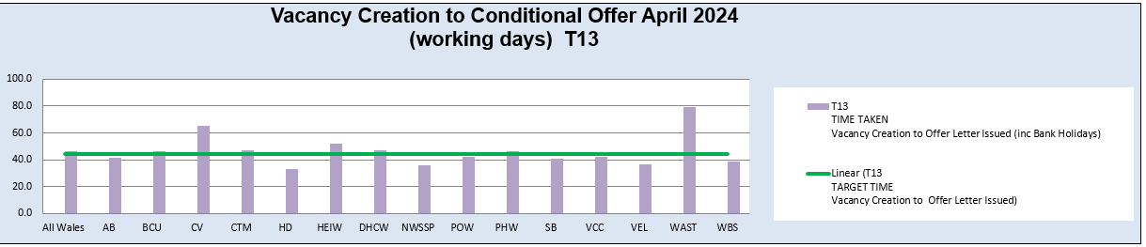  C&L;- Report generated May 2024, by NWSSP (Recruitment). Data source – TRAC system. Outliers are excluded. This is day to day vacancy management. Data excludes outliers.
Current Performance
- Swansea Bay UHB overall performance continues to be on target in April 24, and our monthly average over the last 12 months remains in target. In addition our performance for conditional offer to ready for start date start date was 19 days, which remains below the set target of 27 days.
- The Central Resourcing Team continue to focus efforts on the recruitment of acute ward based HCSW’s and Band 5 nurses as well as providing support to specific difficult to recruit to posts (see above) and vacancy gap has closed significantly evidenced by significant reduction in nurse temporary agency spend
- Current KPI’s (April 24) comparing SBUHB average time to hire vs the CRT on HCSW recruitment is 61 days vs 52 days based on average time taken from vacancy creation to ready to start.
- In collaboration with NWSSP, we have been supporting the wider HB by trying to ‘chase’ outstanding actions on vacancies / pre-employment checks with applicants, in an effort to reduce the overall HB time to hire, which has shown improvements since the last report.

Medical Recruitment

- 288 Health Board substantive & fixed term medical appointments, which includes 66 Consultant posts, undertaking end-to-end recruitment during the period 1.4.23 – 31.3.24.
- Medical HR Team continue to focus on the recruitment of hard to recruit to posts, working closely with the relevant service groups.
- Continuing to offer high level pastoral care for international doctors relocating to the UK.
- Welsh Government have advised that Swansea Bay are an anomaly when it comes to international recruitment of doctors as all other Health Boards in Wales are unsuccessful at Junior and Senior Clinical Fellow levels.
- Medical HR has two dedicated overseas champions.
- 141 clinical attachment placements approved during the period 1.4.23 – 31.3.24, with potential for these to move into a Junior/Senior Clinical Fellow post.

Actions for Next Period
- HRBP’s continue to discuss with Service Groups opportunities to reducing the lag between the date termination of posts are being requested versus date a TRAC entry was initiated.
- The Central Resourcing Team will continue focusing on the recruitment of B5 nurses, B2 ward based HCSW’s and assisting in overseas nurse recruitment. In addition, they are assisting in the recruitment of newly qualified nurses, via the all Wales Student Streamlining process. As well as specific identified hard to recruit to posts.
- In collaboration with NWSSP, we will continue supporting the wider HB by trying to ‘chase’ outstanding actions on vacancies / pre-employment checks with applicants, in an effort to further reduce the overall HB time to hire.
- For doctors we continue to recruit overseas on a post by post basis

Medical Recruitment
- Continue to recruit overseas doctors on a post-by-post basis.
- Support the services for their hard to recruit to posts, exploring the option with Agencies to support permanent recruitment in these hard to fill areas.
- Continue to recruit SAS doctors to support through Portfolio Pathway (formerly CESR)
- Bid submitted to Welsh Government for funding for to aid international recruitment awaiting outcome

Turnover  % turnover by occupational group | Period Turnover Rate (Swansea Bay) – 01 May 2023 – 30 Apr 2024  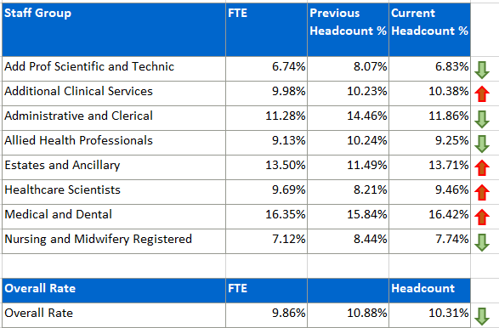  C&L;- Report generated May 2024, within SBUHB (ESR Team). Data source – ESR (Workforce). Small risk of margin of error due to late communication of terminations. Report excludes Bank, Locum, Honorary & Widow/Widower, Junior M&D staff. Internal movement not included – measure is about leaving Swansea Bay UHB.
Current Performance
- Organisationally our turnover has decreased marginally in this reporting period (from 10.88% to 10.31%).
- It is important to recognise that this is reporting on a 12 month rolling period of turnover.
- Medical and Dental appears as the highest turnover at 16.42%, however it is important to note that expected spikes in activity created by seasonal SLE turnover which will lead to elevated M&D levels overall.
- Estates and Ancillary is now the second highest area, having increased from 11.49% to 13.71 and represents the largest increase across all staff groups in the reporting period.
- Other categories are either relatively stable or improving.

Actions for Next Period
- Newly appointed Retention Lead has commenced and will initiate priority retention actions from the all Wales Nurse Retention plan to facilitate the implementation of all Wales Nurse Retention plan. In addition we will be aligning HB retention plans with our People Strategy aims and identifying actions that can be implemented across all of our workforce.
- Results from our “Thinking of Leaving” pilot process to be finalised reported.

PADR  % staff who have a current PADR review recorded  PADR target – 85% | % of staff (Headcount) who have had a PADR in previous 12 months  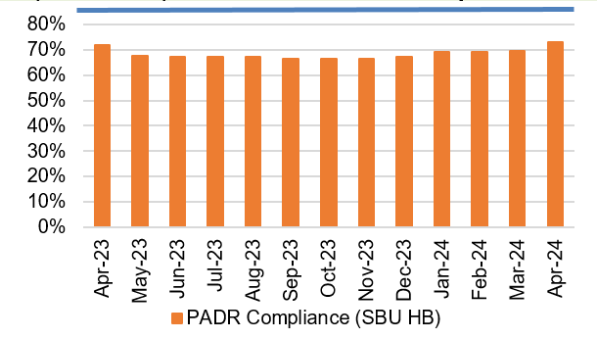  C&L;- Report generated May 2024, within SBUHB (Performance Team). Data source – ESR (OLM Module). Accuracy levels subject to local maintenance and validation standards. Target of 85% added as blue line.
Current Performance
- Staff who have had a Personal Appraisal and Development Review (PADR) at the end of this time period stands at 73%, an increase of 3% since March 2024 and a continuation of the steady rise since Nov 23.
- In the past two months 37 staff have attended 130 PADR - Personal Appraisal Review for Managers the Learning and Education Team signpost colleagues to SBU ESR - ESR User Guides SharePoint Page for resources on how enter PADR Dates in ESR.
- Compliance figures per Service Group (excluding Medical and Dental Staff) – MH&LD 73.95%, NPTS 72.98%, PCCT 83.21%, Morriston 68.59%, Finance and Estates 72.56%
Actions Planned for Next Period
- Supporting activity outlined in previous reports continues, Service Groups continue to focus on highlighting areas for focus.

Operational Casework  Number of current operational cases. | C&L;- Report generated May 2024, within SBUHB (Workforce Digital). Data source – ER Tracker. Accuracy levels subject to local maintenance and validation standards.
Current Performance
- No. of open Formal Disciplinaries since the last reporting period have increased to 53 open cases
- Number of Formal requests for Resolution is 27
- Suspensions, since the last reporting period, remain at 9
- ET’s remain at 3
Actions for Next Period
- A number of actions are on-going in line with the Best Practice Review
- Workshops have been arranged during 2024 in partnership with our Trade Unions facilitated by HEIW and SBUHB covering the following: Employee Investigations – Avoiding Employee Harm.
- Learning from Events sessions will commence to inform best practice and identify opportunities for development
- We have successfully launched the Management Review document, to replace the initial assessment, which allows us to determine the most appropriate course of action at an early stage with the intention to resolve cases informally where possible – education and training ongoing with HR and leaders
- A deep dive will be undertaken on long term sickness absence management and suspensions with actions identified and outcomes measured
- Suspension Guidance for leaders and employees will be launched with the aim of supporting both groups and clarifying the process

