Meeting Date | 24 October 2024 |  | Agenda Item |  |  | 3.2
Report Title | Management of Sickness Absence – Maternity Services (NPTSSG)
Report Author | Cath Harris, Head of Midwifery, Liz Davies and Jessica Harris – HR Business Partners NPTSSG
Report Sponsor | Ceri Gimblett – Service Group Director NPTSSG
Presented by | Catherine Harris, Head of Midwifery
Freedom of Information | Open
Purpose of the Report | To provide the Workforce and OD Committee with a briefing on the management of sickness absence across Maternity Services. The information will cover:  - Data analysis: An analysis of the current Sickness absence performance data for maternity Services (available as of September 2024).  - Previous actions: An overview of actions that have taken place to reduce sickness absence across the service during the last 12 months.  - Planned improvements: Details of the improvement actions that are planned to ensure there are highly effectively, and sustainable mechanisms in place to effectively manage sickness absence across the service (to specifically include details of timescales, improvement targets and responsible officers).  - Monitor and evaluation: Details of the arrangements that will need to be in place to regularly monitor and evaluate the impact and effectiveness of those improvement actions to facilitate the review / adaptation of any actions as necessary.  The Health Board will be able to learn from the approach taken to managing sickness absence in Maternity Services to help inform what improvement actions can be put in place to improve the management of sickness absence in other services in Swansea Bay University Health Board.
Key Issues | Drivers for improving staff availability and sickness absence rates across the Maternity Service:  - Previous Maternity Services Board Papers have referred to both the Health Inspectorate Wales (HIW) Reports and Welsh Government Enhanced Monitoring Terms of Reference documents that have identified the need to improve staff availability across the Maternity Service to support the delivery of safe and effective care.  - The Welsh Government requires Health Boards to actively put in place arrangements and plans to achieve the <5% target absence rate across all services.  - Recognising and accepting the evidence that demonstrates staff health and wellbeing has an impact on staff engagement and experience, and how this enables organisational productivity, individual performance and ultimately the quality of patient care and outcomes across the Maternity Service. The NHS Wales Staff Health and Wellbeing – A Best Practice Guide should be used across the service as an enabler to unlock the benefits of improving staff Health and Wellbeing.
Specific Action Required  (please choose one only) | Information | Discussion |  | Assurance | Approval
Specific Action Required  (please choose one only) | ☒ | ☐ |  | ☒ | ☐
Recommendations | - Acknowledge the approach the Service Group is taking to address the findings of the deep dive sickness exercise to improve employee wellbeing and attendance across Maternity Services.  - Recognise the intentions of the Service Group to monitor the effectiveness of this approach and to identify successful practices that can be implemented in other services across the Health Board to continue to improve sickness absence rates and staff wellbeing.  - Agree to an update being provided to the Workforce & OD Committee 6 months after implementation of the changes.

Management of Sickness Absence – Maternity Services (NPTSSG)

- Data Analysis – Sickness Absence Rates

This report will provide a focus on sickness absence within the Registered Midwife and Additional Clinical Services (Maternity Health Care Assistants, Maternity Care Assistants, Nursery Nurses) staff groups, working across all teams within the Maternity Service.

Additional Clinical Services | - Overall, during the last 12-month period (up to 08/24) absence levels have reduced from 20.44% to 11.27%  - There has been improvement in sickness absence levels recognising that the rate remains above target levels
Registered Midwives | - Overall, during the last 12-month period (up to 08/24) absence levels have reduced from 11.99% to 6.85%  - This improvement has resulted in improved Midwife availability across the rosters  - As at 08/24 97% of all shifts were compliant with BirthRate+ and exceeded the minimum requirement of 14 Registered Midwives / shift

The graph below shows the sickness absence trend data from 09/23 – 08/24.
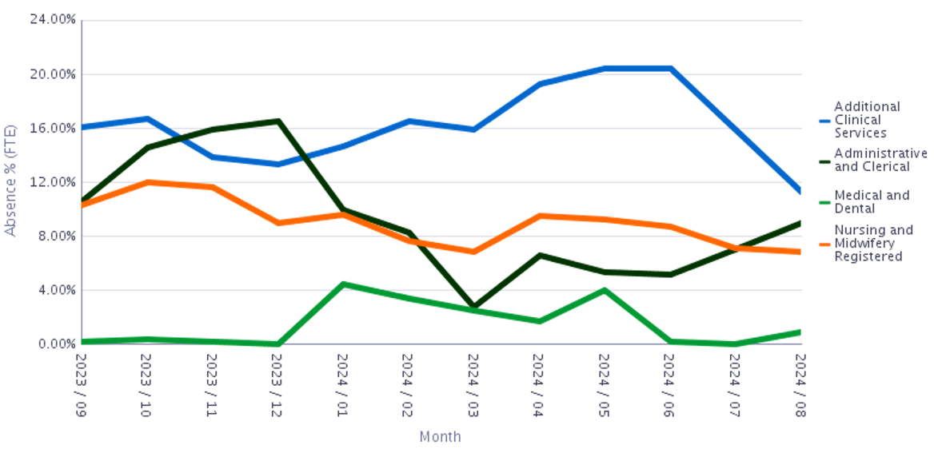

- Previous / Current Sickness Absence Improvement Actions

Actions |  | Detail
Communication and Engagement | Weekly open staff sessions | These continue to be hosted every Friday (Senior members of the Maternity Team / NPTSSG Service Group / Executive Directors / HR Business Partner Team attend). This is an open forum and all staff groups are invited to attend. Staff are encouraged to ask questions or raise any concerns. Staff are reminded about the Wellbeing and Occupational Health Services that are available.
Communication and Engagement | Guardian Service | The Maternity Management Team continue to support the Guardian Service visiting the service.
RCM - Caring for you Charter |  | The Charter was signed in 04/24. An action plan is in place to enable the service to fulfil the expectations of the Charter.
Staff Experience, Wellbeing and Retention Plan |  | The 2023 Obstetric Unit / Community consultation committed to developing an improvement plan for employee health, wellbeing and retention.  A Subgroup of the former Maternity Improvement and Assurance Board has been responsible for developing and implementing a Staff Experience, Wellbeing and Retention Plan (using the HEIW Nurse Retention Framework and NHS Wales Staff Health and Wellbeing – A Best Practice Guide to ensure that the plan is evidence based).  This work is currently in the development phase.
Sickness Absence Management Case Review Meetings (monthly) |  | The Maternity Management Team and HR Operational Team review the management of Long-Term Sickness Absence cases.
Sickness Absence Audit 12/23 |  | A sickness audit was undertaken in 12/23.  The audit recommendations included:  - A three month follow up ‘mini’ audit in 05/24 to evaluate compliance, learning and understanding (actioned)  - Managing Attendance at Work training session including the provision of supplementary written guidance (actioned)  - A continuation of the monthly review of long-term sickness cases supported by HR Operations (actioned)  - A review of the Ward Managers involvement in staff attendance and sickness absence (actioned)
Sickness Absence Deep Dive exercise  07/24 |  | A Deep Dive exercise aligned with the MAAW Policy was commissioned to take place in Maternity Services.  The exercise was planned to review at least 50% of staff files across four teams within Maternity Services.  NOTE: The initial findings of the Deep Dive exercise were made available in 08/24. Following the completion of the deep dive exercise, a final report will be shared with the service (anticipate that this will be in November 2024).  The improvement plan will be reviewed when the full Deep Dive report is available – however it will be possible in the interim to start progressing plans to respond to the recommendations outlined in the initial report.

- Planned Improvements

The Maternity Management Team have welcomed the Deep Dive as an opportunity to learn and seek improvements that can be made to the management of sickness absence to the benefit of the team, the service and service users.

Developing the Improvement Plan
The HR Business Partner Team will engage with the Maternity Management Team to provide the support and guidance in a collaborative style to work up the detailed sustainable improvement actions to be included in the Improvement Plan. It’s important that the Management Team influence and develop the improvement plan so that it is the right fit for the service and can be translated into a practical and achievable set of actions. Part of this process will be to identify any barriers and reasons that could prevent the effective / excellent management of sickness absence.

The Assistant HR Business Partner (supported by the HR Business Partners) will facilitate a structured approach to discuss the infrastructure / processes required across the Services.

The Improvement Plan will be designed in line with the principles of quality improvement, ensuring that the Plan has SMART objectives, it is planned, implemented, reviewed, and evaluated. The plan will be monitored on a regular basis through the Maternity/Neonatal Silver meeting to check it is delivering the expected outcomes. A formal review of the plan will happen 6 months after implementation, commissioned by the Children and Young People and Womens Health Division’s Senior Leadership Team. At that time, it is proposed that an update on progress is reported back to the Management Board and Workforce and OD Committee.

Leadership and Team Development Proposal
A Leadership and Team Development proposal has been produced for the newly established MatNeo Leadership team – which is part of the newly formed Children and Young People and Women’s Health Division. This Development Programme will further support and complement this improvement work and will support the Management team to take proactive ownership and to be fully accountable for the successful implementation of the sickness improvement plan.

The Staff Experience, Wellbeing and Retention Plan
Ensuring that the service is effectively managing sickness absence in line with the MAAW Policy is only one component to improve employee availability and sickness absence rates across the Maternity Service. The continuing development and effective and sustainable implementation of the Maternity Staff Experience, Wellbeing and Retention Plan will form an essential foundation to supporting the health and wellbeing of staff working across the Maternity Service and improved sickness rates.

The Maternity Service is due to initiate a series of Café Conversation sessions with Staff and Trade Unions in November 2024 to engage the broader team in developing the specific themes and actions in the plan. The service is taking a compassionate and collective approach to the design, development and implementation of the plan. There will also be alignment with the work that continues under the Royal College of Midwives ‘Caring for you Charter.’

Improvement Actions
The following table summarises some of the improvement actions that will need to be designed and included in the Improvement Plan.

Improvement Action | Timescales | Improvement Measures | Target | Responsible Person
Develop Improvement Plan (incorporating all recommendations from the Deep Dive exercise)  Note: Full report will not be available until 11/24 | 1/11/24 – 1/12/24 | Report recommendations implemented fully and audit demonstrates compliance  Improved month on month sickness absence rates  Improved Workforce KPI and Quality KPIs | Sickness Improvement Plan to be approved and ratified by the Maternity Improvement and Assurance Board | Head of Midwifery
Sharing of Learning outcomes to benefit other services within the Health Board | March 2025 | Improved sickness absence rates  Improved Workforce KPI and Quality KPIs | TBC | HR Business Partner Team / WOD

Members are asked to:
- Acknowledge the approach the Service Group is taking to address the findings of the deep dive sickness exercise to improve employee wellbeing and attendance across Maternity Services.
- Recognise the intentions of the Service Group to monitor the effectiveness of this approach and to identify successful practices that can be implemented in other services across the Health Board to continue to improve sickness absence rates and staff wellbeing.
- Agree to an update being provided to the Workforce & OD Committee 6 months after implementation of the changes.

Governance and Assurance

Link to Enabling Objectives  (please choose) | Supporting better health and wellbeing by actively promoting and empowering people to live well in resilient communities
Link to Enabling Objectives  (please choose) | Partnerships for Improving Health and Wellbeing |  | ☐
Link to Enabling Objectives  (please choose) | Co-Production and Health Literacy |  | ☐
Link to Enabling Objectives  (please choose) | Digitally Enabled Health and Wellbeing |  | ☐
Link to Enabling Objectives  (please choose) | Deliver better care through excellent health and care services achieving the outcomes that matter most to people
Link to Enabling Objectives  (please choose) | Best Value Outcomes and High Quality Care |  | ☐
Link to Enabling Objectives  (please choose) | Partnerships for Care |  | ☐
Link to Enabling Objectives  (please choose) | Excellent Staff |  | ☐
Link to Enabling Objectives  (please choose) | Digitally Enabled Care |  | ☐
Link to Enabling Objectives  (please choose) | Outstanding Research, Innovation, Education and Learning |  | ☐
Health and Care Standards
(please choose) | Staying Healthy |  | ☐
(please choose) | Safe Care |  | ☐
(please choose) | Effective Care |  | ☐
(please choose) | Dignified Care |  | ☐
(please choose) | Timely Care |  | ☐
(please choose) | Individual Care |  | ☐
(please choose) | Staff and Resources |  | ☐
Quality, Safety and Patient Experience
The improvement plan should contribute to improved employee availability and have a positive impact on staff health and wellbeing.
Financial Implications
There are potential financial implications linked to absence.
Legal Implications (including equality and diversity assessment)
Staffing Implications
The improvement plan should contribute to improved employee availability and have a positive impact on staff health and wellbeing.
Long Term Implications (including the impact of the Well-being of Future Generations (Wales) Act 2015)
Report History
Appendices |  | N/A

The Royal College of Midwives ‘Caring for you Charter’ initiative aims to improve the health, safety and wellbeing at work for all midwives, student midwives and maternity support workers, so they are in turn able to provide safe, high quality maternity care for women, babies and their families.

