Meeting Date | 2nd October 2025 |  | Agenda Item |  |  | 3.5
Name of Meeting | Workforce & OD committee
Report Title | Variable pay plan overview and progress updates
Report Author | Emma Owen, Interim Assistant Director of Workforce & OD
Report Sponsor | Tina Ricketts, Executive Director of Workforce & OD
Presented by | Tina Ricketts, Executive Director of Workforce & OD
Freedom of Information | Open
Purpose of the Report | To update the committee on the variable pay reduction plan and the progress that has been made to date.
Key Issues | To note:  - The ongoing work of the variable pay steering group.  - The bank and agency usage from April to August 2025
Specific Action Required  (please choose one only) | Information | Discussion |  | Assurance | Approval
Specific Action Required  (please choose one only) | ☐ | ☐ |  | ☒ | ☐
Recommendations | The Committee is asked to  - CONSIDER the report which is provided for assurance.

VARIABLE PAY PLAN OVERVIEW AND PROGRESS UPDATES

- INTRODUCTION

Variable pay remains a key challenge for the Health Board. Whilst reductions have been achieved in non-medical agency, overtime and waiting list initiatives, there has been an increase in medical bank and agency.

- BACKGROUND

The Health Board must achieve £55.4m in savings in 2025/6 if it is to meet its financial plan. The Recovery and Sustainability Programme Board was established to achieve the required savings with 12 overarching workstreams. Enhanced workforce controls have been implemented in addition to a dedicated variable pay steering group.

A multi-disciplinary variable pay steering group was formed to provide an overarching structure and cohesive approach to sustainable changes focussed on:

- Variable Pay
- Staffing Unavailability
- Workforce
The Variable Pay Steering Group has dedicated plans covering all professional groups that are led by Executive Directors. Overarching highlight reports are provided to the Recovery & Sustainability Board to monitor progress and ensure delivery.

- GOVERNANCE AND RISK ISSUES

The variable pay steering group has approved a number of plans for each professional group to address the on-going workforce challenges. The table below outlines the 8 programmes of work:

No | Theme | Programme of work | Target
1 to 5 | Variable Pay | Bank & Agency reduction plan - with 5 workstreams established:  - Medical & Dental  - Nursing, Midwifery and HCSW  - AHP and Healthcare Scientists  - Support Services  - Admin & Clerical | To reduce our agency usage by 30% from a 2024/5 baseline.  To reduce our agency usage by a minimum of 15% from a 2024/5 baseline.
6 | Temporary Staffing Model | To undertake an options appraisal to ensure current model is fit for purpose for all staff groups. | Option appraisal considered by Management Boad
7 | Sickness Absence Management | To support each budget holder to meet the sickness absence target. To set improvement trajectories and supporting action plans. | To reduce the rolling sickness absence rate by 0.3% by 31st March 2026
8 | Establishment Control | To develop a policy and standing operating procedures to strengthen the grip and control on variable pay. | Updated policy and standing operating procedures in place.

The programmes are multi -faceted and include both short and medium term objectives. The key deliverables to date include:

Professional Workforce Boards
Weekly professional workforce Boards have been implemented to review variable pay requests for each staff group. This is a new additional step to the previous vacancy control process.

Revised vacancy control process
We have a well-established vacancy control process that has been in place for a number of months. However, to strengthen the grip and control we have implemented new arrangements which include:
- A default position that all vacancies will be advertised internally. By exception posts in highly specialist areas (such as Maternity) will be considered for external advert
- Full TRAC vacancy management with escalation processes
- Divisional and finance control measures

See appendix 1 for more detail.

Agency
Revised processes for agency working have been implemented where executive approval must be received for all bookings. Medical and Nursing panels meet daily to review short-term requests. All other professional group requests are submitted to the relevant Workforce Board for review and decision. These arrangements are to ensure professional ownership and challenge so that all other means of covering roles has been considered. A revised protocol is being developed to outline the revised arrangements.

Data
High quality information is critical to benchmark progress and identify areas of improvement. Detailed work has been undertaken to ensure that data available is correct, current and available to managers to support effective and timely decision making. Variable pay information has been added to workforce dashboards to assist with reporting and decision making. Dashboards have also been updated to include roster efficiency information and sickness trajectories. Further work is being undertaken to triangulate workforce information to support targeted actions.

- FINANCIAL IMPLICATIONS

During the last 12 months the Health Board has experienced challenges in significantly reducing the spend relating to variable pay. The information below outlines the total variable pay spend per month for the first quarter of 2025/2026.

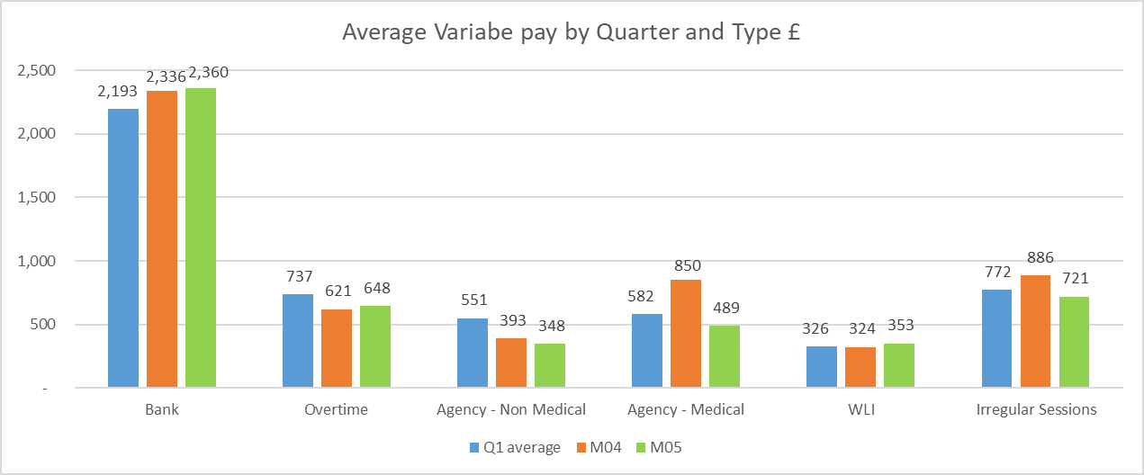

The Variable pay steering group is focussed on delivering the ministerial priority of 2024 in reducing agency usage by 30% and no off-framework usage.

The Health Board is making good progress in reducing non medical agency usage. The table below outlines the whole time equivalent (WTE) usage for 2026 split between framework and non framework.

 | Jan-26 | Feb 26 | Mar-26 | Apr-26 | May-26 | Jun-26 | Jul-26 | Aug-26
Framework | 102.93 | 106.98 | 114.63 | 88.61 | 90.99 | 54.5 | 49.35 | 55.09
Non Framework | 0.79 | 0.78 | 0.78 | 0.72 | 1.87 | 1.12 | 0.73 | 0.65
 | 103.72 | 107.76 | 115.41 | 89.33 | 92.86 | 55.62 | 50.08 | 55.74

Whilst good progress has been achieved in non-medical agency usage, we are still experiencing challenges with medical agency usage (outlined below).

 |  | Jan | Feb | Mar | Apr | May | Jun | Jul | Aug
 | Locum Associate Spec | 1.09 | 0.94 | 0.74 | 0 | 0.08 | 0 | 0 | 0
 | Locum Cons | 7.75 | 8.52 | 9.04 | 11.11 | 12.47 | 11.07 | 12.32 | 9.20
 |  | Jan | Feb | Mar | Apr | May | Jun | Jul | Aug
 | Locum Spec Dr | 0.32 | 0 | 0 | 0 | 0 | 0 | 0 | 0
 | Locum ST Higher | 2.65 | 3.37 | 1.83 | 1.95 | 2.20 | 3.24 | 2.13 | 1.78
 | Locum ST Lower | 4.00 | 2.03 | 1.43 | 0.97 | 1.70 | 2.19 | 0.70 | 0.51
 | Grand Total | 15.81 | 14.86 | 13.04 | 14.03 | 16.46 | 16.51 | 15.14 | 11.49

Please note that there is no off framework agency usage recorded for Medical cover. All agency arrangements are above Welsh Government capped rates. There are on-going discussions to implement a revised rate card both locally and at an all Wales level.

It is also important to note that there are other Medical agency arrangements in place that are for medical services such as specialist assessments that are included within the overall spend information but not part of the locum breakdown above.

Below is the capped rate information for internal medical locums and agency for June, July and August 2025.

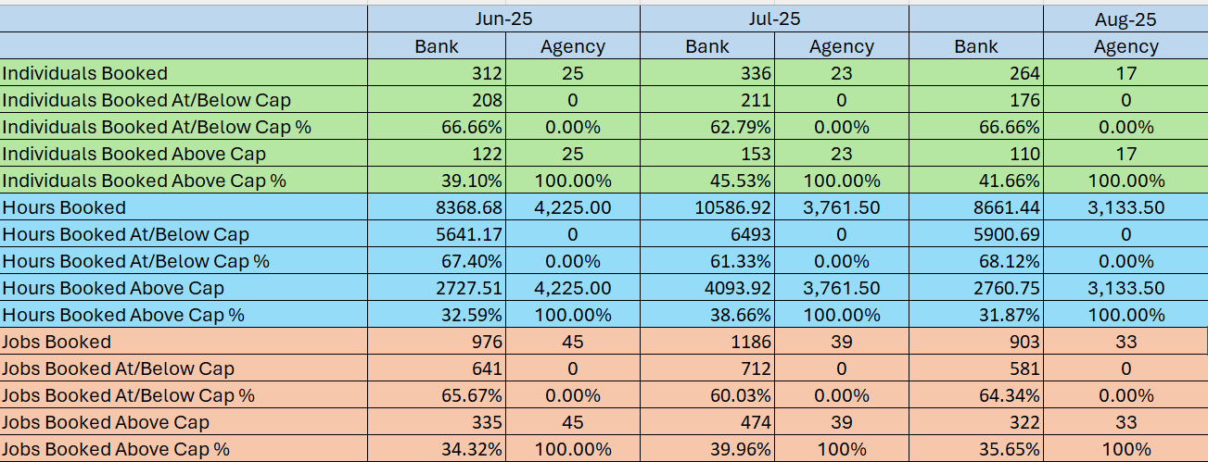

- RECOMMENDATION
The committee is asked to consider the report which is provided for assurance.

Governance and Assurance

Link to Enabling Objectives  (please choose) | Supporting better health and wellbeing by actively promoting and empowering people to live well in resilient communities
Link to Enabling Objectives  (please choose) | Partnerships for Improving Health and Wellbeing |  | ☒
Link to Enabling Objectives  (please choose) | Co-Production and Health Literacy |  | ☐
Link to Enabling Objectives  (please choose) | Digitally Enabled Health and Wellbeing |  | ☐
Link to Enabling Objectives  (please choose) | Deliver better care through excellent health and care services achieving the outcomes that matter most to people
Link to Enabling Objectives  (please choose) | Best Value Outcomes and High Quality Care |  | ☒
Link to Enabling Objectives  (please choose) | Partnerships for Care |  | ☐
Link to Enabling Objectives  (please choose) | Excellent Staff |  | ☒
Link to Enabling Objectives  (please choose) | Digitally Enabled Care |  | ☐
Link to Enabling Objectives  (please choose) | Outstanding Research, Innovation, Education and Learning |  | ☐
Health and Care Standards
(please choose) | Staying Healthy |  | ☐
(please choose) | Safe Care |  | ☐
(please choose) | Effective Care |  | ☒
(please choose) | Dignified Care |  | ☐
(please choose) | Timely Care |  | ☐
(please choose) | Individual Care |  | ☐
(please choose) | Staff and Resources |  | ☒
Quality, Safety and Patient Experience
Engaged motivated and health staff will impact on patient care and clinical outcomes.
Financial Implications
We need to reduce our variable pay by £34.5m if we are to meet the financial target set by the Government.
Legal Implications (including equality and diversity assessment)
None identified.

Staffing Implications
Staffing issues will impact on both the quality and financial sustainability of services.

Long Term Implications (including the impact of the Well-being of Future Generations (Wales) Act 2015)
Best use of resources.
Report History |  | Not applicable
Appendices |  | Appendix 1 – Revised Vacancy control process

