Meeting Date | 02 October 2025 |  | Agenda Item |  |  | 5.2
Name of Meeting | Workforce and OD Committee
Report Title | Progress Report - Management of Sickness Absence – Maternity Services (NPTSSG)
Report Author | Cath Harris, Head of Midwifery
Report Sponsor | Liz Rix, Executive Director of Nursing and Patient Experience
Presented by | Cath Harris, Head of Midwifery  Ceri Gimblett – Service Group Director NPTSSG
Freedom of Information | Open
Purpose of the Report | To set out the progress on the actions identified to improve the management of sickness absence across Maternity Services. The information will cover:  - Data analysis: An analysis of the current sickness absence performance data for Maternity Services (available as of August 2025).  - Progress against planned actions: An overview of progress against agreed actions to improve the management of sickness absence across the service.
Key Issues | There are three main drivers for improving staff availability and sickness absence rates across the Maternity Service, these include:  - The evidence that demonstrates staff health and wellbeing has an impact on staff engagement and experience, and how this enables organisational productivity, individual performance and ultimately the quality of patient care and outcomes across the Maternity Service. The ‘NHS Wales Staff Health and Wellbeing – A Best Practice Guide’ is used as an enabler to unlock the benefits of improving staff Health and Wellbeing.  - There is an ongoing need to improve staff availability across the Maternity Service to support the delivery of safe and effective care.  - The Welsh Government requires Health Boards to achieve the <5% target absence rate across all services.
Specific Action Required  (please choose one only) | Information | Discussion |  | Assurance | Approval
Specific Action Required  (please choose one only) | ☒ | ☐ |  | ☒ | ☐
Recommendations | - ACKNOWLEDGE the progress the Service Group is taking to address the findings of the deep dive sickness exercise to improve the management or sickness absence and support employee wellbeing across Maternity Services.  - BE ASSURED of progress against the action plan.

MANAGEMENT OF SICKNESS ABSENCE – MATERNITY SERVICES (NPTSSG)

- INTRODUCTION

A previous report has been presented in the Workforce and OD Committee in April 2025 which outlined improvement actions, planned improvement actions and the evaluation and monitoring approach.

This report will provide an update on the current sickness absence rates across Maternity Services along with progress against improvement actions. It will include:

- Data analysis: An analysis of the current sickness absence performance data for Maternity Services (available as of August 2025)
- Progress against planned actions: An overview of actions that have taken place to reduce sickness absence across the service.

- BACKGROUND

This report will provide a focus on sickness absence within the Registered and Non-Registered workforce in Maternity Services (including Midwives and the Additional Clinical Services (Maternity Health Care Assistants, Maternity Care Assistants, Nursery Nurses) staff group). The report does not include the Medical Staff Group.

- DATA ANALYSIS – CURRENT / UPDATED SICKNESS ABSENCE RATES
Overview of the Maternity Services Workforce KPI heatmap (all staff groups):
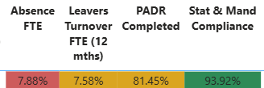
Turnover / PADR and mandatory Training rates have all improved across the service, and the service continues to work to improvement plans to ensure compliance with the Welsh Government target rate of 85%. The service has observed significant improvements in turnover rates. LTR Headcount % turnover rates in 08/23 for Registered Midwives were more than 10% compared to a reduced rate of 4.98% as at 08/25. Improvements can also be seen in the Additional Clinical Services staff group where rates exceeded 6% as at 08/23 and have reduced to 4.88% as at 08/25.
Additional Clinical Services
- Overall, absence levels over the last 12 months have fluctuated between a peak of 18.13% (06/25) and 9.34% (09/24). Whilst absence levels remain high we have observed an improvement in absence rates in 07/25 and 08/25.
- During 06/25, the increased absence rates were impacted by seasonal illnesses (specifically the absence reason ‘cold, cough, flu- influenza’).
- As at 08/08/25 there were 8 employees absent. Since this date, four employees have subsequently left employment in the Health Board and four remain absent and are being managed in line with the Managing Attendance at Work Policy.

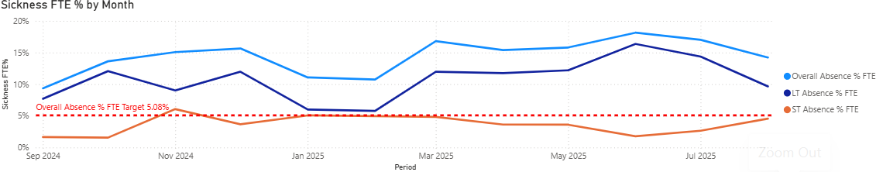
- Over the previous two months (07/25 and 08/25) absence rates are higher than the projected (forecasted) in month absence rates (see graph below).
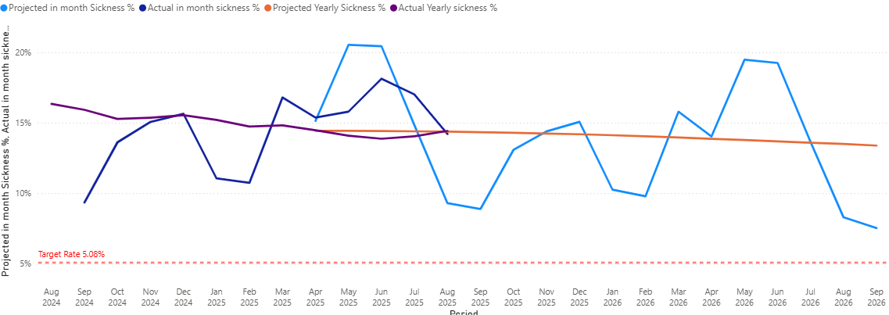
Registered Midwives
- Overall, absence levels over the last 12 months have fluctuated between a peak of 9.60% (12/24) and 6.20% (05/25). Absence levels remain high with current absence rates increasing to 8.48% as at 08/25.
- Between 07/25 and 08/25 most absences were attributed to anxiety, stress and depression (non-work related).
- As at 08/08/25 17 Midwives were absent. Since this date one Midwife has left employment in the Health Board, 10 have returned to work and six remain absent and are being managed in line with the Managing Attendance at Work Policy.

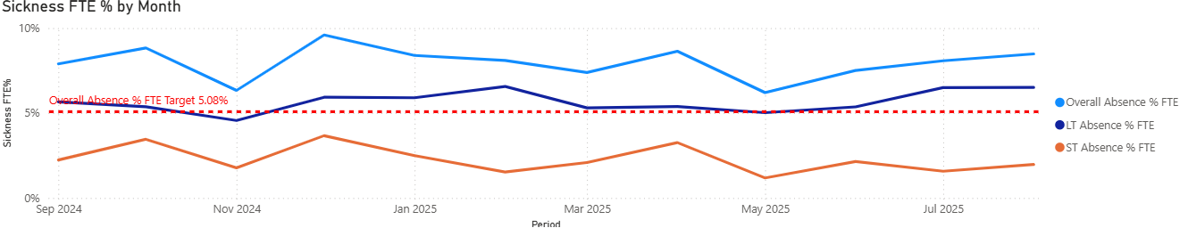

- In month sickness absence rates were below the projected (forecasted rates) for 05/25 and 06/25, however the 07/25 and 08/25 in month rates exceeded the projected (forecasted) rate.

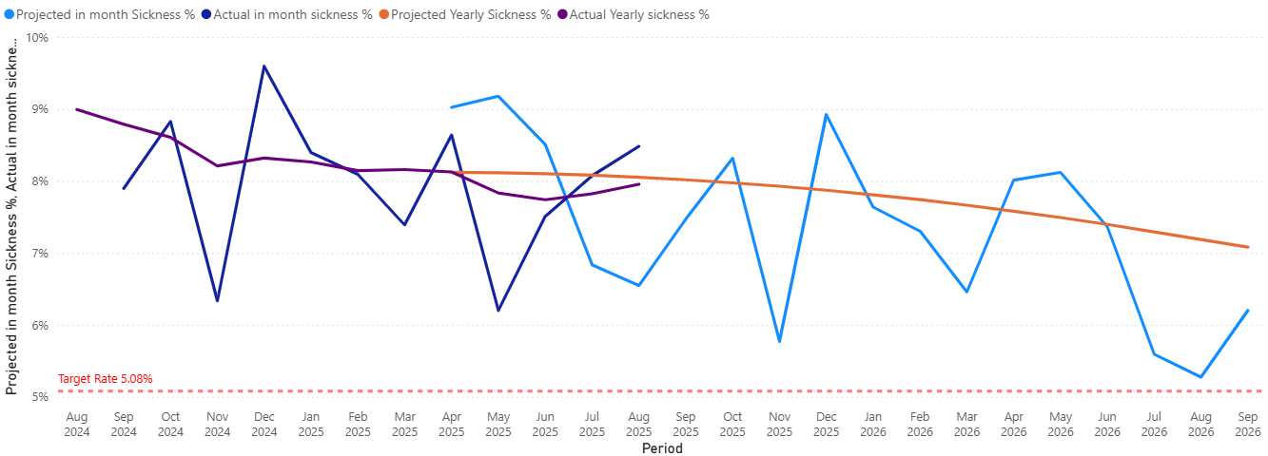

Hotspot Improvement Plan

- Ward 20 is currently identified as a Health Board ‘Sickness Hotspot’ area and as a result the Ward 20 Sickness Improvement plan is being monitored via the UHBs Recovery and Sustainability Board and monthly Performance Reviews.
- The overarching sickness improvement plan (which includes improvement actions for Ward 20) for Maternity Services is monitored within the Division via the Divisional Meetings, Monthly Workforce Group.

4.0 WORKFORCE UNAVAILABILITY

The following diagram demonstrates the improvement in workforce unavailability since 2021.

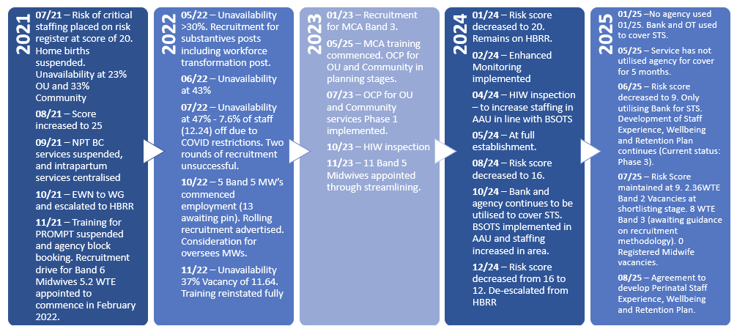

The following diagram illustrates how the perinatal service effectively manage the impact of staff unavailability across the service.
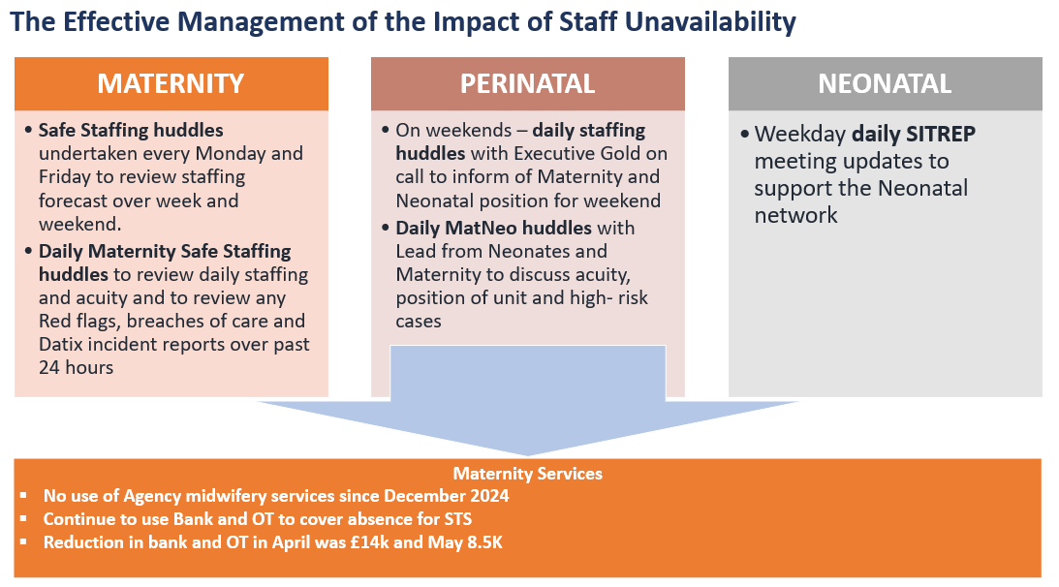

5.0 CURRENT ABSENCE IMPROVEMENT ACTIONS

Following the presentation of the previous report in the April 2025 Workforce and OD Committee meeting, the service has continued to make progress with the additional actions that support the implementation of the Sickness Management Improvement plan.

The progress against each of these actions is detailed below:

Ref | Improvement Action | Timescales | Improve-ment Measures | Responsible Person | Progress
1.0 | Develop Sickness Management Improvement Plan / Monitoring and Evaluation arrangements | 11/24 – 12/24 | Workforce KPIs / Staff Feedback / Quality KPIs / Birthrate+ compliance | Head of Midwifery | Completed
2.0 | Implementation of Sickness Management Improvement Plan / Monitoring and Evaluation | From 02/25 | Workforce KPIs / Staff Feedback / Quality KPIs / Birthrate+ compliance | Head of Midwifery | Completed / Ongoing
3.0 | Weekly open staff sessions | Weekly | Workforce KPIs / Quality KPIs | Head of Midwifery | Completed.  Sessions have now ceased.
4.0 | MatNeo Staff Feedback Newsletter (Quarterly) | Quarterly | Workforce KPIs / Quality KPIs | Clinical Director of Midwifery | Pending  Revising approach to ensure it now moves to a Perinatal focus.
5.0 | Guardian Service Visits (planned by Guardian Service) | On going | Guardian Report | Head of Midwifery | Completed / Ongoing
6.0 | Guardian Service Feedback | Monthly | Guardian Report | Clinical Director of Midwifery | Completed / Ongoing
7.0 | RCM Caring for you Charter | On going | Workforce KPIs / Quality KPIs | Head of Midwifery | Completed / Ongoing
8.0 | Develop Staff Experience, Wellbeing and Retention Plan | 10/25 | Workforce KPIs / Quality KPIs | Head of Midwifery | Pending  Revising approach to develop one plan for the Perinatal service.
9.0 | Implementation of Staff Experience, Wellbeing and Retention Plan | 04/25 | Workforce KPIs / Quality KPIs | Head of Midwifery | Pending  Revising approach to develop one plan for the Perinatal service.
10.0 | Sickness Absence Summit Meetings | On going | Workforce KPIs / Birthrate+ compliance | Head of Midwifery | Completed / Ongoing
11.0 | Sickness Absence Audit Recommendations - Immediate Action Plan (1.1-1.7) | 12/24  7/7 specific actions completed. | Workforce KPIs / Quality KPIs | Head of Midwifery | Completed
12.0 | Follow up Sickness Management Audit and subsequent review of recommendation | 03/25 | Workforce KPIs / Birthrate+ compliance | Head of Midwifery / HR Business Partner Team | On track  Re-audit report received 08/25. Further improvements were noted. Out of 16 controls, 15 were reported as being fully complete and 1 moderately complete.
13.0 | Implementation of the Leadership Development Plan  MatNeo Gold approved the proposal 01/25 | 03/25 – 03/26 | Workforce KPIs / Staff Feedback / Quality KPIs | Associate Service Group Director – Children, Young People and Women’s Health | Delayed  This delay is due to the Health Board being provided with an opportunity to partner with HEIW to access support from Professor Michael West to enhance the current Development Plan.
14.0 | Formal 6-month review of the Sickness Management Improvement Plan | 08/25 – 09/25 | Workforce KPIs / Staff Feedback / Quality KPIs | Head of Midwifery / HR Business Partner Team | On track
15.0 | Sharing of Learning outcomes to benefit other services within the Health Board | 07/25 – 01/26 | Workforce KPIs / Staff Feedback / Quality KPIs | Head of Midwifery / HR Business Partner Team | On track

- GOVERNANCE AND RISK ISSUES

The Sickness Management Improvement Plan will be monitored and evaluated through the Division’s monthly Workforce Group.

From a risk perspective the impact of unavailability and specifically sickness limits can impact on service delivery.

- FINANCIAL IMPLICATIONS

High absence levels could result in variable pay usage to maintain service capacity and safeguard patient and service user care.

- RECOMMENDATION

Members are asked to:

- ACKNOWLEDGE the progress the Service Group continues to take to address the findings of the deep dive sickness exercise to improve the management or sickness absence and support employee wellbeing across Maternity Services.
- BE ASSURED of progress against the action plan.
Governance and Assurance

Link to Enabling Objectives  (please choose) | Supporting better health and wellbeing by actively promoting and empowering people to live well in resilient communities
Link to Enabling Objectives  (please choose) | Partnerships for Improving Health and Wellbeing |  | ☐
Link to Enabling Objectives  (please choose) | Co-Production and Health Literacy |  | ☐
Link to Enabling Objectives  (please choose) | Digitally Enabled Health and Wellbeing |  | ☐
Link to Enabling Objectives  (please choose) | Deliver better care through excellent health and care services achieving the outcomes that matter most to people
Link to Enabling Objectives  (please choose) | Best Value Outcomes and High Quality Care |  | ☐
Link to Enabling Objectives  (please choose) | Partnerships for Care |  | ☐
Link to Enabling Objectives  (please choose) | Excellent Staff |  | ☐
Link to Enabling Objectives  (please choose) | Digitally Enabled Care |  | ☐
Link to Enabling Objectives  (please choose) | Outstanding Research, Innovation, Education and Learning |  | ☐
Health and Care Standards
(please choose) | Staying Healthy |  | ☐
(please choose) | Safe Care |  | ☐
(please choose) | Effective Care |  | ☐
(please choose) | Dignified Care |  | ☐
(please choose) | Timely Care |  | ☐
(please choose) | Individual Care |  | ☐
(please choose) | Staff and Resources |  | ☐
Quality, Safety and Patient Experience
Staff health and wellbeing has an impact on staff engagement and experience, and this in turn enables organisational productivity, individual performance and ultimately the quality of patient care and outcomes across the Maternity Service.
Financial Implications
High absence levels will result in variable pay usage in order to maintain the services capacity and safeguard patient care.
Legal Implications (including equality and diversity assessment)
Actions included in the improvement plan will be required to comply with employment legislation.
Staffing Implications
The improvement plan should contribute to improved employee availability and have a positive impact on staff health and wellbeing.
Long Term Implications (including the impact of the Well-being of Future Generations (Wales) Act 2015)
Developing and retaining a specialist workforce is a key objective of the Health Board and is a fundamental principle of the One Bay Way.
Improving population health is a key objective of the Health Board and the maternity workforce plays a critical role in influencing the wellbeing of future generations.
Report History |  | Previous report was presented at Workforce and OD Committee in April 2025.
Appendices |  | N/A

