

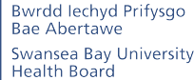

A Healthier Swansea Bay
Swansea Bay UHB Organisational Strategy

Foreword
We are pleased to present the organisational strategy for Swansea Bay University Health Board. This strategy describes our commitment to building a healthier future for everyone in our communities, a future
where people live well and age well, supported by high-quality care that is compassionate, equitable, and delivered close to home.

Our vision is clear: a healthier Swansea Bay where individuals enjoy longer, happier, and more independent lives, with access to the care they need when they need it most.

This vision guides every decision we make and every service we design. But achieving it requires more than just healthcare, it demands a system that prioritises prevention, early intervention and a deep understanding of the social, economic, and environmental factors that shape health.
Our mission, Better Health, Better Care, Better Lives, reflects this holistic approach. We are committed not only to treating illness, but to support wellbeing throughout peoples’ lives. By working with our communities and partners, we seek to tackle health inequalities, empower people to make informed choices, and foster environments where everyone can thrive physically, mentally, and socially.
This strategy is grounded in the principles of the Wellbeing of Future Generations (Wales) Act 2015. We are determined to act today for a better tomorrow, promoting sustainable, long-term wellbeing for both current and future generations. The Act strengthens our resolve to think long-term, work collaboratively, and focus on prevention as we design services that are inclusive and resilient.
The foundation of this work lies in our values:
- Caring for each other, where kindness and dignity shape every interaction.
- Working together, where openness, respect, and partnership guide how we engage with patients, families,
staff, and communities; and
- Always improving, where safety, professionalism, and learning drive us to be the best we can be.
This strategy charts a course for transformation. We will shift care closer to home, redesign services with people and communities, and harness digital innovation and research to improve outcomes. We will strengthen prevention and early intervention, ensuring that care is proactive rather than reactive. And we will build a culture that supports our workforce, embraces continuous improvement, and drives quality and safety in everything we do.
Our Strategic Objectives to deliver this are:
- People of Swansea Bay live healthier, fairer and more prosperous lives.
- Care is high quality, safe, efficient and delivers the best possible outcomes for people.
- Care is delivered in partnership with our communities in safe and appropriate settings, supported by innovative digital solutions, research, development and innovation.
- The Health Board is a great place to work where all staff feel valued and work together towards a common goal.
- The Health Board is a resilient, sustainable and responsible Organisation.
None of this will be easy. The challenges ahead are significant: rising demand, workforce pressures, persistent inequalities, and financial constraints. Yet, we are confident that by working together with our colleagues, patients, partners, and communities we can build a system that is resilient, inclusive, and fit for the future.
Together, we will make Swansea Bay a place where better health, better care, and better lives are not just
aspirations — but realities for all.

About our Health Board
The Health Board has responsibility for assessing the health needs of our population in Swansea and Neath Port Talbot local authorities and then commissioning, planning and delivering healthcare for those
people. We also have a joint responsibility for improving the health and wellbeing of our diverse communities.

Our population – some key facts
This data is for 2024-25.




401,550
patients registered with a practice
in SBUHB
23.2%
of children in SBUHB are living in
poverty

14%
Just under 1 in 6 children aged four in SBUHB aren’t up to date with their vaccines



Life expectancy
Female
81.6 years

Male
77 years

Gap in life expectancy
Most deprived versus least
deprived (years)

7.4
years

20.2
healthy years

10
years

Ageing population

13%
The number of people
aged 75+ in SBUHB is
projected to increase from around
40,800 in 2025 to around 46,300 in
2035, a growth of 13%.
Over the last 20 years the proportion of the SBUHB population aged 65+ has increased from 18% to 21%, while the proportion of
the population that is traditionally working age (aged 16-64) has decreased from 64% to 62%.

Employment
4.3% / 6.4%

4.3% of 16+ years old in Swansea, and 6.4% of those in NPT, are long-term unemployed
Behaviours


14%
of adults currently smoke

16%
of adults drink above the guidelines

64%
of working age adults are not a healthy weight


Diversity

9% / 3%
9% of the population in Swansea and 3% in NPT are from a non-white ethnic group

9% /4%

Female

16.4
healthy years
Male
9% of the population in Swansea


and 4% in NPT were born outside the UK

Health inequalities
There are persistent inequalities in SBUHB, linked to differing experiences of the wider determinants of health (such as education, housing and income) throughout life.

5% / 1%
5% of the population in Swansea’s first language and 1% of the population in NPT’s first language is not English










Our services
In a single year across the Health Board there are:
78,157
ED attendances
53,720
MIU attendances
630,991
Outpatient appointments
138,315
Diagnostic procedures
30,178
Inpatient and daycase procedures
283,416
District nursing visits
60,746
Common Ailments Scheme Consultations
127,905
Eye care examinations
19,763
Calls to 111 press 2
9,303
Referrals to local mental health services
2,170,000
GMS consultations
786,782
GMS consultations were urgent or acute
161,840
Referrals from primary care
33,063
Urgent dental care appointments
4,100
Psychological therapy referrals
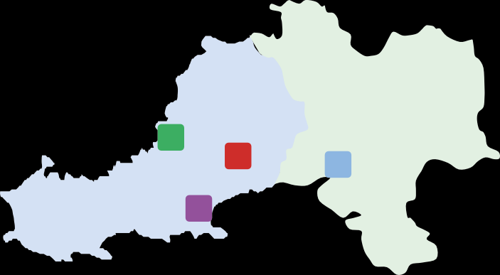








In addition to serving our Swansea Bay population, we also provide a range of specialist and tertiary services for a much larger population across South Wales, and in the case of burns and plastics services we provide service to South Wales and South-West England. We also host the Major Trauma and Spinal Networks on behalf of the South Wales Health Boards and the Emergency Medical Retrieval Service (EMRTS) on behalf of all health boards. Our joint work with Hywel Dda, formalised in our joint committee, now provides us with the opportunity to plan and deliver services together for a total population of nearly one million people.
Services across our region:
44
GP practices
H1 Morriston Hospital

H2 Singleton Hospital

H3 Neath Port Talbot Hospital
H4 Gorseinon Hospital
Swansea
Neath Port Talbot
90
Community pharmacies
H4
H1
H3
63
Dental practices
H2
32
Optometry practices


Our people
Headcount
We are a teaching and research-active Health Board – working closely with our partners in Swansea University and local colleges to train the next generation and to contribute to finding solutions to the healthcare challenges we face today. Our workforce is diverse and reflects the broad make-up of our communities across Swansea Bay.
Many colleagues live in our area – so the services we provide are for them, their families and friends.

Age profile

2,500

2,000

1,500

1,000

500

0
<=20 21-25 26-30 31-35 36-40 41-45 46-50 51-55 56-60 61-65 66-70 >=71

Age

Members of staff
14,649
Gender
77%
23%
Female Male
Staff Group
32.7%
7.2%
2.7%
7.8%
7.7%
18.2%
19.9%
3.4%
Nursing and Midwifery Registered 4,795
Medical and Dental 1,061
Healthcare Scientists 402
Estates and Ancillary 1,152
Allied Health Professionals 1,136
Administrative and Clerical 2,673
Additional Clinical Services 2,923
Add Prof Scientific and Technic 507


Our finances





Expenditure on primary healthcare services:
£227,549,000
Capital Resource Allocation
£53,964,000
Expenditure on healthcare from other providers:
£335,625,000
Revenue Resource Allocation:
£1,375,303,000
Expenditure on hospital and community health services:
£1,178,189,000
Gross Operating Costs:
£1,741,363,000

Figures relate to end of year position 2024-25


What is the purpose of this organisational strategy?
This document provides the strategic context and planning framework for all of our plans as a Health Board and as a partner in the wider health and care system for our communities. Through meaningful engagement with our communities, colleagues and system partners, we will plan and organise our services to deliver the ambitions described in the strategy.

Vision
Aspirational statement of
what we want to achieve
Mission
A concise statement that outlines
how we achieve our vision
Strategic
indicators
Values
The core principles that guide and
direct our organisational culture
Organisational standards
System
measures
Our One Bay Way sets out the ways
we must work to drive change
Strategic objectives
What we want to achieve
for our population
Strategic plans/portfolios
What we need to do to achieve our
Strategic Objectives (5 years)
Process
measures
IMTP
Our medium term
actions (3 years)
Operational delivery plans
Our immediate operational
actions (1 year)
Single improvement methodology
A consistent approach
to improvement

7 Swansea Bay University Health Board

The four ways we can make a difference
Our Health Board’s influence goes well beyond the walls of our hospitals. To truly achieve a healthier Swansea Bay we must think holistically about the many roles we play in the community. Health is shaped not just by the care people receive, but by the environment they live in, the opportunities they have, and the support networks around them.
By embracing this broader perspective, we can unlock new ways to create positive change and contribute to a healthier, more equitable region. This means recognising the diverse ways in which we impact lives not only as providers of care but also as a major employer, a key economic player, and a collaborative partner within the wider system.
It is through this multifaceted approach that we will make the greatest difference; building healthier communities,
stronger economies, and more connected services.
Below are the four dimensions where the Health Board has the power to make a difference for the benefit of all Swansea Bay residents.




As a healthcare provider
We directly influence health outcomes by delivering safe, effective, and
compassionate care. Our services support individuals at every stage of life, improving quality of life and reducing health inequalities.

As a major local organisation (anchor institution)
Our influence stretches beyond health care. We impact economic stability, community wellbeing, and social progress through responsible stewardship of resources and active engagement in local development.

As an employer
We play a critical role in the local economy, employing over 14,000 people. We are committed to creating a supportive, inclusive, and healthy working environment where our staff can thrive and contribute their best.

As a productive partner
We collaborate closely with a wide range of organisations, public bodies, and communities to deliver integrated, person-centred solutions.

Our vision
At Swansea Bay University Health Board, our vision is to create
a healthier future for everyone in our communities where people live well and age well. We envision a future where everyone enjoys longer, healthier, and happier lives, where people are supported
to remain active and independent for as long as possible and access high-quality care when they need it most.
Our ambition is to create a wellness-focused system that prioritises prevention, early intervention, and anticipates health needs. Care will be delivered as close to home as possible, reducing reliance on hospital services and enabling faster recovery when hospital care is necessary. We are committed to delivering seamless, equitable, and person-centred care that responds to what matters most to individuals and their families. Through strong partnerships with patients, communities, and stakeholders, we will tackle health inequalities and empower people to take control of their wellbeing.
We are committed to fostering a culture of continuous improvement, innovation, and inclusion where staff feel valued, supported, and inspired to deliver their best. Through research, education, and collaboration we will shape a smarter, more sustainable health service that is fit for the future. We will make responsible decisions that prioritise environmental sustainability, financial integrity, and social responsibility. We will embrace digital transformation, harness technology, and redesign services to meet the changing needs of our population ensuring care is safe, effective, and equitable.
Rooted in compassion and driven by excellence, we are working together toward a future where the Health Board is recognised as a leading example of compassionate, forward-thinking healthcare and Swansea Bay is a place where everyone has the opportunity to thrive.



Our mission
Our mission is simple yet powerful: to deliver better health, better care and better lives for the people we serve. This means helping individuals, families, and communities to live healthier, more fulfilling lives, preventing illness where we can and treating it swiftly, safely, and compassionately when we must.

Better Health means focusing on prevention, education, and early intervention. We work alongside our partners and communities
to tackle the root causes of poor health supporting people to make informed choices, promoting mental wellbeing, and reducing health inequalities.
Better Care is about putting people at the heart of everything we do. We aim to deliver safe, timely, and personalised care
As a Health Board, we recognise that our direct influence on people’s overall health, wellbeing, and quality of life is limited. Many of the factors that shape health outcomes such as housing, income, education,
and social connections sit beyond the boundaries of health services. Our strategy therefore focuses on the areas where we can make the most direct and meaningful impact, including the quality, accessibility, and effectiveness of care. However, we remain mindful of the wider determinants of population health and wellbeing.
We will use broader indicators such as the three below to inform our priorities, strengthen partnerships, and advocate for collective action that supports healthier lives and communities.

which reflects what matters most for each individual. Whether
at home, in the community, or in hospital, we strive to ensure every patient experience is
grounded in dignity, respect, and
excellence.
Better Lives reflects our wider commitment to supporting wellbeing beyond healthcare. By collaborating with social care, education, housing, and voluntary sectors, we aim to create the conditions where people can thrive physically, mentally, and socially.
Together, this mission drives every decision we make, as we build a stronger, healthier and more equitable Swansea Bay.
Better
Health

Better Care

Better Lives
Life expectancy at birth
Why is this important?
Measuring life expectancy is important because it provides a key indicator of a population’s overall health and wellbeing.

Decrease in premature mortality
(Age 30-70 years) from non-communicable disease (cardiovascular disease, cancer, diabetes and respiratory disease per 100,000 population
Why is this important?
It indicates how effectively preventable deaths are being reduced through public health efforts, early detection, and treatment. It also highlights health system performance, social inequalities.

A smaller gap in healthy life expectancy
- Gap in healthy life expectancy at birth between those living in the least deprived fifth and the most deprived fifth.
Why is this important?
It is the difference between how many years
in good health you can expect to live if you live in the most deprived areas compared to the least deprived. It is a key measure of health inequality in the population.
Females:
81.5 years
Males:
77.3 years

335.7 people
per 100,000

Females:
20.2 years
Males:
16.4 years



10 Swansea Bay University Health Board

Our values
Our values are those things which define our culture. They are the answer to the question: what is important to us? They serve as a reference point for everything we do and how we lead and manage the organisation.






Caring for each other in every human contact, in all of our communities and each of our hospitals.

We are friendly, helpful and attentive. We welcome others with a smile.

We see people as individuals. We do the right thing for every person and treat everyone with dignity and respect.

We are kind, compassionate, patient and empathetic to the needs of others.

Working together as patients, families, carers, staff and communities so that we always put patients first.

We communicate openly and honestly and explain things clearly.

We take time to listen, understand and involve people. We value everyone’s contribution, and we work with
our partners to join things up for people.

We are open to, and act on,
feedback.

We speak up if we are concerned.

Always improving so that we are at our best for every patient and for each other

We keep people safe and provide an efficient and timely service.

We are professional and hold ourselves and each other to account.

We choose a positive attitude, seek out learning and continually develop our skills and services.



11 Swansea Bay University Health Board

Organisational standards – Our One Bay Way
Our One Bay Way sets out the ways we must work to drive change. These standards should inform all that we do from Ward to Board.

How we work is as important as what we do. Our One Bay Way standards guide our culture, shape our decisions, and define the way we deliver care, lead teams, and collaborate across the system.

We are committed to organising ourselves around our patients, not our structures, and to being clinically led, ensuring care is driven by expert knowledge
and compassionate practice. We will empower our workforce, recognising that staff wellbeing directly influences patient outcomes, and we will maintain a relentless focus on performance as a reflection of quality and experience. Our work will be grounded in partnership and system thinking, with services designed and delivered in collaboration. We will also adopt the five ways of working from the Future Generations Act
(long-term thinking, prevention, integration, collaboration and involvement) to ensure that we act sustainably, inclusively and in the best interests of both present and future generations.


We will be a clinically led organisation, guided by a shared philosophy of personalised outcome focused care, that puts patients first in every action and decision we take.

We will work as one system across organisational and professional

boundaries to achieve shared goals.

We will work as one team to co-design solutions, value lived experience and build equity and trust .

We will be responsible for managing our resources wisely.

We will focus on performance improvement recognising the positive impact this will make to quality and patient experience.

We will provide person centred care focusing on what matters most to individuals, tailoring our services to support independence and wellbeing.

We will foster a culture of transparency, accountability and continuous improvement by openly sharing outcomes, challenges and successes.

We will encourage reflective practice using data and feedback

to improve our individual and team performance.


We will take action to be a sustainable organisation reducing our
carbon footprint.
12

We will embed prevention across all services, tackling root causes
of ill health and inequality.

Swansea Bay University Health Board

Our strategic objectives
Our organisational Strategic Objectives reflect the breadth of our responsibilities and describe what we want to achieve for our population as part of attaining a healthier Swansea Bay.

Strategic Objective 1

People of Swansea Bay live healthier, fairer and more prosperous lives

Better health for all
Creating a healthier, fairer, and more prosperous future for the people of Swansea Bay lies at the heart of our strategy. This objective recognises that health and wellbeing are shaped not only by access to healthcare but by a wide range of social, economic, and environmental factors. As a health board, we are committed to working
collaboratively with partners and communities to tackle the root causes of health inequality and to support people across the life course from early years through to older adulthood.
This objective means ensuring that every child has the best start in life, and that all individuals are enabled to realise their full potential and have genuine agency over the decisions that affect their lives. We will advocate for and contribute to fair employment, good work, and a healthy standard of living, recognising their vital role in shaping physical and mental health outcomes.
We are committed to creating healthy, safe and sustainable places through a place-making approach that values community, wellbeing, and the environment. We will also prioritise prevention strengthening our focus on early intervention to reduce avoidable ill-health. At the same time, we will take deliberate action to tackle racism and discrimination, and pursue environmental sustainability hand in hand with health equity. This strategic objective is ambitious, but essential to achieving long-term improvements in the health and prosperity of everyone across Swansea Bay.



Strategic Objective 1

How will we measure success?

Primary Strategic Indicator | Baseline 2025/26 | By 2028 | By 2032
More children are protected from communicable diseases  Percentage of children who are up to date with the scheduled vaccinations by age 5 (‘4 in 1’ preschool booster, the Hib/MenC booster and the second MMR dose)  Why is this important?  Vaccines save lives and reduce hospital admissions. Vaccination is one the most important things we can do to protect children against ill health. | 88%¹ | 90% | >95%
More children are protected from non-communicable disease  Percentage of children receiving the Human Papillomavirus (HPV) vaccination by the age of 15  Why is this important?  Having the HPV vaccine protects against a range of cancers, including cervical cancer. More than 70% of people who haven’t had the vaccine will get HPV at some point in their life. | 86%² | 88% | >90%
Fewer adults are smoking  Percentage of adult smokers who make a quit attempt via  smoking cessation services  Why is this important?  Smoking is a major cause of illness and death. Smokers who make a quit attempt via smoking cessation services are up to three times more likely to quit than trying to quit on their own. | 3.7%³ | 5% | >5%
There are fewer deaths from cancer  Percentage of eligible adults who participate in bowel screening  Why is this important?  Bowel screening reduces the risk of dying from bowel cancer. There is a big gap in the percentage of people taking up the offer between the most deprived and least deprived areas of Swansea Bay. | 62%⁴ | 65% | 70%
- The percentage of children reaching their 5th birthday between 01/01/25 and 31/03/25 who have received all of these vaccines and were resident in Swansea Bay on 31/03/25 (COVER Report 154).
- The percentage of children reaching their 15th birthday between 01/09/24 and 31/08/25 who have received the HPV vaccine and were resident in Swansea Bay on 31/03/25 (COVER Report 154).
- Percentage of estimated smoking population of Swansea Bay who make a quit attempt via smoking cessation services in 2023/24.
- The percentage of eligible adults resident in Swansea Bay who participated in bowel screening in the last 2.5 years as of 01/10/23.

Strategic Objective 2

Care is high quality, safe, efficient and delivers the best possible outcomes for people

Improved patient safety
Delivering consistently high-quality care is a fundamental commitment of the Health Board. This strategic objective sets out our ambition to ensure that every interaction with our services is safe, effective, compassionate, and focused on achieving the best possible outcomes for people wherever and however they receive care.
High-quality care starts with safety. We aim to continually minimise avoidable harm and ensure care is reliably delivered to the highest standards. Our services will be grounded in evidence-based practice, informed by the latest research and clinical guidelines to improve outcomes and promote innovation. We recognise that timeliness matters, so we will strive to ensure people receive the right care, at the right time, from the right person, in the right place.
As demand grows and care becomes more complex, efficiency will be central to ensuring patients receive timely, high-quality care. By streamlining pathways and reducing duplication, we can improve outcomes, minimise delays, and make every interaction count for the people we serve. At the same time, we are committed to ensuring that care is equitable, with fair access and outcomes for all, regardless of background, location, or circumstance.
Above all, we will ensure care is person-centred and delivered with compassion, dignity, and mutual respect. By working in genuine partnership with patients, families, communities, and colleagues, we will co-produce improvements and build a culture that values learning, accountability, and kindness at every level of care.



Strategic Objective 2

How will we measure success?

Primary Strategic indicator | Baseline 2025/26 | By 2028 | By 2032
Elimination of avoidable harm  Number of Never Events and Nationally Reported Incidents (NRI).  Why is this important?  Never events and serious incidents highlight potential weaknesses in how an organisation manages fundamental safety processes. | 5 NRI  1 Never event (May25) | 0 | 0
Avoidable mortality; preventable and treatable mortality
European Age-standardised rate (EASR) per 100,000. | Avoidable: | Best in | Upper
Why is this important?  Understanding preventable mortality (preventing illness from | 306  Treatable: | Wales | quartile in  UK
occurring) and treatable mortality (treating illness to prevent | 105
death) rates is essential for understanding effectiveness of  public health and healthcare delivery e.g. identifies where interventions are needed. | Preventable: 201
 | 2022 data published Dec 2024
Improving access to care
Achievement of nine access targets for both Emergency and | 1/9 | 6/9 | 9/9
Planned Care – Ambulance handover; 4- & 12-hour ED waiting
time; waiting times for outpatient appointments <26 weeks,
Planned Care treatment>36 weeks; Stroke CT scan <1hr;
Diagnostics wait >8weeks; MH assessments <28days; Cancer
treatment <62 days.
Why is this important?
Longer waiting times are significantly associated with a
deterioration in patient outcomes.
Reduction in concerns  Number of formal complaints received.  Why is this important?  Patient feedback provides valuable insights into the quality of care and helps identify areas for improvement. Patient feedback goes beyond clinical outcomes and focuses on the experiences, perceptions, and satisfaction of patients, offering a more holistic view. | 2,697  formal complaints | Year on Year  reduction | Year on Year  reduction

Strategic Objective 3

Care is delivered in partnership with our communities in safe and appropriate settings, supported by innovative digital solutions, research, development and innovation.

Care is delivered in partnership
This strategic objective focuses on delivering care in partnership with communities closer to home, in appropriate, modern settings and enabled by digital innovation, research, and evidence-based development. By redesigning services in collaboration with patients, carers, researchers and partners, we aim to improve access, enhance experience, and deliver better outcomes across Swansea Bay.
Care will be organised around people, not systems; delivered in the most appropriate setting, as close to home as possible, with seamless integration between physical and digital pathways. We will invest in fit-for-purpose environments that are safe, welcoming, and equipped to meet current and future needs. This includes embracing digital technologies, research-driven innovations and data insights to support decision-making, improve clinical outcomes, and enable more proactive, personalised care.
Our ambition is to foster a digitally inclusive and innovation-friendly culture, where patients and staff work together to co-design and adopt solutions that are accessible, evidence-based, and equitable. We want to empower people with the tools and information they need to make meaningful choices about their health and care.
Through where and how care is delivered and by embedding innovation and research into our work, our services will contribute to the environmental, economic, social and cultural wellbeing of Swansea Bay, supporting long-term resilience and sustainability.

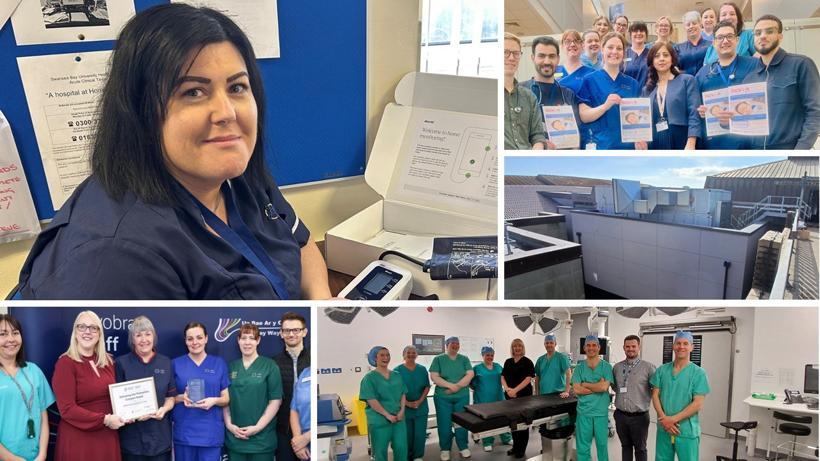

Strategic Objective 3

How will we measure success?

Primary Strategic indicator | Baseline 2025/26 | By 2028 | By 2032
Fit for purpose estates  % reduction of backlog maintenance relative to estates  risk register and strategic priority.  Why is this important?  Fit for purpose environments improve patient safety and operational delivery, enable effective delivery of care and enhance patient experience. | No baseline data available | Year on year  reduction | Year on year reduction
Modern and accessible clinical record  HIMSS Digital maturity assessment outcomes EMRAM (Electronic Medical Record Adoption Model).  Why is this important?  Quick and simple access to all the relevant digital information at the point of care, will enable our clinicians to be more effective, efficient and safe. Improvement in HIMSS EMRAM scoring over the next 10 years signals progressive digital maturity, enabling safer, more efficient, and data-driven care. It also strengthens the Health Board’s position for national alignment, funding opportunities, and readiness for future innovations in integrated digital health systems. | 1 – lowest | 3 | 7
Time to open studies  % set up within 90 days.  Why is this important?  Measuring the time taken to open clinical trials shows a health board’s commitment to research, innovation, and high-quality care. It reflects opportunities for patients to access new treatments, supports evidence-based practice, attracts talent, and strengthens academic partnerships—driving improvements in health outcomes and service development. Health and Care Research Wales have set  a target for studies to be set up within 90 days which is an area for improvement for the Health Board. | 50% | 75% | 85%

Strategic Objective 4

The Health Board is a great place to work where all staff feel valued and work together towards a common goal

A great place to work
Our people are the driving force behind everything we do. Creating a great place to work is not only essential to delivering high-quality care. It is also a moral and organisational priority. This strategic objective sets out our
commitment to building a positive, inclusive, and compassionate working environment where all staff feel valued,
supported, and connected to a shared purpose.
We want all colleagues across Swansea Bay University Health Board to feel engaged, motivated, and healthy, with access to fair rewards, supportive leadership, and opportunities for development. We will foster a culture in which people feel proud to work for us, and where we are consistently seen as an employer of choice.
To meet the needs of today and tomorrow, we are committed to developing a well-planned, skilled and adaptable workforce, supported by robust workforce planning and digital capability. We want our people to feel confident and ready for our digital future and empowered to continuously grow their skills and knowledge.
Leadership at every level will be grounded in our core values and compassionate, collective behaviours, creating the conditions for teams to thrive. We are also resolute in our commitment to diversity and inclusion, ensuring that every voice is heard, respected, and represented. Together, we will shape a workplace where people can do their best work, feel their best selves, and deliver their best care.

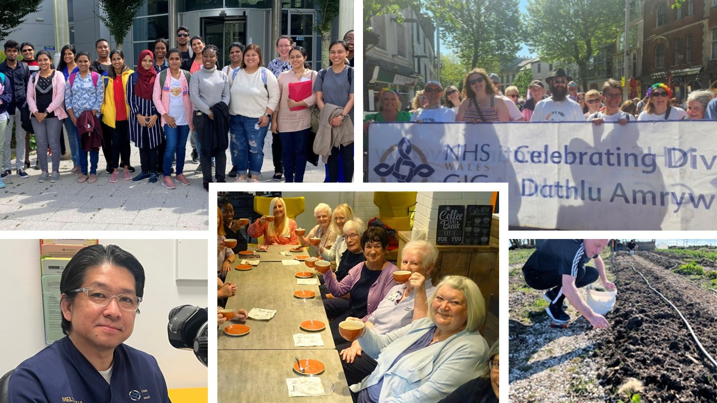


Strategic Objective 4

How will we measure success?

Primary Strategic indicator | Baseline 2024 | By 2028 | By 2032
% Engagement score, reported via the NHS Wales Staff Survey Why is this important?  Our engagement score helps us understand the experiences, opinions, and wellbeing of our workforce, providing insights into working conditions, challenges, and satisfaction levels | 71.2% | >75% | >78%
% NHS Staff Survey respondents that feel their line manager takes effective action to help them with any problems they face  Why is this important?  Staff feeling that their line manager takes effective action leads to better wellbeing, increased job satisfaction, stronger team dynamics, and improved patient care | 65.8%  positive responses | >70% | >75%
% NHS Staff Survey respondents agreeing that the organisation respects individual differences  Why is this important?  Diversity and inclusion help create a workforce that better reflects the community it serves, enhances team performance, improves decision-making, and ensures equitable care for all patients. | 63%  positive responses | >68% | >73%

Strategic Objective 5

The Health Board is a resilient, sustainable and responsible organisation

Use every NHS £ wisely
To deliver high-quality care now and into the future, Swansea Bay University Health Board must be a resilient, financially sustainable and socially responsible organisation. This strategic objective focuses on ensuring we have the capability, capacity and foresight to respond to immediate needs while investing in long-term transformation that benefits our communities and the wider health and care system.
We are committed to achieving and maintaining a financially balanced position that enables us to invest in innovation, service redesign and prevention. Our decisions will be driven by a commitment to both short-term improvements and long-term impact, with a clear focus on using resources efficiently, reducing unwarranted variation, and minimising waste across the system.
We will take proactive steps to reduce the environmental impact of healthcare delivery, playing our part in the broader sustainability goals of Wales and contributing to the health of future generations. Our responsibilities also extend beyond service delivery—we aim to act as an anchor institution, using our assets, influence and partnerships to support local economic, social and environmental wellbeing.
True resilience also depends on how we prepare for uncertainty. We will ensure the Health Board is equipped to plan for and respond to emergencies, and that our communities and staff can adapt to change. Importantly, we will continue to engage citizens meaningfully in decisions, ensuring transparency, trust, and shared ownership of the health and care agenda across Swansea Bay.

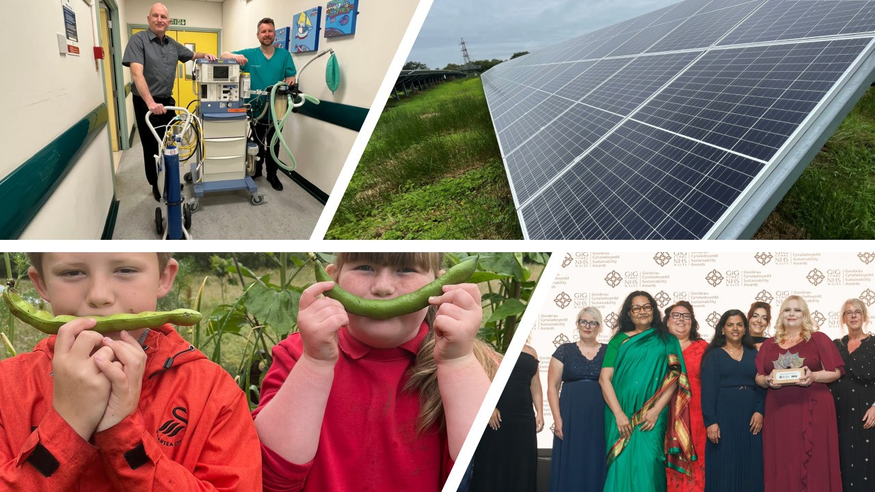

Strategic Objective 5
How will we measure success?

Primary Strategic indicator Baseline By 2028 By 2032 2025/26
Financial position: delivery of financial savings We will improve our financial position and
deliver savings targets to improve our underlying deficit with a plan to achieve financial sustainability through better value and the transformation of services
Why is this important?
The HB has a Statutory Duty to financially balance and managing our money effectively, this means being able to invest in service change, environmental and technical improvements, and improved outcomes
Annual emissions carbon footprint 175,611.67 Reduction Further (tCO2e) reduction
Why is this important?
Reducing carbon emissions is integral to improving public health, reducing health inequalities, ensuring sustainable healthcare delivery, and building resilience in the face of climate change

Our Strategic Plans



















Our strategic plans set out how we will take forward the organisational strategy.

Population Health
Clinical

Strategic Equality Plan We All Belong

Quality, Safety and
Patient Experience

Estates

Community and Engagement

Organisational Strategy

Environment and Sustainability

People

Research and Innovation

Digital

Better health Better care Better lives

GIG

CYMRU

NHS
WALES

Bwrdd lechyd Prifysgol Bae Abertawe
Swansea Bay University Health Board

