
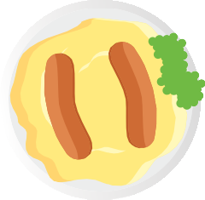
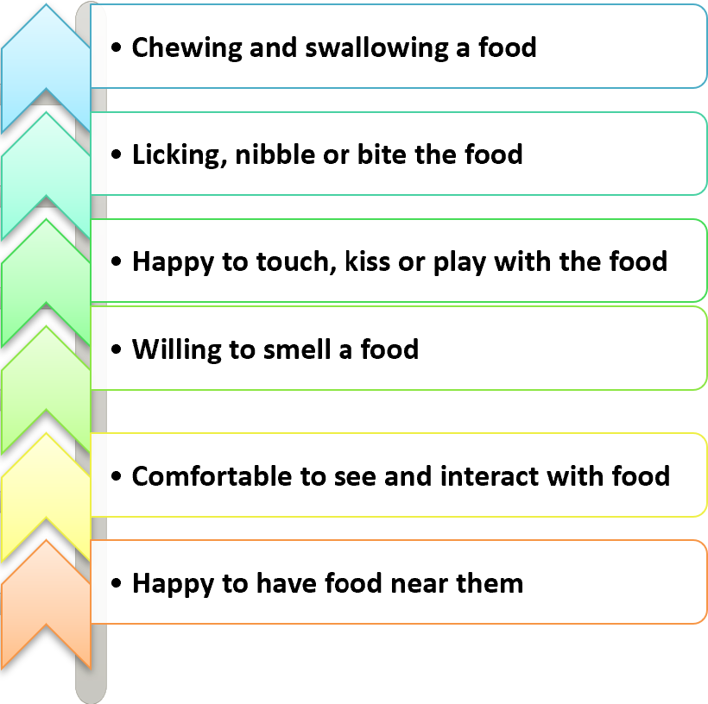
Selective Eating – Approaches to New Foods
Refusing food can be a temporary phase in a child’s development and can be a way for children to express their choices and independence.
It is often a worry for parents if a child eats variable amounts on a
day-to-day basis. For some children, this can be a normal way of eating and shows the child is responding to their body’s signals for regulating their appetite and growth. For other children, they may not have an appetite due to stress or anxiety and may benefit from strategies to help overcome these feelings.
Common challenges with new foods
Stages of acceptance
To accept a new food, often children have to experience the food repeatedly and use their senses to learn about the food. This is known as ‘the stages of acceptance’ and includes;
When speaking with parents, some of the most common challenges around food are;
•
•
•
•
•
‘They will only eat puréed baby food’. ‘They gag with lumps and textures’. ‘They just prefer milk’.
‘They want sweets and treats, not family food’.
‘They say ‘no’ or refuse food based on visual appearance’.
‘They become upset and distressed when new foods are offered’.
•
To move through these stages of acceptance a child will need to have regular experiences of the food over many days, weeks and months. The important aspect of this process is to avoid an expectation that a child has to eat a
food. This will only happen when they are ready to move to that final stage of chewing
and swallowing.


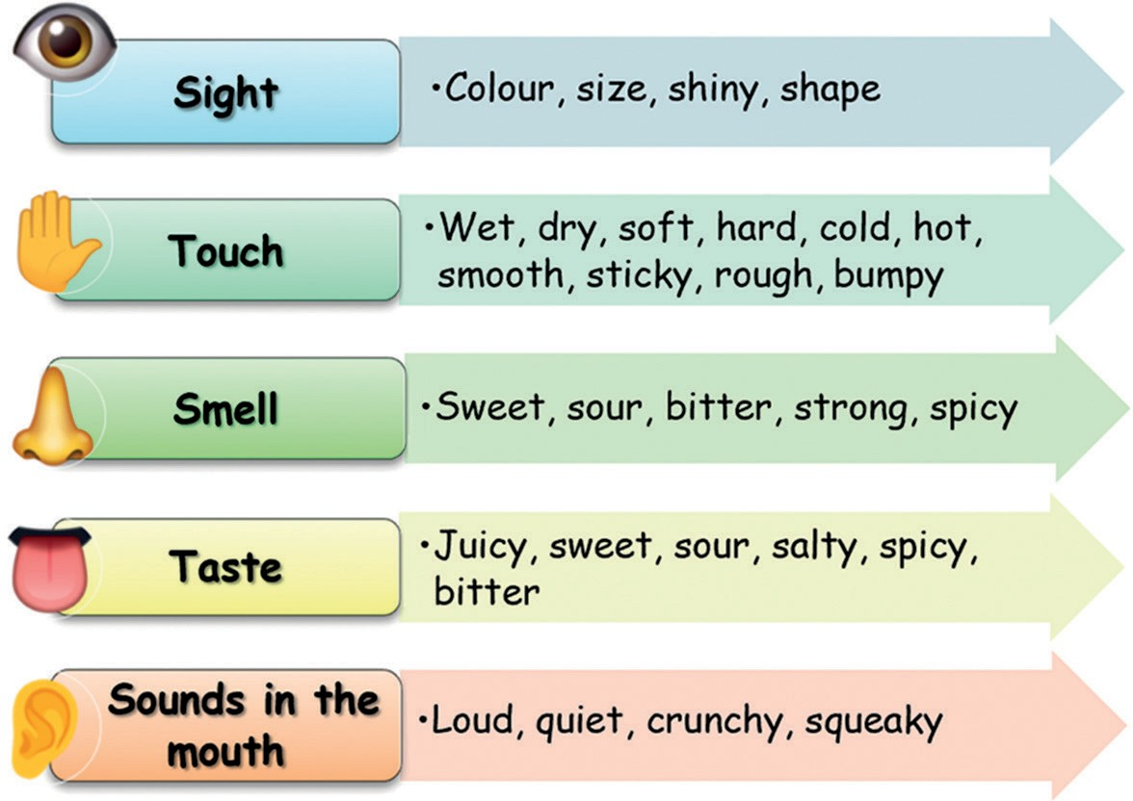
With each new food experience your child will
be using all of their senses to learn about the food and gradually accept it.
Other tips to increase acceptance;
•
Start with a very small portion of the new food alongside familiar foods.
Talk about the foods as you cook and serve them. Describe how it looks, feels, smells and tastes e.g. “this is a round, green pea which pops when I squeeze it”.
Your child may like to serve or feed the food to you to start rather than eat this themselves at first.
Use sauces or condiments your child like as dips
e.g. ketchup, hummus or mayonnaise. This can help your child to feel more comfortable.
If your child likes a particular flavour e.g. garlic try the new food cooked in these flavours.
Similarly, if it is a certain texture your child likes, then try to find new foods with similar textures.
•
Chewing foods
•
It is not uncommon for children to gag or spit out some food as they learn to chew. Examples may be vegetables or meat which has a more unpredictable texture or require more effort to chew before swallowing. Children continue to
develop their chewing skills up to age of 5 years. You may find the below tips helpful;
•
•
•
Begin with softer chewy foods such as fingers of soft cooked sweet potato or carrot, soft mango or very ripe pear.
Bite and dissolve foods can also be helpful as they melt in the mouth when mixed with
saliva and allow children to practice the motion of chewing. Examples include soft crisps (skips, wotsits, pombears or quavers) and chocolate buttons.
Be a positive role model by showing your child how to take small bites, moving the food to the side of the mouth to chew before swallowing.
Encourage your child to bite through the food. Offer drinks alongside meals and snacks.
•
Lumps and textures
Transitioning from smooth to lumpier textures can be tricky process. Some children may also struggle with foods that are mixed textures containing smooth sauce and solids for example
baked beans in a tomato sauce. Some tips to help overcome this include:
•
•
•
•
•
Thicken the food gradually.
Gradually progress from smooth foods to a mashed consistency.
Slowly increase size of the lumps and decrease the amount of mashed food.
Offer a variety of different tastes when offering lumpy foods.
•
•

Developed by: Department of Nutrition and Dietetics, SBU Health Board
Date: February 2024
Review: February 2027
Deciding what food to try next
It is useful to firstly think about a food group that you would like your child to eat more of e.g. vegetables. You can then consider if there are any that are similar foods to ones your child already accepts. In this case, your child may already eat chips therefore, introducing sweet potato chips could be helpful.
A food from a food group that you’d like your child to eat more of
e.g. vegetables.
Sweet potatoes.
A food that matches your child’s food preferences. e.g. crunchy or dry.
A food that has lots of variations on the food currently accepted and that
are easy to change one element at a time. e.g. chips.

