
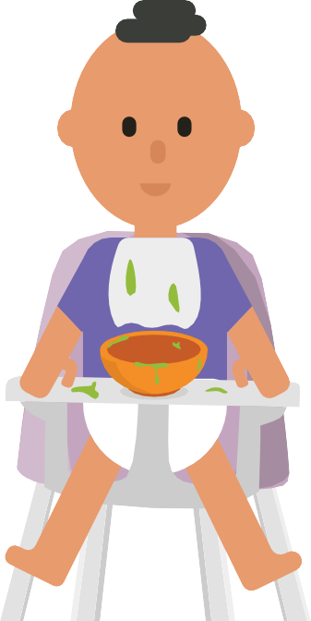
Selective Eating – Building Food Experiences Outside of Mealtimes
Opportunities to develop skills outside of mealtimes through play creates less pressure and allows the child to develop more positive experiences with food. When food play is separate from the child’s meal, children know that they are not expected to taste or eat the food. This gives them confidence and greater willingness to experience the food in other ways.
Activities for children to build food experience:
Messy play
Food exploration / play activities:
•
Give your child daily opportunities to explore different textures and messy play. This helps to build up your child’s knowledge and confidence with touching different textures.
Textures could include non-food as well as food items; dry, grainy, fluffy, rough, wet, slimy, sticky.
Often children are better starting with dry textures that don’t stick to them and over time they start to explore different textures. To help them move onto wet textures give them a jug of water that they can pour onto the dry textures themselves. They can use a spoon or brush to play with the food rather than expecting them to use their fingers
•
To gain knowledge of food, the appearance, texture, and smell, give your child daily opportunities to explore food. This can
be through play and helping with meal preparation.
Helping with gardening or growing food such as growing cress in the kitchen.
Pouring games – have several different sized pots, spoons, jug, scoops and using these
to fill up the pots with different liquids (water/ coloured water/squash) and foods such
as flour, sugar, rice, biscuit crumbs. When your child is happy to touch and explore dry materials and water separately try offering a small jug or bowl of water with something to pour it alongside the dry materials.
Blending Weetabix to make ‘sand’ and add water to make it soggy to make castles.
Dip hands into cooled melted chocolate and make handprints/drawings.
Encourage your child to play with different foods – incorporate it into play activities e.g. Hiding plastic animals, cars, small figures in vegetable peelings/lentils/pasta/rice/flour/jelly/custard.
Helping to place food on a plate to serve, take plates of food to the table, clearing plates away, scraping the food into the bin.
•
•
•
•
- Arts and crafts with and without food – cornflour, dry pasta pictures or necklaces, rice in music makers, potato prints, paint, shaving foam.
- When doing messy play always have something that your child can clean their hands with near them but not in front of them i.e. a damp towel or bowl of water. This often makes them more confident to touch and make mess as they know they
can wash their hands.
•
•
•
•

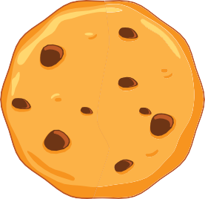
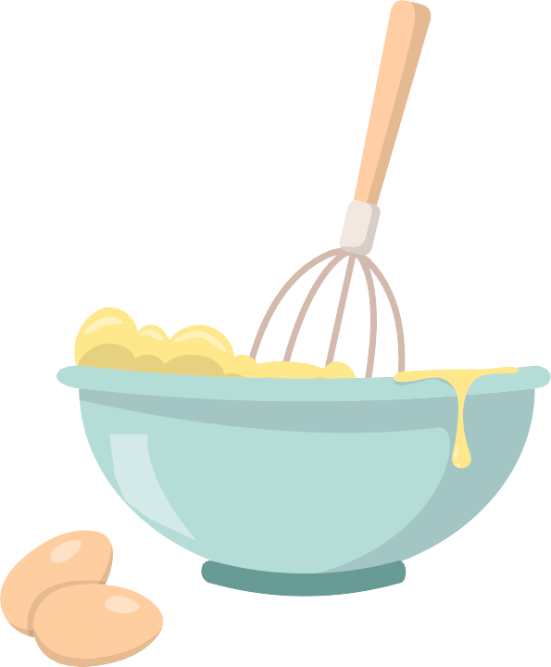
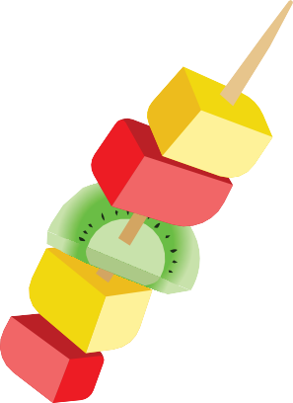
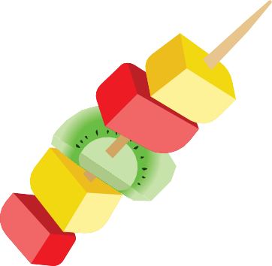
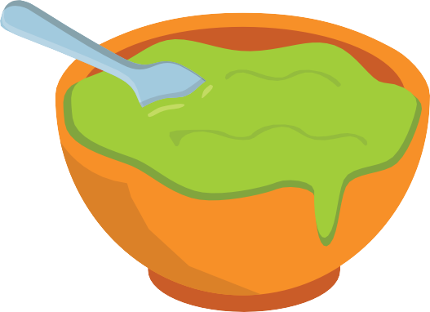
Developed by: Department of Nutrition and Dietetics, SBU Health Board
Date: February 2024
Review: February 2027
Role play
Oral motor play and activities
Playing with pretend food e.g. with a shopping basket/trolley.
Feeding their dolly with pretend food, utensils and cups.
Create a tea party or teddy bears picnic.
Shopping list memory game, jigsaw puzzles and matching food items games.
Giving opportunity to use face and mouth muscles through fun and games. These muscles are important for eating and drinking. Ideas could include: -
•
•
•
•
Blowing bubbles Blowing through straw
Blowing musical instruments
Brushing teeth
Food preparation: Encourage your child to take part in activities
Remember to have fun. When we enjoy activities, we want to do more. At this stage you are exposing your child to the foods through play, so ensure there is no expectation for them to eat it.
•
Buttering crackers or toast and adding other toppings.
Making sandwiches.
Ice and decorate biscuits, cakes, adding sprinkles, chocolate buttons.
Make your own pizza such as grated cheese, sliced mushrooms, slices of meat.
Stir foods that you are preparing
i.e. cake mixture, dips, pasta sauce, curry. Make a milkshake or a smoothie.
Make a fruit salad or fruit kebabs.
•
•
•
•
•
•
When carrying out activities it is important to not expect your child to eat the food, avoid asking your child to try it as this may cause anxiety, instead you can model tasting and eating behaviours.

