
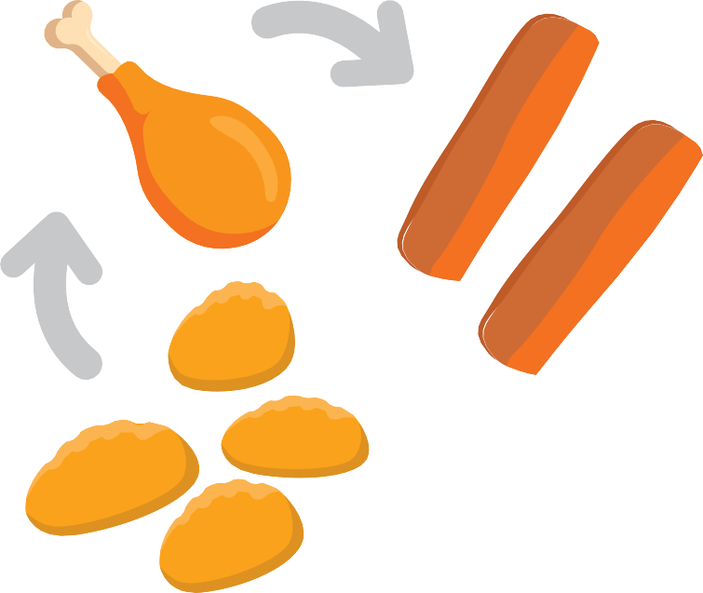
Selective Eating – Food Chaining
Food chaining is an approach to offering new foods which are similar in taste, shape, colour, smell, temperature or texture to those your child prefers.
The new food is offered alongside the foods that they eat, to build their confidence with this food.
If the new food has features similar to foods your child accepts they may be more likely to be willing to explore, touch and eventually taste this new food.
As with all new foods it may take multiple times of experiencing the food before your child may be willing to taste it.
To identify foods that you may want to try it is helpful to think about the sensory properties that are important to your child. Look for a pattern in the foods they will eat and consider the foods similarities (colour, texture, taste, flavour, smell).
Do they have a particular similarity?
Start with Chicken Nuggets.
A different brand of chicken nuggets
Chicken goujon
- Do they like crunchy foods?
- Do they like a certain flavour?
- Do they like a certain shape?
For example, your child may eat chicken nuggets. Every brand is slightly different. They may be breaded or battered, there are different shapes, colours and cooked for different lengths of time.
- Try offering a different brand (alongside the nuggets they prefer).
- Be open and honest when your child questions the food – using phrases such as ‘they are similar nuggets – they have bread crumbs but are a different shape’;
‘these nuggets have a batter coating’.
Over time you may want to build on this further.
A strip of plain chicken
Finish with
Fish nuggets, fish cakes, fingers
Strips of other meat
e.g. fish

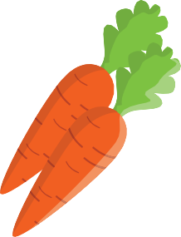

Developed by: Department of Nutrition and Dietetics, SBU Health Board
Date: February 2024
Review: February 2027
Each of these stages may need repeat exposures to provide maximum opportunities to learn about the new food.
Try introducing another fruit/vegetable with a similar colour/texture/shape
Start with A satsuma. Carrot.
Orange bell pepper. Apricot.
Finish with
butternut squash.
Here are some other examples of how food chaining could be used;
Example – child likes square cream crackers.
Start with
Square cream cracker.
A different brand of square cream cracker. A plain circular cracker.
A flavoured circular cracker.
Finish with
A Rich Tea biscuit.
•
Try introducing another brand of square cream cracker, offer them on the same plate or 2 separate plates and allow your child to choose which cracker they want to eat (they will be very similar in taste, shape, colour and texture).
This may lead to offering a round cream cracker (change of shape) which can lead to another round cracker (change of texture and flavour).
This may lead to sweet biscuits, toast, cracker bread.
Food Chaining
•
•
Remember
It is not expected that your child will make changes very quickly but they may make a change at their own pace.
It is very important to give your child time and experience to make changes, be relaxed, don’t pressurise them to tasting food, the aim is to enjoy exploring different foods.

