
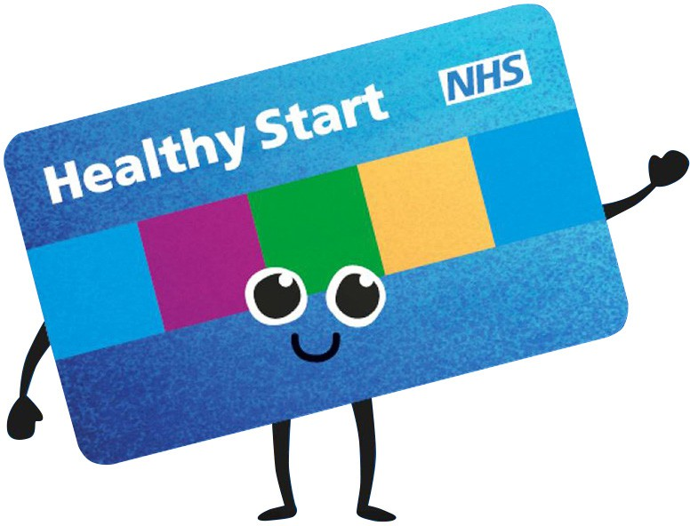
Selective Eating – Multivitamins
When a child is eating a limited range of foods it can be helpful to provide a multivitamin. This leaflet provides information on children’s vitamins and minerals available from the Healthy Start scheme or to purchase over the counter in pharmacies and supermarkets.
The NHS recommends all children aged 6 months to 5 years are given vitamin supplements containing vitamins A, C and D every day who are taking <500ml/17fl.oz formula/day.
Healthy Start
Vitamins available to purchase
If you are entitled to a Healthy Start prepaid card, your child is also entitled to receive free vitamin drops up until their 4th birthday. A daily dose (5 drops) of Healthy Start children’s vitamin drops contains:
- 233 micrograms of vitamin A
- 20 milligrams of vitamin C
- 10 micrograms of vitamin D3
The vitamins are suitable for vegetarians and Halal diets. They are free from milk, egg, gluten, soya and peanut residues.
For more information please visit:
www.healthystart.nhs.uk
There are many types of multivitamins available to purchase:
Drops
Age: Recommended for those aged 3 months to 5 years.
Flavour range: Orange.
Examples: Nature’s Aid Multi Vitamin Drops, Abidec Multivitamin Drops for Babies & Children.
Syrup
Age: Recommended for those aged 1 month to 12 years.
Flavour range: Orange, raspberry,
Examples: Vitabiotics Wellbaby Multi-Vitamin Liquid, Abidec Advanced Multivitamin Syrup Plus Omega 6 & 9, Boots Kids Daily Health Multivitamins.
Chewable
Age: Recommended from 3 years of age. Flavour range: Strawberry.
Examples: Sainsbury’s Kids Chewable Multivitamin & Minerals, Boots Kids Daily Health
A-Z Multivitamin + Minerals, ASDA Kids Chewable Multivitamins & Minerals.

Developed by: Department of Nutrition and Dietetics, SBU Health Board
Date: February 2024
Review: February 2027
Top Tips for choosing a vitamin or mineral for your child:
Gummies
Age: Recommended from 3 years of age.
Flavour range: Strawberry, orange, blackcurrant, and blueberry.
Examples: Boots Kids Daily Health Multivitamins Strawberry Flavour, Chewy Vites Kids Multivitamin Advance (VE), Vitabiotics Wellkid Peppa Pig Multi-Vitamin Strawberry Flavour (VE).
Spray
Age: Recommended from 1 year of age. Flavour range: Raspberry.
Example: Better You Children’s Health Daily Oral Spray.
Sprinkles
Age: Recommended from 6 months of age. Flavourless.
Example: Nutrigen Vitamixin Sprinkles.
VE – Suitable for Vegans.
•
Always select a multivitamin and mineral that is the correct age for your child.
Often you will need to think about the preparation and flavour that your child is most likely to accept.
You may also want to look at the range of vitamins and minerals included in the different preparations and choose the one that will help to meet the nutritional needs of your child.
For example if your child does not drink milk or eat dairy rich foods look for a multivitamin with calcium included. If your child does not include meat or iron rich foods in their diet then a multivitamin with iron included would be helpful.
If they are finding it difficult to take their multivitamin, try including it in an already established routine such as bedtime, or giving it at the same time as other medications.
If they initially refuse their supplement, keep trying as children will often accept it if they see it as part of their routine.
•
•
•
- Always read the label to check the dosage or for any allergens/intolerances your child may have.
Note: All information was correct at the time of publishing.

