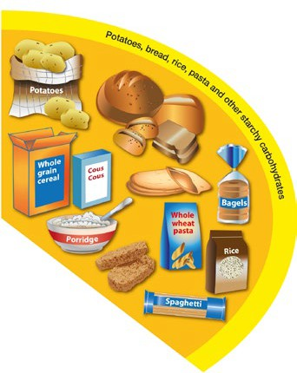
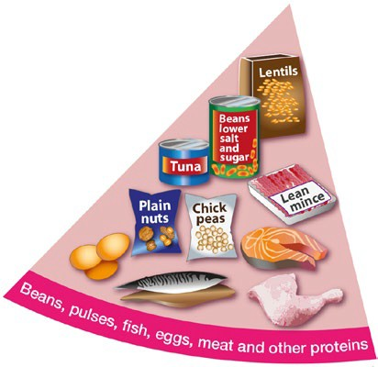

Selective Eating – Supporting Growth and Nutrition
Most children will continue to grow well despite having a limited diet.
The following information provides additional ideas to help maintain healthy growth for children who may eat a more limited diet.
Whilst your child may not eat every food from each food groups below, whenever possible include accepted foods from each of the main food groups at each meal:
Carbohydrates
•
Examples include potatoes, bread, rice, pasta, cereals and crackers.
Many carbohydrate foods contain naturally occurring vitamins and minerals whilst others are fortified with vitamins and minerals when they are processed, for example breakfast cereal and white breads. Try to vary the carbohydrates you offer as each provides different nutrition. For example, each breakfast cereal has different nutritional properties so by varying the cereals you offer your child will get different vitamins and minerals each day.
Consider the texture of these foods when offering them to children. Some children do not like wet food such as mashed potatoes, pasta with sauces or cereal with milk. By offering sauces on the side of pasta or a glass of milk with dried cereal you can provide the same nutrition in the way your child will accept.
•
•
Proteins
•
Examples include, beans, pulses, fish, eggs, meat, and smooth nut butters. Soft fish is often an easier texture to explore too.
Try to offer softer meats. Don’t worry if your child chews and spits these out initially as this will build exposure to the texture and flavour.
Try adding protein foods to sauces, stews or soups.
Compare food labels to see if there are ways to get the most nutrition from the accepted foods, for example if your child likes processed meats such as sausages or nuggets.
Choose the versions with the highest meat content.
•
•
•
If your child doesn’t eat any foods from this group or only a very small amount, consider providing them with an age appropriate multivitamin that contains iron.

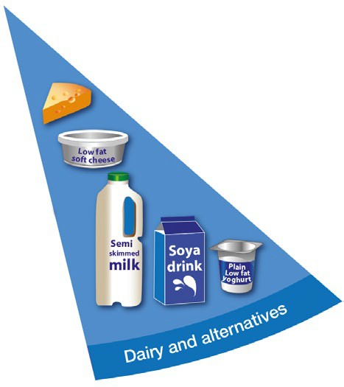
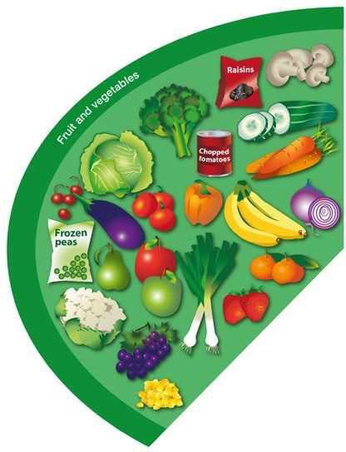
Fruit and/or vegetables
•
•
Fresh, frozen, canned and dried can be included.
Try and think of textures your child prefers – maybe they prefer crunchy textures, therefore opting for raw fruits and vegetables may be beneficial, if their
preferences is soft items try cooked vegetables or soft tinned fruits.
If they don’t like the appearance of bruised fruits then consider chopping these so you avoid offering the discoloured parts.
Some children will accept these foods when blended into smoothies or puréed into soups or sauces.
If you only offer fruits and vegetables in puréed form or from pouches your child will not have the opportunity to learn about the sensory properties of these food and may therefore reject the same fruit or vegetable in its natural form. It is important that children have the chance to explore the colours, textures and feel
of these foods.
•
•
•
If your child struggles with this food group it is worth considering a multivitamin supplement.
Dairy and alternatives
•
These include milk (or non-dairy alternatives like fortified oat milk), cheese, yoghurts, and milky pudding such as custard and rice pudding.
They provide protein and vitamins, and are a particularly important source of calcium.
If your child does not like dairy products (or non-dairy alternatives) do not worry, calcium can also be found in dairy alternative milks, white bread, fortified breakfast cereals, broccoli and green leafy vegetables.
•
•
If you are worried that your child is not having enough calcium, it is worth considering a multivitamin and mineral supplement with calcium included.
Even if your child eats only a couple of foods from each of the above food groups, this will still be contributing valuable nutrition.


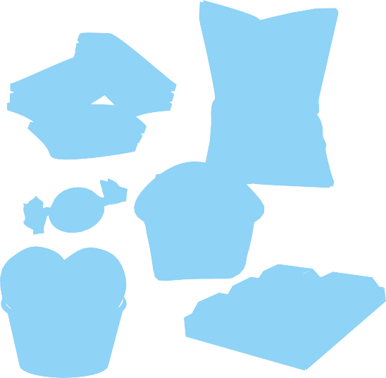























Sweet, crisps, chocolates, biscuits and cakes
The following strategies can help to provide enough vitamins and minerals.
These foods are not needed in our diet and have not been included in the Eatwell Guide. They should only be eaten infrequently and in small amounts. It is important to consider limiting these foods in children’s diets. Often these foods are high in calories but low in other nutrients so your child will feel full up and then may not eat family foods. Some of
these foods will be marketed for children even if they are not healthy choices and often the pack sizes are much larger than would be suitable for children.
•
Offer age-appropriate portion sizes. Offering too much food on a plate can feel overwhelming for some children.
Allow your child to eat their preferred foods to help maintain their weight.
Offer food that your child is confident to eat at each meal – maintain the variety of nutrients by offering as many different accepted foods across the day as possible.
Offer an age-appropriate multivitamin.
Include foods that have been fortified with additional multivitamins such as breakfast cereals, 50:50 or best of both breads.
Maintain regular meal routines – offer 3 meals and 2 snacks a day.
Include nutritious snacks from the main food groups such as fruit, cheese or yoghurts rather than crisps and biscuits.
Don’t worry about perceptions of ‘normal’ meals – if you child likes carrots it is fine to serve these alongside any other accepted foods, be it sandwiches, pizza or pasta.
If a child has stopped eating a food they previously accepted – continue to offer it but do this alongside currently accepted foods. We know that previously accepted foods can usually be reintroduced into the diet over time.
Seek advice for any underlying medical issues. For example, if your child is constipated and experiencing tummy pain this may reduce
their appetite.
Allow your child to eat to their appetite and avoid pressure to finish meals.
All food should be treated the same, try to ensure that no foods are more appealing than others.
•
•
•
•
•
i
•
Sauce
•
•
•
•
•
r s
C
s
p

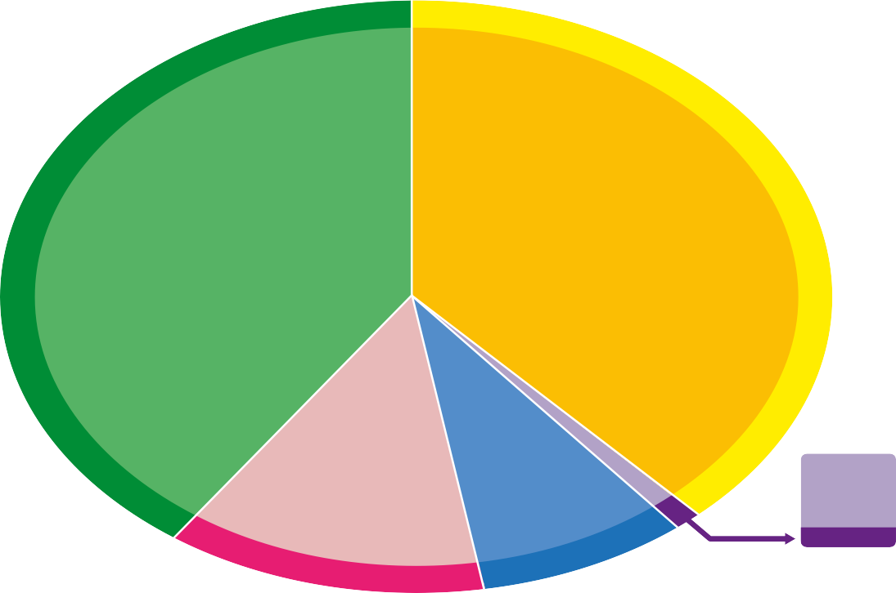



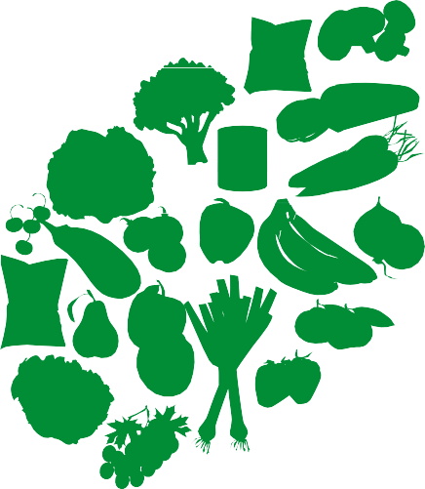

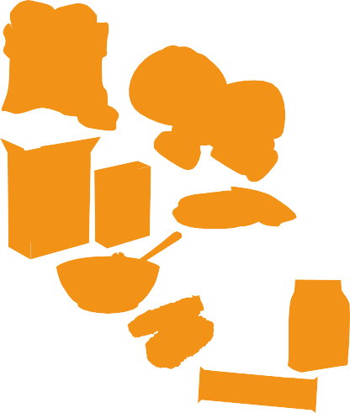
















































































































































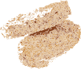












Developed by: Department of Nutrition and Dietetics, SBU Health Board
Date: February 2024
Review: February 2027
When to seek further help
•
If your child is losing weight or experiencing faltering growth.
If you child is coughing when eating and drinking, experiencing breathing difficulties when feeding or a wet gurgly voice.
If they have a diagnosed nutritional deficiency.
If they are experiencing physical symptoms such as constipation, diarrhoea, vomiting or reflux.
•
If they are delayed in achieving development milestones such as sitting up, hand to mouth coordination.
If they are not able to tolerate some variety of food textures by around 18 months of age.
Low energy levels are preventing your child from taking part in usual daily activities.
•
•
•
•
•
Check the label on packaged foods
Each serving (150g) contains
Energy Fat Saturates Sugars Salt
1046kJ 3.0g 1.3g 34g 0.9g
250kcal
LOW LOW HIGH MED
6-8
a day
13% 4% 7% 38% 15%
of an adult’s reference intake
Typical values (as sold) per 100g: 697kJ/ 167kcal
Choose foods lower in fat, salt and sugars
Water, lower fat milk, sugar-free drinks including tea and coffee all count.
Limit fruit juice and/or smoothies to a total of 150ml a day.
t
p
a
g
o e
Whole wheat
r
e
l n
h
u
P
n
C
p
g i
skimmed
milk
i
i
w
Sauce
Oil & spreads
Choose unsaturated oils and use in small amounts
th
of oil
Eat less often and in small amounts
Source: Public Health England in association with the Welsh Government, Food Standards Scotland and the Food Standards Agency in Northern Ireland
© Crown copyright 2016
a o
e
a
pasta
i
w a
u
l
r s
n f
o e
s
y
t
p
r
r
B
o
w
c
e
O
Semi
a
s
is
o
o
a
F
p
l
s
a
T
V
l
o
g
C
d
on
h
P
m
o
n
ti
ic
h
B
t
s
a
or
h
Spaghetti
o
P
L
t
p
w
P
f
a
2
of
o
e
,
e
m
es
n
C
L
,
s
o
t
C
o
gs
ul
,
a
h
g
p
ek
e
o
o
e
d
e
m
os
,
n
w
d
e
t
sh
a
e
s
fi
er
s
w
Po
s,
ns
p
s
ho
t
e
a
e
l
a
ls
h
c
eg
to
u
e
s
o
r
e
p
b
fi
r
ai
s
y
s,
e
p
n
,
an
r
d
o
b
e
o
d
r
re
B
e
n
h
a
m
c
a
i
d
r
g
,
t
u
d
h
r
a
o
er
ic
e
e
E
s
r
fi
,
b
re
p
a
v
s
e
t
r
a
si
a
o
n
n
d
s
o
w
t
it
h
h
e
l
r
e
s
s
t
s
a
r
a
c
d
h
d
y
e
d
c
a
f
r
a
b
t
,
o
s
h
a
y
l
t
d
r
a
a
n
t
e
d
s
s
u
g
ar
E
a
t
a
t
l
e
a
s
t
5
p
o
r
t
i
o
F
n
s
r
u
o
i
f
t
a
a
n
v
a
d
r
ie
v
t
e
y
g
o
e
f
t
f
a
ru
b
i
l
t
e
a
s
n
d
v
eg
e
t
s
a
e
d
bl
iv
n
e
Lean
mince
at
a
s
s
n
t
on
e
r
fa
ti
v
te
r
op
er
al
e
r
y
ow
a
d
nd
l
ug
a
a
se
s
y
Cous
Cous
o
r
ry
ho
e
Whole
grain
cereal
ai
C
w
D
lo
s
e
t
e
t
s
s
y
e
r
Lower fat
spread
in
bl
s
n
g
Rice
a
e
k
e
a
es
d
s
Lentils
s
r
r
a
n
s
c
s
s
t
u
ot
ain
t l
s
o
e
l
d
n
e
f
e
a
ai
t
i
a
Soya
r
st
a
Raisins
e
e
t
z
s
a
t
d
g
n
l
u
h
e
p
drink
a
h
r p
u
. E
Per day 2000kcal 2500kcal = ALL FOOD + ALL DRINKS
Eatwell Guide
Use the Eatwell Guide to help you get a balance of healthier and more sustainable food. It shows how much of what you eat overall should come from each food group.

