
Selective Eating – Creating a Supportive Mealtime Experience
There are a range of principles which are key to family mealtimes being supportive for children. Here we will explore some of these in more detail;
Mealtime routine
Establishing a mealtime routine is really important as it prepares children, allowing them to know when and what to expect from a meal. It also helps stimulate and recognise hunger cues and allows families to set aside time from their busy schedule to eat and drink in a calm and relaxed way. Mealtime routines should be part of daily routines along with cleaning teeth, bathing, dressing, going to nursery or school, reading bedtime stories. Below are some useful tips to help with this;
•
•
•
•
•
•
•
T
•
Being aware of our own relationships with food: Children are able to pick up on signs and signals that we show towards foods.
Labelling foods as ‘good’, ‘bad’, ‘nice’ or ‘yucky’ can result in children developing poor relationships with food.
Remaining calm and relaxed: Children recognise changes in your behaviour and will sense when you become more anxious at mealtimes, and may mirror this behaviour.
Communicating as a family: Talking about things which are not food related at mealtimes such as ‘how was your day?’ or ‘what made you smile today?’ can help to distract your child and create an enjoyable environment for all.
Seeking support from those around: It is important to ask for support from other family members, friends and childcare settings. It can be useful to explain to them what helps and what doesn’t as well as signposting them to useful resources. Ask others to tell you what they observe with your child’s eating.
Recognising the importance of trust: Talk to your child about what new foods will be introduced and where and when this will
happen. This can help the child feel supported and build trust. Don’t hide food within their accepted foods as this can break trust. Allow you child to eat food off your plate.

Pre-mealtime preparation: Preparation activities can often help you and your child have a more positive mealtime experience. In addition, building consistency and a predictable mealtime routine can also increase certainty and reduce anxiety which will in turn allow your child to feel safe in the mealtime environment
•
•
•
•
•
Use a visual chart to display weekly meals and schedules.
Give a 5 minute warning so your child can finish what they are doing and prepare for a meal.
Accompany your child at mealtimes even if you are not eating.
Offer 3 meals per day and 2 snacks, limiting meal times to around 30 minutes and snacks to 15 minutes.
Implement small tasks before eating such as washing hands, setting table and involving them in food preparation. This allows children to become focused and minimise other distractions.
Empowering your child by giving an option of serving themselves. This will give them a sense of control without having too many decisions to make.
Consider the environment where eating takes place. Many children may find noisy environments or bright lights overwhelming and others may benefit from having other distractions such as calming music.


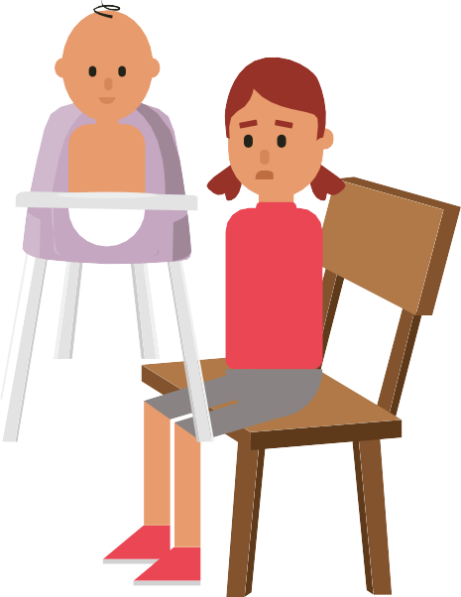




Developed by: Department of Nutrition and Dietetics, SBU Health Board
Date: February 2024
Review: February 2027
- Cool sips of water
- Singing a song
- Take a break from the action
- Take a moment to stop and look at something interesting (also known as mindfulness)
- Squeezing a soft ball or play dough Blowing bubbles
- Go outdoors for some fresh air
- Pre meal preparation
- Predictability
- Familiar mealtime cues
- Calm lighting
- Hand washing
Have a consistent mealtime cue that alerts the child that it is nearly mealtime. It may be useful to use an object of reference such as:
- A favorite plate
- Special cutlery
- A special cushion to put on their chair
- A mealtime song or a specific story before mealtime will relax your child and help them to know that mealtime is due
- Allocate your child a specific chair for them to sit at the table for meals

Signs that your child may be hungry or ready for food include – leaning towards food, opening mouth, licking lips, excitement at the sight of food, appearing focused on the food.
Signs that may tell you your child has eaten enough for their appetite – playing with food, pushing food away, turning
head away when offered a food, closing mouth when food is offered, losing interest in the mealtime, slowing pace of eating, appearing tired.
Strategies to consider
Responsive
feeding
This can be a tool to support responding to your child’s hunger cues and allows your child to eat to appetite by paying attention to fullness cues and ending the meal when your child indicates they have had enough. Children need to eat more regularly through the day as their stomachs are smaller than adults therefore, offering regular meals and snacks is important to ensure your child has enough opportunities to eat.
Regular sleep patterns and physical activity are also important for appetite stimulation.
•
•

