

What is Selective Eating?
Refusing to eat or fussiness around food can be a normal phase of childhood development. For these children, it can be a way for them to express their assertiveness and independence and may be a temporary phase.
Having food preferences is normal but very restrictive eating can cause nutritional and social challenges. We understand that children choosing not to try new foods or eating small amounts of food can be worrying for parents and carers.
Some common signs of selective eating include:
Why can children be selective eaters?
•
•
Only eating a small variety of foods.
Being very specific about the way that a food is presented. For example, not having different foods touching on a plate.
Showing feelings of distress or upset when offered or encouraged to try a new food.
Avoidance of whole food groups in their diet such as fruits and vegetables or dairy foods.
They may have a low interest in food and avoid coming to the table to eat.
They may refuse to eat in unusual environments such as at school, restaurants or friends house.
Refusing a food, they previously ate, because it doesn’t quite look right. For example, the shape, size, texture and taste of fruits and vegetables often vary. A ripe banana will be softer and sweeter and have a yellow colour compared
to an unripe banana which will be firmer, less sweet and greener.
If we try to understand the reasons behind our child’s selective behaviours or reluctance to eat certain foods, we can support them with strategies to gradually overcome this. It is important to consider the possible causes of selective eating but remember that you should never feel any guilt as this is very common in young children.
•
•
Selective eating can be linked to:
•
•
•
•
Being too full from drinks or snacks.
Sensitivities around the smell, touch or appearance of foods.
Difficulties with sitting position or distractions around mealtimes.
Copying the behaviour of other family members who may also be selective eaters.
A negative experience of eating a food for example, vomiting after eating.
Being unwell.
Difficulties with eating skills such as chewing or swallowing.
Some children may have less awareness of feelings such as hunger or thirst and therefore appear less interested at mealtimes.
Difficulties with the use of cutlery and coordinating movement – making your child feel anxious and tired more quickly.
A medical condition that affects their eating.
•
•
•
•
•
•
•
•
•
Showing preference for processed or packaged foods. Often these foods will be more predictable in colour, appearance, taste and texture, therefore more widely accepted.
•

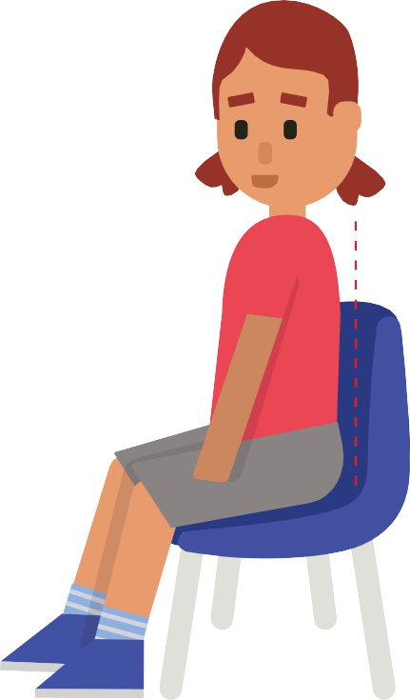
•
•
•
•
•
•
Force feeding or showing frustration when your child does not eat.
Hiding or disguising new foods in foods that they accept and enjoy. This may cause a break of trust and refusal of foods they previously accepted.
Offering an alternative meal if the first option is refused.
Offering too many choices at mealtimes. Offering food-based rewards.
Offering snacks/milk just before a meal as this can lead to feelings of fullness.
Serving large meal portions can be overwhelming.
Giving up on foods that have been refused. It can take children a long time to accept new foods and sometimes this includes very gradual steps such as playing with foods or touching foods before they will taste a food so continue to offer new food choices consistently, even when they have refused
Things to avoid
•
•
•
•
•
•
•
•
•
•
Develop a daily meal and snack routine.
Offer small frequent meals and nutritious snacks. Introduce new foods slowly.
Offer finger foods and opportunities to self-feed. Don’t rush mealtimes.
Eat in a calm and relaxed environment.
Allow children to eat to their appetite.
Make mealtimes fun – include your child in the cooking, preparing and serving of foods.
Provide a chair that allows them to sit upright at the table with their feet on the floor
or on something hard.
Eat together and allow your child to learn from you.
Developed by: Department of Nutrition and Dietetics, SBU Health Board
Date: February 2024
Review: February 2027
Approaches to supporting a child with selective eating
Things to try
Make conversation about the food being eaten; how it feels, tastes or changes when it cooks
•
Ensure all family members are seen to be eating and enjoying a variety of foods as children often model and copy behaviour.
Involve children in food shopping and preparation; putting shopping in trolley or making a sandwich.
Offer meals as a shared plate allowing children to choose what they want and how much they want to eat.
Let them explore foods with their hands; offering finger foods at mealtimes and creating fun activities to explore foods outside of mealtimes.
•
•
•
•
•
Useful Tips
When should I be concerned about selective eating?
•
If your child is losing weight or experiencing faltering growth.
If your child is coughing when eating and drinking, experiencing breathing difficulties when feeding or a wet, gurgly voice.
If they have a diagnosed nutritional deficiency.
If they are experiencing physical symptoms such as constipation, diarrhoea, vomiting or reflux.
If they are delayed in achieving development milestones such as sitting up, hand to mouth coordination.
If they are not able to tolerate some variety of food textures by around 18 months of age.
Low energy levels are preventing your child from taking part in usual daily activities.
•
•
•
•
•
•
If you are concerned, please seek advice from your health visitor or GP.

