Cardiac patients on road to recovery with help from tai chi
Tuesday, 25 April 2017
Recovering from a heart attack may mean major lifestyle changes for patients but it’s not all about diet and the gym - the gentle movements of tai chi have been playing a part too.

Originally a Chinese martial art practised around the world to help benefit health, ABMU’s cardiac rehabilitation team has been using adapted tai chi in a successful trial.

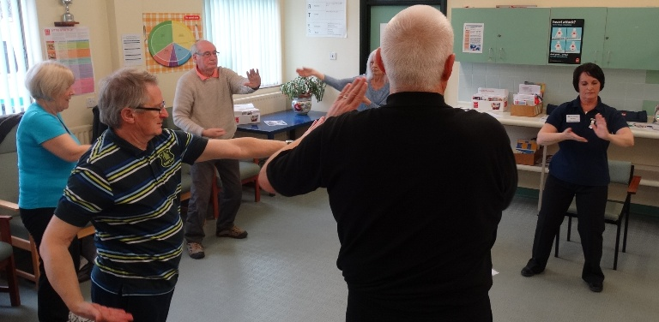As part of their six-week rehab course patients recovering from heart attacks and surgery were invited to attend sessions at Singleton and Morriston hospitals and learn the techniques involved.

Susan Davies, an occupational therapy technician with the cardiac health team, leads the classes: “Tai chi is often called meditation in motion and combines deep breathing and relaxation with slow and gentle movements.”

Clinical nurse specialist Carolyn Cude added: “Patients come to us twice a week for a six-week period. We encourage them to look at lifestyle changes and we help them to start doing regular exercise.

“The recommendation is to do 150 minutes of cardiovascular exercise a week. Tai chi is not cardiovascular exercise but it certainly has other benefits.

“Tai chi is a neuromotor exercise so it helps people with their balance, posture and flexibility. It helps them to feel good and is an additive to the exercise we offer on the programme.”

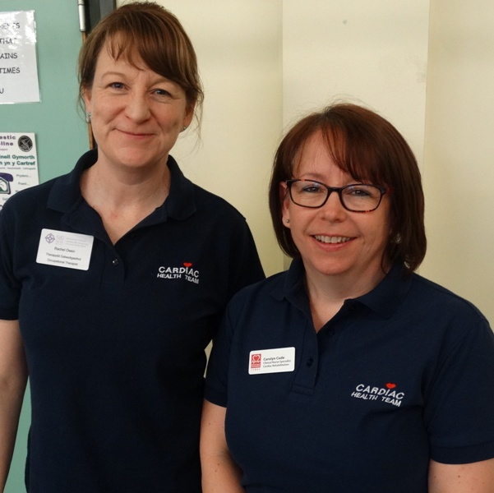
The team, which includes nursing staff and therapists, wanted to introduce an additional form of exercise into the rehab programme and decided to try tai chi.

Occupational therapist Rachel Owen and
clinical nurse specialist Carolyn Cude.

The trial has been so successful that from June it will be incorporated into the programme for patients alongside gym sessions.

Susan, (pictured below leading a class) who had previously taught adapted tai chi while working with the Macmillan therapy team, added: “There are several different styles, we use a modern style called shibashi, which is a set of 18 movements which are easy to learn and we can adapt the movements to meet anyone’s needs.

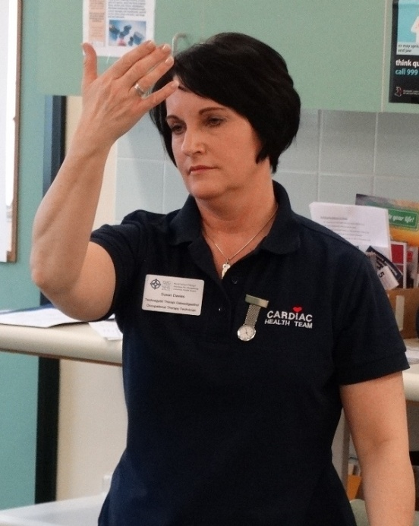
“The delight of tai chi is that anyone can practise it and it is suitable for everyone.”

Cardiac patient Sharon Garry, of Swansea, had never tried anything like tai chi before she began her rehab course but has been so pleased with the results she will be carrying on now her rehab programme is over.

“It’s very focused with relaxing slow movements and it’s harder than you think it’s going to be. It’s good for concentration and working your muscle groups as well.

“I really enjoyed doing the classes, I am so glad the team introduced me to tai chi. I now want to carry on with it so it will continue to help me relaxing and focusing,” she said.

Sharon’s enthusiasm comes as no surprise to senior occupational therapist Rachel Owen who is collecting information to illustrate how it helps patients.

Rachel said: “There is extensive evidence that tai chi movements lower blood pressure and heart rate and improve symptoms of stress and anxiety in the cardiac population.”

She wants to use the information from the patients to demonstrate just how tai chi improves feelings of relaxation and heart rates.

“We not only record their heart rate at the start of each session but also ask them to assess how relaxed they feel. We then ask them to do the same at the end of the class.
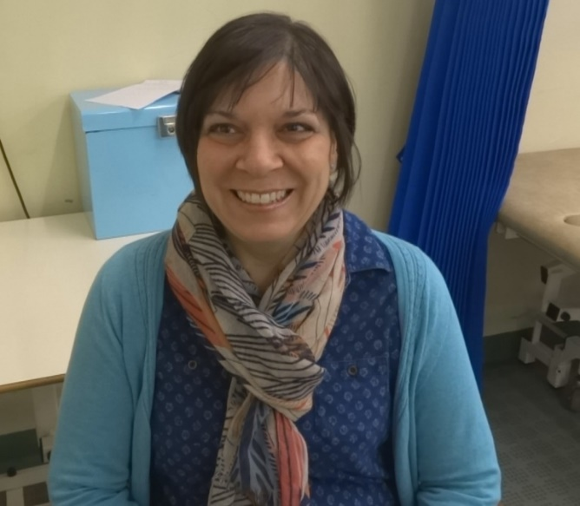
“We have been having a very positive reaction, we know they are really enjoying the classes and many are so motivated they want to carry on with tai chi after the course.”

Cardiac patient Sharon Garry says she now plans to continue with tai chi after enjoying her sessions during her rehab course.

https://www.youtube.com/watch?v=8xp3Cs9Ji_Y

Source: Abertawe Bro Morgannwg University Health Board

