Family’s fundraiser for neonatal unit in memory of baby son
Thursday, 27 April 2017
A brave mum whose baby son survived for just two hours after being born four months prematurely has returned to Singleton Hospital to thank staff who looked after him.

Lisa Penhale brought with her a bumper cheque for £1,650 to support the work of the neonatal unit which treated little James Leonard Maddick.

Following his death last July Lisa and her partner Chris Maddick, from Bonymaen in Swansea, devoted themselves to doing all they could to raise money for the unit.

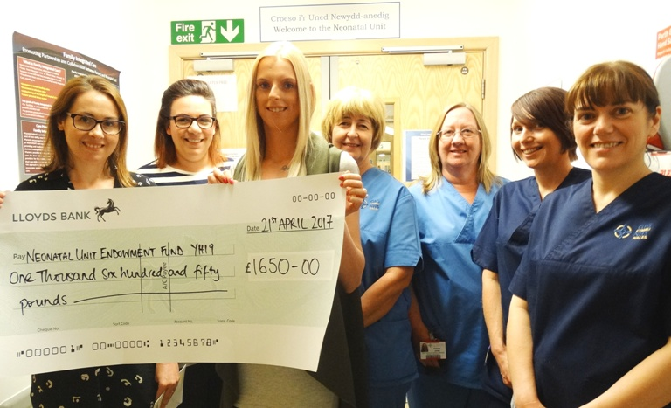
They organised a charity night held at the Smith’s Arms in Llansamlet which featured a disco, raffles and an auction.

Lisa Penhale (third from left) hands over the cheque to consultant neonatologist Joanna Webb as neonatal unit staff Gemma Davies, Ruth Morgan, Gaynor Jones, Alison Hopkins and Gail Smith look on.

Lisa said: “The staff at Singleton were all amazing and couldn’t do enough for us. The doctors and nurses never gave up and did all they could. We wanted to do what we could to thank them.

“Raising the money has given us something positive to focus on and we are so pleased with the way the community came together to support us and the event.

“It wasn’t only all the people who came along on the night but everyone who gave us donations and prizes. It was a wonderful evening.”

It was Lisa’s first visit to the unit since James’s death but because he was suffering with a bug Chris couldn’t accompany her when she handed over the cheque to consultant neonatologist Joanna Webb who had looked after the family.
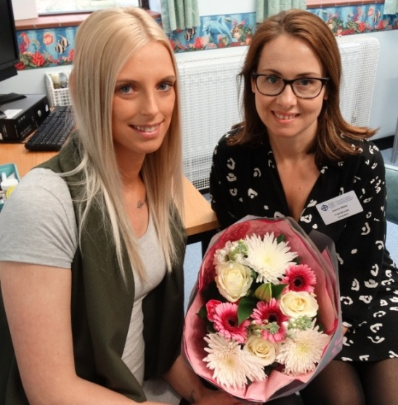
“Sadly Chris can’t be with me today but he has been by my side every step of the way, he has been my rock since James died and we have supported each other through this,” she said.

James was delivered by emergency caesarean section after Lisa developed complications with her pregnancy but despite staff’s efforts he didn’t survive a bleed on the brain.

Lisa Penhale brought a bouquet of flowers for
Dr Joanna Webb when she returned to Singleton.

Dr Webb said: “We are so grateful for all Lisa and Chris’s hard work to raise such a fantastic sum of money.

“We are particularly touched that they wanted to support us after their own sad experience and we want to assure them, and everyone who helped them reach this total, that this donation really will make a difference. It will be used to help us continue to offer the very best care we can to babies and their families.”

Besides presenting the money, Lisa was also able to share the happy news with staff that she is now 20 weeks pregnant and expecting another little boy – a brother for six-year-old Lexi, Sam aged four and Amelia, who is 18 months old.

“Everything is going well and we are very happy but we won’t ever forget how the staff here helped us. We would still like to carry on fundraising to help other families who need the unit in the future,” added Lisa.

Source: Abertawe Bro Morgannwg University Health Board

