'It’s goodbye from him and it’s goodbye from me!'
Tuesday, 4 April 2017
Those words were immortalised by the Two Ronnies at the end of their hit TV show - now it’s the turn of the two Mikes to say farewell.

Colleagues Mike Cratchley and Mike Craddock work as estates officers in the Estates Department at Morriston Hospital and are both due to retire on Friday, 7th April.

Mike Craddock has enjoyed a 41-year career, beginning when he started learning his trade as an electrician back in 1975 while Mike Cratchley has clocked up 45 years working with the NHS since becoming an apprentice painter and decorator on his 16th birthday.

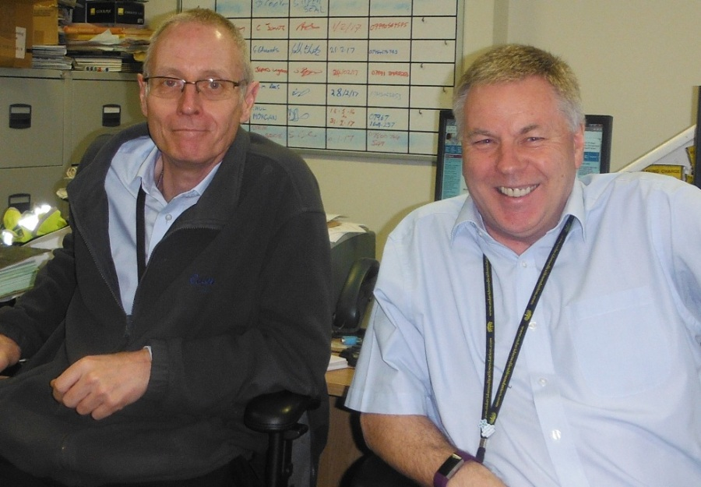
The pair have spent the past four years alongside each other at Morriston but over the decades their roles have seen them working at all the hospitals and many of ABMU’s clinics and health centres.

Mike Craddock (left) and Mike Cratchley who retire on Friday.

Mike Craddock’s job involves keeping essential ventilation and lighting systems in operating theatres working properly, a role which has seen him work closely with staff at the Welsh Centre for Burns and Plastic Surgery at Morriston.

“We are backroom staff but if something is wrong with a theatre then an operation can’t go ahead. I always think it could be one of my family members that needs that operation so we have to make sure we do the best job we can to keep them working properly,” he said.

“It’s all about working as part of a very big team, we are cogs in a mechanism and everybody’s job makes a difference.”

A member of Swansea Ramblers, Mike, who lives in Llandybie with his wife Joanna, is now looking forward to being able to spend more time walking and is also planning to use his retirement to travel.

“I’ve enjoyed my career and met some very interesting people over the years,” he added.

Mike Cratchley agrees. Now a building services officer, over the years his role in maintenance has taken him to former health sites that many colleagues may not remember.

“Stouthall convalescent home in Gower had the most beautiful gardens, as did Llwynderw House in West Cross,” he recalled.

“My job has let me see different perspectives on life because it has brought me into contact with staff in every department.

“I am a great believer in first impressions - if a hospital looks well maintained, from a patient’s perspective, it is going to give them some confidence in the service it offers. They can relax because they know they are going to be looked after. Those small things are all part of the bigger picture.”

Mike, of Morriston, is retiring just as he and wife Mary prepare for the arrival of their sixth grandchild.

“I will have plenty to keep me busy in my retirement but I will miss my colleagues and the friendships I have built up over the years. My job has given me a lot of satisfaction.”

Estates manager Liza Powell said: “The two Mikes have given loyal and dedicated service for decades and will be missed very much by their many friends and colleagues across the health board.

“We would like to wish them both well for retirement and thank them for their contribution to helping keep our sites and services running over the years.”

The two Mikes would like to say goodbye and a big thank-you to all the staff in the many wards, departments and clinics that they have dealt with over the years.

They are now planning to raise a glass at a joint retirement party being held on Friday 7th April.

Source: Abertawe Bro Morgannwg University Health Board

