Kelly makes marathon debut to thank hospital staff
Wednesday, 19 April 2017
A first-time marathon runner is raising hundreds of pounds for the hospital ward that looked after her dad in his final days.

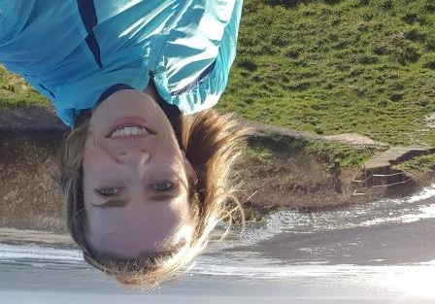
Colin Marsh from Llantwit Major passed away at Princess of Wales Hospital earlier this year at the age of 79 following a period of ill health.

His daughter Kelly Evans has been training hard ready for this Sunday’s Virgin London Marathon.

Kelly (left) has already passed her £500 target after setting up a JustGiving page in support of ABMU Charitable Funds – an umbrella charity that uses more than 500 separate funds to enhance patient and staff welfare.

Fundraisers are able to specify which fund they want the money they generate to go to. Kelly is donating hers to Ward 5 at Princess of Wales Hospital where her father was taken in January this year.

“Dad was there for about three weeks and they did everything they could for him, but sadly it wasn’t to be and he passed away at the end of January,” said Kelly, who works for the Welsh Government in Treforest.

“Not only did he receive fantastic care, but the staff were very much there for families as well as patients. They made a very difficult time that little bit easier for us.”

Kelly said that while she wanted to thank all the staff involved in her dad’s care, she particularly wanted to mention consultants Martin Sevenoaks and Jacqueline Woolley.
“We were back and forth a lot and I know other families there had the same care and attention from everyone on Ward 5.
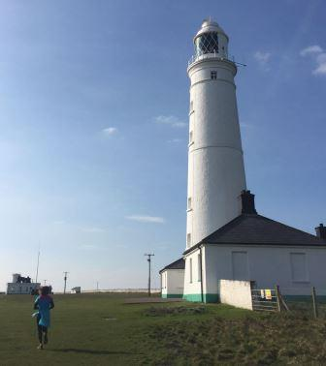
“The NHS gets a lot of criticism but there is a lot of great work being done as well and that isn’t always acknowledged.”
Kelly, aged 35, and originally from Llantwit Major but now living in Cardiff, decided she wanted to run the Virgin London Marathon to raise money for Ward 5, and was delighted when she was accepted.
Although she has completed half-marathons, Kelly has never run a full 26.2 mile course before.
“It is going to be a new experience for me and a bit more of a challenge.
“But I’ve got up to 19 miles in my training so I’m hoping the adrenaline and the crowd will get me around the last seven miles.”
To support Kelly, click here or go to: https://www.justgiving.com/fundraising/Marshy1982

Source: Abertawe Bro Morgannwg University Health Board

