Lisa takes on triple challenge to say thanks for grandad’s care
Wednesday, 12 April 2017
A Singleton Hospital nurse is aiming high when it comes to fundraising to help Ty Olwen.
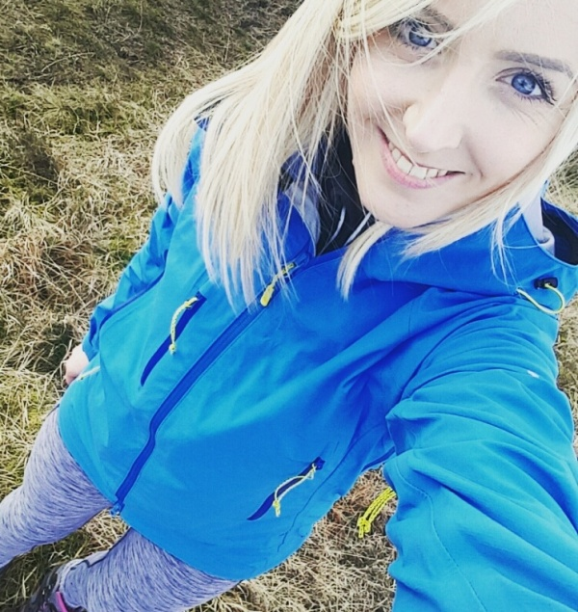
Staff nurse Lisa Rees (left) is taking on the Welsh Three Peaks challenge to support the work of staff at the Morriston Hospital hospice which cared for her late grandad Ronnie Rees.

She said: “As a nurse I always knew Ty Olwen provided amazing care but it was interesting to see it from a relative’s perspective.

“Everyone there was so supportive – they do just as much to help us as relatives as they do for the patients. I think they are all angels.”

Lisa, from Clydach, is now in training for her mission to climb the three highest mountains in Wales - Snowdon, Cadair Idris and Penyfan – in just one day on Sunday, 4th June.

She is already well on her way to her target of £400 but says she is grateful for whatever support she receives.

Her donation will go to the Ty Olwen Trust which provides extra comforts and amenities for patients.

“It is a service that I am personally very grateful to and would love to show my gratitude by challenging myself physically and mentally and raising as much money as possible.

“I just want to do what I can to help – and hope I don’t get too many blisters,” she said.

If you would like to support Lisa go to www.justgiving.com/LisaRees88

Source: Abertawe Bro Morgannwg University Health Board

