Morriston team's app could transform pressure ulcer care
Tuesday, 18 April 2017
An award-winning team at Morriston Hospital has created an app that could transform the care of patients with a potentially crippling condition.

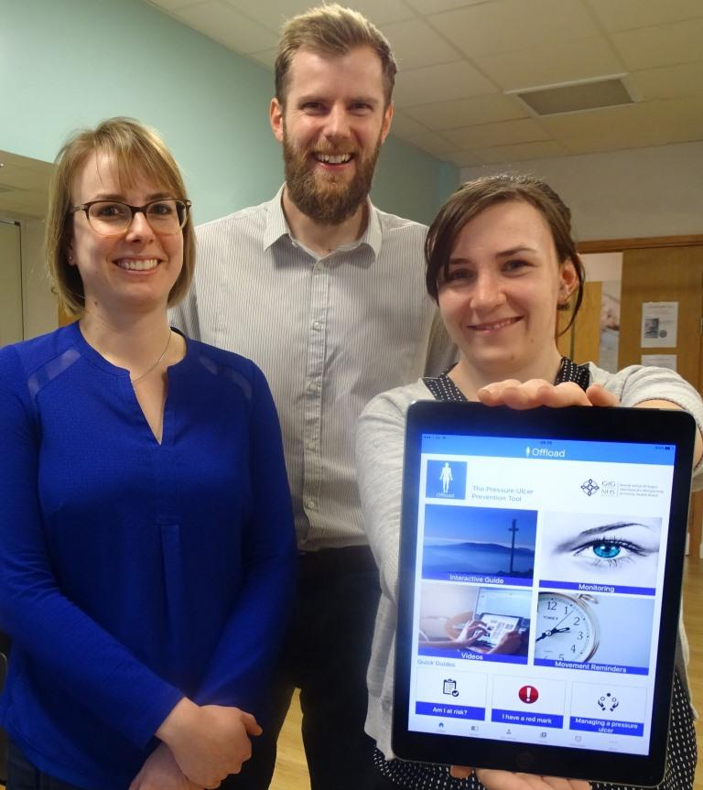
It may eventually be available to people at home with, or at risk of developing, pressure ulcers, as well as the health professionals caring for them.

Head of rehabilitation engineering Dr Lorna Tasker, principal clinical scientist Dr Mark Bowtell and rehabilitation engineer Kelly Jones with the new app

The app, developed with Welsh Government funding, is aimed at reducing pressure ulcers developing in the first place.

But when they do occur, it will help make the best use of resources by allowing specialist staff to prioritise the most serious cases.

A prototype has been trialled, and additional work to expand and further evaluate the app will now be carried out.

It was created by Morriston Hospital-based PUPIS, ABMU’s multidisciplinary Pressure Ulcer Prevention and Intervention Service.

PUPIS is hosted by the Rehabilitation Engineering Unit, part of the Department for Medical Physics and Clinical Engineering.

The service assesses and provides intervention for around 250 patients a year, seeing on average 10 pressure ulcers a week.

These can occur in people with limited mobility, who may sit or lie in one position for long periods of time.

With blood flow restricted to bony parts of their body, there can be severe tissue damage. The impact can be devastating and in some cases may lead to major surgery.

ABMU principal clinical scientist Dr Mark Bowtell led the app project, working with Fujitsu software developers.

He said: “The main aim was to engage with patients and frontline staff in the community so they can have specialist information at their fingertips.

“It provides district nurses with the information they need to spot the risks early and grade pressure ulcers with confidence – as well as how best to get the patient directly involved in their own care.

“The app includes an interactive information guide, short videos, and an ‘Am I at Risk?’ quiz.
“There are illustrations staff can show patients to explain why they are at risk and what can happen to their skin if they sit in a certain way, for example, or don’t move for a certain amount of time.”
The iPad app has been trialled with selected district nurses in Bridgend and specialist nurses in Swansea, along with a small group of patients.
Mark said: “Patients were able to look in their own time at the interactive information and even actively participate in their wound monitoring.
“They also used a reminder tool – where they could set a reminder to lift themselves maybe every half an hour to relieve pressure and let the blood flow back in.”
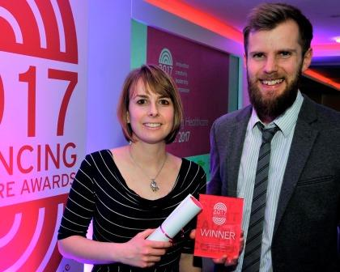
The monitoring tool was found to be most powerful, allowing photographs of the pressure ulcer to be taken and details logged.
This helps indicate whether the wound is getting better or worse, and to track the effectiveness of interventions.

Right: Dr Tasker and Dr Bowtell with the Academy of Healthcare Science Award for Innovation, presented to them at the 2017 Advancing Healthcare Awards
During the trial, monitoring and assessing the wounds electronically led to the percentage of these referrals requiring a home visit by a PUPIS clinical nurse specialist falling from 60 to 33 percent.

This represents a more effective use of resources as it frees up specialist nurses to focus on the most serious cases.

Further work is needed to see what other features can be introduced into the app, followed by additional evaluation.

Mark said: “Eventually we would like to see it available as an all-Wales approach to pressure ulcer care in the community.”

PUPIS employs a variety of innovative solutions to pressure ulcers, ranging from the mechanical – it has its own workshop – to the high-tech, such as the use of 3D imagery.

The team has worked with a Swansea-based company, GPC, on evaluating new 3D technology.

It also ran an extensive leaflet campaign in 2016, and produced a video featuring patients talking of their own experiences to help convey important information about pressure ulcer prevention and treatment.

All this has led to it winning the Academy of Healthcare Science Award for Innovation at the 2017 Advancing Healthcare Awards.

Head of rehabilitation engineering Dr Lorna Tasker said: “It’s great to have recognition of the department’s innovative work.
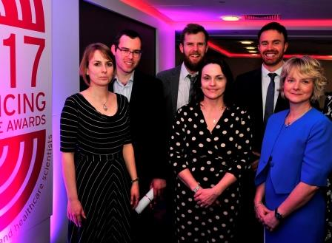
“This is as a result of the multi-professionals involved and the joint working with other services and organisations.”

L-r: Dr Lorna Tasker, rising star winner Mark Edwards, Dr Mark Bowtell; and Beth Lavercombe, Mathew Tidball and Rachel Turner of the ABMU Staff Wellbeing and Attendance Project.

Also at the awards was Mark Edwards, lead clinical scientist in the medical physics and clinical engineering department at Singleton Hospital, who was among the candidates for the HSL Rising Star Award.

On the night there was no overall winner. Instead all those shortlisted, Mark included, were named rising stars and called on stage together to receive certificates.

Additionally, the ABMU-wide Staff Wellbeing and Attendance Project was runner-up in the Welsh Government Prudently Advancing Practice category.

You can read more about this project, and about Mark, in our previous press release here

Source: Abertawe Bro Morgannwg University Health Board

