Mum’s legacy provides high-tech help with youngsters’ speech therapy
Thursday, 6 April 2017
The friends and family of a Swansea Valley-born mum have given youngsters a helping hand with their speech problems in her memory.

The children will benefit from high-tech speech therapy equipment bought for the cleft lip and palate team based at Morriston Hospital as a lasting legacy to Rebekah Bartolozzi who died in 2015.

It was a cause close to Rebekah’s heart as she was treated by staff from the hospital’s Welsh Centre for Cleft Lip and Palate during her own long illness.

Her parents, Roger and Paulette Smith of Clydach, visited Morriston to meet staff and see the equipment bought using £1,710 donated by the community following Rebekah’s death at the age of 43.
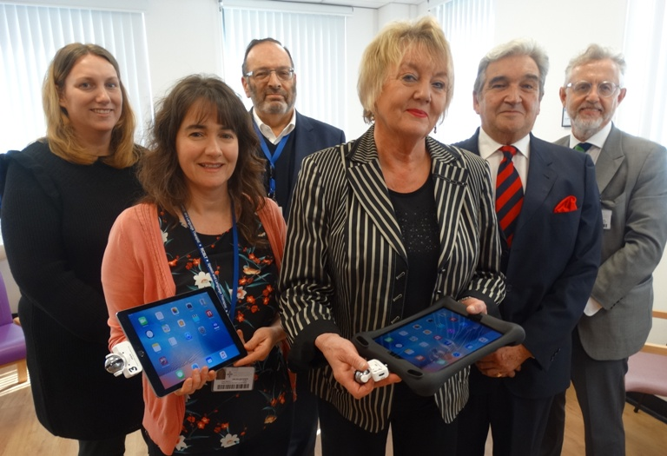
(From left) Specialist speech and language therapist Sharon Baker, lead speech and language therapist with the cleft lip and palate team Helen Extence, cleft team clinical director Adrian Sugar, Paulette Smith, Roger Smith and consultant in restorative dentistry Karl Bishop with some of the new equipment

Lead speech and language therapist with the cleft lip and palate team Helen Extence showed the couple the three new iPads, complete with specialist articulation apps and child-proof covers to protect them, and three IQ recorder attachments to use with them.

The money also paid for a hand-held nasality microphone which therapists can now use with a nasometer, a device to monitor and assess the speech of children with cleft palate.

Helen, who had looked after Rebekah during her treatment, said: “It really is a lovely piece of equipment and we wouldn’t have been able to buy it if it hadn’t been for this generous donation. It will help us to confirm the speech diagnosis and can also be used to obtain speech scores for research projects.

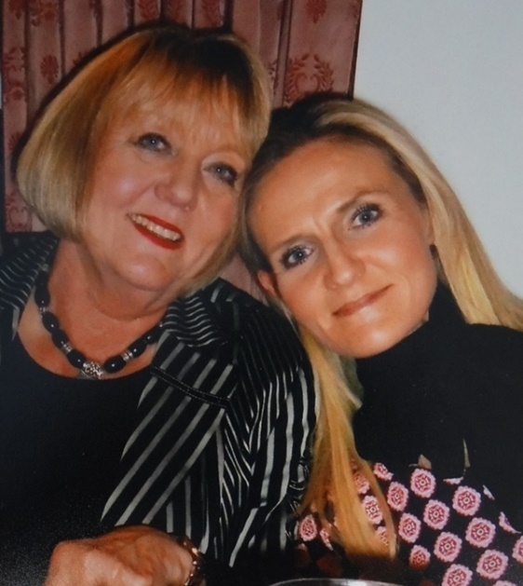
“We wanted to purchase something that would be used everywhere – in the hub here at Morriston and out in the community. This equipment is already in use and making a difference.”

Mrs Smith said: “It is wonderful to see what the team has bought and to hear about how these items will be used to help children.”

Nurse Rebekah was diagnosed chordoma, a rare type of cancer, in 1992 and she was treated by surgeons in Liverpool and at Morriston where she also received rehab care from the cleft team, especially speech therapists and restorative dentists, including Helen and consultant Karl Bishop who attended the presentation.
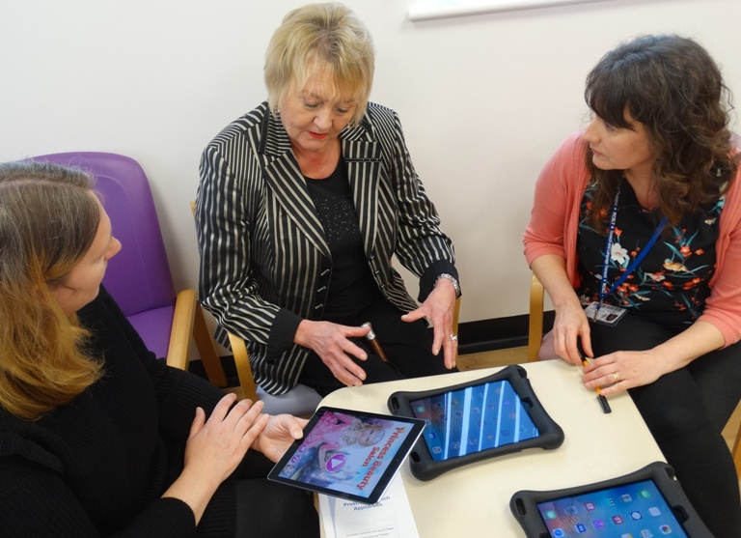
Rebekah and her mother Paulette and (right) specialist speech therapist Sharon Baker explains to Paulette Smith how the apps on the new iPads will help young patients as Helen Extence looks on.

She and her husband Fabio, a cardiothoracic surgeon, met while working at the University Hospital of Wales. The couple had four children – Edward, Henri, Sophia and Federico - and lived in Galway but she passed away during a family holiday in Sicily.

At a service to celebrate her life held in Clydach, her family asked for donations for the cleft lip and palate team who had given her so much support and help.

Her father added: “Everybody loved Rebekah and the amount of money that was donated after her death is a testimony to that. We are very grateful to everybody who contributed.

“The team here do marvellous work and we wanted to recognise the role they played in Rebekah’s care over the years.

“Knowing that this donation in her memory will make a difference to others makes us feel very proud.”

Source: Abertawe Bro Morgannwg University Health Board

