Patients’ art project helps cheer up hospital walls
Friday, 7 April 2017
Patients and staff have worked together to brighten up a bare courtyard at the Princess of Wales Hospital.
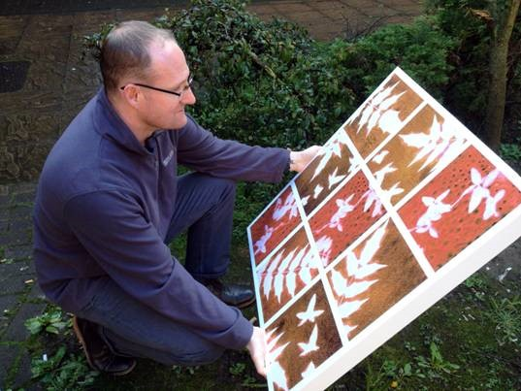
They created striking images to decorate the external area at the Psychiatric Intensive Care Unit (PICU).

Occupational therapy technician Tony Poole with one of the panels.

Artwork designs were created in workshops led by capital arts manager Heather Parnell using a photographic process called cyanotype.

The group’s inspiration came from plants and vegetation collected on walks and the panels reflect seasonal colours in nature.

Heather said: “We had received a donation from a patient’s family towards providing art for the courtyard.

“They wanted to give something back after the care their relative received at the unit. Their donation made it possible for other patients to enjoy learning new skills and contributing to the artwork.”
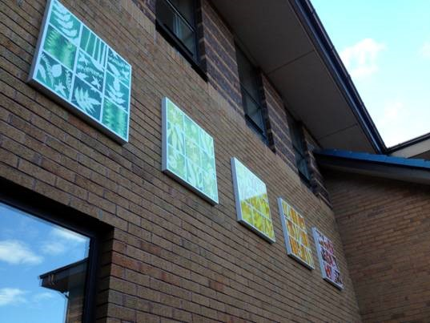
Nurse Director for Mental Health and Learning Disability Hazel Powell said: “The artwork looks amazing – well done all.

“This is a great example of a multidisciplinary team working with and being responsive to people and their families.”

The panels take pride of place in the courtyard.

Source: Abertawe Bro Morgannwg University Health Board

