Radiography staff become first to hold groundbreaking new qualification
Tuesday, 4 April 2017
Two Singleton Hospital workers are celebrating after become the first in Wales to achieve a new professional qualification.

Radiography health care support workers Rachael Lee and Natasha Peters are now the proud holders of a Level 3 certificate in Clinical Imaging Support.

The qualification was introduced by the hospital’s radiology department to not only improve skills and help with professional development but also to give staff expertise and knowledge to be able to better reassure their patients.
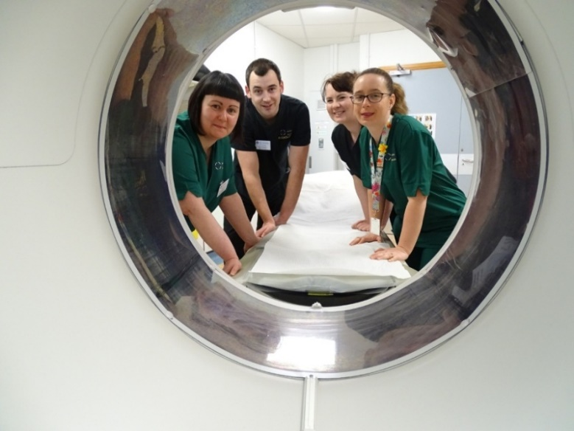
The health care support workers are often the first members of staff who see patients coming to the department for ultrasounds and scans.

(from left) Rachael Lee, senior radiographers Ian Worthington and Danielle Williams and Natasha Peters at Singleton Hospital CT scanner.

Superintendent radiographer Ian Worthing, who helped develop the course, said: “Now they have the knowledge to be able to reassure and inform patients. Completing the course has improved their skills and improved the service they can offer patients.”

He explained that previously the role of HCSW in radiology did not require any formal training about basic radiation safety so a clinical imaging programme had been developed by radiology departments across Wales, however this certificate is the first to test and reward that training.

The certificate, accredited by Welsh professional awards organisation Agored, is the equivalent of an A-level. Both Natasha and Rachael had previously undertaken NVQ qualifications and were eager to continue learning.

Natasha said: “It has been great to have the opportunity to develop our skills and challenge ourselves.

“I have found out more about the other areas in the department, rather than just where I had been working in ultrasound.”
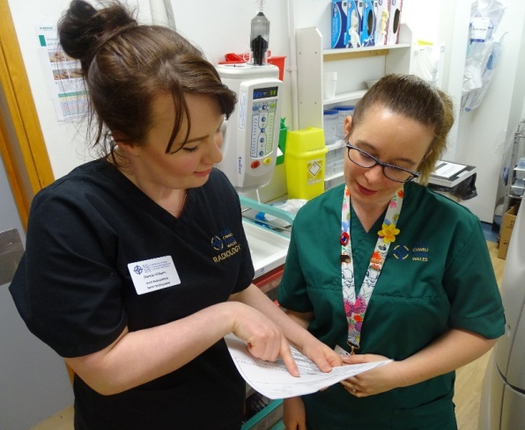
The department at Singleton covers ultrasound, MRI, CT scanning, fluoroscopy - a type of imaging that shows a continuous X-ray image on a monitor - as well as general X-rays.

Natasha Peters with Danielle Williams who mentored her during her course.

“Now I have a better understanding of what a patient has to go through and I can answer their questions and hopefully make them feel less anxious. This is definitely helping me in my role,” she added.

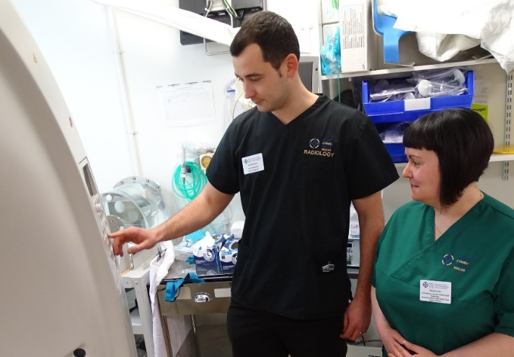
Rachael, (right with senior radiographer Ian Worthington) has now moved from the department to work in endoscopy, said: “I would definitely recommend this course to anyone. We had tremendous support and it was a very well structured and delivered programme.

“There may have been a small cost in terms of time spent learning but it has been priceless. The qualification has not only benefited me but also the people I am looking after and that is the most important thing.”

The course saw senior radiographers Ian Worthington and Danielle Williams mentor and deliver the training to Natasha and Rachael.

They were assessed through one-to-one questioning, clinical observation and had to prepare written workbooks which were checked by ABMU’s HCSW development lead Julie Williams before being externally examined by Agored.

Besides technical knowledge of radiation and equipment, the certificate also covered other areas including health and safety, anatomy, infection control and communication.

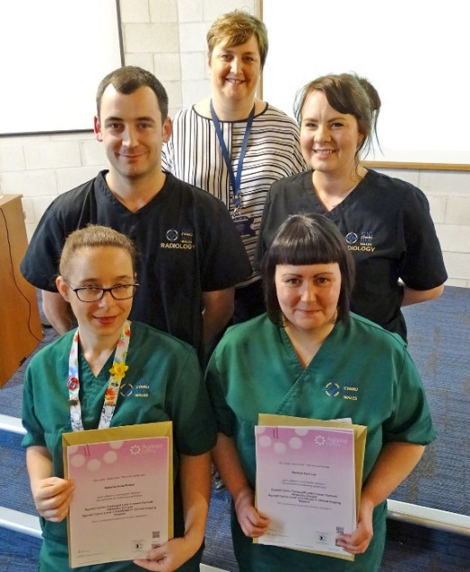
Natasha and Rachael with their certificates which were presented by Singleton Hospital Director Jan Worthing (back) and their mentors Ian Worthington and Danielle Williams.

Danielle said: “Though the award had to be completed in a maximum of two years, Natasha and Rachael did it in half that time.

“Now the depth of knowledge they have means they could move around to cover the department’s needs as required.”

Ian Worthington added: “We have had excellent feedback from Agored and from Rachael and Natasha so we can develop and adapt the course for the future – and we already have our next two candidates enrolled.”

Their work developing and delivering the certificate led to Ian Worthington and Danielle earning the Team of the Month award which is handed out to members of staff at Singleton Hospital who have helped improve services for patients.

Presenting them with their trophy, Hospital Director Jan Worthing congratulated the pair on giving the HCSWs the maximum potential to develop their roles.

Ian Worthing added: “It is important to develop staff and on the job is the best place to learn. We regularly have student radiographers here for placements so our team is used to mentoring. This really was the logical next step forward.

“We are just very proud that Singleton radiology unit is the first to achieve this.”

Source: Abertawe Bro Morgannwg University Health Board

