Rugby stars support fundraising screening of charity film
Monday, 24 April 2017
Kathmandu to Dhaka, the documentary charting two families' epic charity motorbike trek, is being screened as part of a fundriasing evening in Swansea this week.

Special guests at the event, being held on Thursday, 27th April at Swansea Uplands Rugby Club, will be Ospreys stars Tyler Ardron, Jeff Hassler, Josh Matavesi and Ma’afu Fia.

The film was made to raise awareness and money for global burns prevention charity Interburns which was co-founded by Professor Tom Potokar, consultant plastic surgeon at Morriston Hospital’s Welsh Centre for Burns and Plastic Surgery.

It follows the 1,200 mile journey made by Tom, his wife Morriston burns intensive care nurse Dominique, their children Arthur and Alex along with his Interburns colleague paediatric burns surgeon Sian Falder and her family.
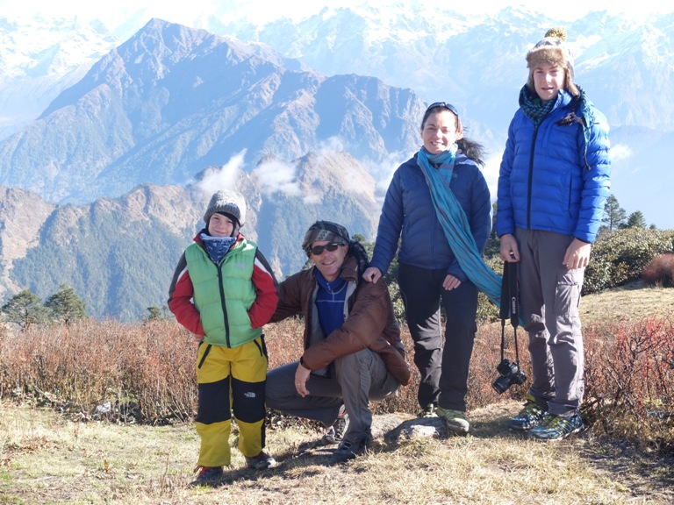
They were accompanied on their adventure by filmmaker Tom Woodrow, of Geek Media, who documented how the families coped with the trials and tribulations of life on the road as they made the journey from Napal to Bangladesh through India on four Royal Enfield Desert Storm 500cc motorbikes.
The Potokar family during their journey.
So far the families have raised in excess of £40,000 but they are hoping sales of the DVD will give their total a major boost.

There will be an auction featuring a variety of great items as well as Indian food on sale.
Tom, who was rewarded with an OBE for his global burns prevention work in the New Year’s Honours, said: “The journey was a way to experience those countries and it was also about doing something unforgettable while our children were old enough to remember it all their lives. It also helped us to raise awareness about Interburns’ work."
Tickets cost £10 per person, under-16s free and doors open at 7pm. To book your place go to www.Eventbrite.co.uk

Source: Abertawe Bro Morgannwg University Health Board

