Teams share ideas with families to celebrate Help Me Speak Week
Wednesday, 26 April 2017
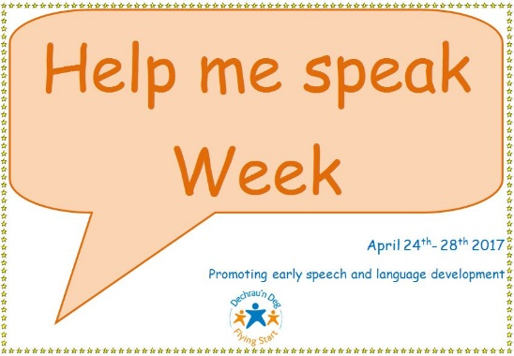
ABMU staff are busy speaking up to help families improve children’s speech and language development.

They are out and about in the community, meeting parents and spreading the word about Help Me Speak Week, which runs until Friday.

The Paediatric Speech and Language Therapy Department has teamed up with the Designed to Smile team, health visitors, Flying Start and Best Start Swansea to promote key messages about language development.
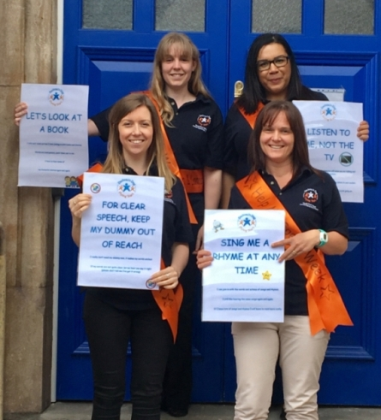
Each day of the week has a different message including Let’s play every day, Look at me not the TV and For clear speech keep my dummy out of reach.
The therapists are heading out to as many settings as possible during pick-up and drop-off times to meet parents, talk about the messages and suggest activities they take part in at home.
Members of the speech and language therapy team (clockwise, from back left) Katie Oakley, Sinead Campbell, Kate Ashton and Kath Davies, who are taking part in the week pictured at their base at Taibach Library.

Highlights of the week will be on Thursday 27th April when there will be special events at the Children’s Centre, Neath Port Talbot Hospital from 10am to 2pm and the Integrated Children's Centre at Clwyd Primary School, Swansea from 11am to 2pm.

There will be a further chance to meet the team at Aberafan Shopping Centre, Port Talbot on 28th April from 10am to 2pm.
Speech and language therapy students from Cardiff Metropolitan University are getting involved in the events, which are also being supported, by the Royal College of Speech and Language Therapy.

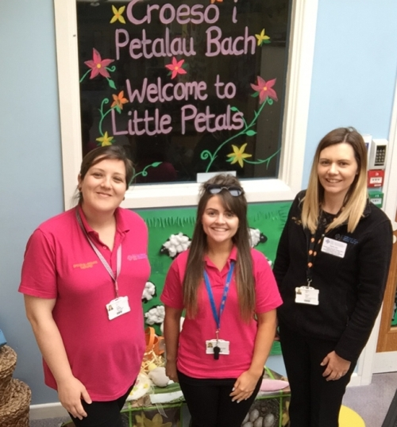
Laura Howells, Bea Trigg and Sophie John from the Flying Start speech therapy team.

Preschool lead speech and language therapist Sue Koziel said: “Children need to talk to learn, they need to talk to succeed in school and later life. The learning to talk journey starts before birth and is important for wellbeing throughout our lives.

“Help Me Speak Week is a chance for us to show parents how fun and easy it can be to help their little ones learn to talk.
“In some areas of the country, up to 50 per cent of children in early years have delayed language.
“The key messages are simple and catchy and we hope people will remember them and use them every day.”

Source: Abertawe Bro Morgannwg University Health Board

