Volunteers needed to give clinic artwork a makeover
Tuesday, 18 April 2017
Can you spare some time to take part in a spring clean with a difference on Thursday, 20th April?

ABMU’s Heritage group is inviting staff and members of the public members who are free to lend a hand sprucing up the mural on the front of Central Clinic in Swansea’s Orchard Street at 1pm.
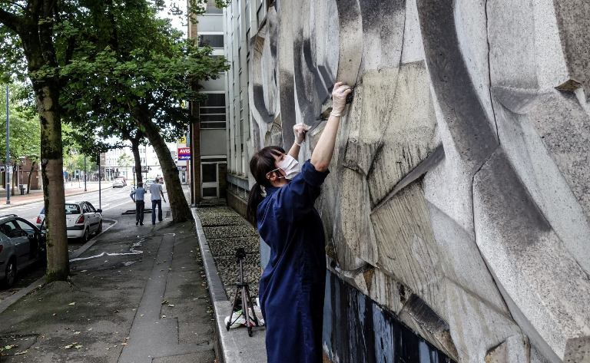
They will be working alongside artist Catrin James whose Guerrilla Restoration project has seen her cleaning small square sections of dirty buildings across Swansea – including the mural (pictured) - armed with just a video camera, bucket of soapy water and a sponge.

The Heritage Group, which aims to protect and share ABMU’s artefacts, was so impressed by Catrin’s work they invited her back to help staff finish off the cleaning.

The mural was created in 1969 by students at Swansea Art College, inspired and supervised by sculpture lecturer Harry Everington, a co-founder of the Frink School of Figurative Sculpture.

He died in 2000, but Fiona Edwards, of ABMU’s Arts in Health Group, has tracked down his family who are planning to come along to the event and see the mural for the first time.

The Heritage Group hopes the clean will give participants the opportunity to do something different, to celebrate the work of one artist through the work of another while working together and gaining a sense of satisfaction.

Heritage lead Martin Thomas said: “Because of the heavy bombing during the Second World War, Swansea city centre was extensively rebuilt in the following decades with architecture and art of its time.

“Following the 1951 Festival of Britain mural art really helped characterise that era.

“Post-war civic art like the clinic’s bold abstract mural is not to everyone’s taste but for me mural art helps captures the energy of change and optimism in Britain at this time.

“Unfortunately, according to the C20Society, post-war murals across the country are an endangered species. So we are going to look after ours and peel back the dirt and grime to bring it back to its former glory.”

A platform, materials and overalls will be provided for all volunteers taking part.

To find out more about Catrin James’s work go to http://catrinsaranjames.tumblr.com/

Source: Abertawe Bro Morgannwg University Health Board

