Blooming great idea for gardening group needs help to get growing
Friday, 20 April 2018
The seeds of an idea have been planted for a new gardening group for patients at Princess of Wales Hospital.
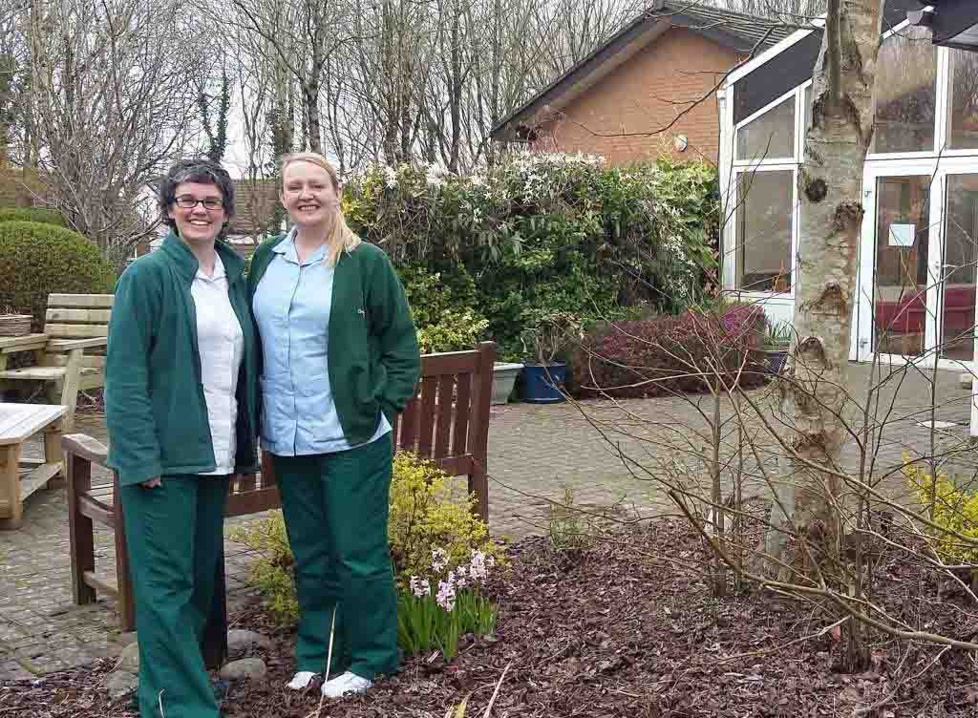
It would not only give patients in Y Bwthyn Newydd, POWH’s palliative care unit, a new interest but would be used to provide therapy for them too.

Alison Docherty (left) and Lisa Evans in Y Bwthyn Newydd’s garden

Now all that is needed to make the idea blossom is a bit of help by way of donations of plants and other essentials.

The unit has a large garden, and a conservatory that could be used should bad weather prevent outdoor activity.

The idea for the Good to Grow gardening group came from Macmillan specialist occupational therapist Alison Docherty.

The group would be open to all patients known to the palliative care service, including inpatients.

Alison explained: “There is a lot of evidence to support the therapeutic use of horticulture.

“The group will look at supporting patients to take part in gardening activities, which in turn will benefit their physical health by keeping them active and mobile.

“It will also have a positive impact on their psychological wellbeing, confidence and self-esteem.

“There are lots of benefits from seeing things grow.”

Alison was, until recently, the only occupational therapist in the unit. However, following the appointment of assistant OT practitioner Lisa Evans, she now has time to set up the Good to Grow group.

“We have a good team here and we are keen to provide opportunities for all of our patients,” Alison said.

“Many community groups available are female-orientated – men are not likely to come to arts and crafts or knitting.

“Gardening, though, is something men and women alike can get involved with.

“We have a lovely, spacious and mature garden at Y Bwthyn Newydd but at the moment we don’t have any smaller pots, planters and hanging baskets to fill it with colour.

“If anyone can help with donations of things like pots, planters, compost, seeds, small plants or hand tools we would be extremely grateful.”

If you would like to support Good to Grow, please email Alison at Alison.Docherty@wales.nhs.uk

Source: Abertawe Bro Morgannwg University Health Board

