Free support to help you stub out your smoking habit for good
Tuesday, 10 April 2018
A free stop smoking service at local pharmacies is helping smokers give up the habit for good.

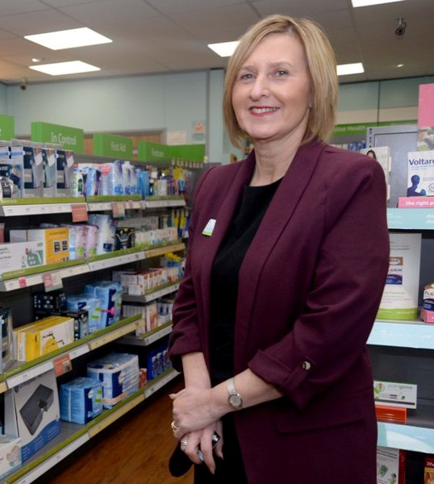
It is being offered because people who try to give up smoking by themselves are four times more likely to fail. They are also likely to be a lot worse off with the high price of nicotine patches, inhalers and gums.

Those things come free, however, for anyone joining the smoking cessation scheme at a pharmacy.

Debra Hughes, manager of Lloyds Pharmacy in Baglan Moors.

Not only that, but smokers get all the support they need from trained staff to see it through to success.

Lloyds Pharmacy in Baglan Moors is one of 84 pharmacies currently running the scheme across the ABMU Health Board region. With the number of smokers in Neath Port Talbot being the highest in Wales at 25 per cent, it’s a much needed service.

People don’t need a doctor’s referral to join the stop smoking programme; they can just turn up at their local participating pharmacy.

“When people come in for a chat we usually ask them to take away a questionnaire to fill in and then bring back. The reason we do that is because we have found that if people sign up on impulse, they are much less likely to succeed,” said pharmacy manager Debra Hughes.

“If they come back or if people come in and they have really made up their minds to stop, we put them on a 12 week programme.”

Participants are given weekly supplies of the nicotine substitute they think is most likely to help them and have regular sessions with a trained counsellor.

“The sessions are one-to-one and completely private,” said Debra.

“We start them off with a weekly consultation with one of our trained staff for five weeks and then a fortnightly one for the rest of the time, but people could come in every day if that’s what they need to stop smoking.
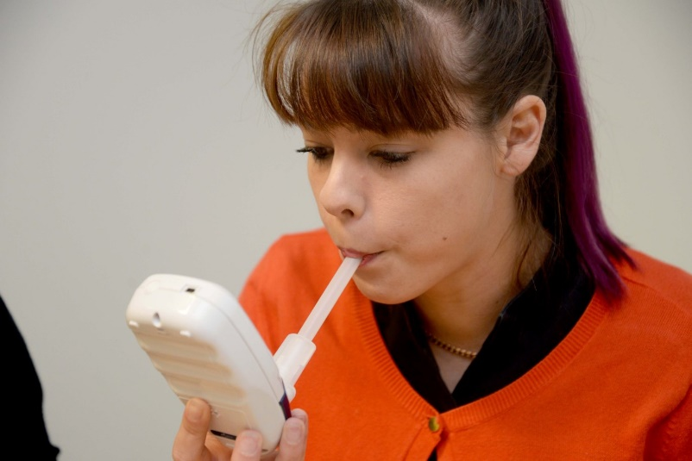
“It helps the surgeries massively as well as people don’t need to take up their doctor’s time to get help.”

Zoe Thomas, 24, (left, having her carbon monoxide levels checked) is one of three colleagues at the pharmacy who have given up smoking using the scheme.

“I started smoking when I was 14 because I thought it was cool. It was the worst decision of my life - and the most expensive,” she said.

“I tried quitting a couple of times before but I always went back. This time it hasn’t fazed me at all. I can stand in a group of six people smoking and not be tempted.

“I found it hard at the start but the support I’ve had has been brilliant. Using a nicotine inhaler helped me because I missed the act of smoking, but I gave that up too after 10 weeks.

“What I have learned is that the craving is there for a split second but once you get over that, it’s gone. I was spending £35 to £40 a week on cigarettes so I have definitely noticed a difference in my finances as well as my breathing.”

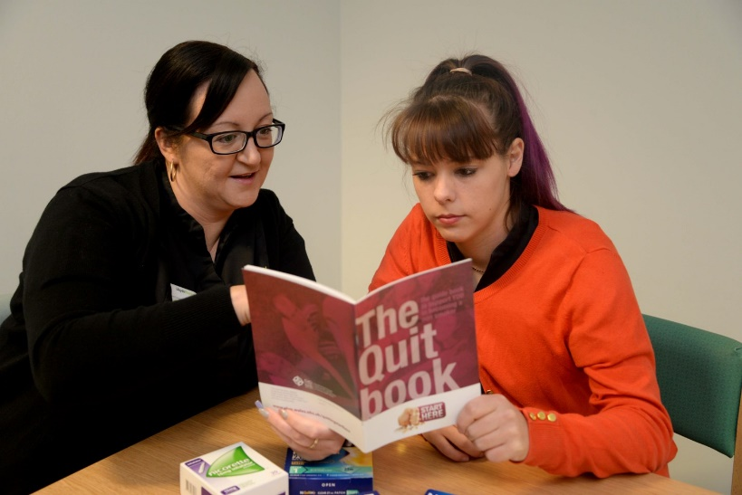
Zoe and the other staff at the pharmacy are keen to get the message across to smokers in the local community who may be able to give up the habit with the right support.

Joanne Larkman, (right, advising Zoe Thomas) one of staff members trained to counsel smokers under the scheme finds that being an ex-smoker herself helps.

“I know what they are going through and they know that if they have a relapse early on, I am not here to give them a row!”

The smokers’ commitment is tested at every consultation, however, with a carbon monoxide test that will show up if they have lapsed but also show how their health is improving as levels go down.

“That can be a great motivator. I always emphasise the positive and I remind them why they wanted to give up smoking in the first place,” said Joanne.

“I know how much better they are going to feel when they succeed. You can breathe better, smell better and taste better after you give up smoking.”

All four of Lloyds’ Port Talbot pharmacies are running the scheme and across the health board area there are 84 pharmacies offering the service and this will rise to 100 by April.

Steve Ridd, Lloyds’ Welsh business development manager, said: “Nearly 70 per cent of smokers want to stop smoking. Of those, 41 per cent are trying, but only 2.9% of those are in a scheme like this one.

“We hope more people take it up because we know this scheme works. Smoking still remains the single largest cause of preventable ill-health in Wales. That’s why the Welsh Government has set a target of reducing smoking from 20 per cent of the population to 16 per cent by 2020.”

In Lloyds’ Baglan Moors pharmacy, the number of people signing up to do the programme has seen an increase since the pharmacy extended its opening hours – 8.30am-10.30pm Monday to Friday, 9am-9pm Saturday and 11am-1pm Sunday.

The health board is commissioning other pharmacies to open on Sundays and extend their hours generally so that patients always have access to medicines, services and advice. Before April last year only two pharmacies were commissioned to open on a Sunday but now there are 10.

“It is getting busier as people realise that we are open longer,” said Zoe.

“People can walk in here late at night or at the weekend and ask for help in stopping smoking. It really helps people who are working full time.”

•The Smoking Cessation Scheme is currently offered by 84 pharmacies across Swansea, Neath, Port Talbot and Bridgend. It is one of three services on offer in Wales that can help smokers wanting to quit.

Stop Smoking Wales runs community-based sessions with group therapy, while the Time to Quit scheme helps hospital in-patients give up the habit.

They all come under the umbrella of Help Me Quit and you can find out more about which service would suit you best by checking out www.helpmequit.wales or ringing 0800 0852219.

Find out if your local pharmacy is offering the service by visiting this link and entering your postcode.

Case study
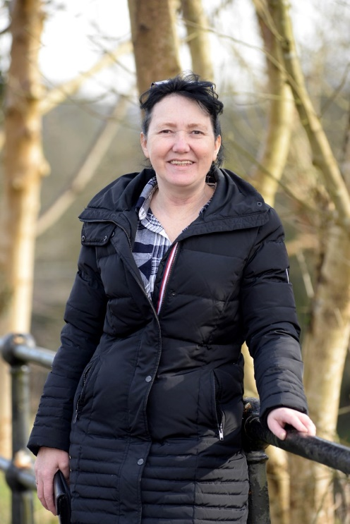
Nicola Clarke, 47, (right) signed up for the free stop smoking service at Glynneath Pharmacy on High Street, Glynneath, last year.

“I smoked for 32 years and had a heart attack when I was 40 and I was told to stop then, but I carried on.

“It wasn’t until recently when I came into the pharmacy and Nik, the pharmacist, told me there was a scheme that I decided to have a go,” she said.

“My carbon monoxide levels were off the scale when I was first tested but after not smoking for two days, they plummeted.

"It showed me what I could achieve and after that I couldn’t wait to come back every week and blow into the machine!

“Me and my daughter did it together, which helped. I always felt embarrassed about smoking and I had brown fingers from rolling my own but Nik was so supportive and non-judgmental.

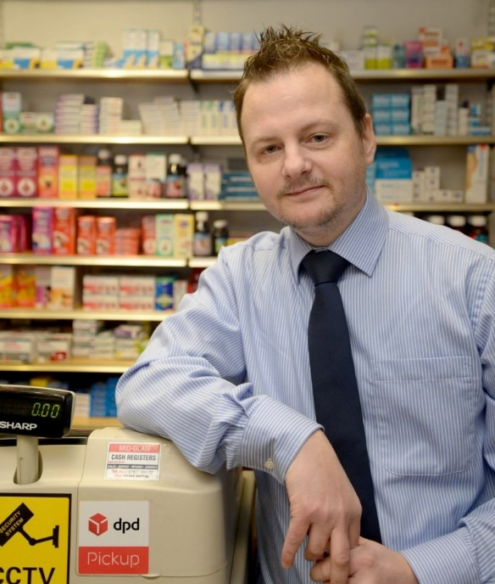
“The first two weeks weren’t easy but I promised my family I would be smoke-free and patch-free by Christmas Day, and I was. Now food tastes amazing and I’ve bought loads of cook books!”

Pharmacist Nik Watts (left) said: “There is a high prevalence of smoking in the area and we’ve usually got 20 people on the scheme at any one time.

“We do everything we can to support them in giving up. It’s has been very successful and I’m pleased to say we’ve had a lot of quitters.”

https://www.youtube.com/watch?v=EL4iYRApxDg

Source: Abertawe Bro Morgannwg University Health Board

