Hywel dda change consultation - ABMU initial response
Thursday, 19 April 2018
Like our partners at Hywel Dda University Health Board, we are dedicated to making the best use of staff and resources to provide modern, efficient healthcare designed to meet the growing demands and expectations of our South West Wales population.
We strongly believe that health board boundaries must not be a barrier to patient care, so increasingly we are working in partnership with Hywel Dda to plan services on a regional basis.

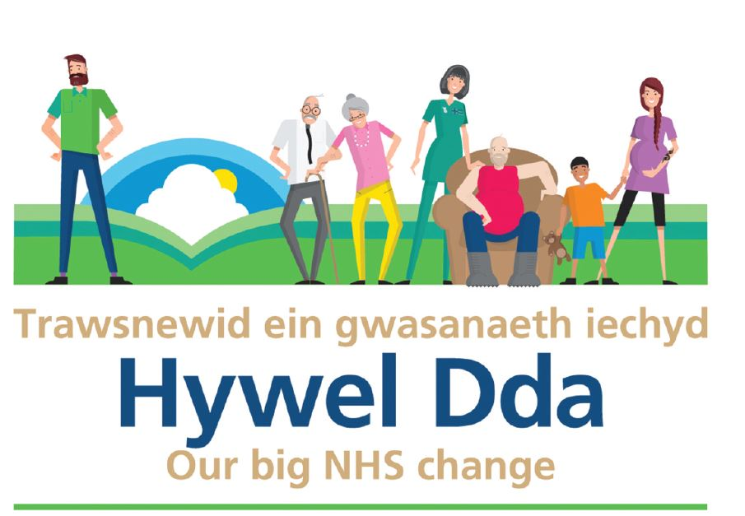
All three options put forward in Hywel Dda’s consultation document are likely to mean more patients coming to our hospitals – particularly Morriston Hospital, but also Singleton too. The nature and impact of this increased activity will need to be quantified, along with practical plans on how this will be addressed. Clearly, it is important that ABMU patients are not disadvantaged by these proposals.

However, we also believe there are also real opportunities worth exploring, which will support care for both Hywel Dda patients and ABMU patients - particularly those living closer to the Hywel Dda border.

By planning regionally, patients moving in both directions across the boundary between our health boards are far more likely to receive equitable access and excellent outcomes.

We will be working closely with Hywel Dda to better understand these potential risks and opportunities to services across the region, throughout the consultation period. We will use the information obtained through this work to enable us to provide a formal response to the consultation.

Hywel Dda and ABMU will then collaborate closely on the business plans that will be required for both health boards, once the outcome of the consultation is known.

We would also urge patients and the public to take part in the consultation over the next few months, to share their views and suggestions, and help shape future healthcare provision in South West Wales.

You can find out more about the Hywel Dda ‘Our big NHS change’ proposals and consultation information on the Hywel Dda website: http://www.wales.nhs.uk/sitesplus/862/page/95249
Source: Abertawe Bro Morgannwg University Health Board

