Maternity staff's Bollywood boost for grieving parents
Wednesday, 18 April 2018
Dedicated Singleton Hospital maternity staff teamed up to show off their dancing talents at a special evening of Eastern-inspired entertainment.

The Bollywood event raised more than £4,400 money to improve facilities for grieving families who have experienced the devastating loss of a baby.

Dr Manju Nair said: “As a team of midwives and obstetricians we are thrilled to now be able to update our existing facilities to provide parents who have suffered a bereavement with the space they need, within a comfortable and supportive environment.”
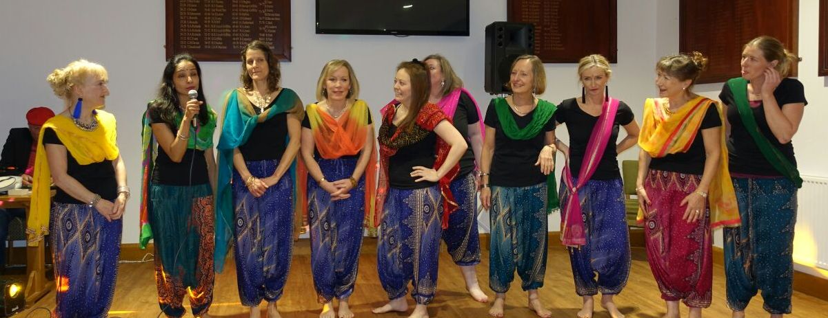
The Bollywood Beauts, a dance group made up of obstetricians, secretary and midwives who took the floor at the fundraiser.

Keen to support families who have suffered in this way, Dr Nair, along with midwives Sharon Jones and Catrin Elis, came up with idea of holding a fundraiser but say plans for the event just snowballed.

In the end more than 100 people attended the evening which was held at Swansea Uplands RFC, who kindly offered their support.

She said: “Its final success grew from the support, dedication and commitment of many colleagues, friends and family.”

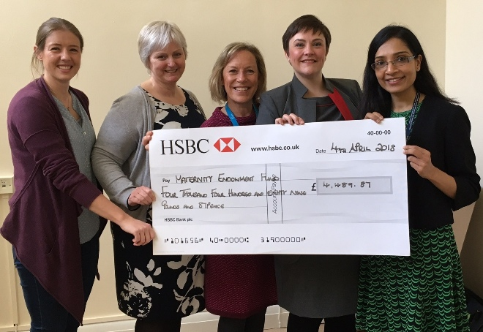
The evening included a three-course Indian buffet meal, an auction, professional harpist and a Bollywood DJ as well as a number of very skilled dance performances finishing with a special contribution by staff themselves.

Maternity staff with the money they raised to help improve facilities for bereaved families.

Catrin said: “We formed a dance group called the Bollywood Beauts made up of obstetricians, secretary and midwives.

“The group was formed with good humour and dedication. We would meet just before night shifts, stay on after work and come in on our days off to practise.

“We wish to thank everyone in the group for their fantastic support and team spirit as we worked together towards the event.”

The money was raised through ticket sales for the evening along with generous donations from local businesses for a raffle and auction and support from the HSBC bank.
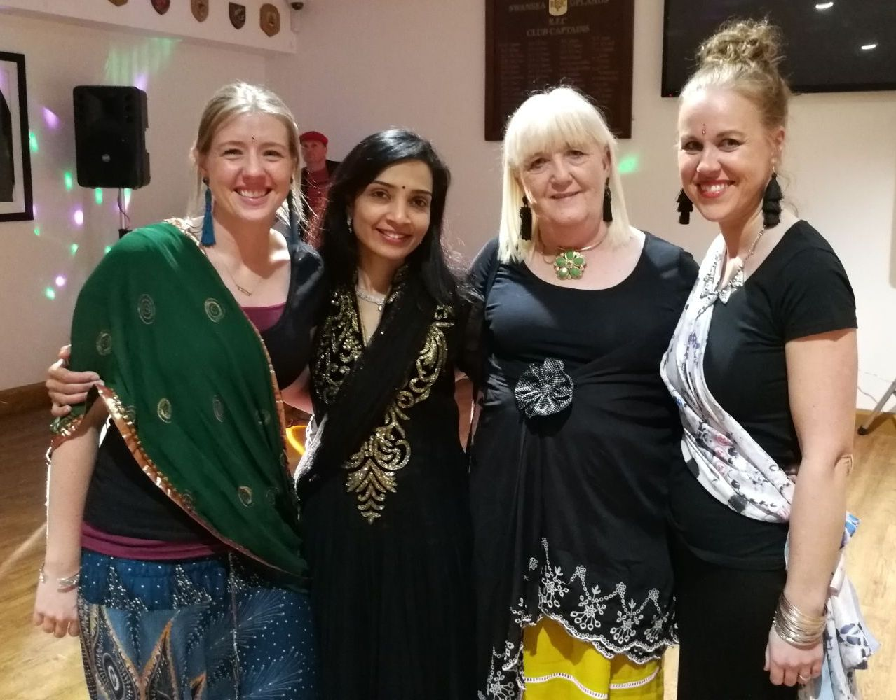
“The feedback we’ve had has been extremely positive. A special thank-you goes to Margaret Lloyd for her relentless raffle ticket sales.

(From left) Catrin Elis, Manju Nair, Margaret Lloyd and Eve Watkins

The money will now be spent on refurbishing a dedicated room where women and their families stay if they have lost their baby. It will also help provide a new counselling room offering private comfortable space.

Catrin added: “Our department strives to provide women and their families with the best possible care, and it is with great pride we now offer the funds we have raised to support, in some small way, our bereaved parents and their families.”

Source: Abertawe Bro Morgannwg University Health Board

