Patient's gift celebrates nursing - at the sharp end
Tuesday, 10 April 2018
A nurse with a particularly steely gaze is keeping a stern eye over the comings and goings at Morriston Hospital’s Cardiac Centre.
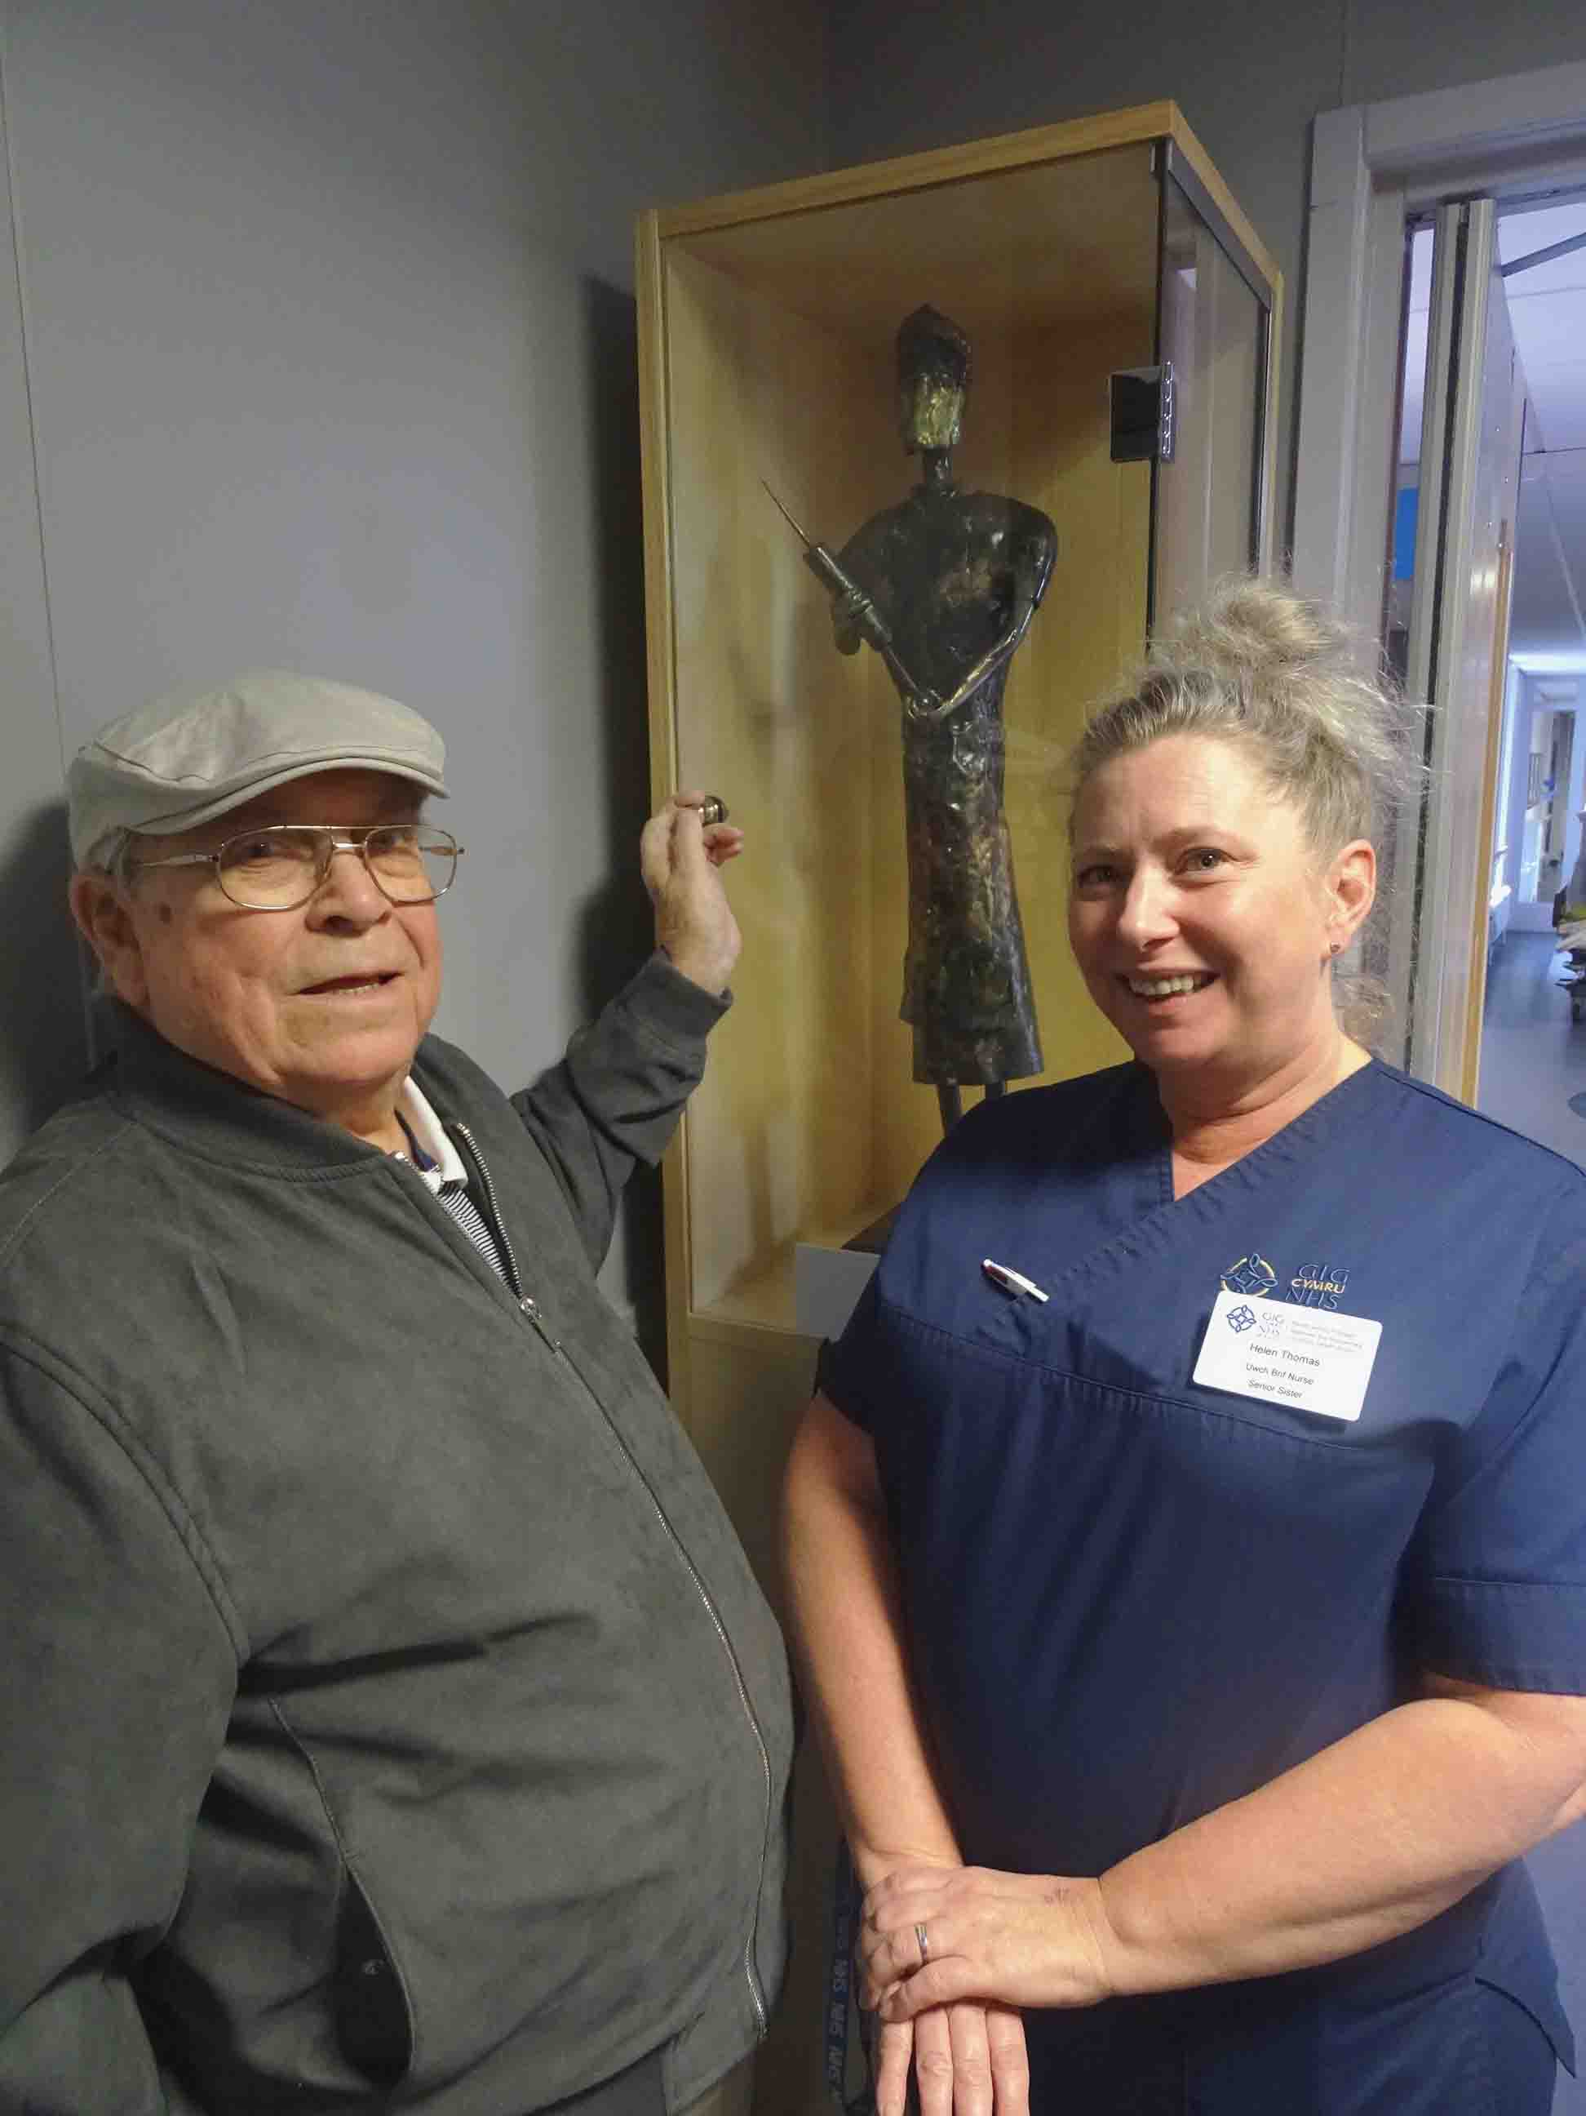
Nurse is the name of a sculpture donated by a former patient who used to create striking metal figures as a hobby.

Complete with outsized syringe, Nurse now takes pride of place in one of the centre’s main corridors.

Dai Griffiths, pictured with Cardiac ITU senior sister Helen Thomas, returned to Morriston Hospital to see Nurse in her new home

Four years ago, Dai Griffiths was admitted to hospital with what he thought was a cold but which transpired to be a serious heart problem.

Dai, aged 82, said: “They tested me when I went in and they found my heart was murmuring.

“They told me I had something wrong with the aortic valve.

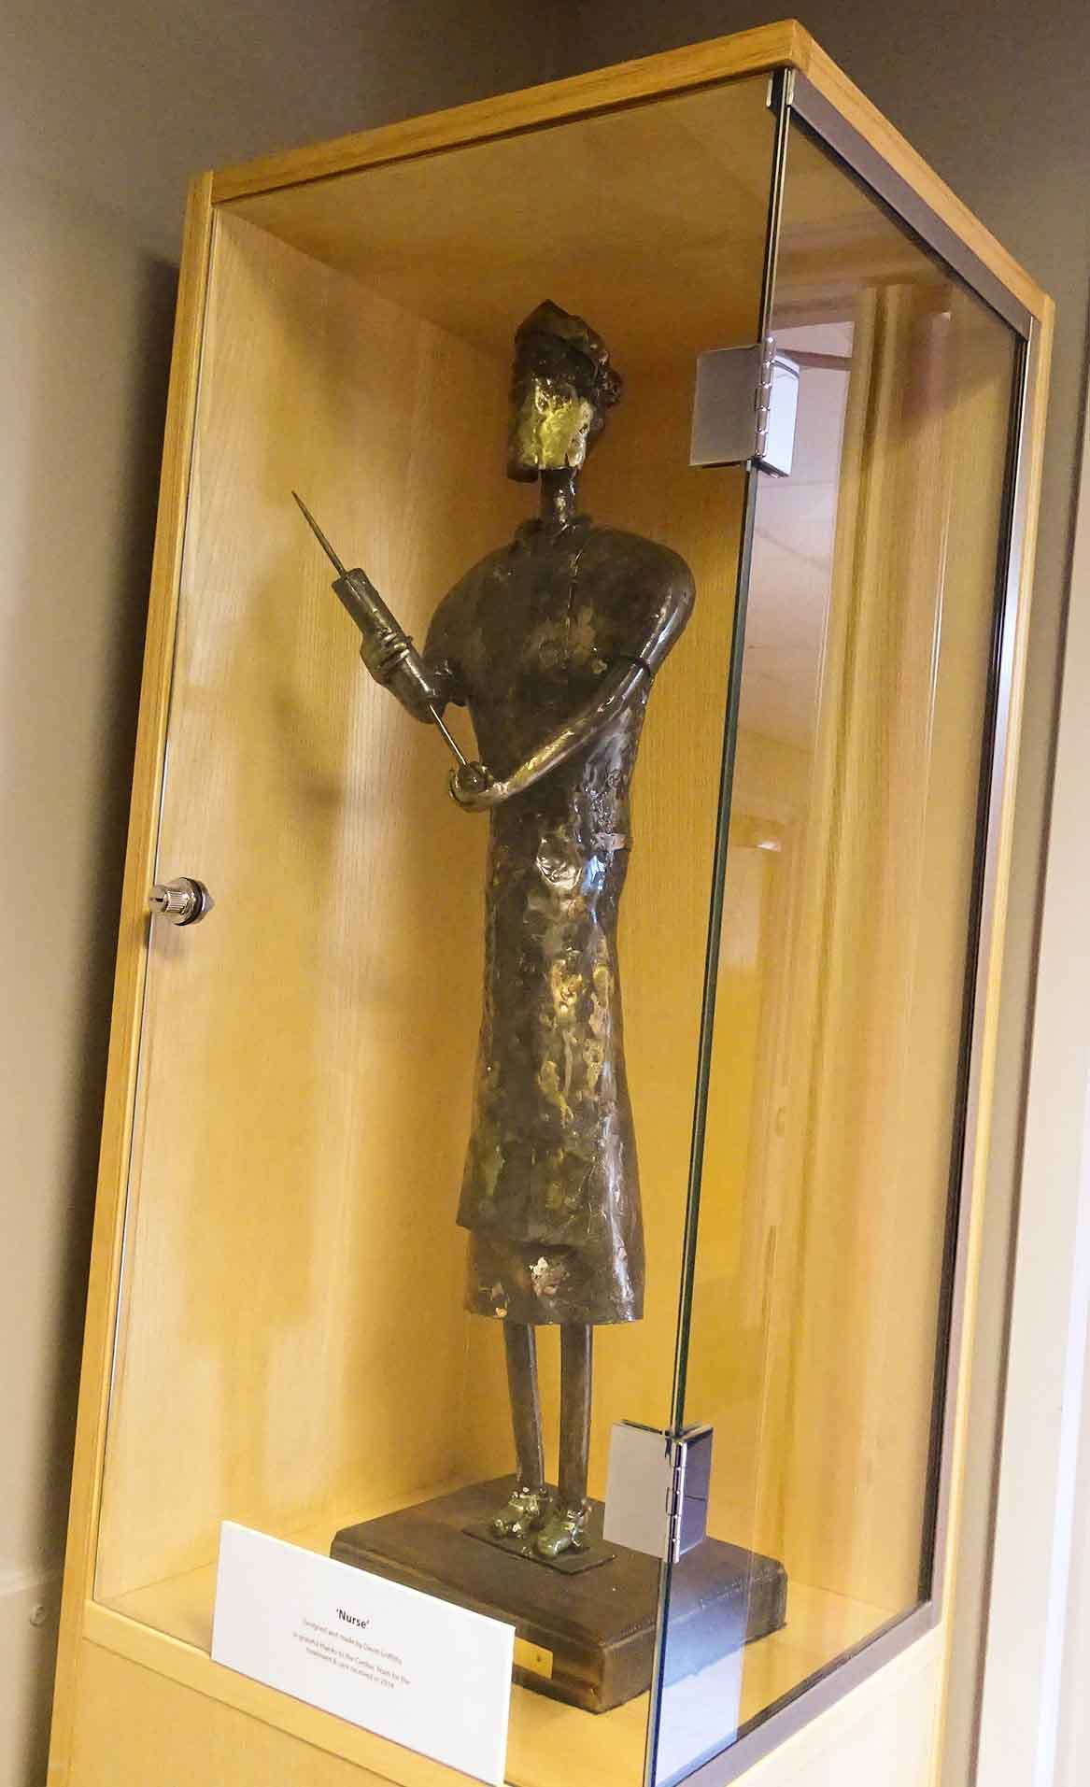
“I had to have that replaced and a pacemaker fitted. That was 2014 and I’m glad to say I’m fine now.”

The retired electrical technician spent an initial four weeks in Prince Phillip Hospital in his home town of Llanelli. That was followed by five weeks in Morriston Cardiac Centre, where he underwent surgery.

“The standard of care here was very good. They looked after me really well,” Dai said while revisiting Morriston Hospital to see the sculpture in its new glass cabinet outside Cardiac ITU (pictured right).

“The sculpture was my way of thanking the staff for what they did for me. I had already made it but I thought I would donate it to the hospital.

“It’s made from steel, with copper on top and brass to give it that shine. I worked on it every morning for three weeks.

“I used to have my own workshop but I don’t do it now. My eyes are not so good and I’ve got to look after them.”

Dai also made several smaller versions of the sculpture, one of which he gave to a Morriston cardiac nurse as a wedding present while he was in hospital.

ABMU property manager Fiona Edwards said: “We have a lot of 2D art in the hospital, so it is great to have a piece of sculpture, particularly one created by a grateful and talented patient.

“I would also like to thank John Weavers Contractors, which tailor-made the cabinet to display Nurse beautifully.”

Source: Abertawe Bro Morgannwg University Health Board

