Pharmacists boost services to offer extra help for patients
Thursday, 26 April 2018
Your local pharmacist is taking over some of the services traditionally provided by doctors in a bid to make life easier for both patients and GPs.

ABMU Health Board has commissioned the new services from chemists to ease the pressure on doctors and give patients faster access to some treatments.

Pharmacists study for five years before they can become qualified and registered so they are experts on medicines and how they are used.

With the number of complex and chronic health problems on the rise, the NHS is calling on the expertise of pharmacists more and more to make sure patients are taking the right medicines for their conditions.

It is keeping staff busy at pharmacies like DR Cecil Jones in Glynneath, where pharmacist Niki Watts is many patients’ first port of call for health advice.

He runs a successful stop smoking scheme, supports local GPs by taking on complex medication usage reviews, and has performed more than 500 flu vaccinations this winter.
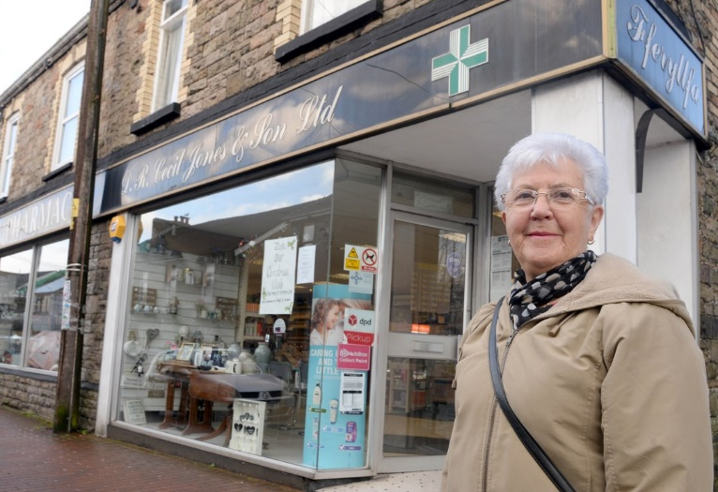
“It makes sense for us to take over things like medication usage reviews or hospital discharge medicine reviews because they take so long and a GP appointment is usually only 10 minutes long,” said Niki.

Customer Ann Pike outside her local pharmacy in Glynneath.

“We are experts on drugs and their side effects and we’ve got the time to explain why the patients are taking them and the best times of day to take them.”

The service is hugely valued by local residents.

“I think it’s marvellous,” said customer Ann Pike, 77. “I couldn’t manage without him.

“My husband has had a stroke and has to take a lot of medication. They put all his tablets out in a box marked with the days so I don’t have to worry about whether he has taken them. They even deliver them to the house.”

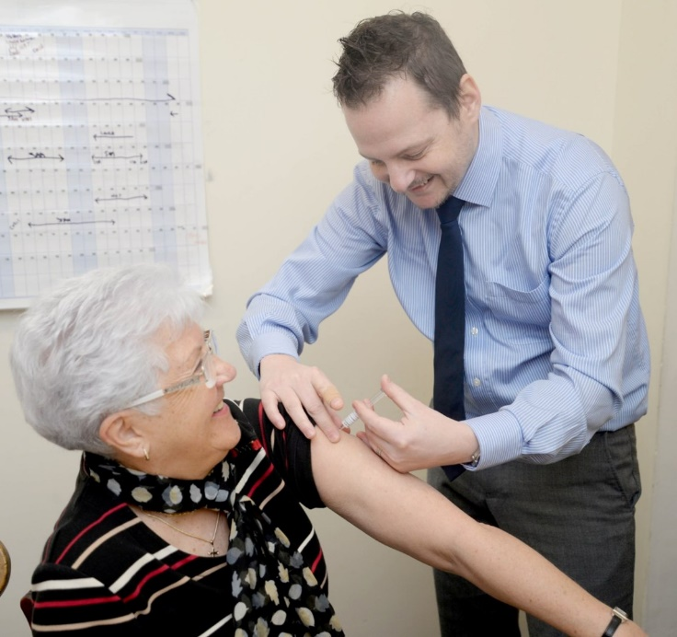
Ann also had a flu vaccination at the pharmacy after seeing a lot of her friends at her bowls club suffering from the flu.

Ann getting her flu vaccination from pharmacist Niki Watts.

She said: “I’m glad I had it done, it wasn’t painful, there weren’t any after effects and it didn’t cost me anything. My doctor’s surgery is so busy; it was much quicker and easier to have it done here.”

“Quite a few people have been hospitalised with the flu this year so we’ve had a huge banner in the window advertising the flu service,” said Niki.

“A lot of people said yes because they could have it done there and then without having to make a special appointment.”

Pharmacists are also supplying emergency prescription medicine and palliative care drugs after hours. For a list of 26 minor ailments, they can now also prescribe prescription-only medicines without the need for a GP appointment.

Meanwhile, extended weekday and Sunday opening hours at chemists is making it easier for people to use the new services.

The extra work being taken on by pharmacists has been welcomed by GPs.

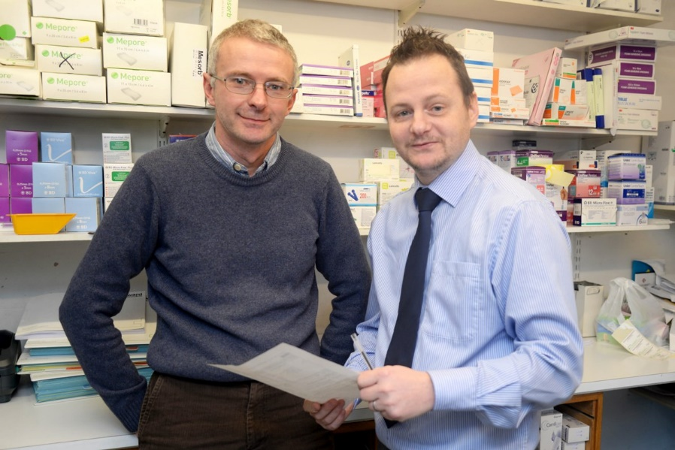
Dr Richard Tristham, who is based at Clydach Health Centre, said: “Pharmacists are vital and we welcome their input. Working together with them is helping ease the pressure we are facing.”

Dr Steve Harrowing (left) with pharmacist Niki Watts.

Dr Steve Harrowing, at the Vale of Neath practice, added: “Not having to spend ages doing complicated medicine usage reviews is freeing up my time to concentrate on sicker patients and more complex cases.

“And from the patients’ point of view, it is a lot easier to walk into a chemist than take a day off work to make a GP appointment. They are open on weekends too, which helps people who are working.”

ABMU primary care programme manager Lowri Hartson has overseen the commissioning of the new services, and is keen to see pharmacies extending their opening hours further.

She said: “Until recently, only two pharmacies in the health board area were commissioned to open on a Sunday.

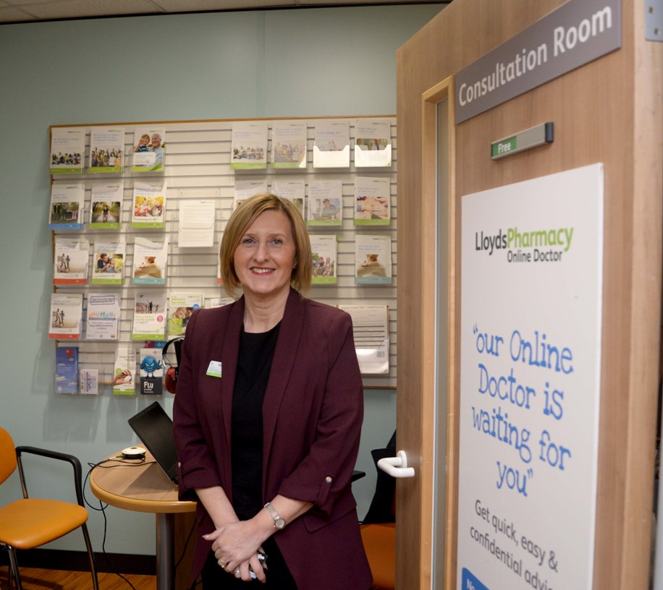
“Now we have commissioned 10 pharmacies to open on Sundays and another six open voluntarily. They open on staggered hours to make sure a pharmacy is always open.”

Pharmacy manager Debra Hughes (left) says customers at Lloyds Pharmacy at Baglan Moors are delighted that the dispensary now stays open until 10.30pm on week nights and 9pm on Saturdays.

“One worried mum pulled up late one night with a poorly child in the back of the car,” she said.

“It’s when you can help in those sorts of circumstances that you don’t mind giving up your Saturday night!”

Find out if your local pharmacy is offering the service by visiting this link and entering your postcode here.

https://www.youtube.com/watch?v=XFZl2XMxFpM

Source: Abertawe Bro Morgannwg University Health Board

