Professor’s prestigious role with Royal College of Surgeons
Monday, 30 April 2018
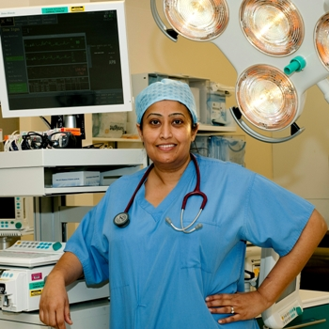
Morriston Hospital’s Professor Farah Bhatti has just been elected to the Council of The Royal College of Surgeons of England.
It is the latest prestigious appointment for the consultant cardiothoracic surgeon who is the current Chair of RCS’ Women in Surgery Forum (WinS).

She becomes the first female cardiothoracic surgeon ever elected to serve on the Council.

Professor Bhatti (right) said her four-year term of office would give her the opportunity to work on behalf of all surgeons including those in training, SAS (staff and associate specialist) surgeons and consultants, regardless of background.

“I am delighted to have been successful in the Royal College of Surgeons of England Council elections. Being on the RCS Council will be both an honour and a privilege,” she said.

The role will also allow her to continue pursuing her passion for teaching, training and equality.

As Chair of the WinS forum she hosts and speaks at events across the UK aimed at encouraging, enabling and inspiring women to fulfil their surgical potential, and so improve gender balance in the profession.

Professor Bhatti, who will be one of only two Council members from Wales, added: “I am excited about being able to support the RCS’ agenda to advance surgical care and ultimately benefit patients across the UK and, of course, our patients here in Wales.”

AMBU Executive Medical Director Hamish Laing said: “I am delighted that Farah has been successful in being elected to the Council.

“As a Fellow of the College myself I know how competitive the process is and how surgeons from the smaller specialties can find it hard to secure the required number of votes, and so her achievement is all the more noteworthy.

“I am in no doubt that it reflects the leadership she has shown for women in surgery, which is vital for the specialty, as more of our young medical trainees are female. It also reflects well on NHS Wales and ABMU and I am sure she will represent us well on Council.”

Source: Abertawe Bro Morgannwg University Health Board

