Pupils given lessons about Welsh in the workplace
Tuesday, 17 April 2018
Schoolchildren have been given the chance to find out just how staff at Neath Port Talbot Hospital use Welsh during their jobs.
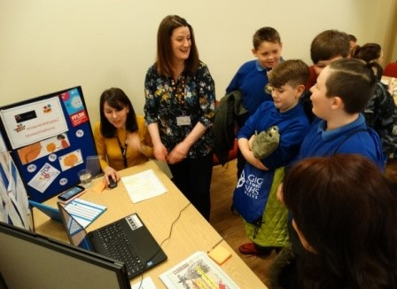
The youngsters from Years 5 and 6 at Ysgol Y Ferch o’r Sger in North Cornelly were the special guests at an information day hosted by the hospital.

They discovered more about health staff’s different roles and what their jobs entail in a series of fun interactive workshops, all delivered through the medium of Welsh.

Quality, safety and improvement manager Angharad Higgins, who organised the visit, said: “It is really important for children to appreciate the breadth of roles in the NHS and the fact that Welsh is a live language that is used in the workplace.

“We want them to realise that Welsh does matter.”

During their welcome the 50 children were told about the many career opportunities that health boards like ABMU offer.
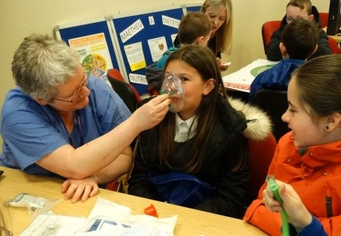
They were then split into groups to take turns finding out more at individual stations hosted by theatres, dietetics, physiotherapy, school nursing, speech and language therapy, pharmacy, occupational therapy, ABMU’s Welsh language department and the Welsh Ambulance Service.

Mitchell Jones, from ABMU’s Apprentice Academy, who helped arrange the event, said: “A big part of my role is going out to schools and explaining what careers we can offer. Today is great because it sees a school coming to us instead.

“We can make them aware of how big the NHS is and hopefully this shows children the kind of careers available to them locally where they could continue to use their Welsh at work.

“Also it is always helpful for us to build up our links with the community.”

The children were accompanied by members of staff Eirwen Keirl, Sara Marks, Rhys Lewis and Bethan Morgan.

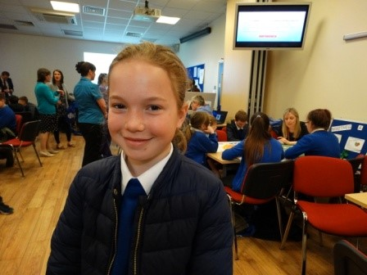
They said: “This has been a great opportunity for the children. It has been engaging and interactive. Nobody has been bored and they have all learned so much.”

Among the children was 10-year-old Georgia Smele (right). She said: “I have really enjoyed it. I definitely know much more about the NHS now. I liked finding out about all the different jobs.”

Angharad added: “We’re delighted with how well it went. We had a great response from the children, their feedback has been totally positive.

“We look forward to holding more of these events and giving other schools the opportunity to come in and find out more about us.”

To see our Welsh language Facebook post about this click here

Source: Abertawe Bro Morgannwg University Health Board

