School nurses roll up sleeves to give MMR vaccines during school hols
Tuesday, 17 April 2018
School may have been out for Easter but it was far from a holiday for Swansea’s dedicated team of school nurses.

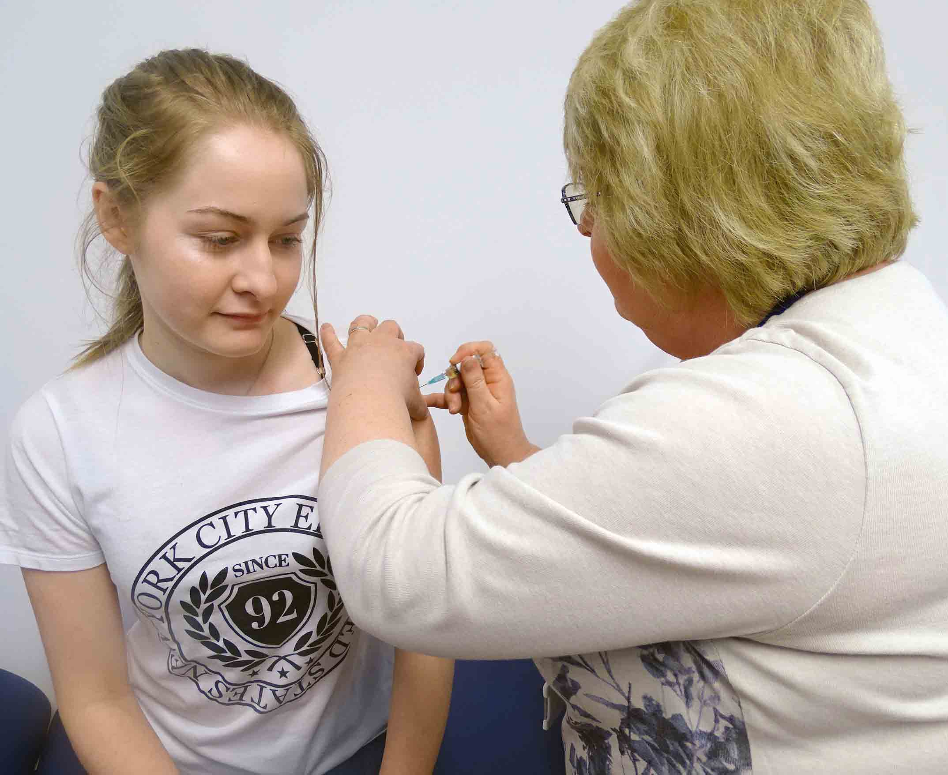
They rolled up their sleeves to help GP surgeries make sure youngsters were fully protected against measles, mumps and rubella.

17-year-old Paulina Skoczek has her MMR vaccine from school nurse Jackie Clements

They teamed up with the Penderri cluster of practices in the city to run MMR vaccine catch-up sessions for 5-18-year-olds.

Each practice contacted parents whose children were due either their first or second dose, inviting them to attend one of a series of drop-in sessions the surgeries hosted during the holiday.

ABMU’s school nursing lead Susan Jones said: “The aim of the exercise was to try to get MMR in 5-18-year-olds up to the level it should be so we have herd immunity across the health board.

“Herd immunity is when people who, for one reason or another, genuinely can’t be vaccinated, are protected. You need to be above 95 per cent and we are not yet at that level.”

Latest figures for the health board show only 90.7 per cent of 5-year-olds have had 2 MMRs, falling to 84.8 per cent of 16-year-olds.

Susan said it was important the take-up rate was increased as measles was circulating as close as Cardiff and Newport.

“A lot of children and young people from our area will go to Cardiff during the school holidays.

“And with lots of large events coming up in Swansea, such as the Biggest Weekend in Singleton Park, we know that those from Cardiff and Newport will be coming here too.

“But it’s not just about measles. Mumps can cause fertility problems in girls and boys, while rubella can have devastating effects, especially during pregnancy.”

Children should have had two MMR vaccines before starting school – the first at around 12 months and the other aged three years and four months.

The vaccine programme is usually delivered by practice nurses. However, during the Easter holidays the school nurses ran two all-day drop-in sessions in the five surgeries within the Penderri cluster.

Susan said: “School holidays are far from a break for the school nurses.

“That is when they do all the catching up, contacting parents, making sure our electronic files on the children are up to date, doing any follow up calls and so on.

“So these drop-in sessions are not something we would usually do.

“We did them to support our GP practice colleagues because we are very concerned about children and young people having the full range of vaccines and being fully protected.

“If this pilot works we will look to see if we can do it in the other school holidays, perhaps an annual event to try to catch up.”
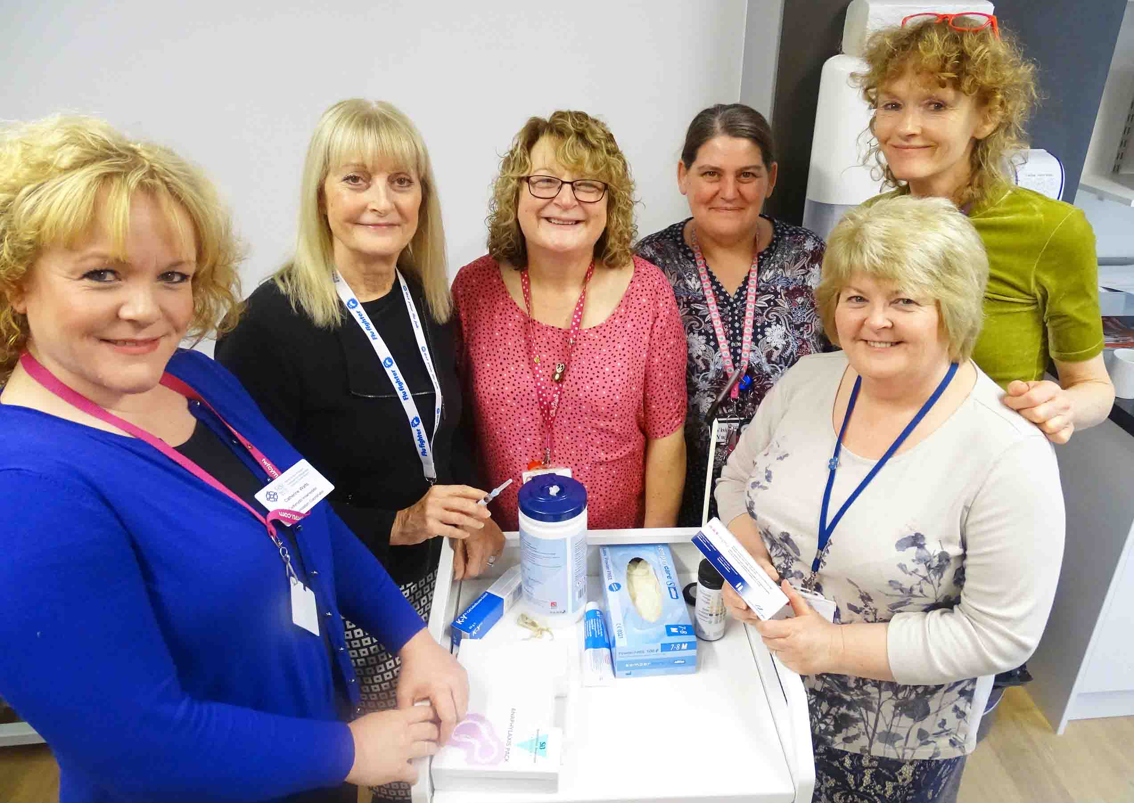
l-r: ABMU Immunisation coordinator Cath Watts, school nursing lead Susan Jones and school nurses Sandra Marten, Penny Kieft, Tracy Warrington and Jackie Clements

Among the young people who attended the drop-in sessions was 17-year-old Paulina Skoczek from Penlan.

Paulina, who went to the session in Brynhyfryd Medical Centre, said: “It was fine. It didn’t hurt at all.”

ABMU area clinical director Richard Tristham said: “This offers us a fantastic opportunity to vaccinate people who have not had the immunisations.

“It has been made possible due to close working partnerships and we hope to build on these in the future to improve the health of the citizens of Swansea.

“I would like to offer my thanks to our school nursing service, which has performed exceptionally well this year with regard to immunisations.”

Source: Abertawe Bro Morgannwg University Health Board

