Cancer patients will help design new nursing course in Swansea
Tuesday, 8 August 2017
Cancer patients and hospital staff are being recruited to help design a new nursing course created and delivered in Swansea.
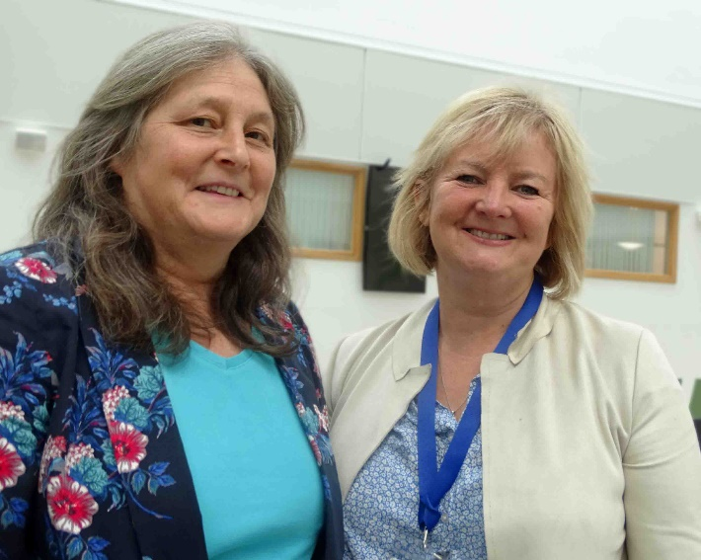
Specialist ABMU staff are working with Swansea University on the tailor-made module, which will not only help drive up standards but could also address a Wales-wide issue with nursing vacancies.

Consultant haematologist Ann Benton (left) and senior specialist haematology nurse Elizabeth Lardner.

This national, accredited course in haematology and oncology nursing is due to start in January and will be open to nurses at all levels of experience working in Wales.

It is being designed to help support, educate and train staff to deliver the most effective cancer nursing care to patients.

The course will be taught by nurses, as well as senior clinicians and other relevant healthcare professionals, and will be repeated in 2019 and 2020.

Staff in ABMU’s haematology department came up with the original idea as part of a package of ways of raising awareness and interest in becoming a haematology or cancer nurse working in Swansea.

Senior specialist haematology nurse Elizabeth Lardner is leading the development of the course with consultant haematologist Ann Benton.

Morriston Hospital-based Elizabeth said nurses, often newly-qualified, needed additional training if they wanted to enter a speciality such as haematology (blood-borne cancers) or oncology (hard tumours).

With the demands of the service having changed over the years, she said, the type of training provided on existing courses was not always the most appropriate to equip staff to deliver the highest standard of care.

Elizabeth said: “It is costly both in time and resources to send people on these courses and for various reasons they don’t always come back with the skills they need to work most effectively.

“This can lead to problems such as delays to treatment if there are not enough suitably-trained nurses on that shift.

“We have to get back to basics because there is a real problem all across Wales with retaining staff.

“Nurses are leaving and one reason why is because they feel they do not always get adequate training in these specialist areas.

“We realised we needed to do something. We needed to set up a recognised accredited course that was clinically driven and run by clinicians. That was the starting point.”

Elizabeth said the views of nurses and patients who had experienced acute clinical care would be crucial in designing the course content.

As a result they were being invited to a workshop in Morriston Hospital’s education centre on Thursday 31st August, from 9am-12pm.

Elizabeth said: “We want patients and their families to work with us, to share their opinions – positive or less positive, but constructive – so we can try to meet everyone’s expectations.

“In my experience I don’t think we’ve ever done it this way before.”

The course will run one day a week over 14 weeks at Swansea University, with nurses also having portfolios and assignments on top of this.

Elizabeth said there were still details to be worked through and the ideas generated by everyone at the workshop would be very important in helping to shape the course.

“It is important that different parts of the course can be delivered by the most appropriate people with the right level of practical experience from working with blood and solid cancers.

“Using the experiences of patients and their carers of what it feels like to be cared for by our nurses is a very important part of making sure we get the content and balance of the course right.

“We are going to have nurses teaching nurses for maybe 50-60 per cent, giving them exactly the level of instruction they need.

“Then as the course progresses we will have more senior people coming in.”

Elizabeth said it was not just about attending the course one day a week. Nurses would also work closely with a mentor as they went about their everyday duties.

They would also have the opportunity to learn from each other by sharing their own experiences of caring for patients and what they found most challenging.

Elizabeth added: “We’re hoping the 10 nurses on the first course will then go out and tell others how good it is so we get 10 the year after and again the year after that.”

Haematology and oncology patients who have experienced acute care and would like to attend this month’s workshop are asked to email Elizabeth.Lardner@wales.nhs.uk

Source: Abertawe Bro Morgannwg University Health Board

