Careers day for speech therapists of the future
Thursday, 24 August 2017
Places are now available at a special event aimed at highlighting what a career in speech therapy has to offer.

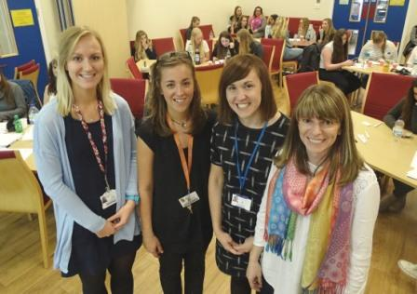
The workshop is aimed at students in Year 10 and above who are considering speech and language therapy as a career option.

Speech therapists Alys Cootes, Nia Jenkins, Sian Matthews and Sarah Brown at last year’s event.

The event, organised by ABMU speech and language therapy staff, takes place on Thursday 19th October from 9.30am to 4pm in Neath Port Talbot Hospital and is open to students living within the health board area.

Speech and language therapists are trained to assess, diagnose and treat children and adults who have difficulties with speech, language, voice and communication, or with eating, drinking and swallowing disorders.

They work in a variety of settings - from hospitals and clinics to schools and play groups as well as in the home dealing with many different clinical conditions in patents of all ages.

The event will include workshops, video material and presentations from experienced therapists who work with a range of adult and paediatric client groups.

There will also be an opportunity to meet newly qualified therapists who can offer valuable insight into applying and studying for a career in speech and language therapy. This is an interactive day so please come with your questions.

The event could form part of the work experience requirement for students in school or college.

As it features a varied timetable anyone coming along needs to be able to attend the full day a certificate of attendance will be provided.

There is a limited number of places so contact Judith Williams on 01656 752143 to register and request an information pack. Pre-booking is essential.

For more information about speech and language therapy as a career, visit the Royal College of Speech and Language Therapists website www.rcslt.org or take a look at their careers guide booklet http://www.rcslt.org/speech_and_language_therapy/careers/career

Please note that information about qualifications required to access speech and language therapy courses needs to be obtained from the universities directly. NHS therapists are unable to provide this information.

You can also view the ABMU speech and language therapy page at http://www.wales.nhs.uk/sitesplus/863/page/54322

Source: Abertawe Bro Morgannwg University Health Board

