Health board looking for new recruits as apprenticeship scheme continues
Tuesday, 15 August 2017
School leavers picking up exam results this month are being invited to consider a career in health care as ABMU gets set to recruit its latest apprentices.

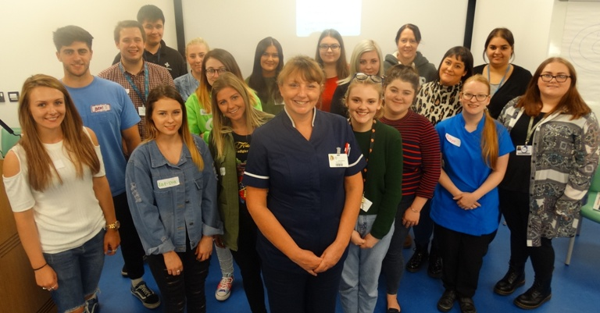
Since launching apprenticeships for the first time last September, the health board scheme has gone from strength to strength.

ABMU apprentices with Morriston Hospital Nurse Director Nicola Williams

There are now 41 apprentices, ranging in age from 17 to 38, at varying stages of training working in a wide variety of departments.

Apprenticeships are a way of giving people a chance to learn new skills while gaining nationally recognised qualifications and being paid at an apprentice rate. It also provides a close-up look at the health service and the many career opportunities it offers.

At a special workshop, organised by ABMU apprentices team at Morriston Hospital, the current trainees have been sharing their experiences of what it’s like to be an apprentice.

Alexandra Perry, who is an apprentice physiotherapy assistant at Princess of Wales Hospital, says it has been a valuable stepping stone on her career path.

“I work on Ward 2, the stroke ward, and basically assist the physiotherapists with looking after the patients, carry out transfers assessments and general duties.

“I am hoping to go on to university to do a physiotherapy degree and it’s given me a really good idea of what it entails – I’ll know what the job’s about because I have experienced it.”

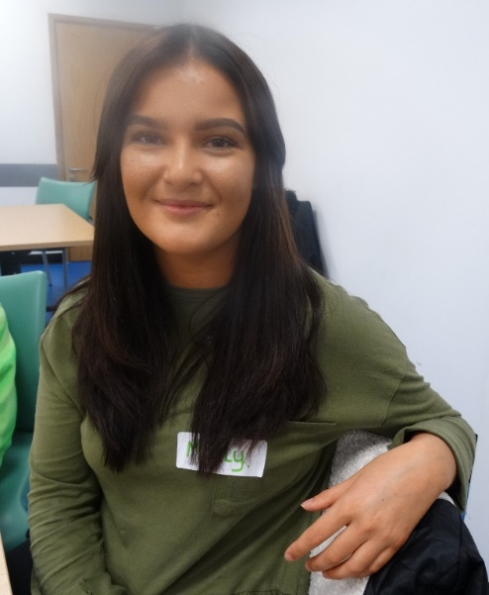
Molly Cornelius, (left) aged 20, of Ystradgynlais, is working as an apprentice health care support worker on Cyril Evans Ward at Morriston Hospital.

“I am really enjoying my role and it’s given me opportunities I wouldn’t have had otherwise. I wasn’t sure what would be involved when I first started but I am helping with patents’ personal care, prepping for theatre, taking blood pressure - no two days are the same,” she said.

Other apprentices who attended are working in areas including audiology, pharmacy, pathology, patient experience and IT.

ABMU’s apprenticeship and widening access co-ordinator Mitchell Jones said: “There’s a real variety of careers that people can opt for. This is a great way of nurturing our own talent and offering people the opportunity to earn while they learn.

“We want to give people the opportunity to start with us and build a life-long career in the NHS.”

He said the difference apprenticeship has made to those talking part has been remarkable.

“You can see the confidence that they get – it’s nice to see them growing in confidence and believing in their own ability.”

He added: “Essentially we are hoping that they will get a permanent role and we do have a number who have now secured job.”
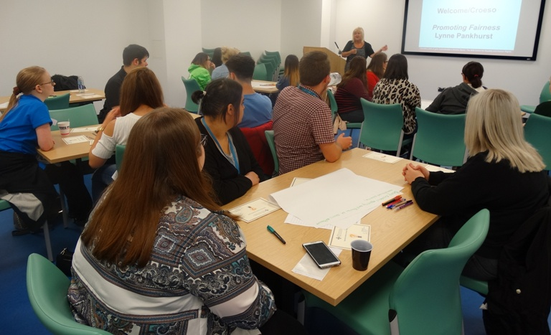
Among those is Amber Anderson who will be moving from the ENT outpatients at Morriston Hospital to take up a post in the maxillofacial department.

Apprentices taking part in the workshop at Morriston Hospital.

“I am very pleased and I am looking forward to starting my new job. Becoming an apprentice definitely improved my job opportunities. I feel really excited about the future.”

Mum-of-one Amber said: “I have always been made to feel one of the team, nobody has ever looked down on me because I’m an apprentice – they have always had the time to explain things to me and answer my questions. I have learned so much.

“I would say to anyone considering an apprenticeship apply, it really has been worthwhile for me. “

Morriston Hospital Nurse Director Nicola Williams also attended the event to meet the apprentices. She told them: “We are so grateful for your contribution. We are very keen to do all that we can to support you because you are the next generation of staff.”

During the day the apprentices compared notes on their duties and also got a chance to receive additional training on equalities as well as a session in the importance of positive psychology in the workplace.

They also provided feedback and suggested changes to help the recruitment process for the latest intake of apprentices.
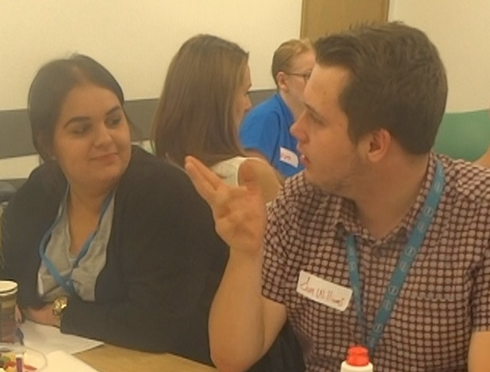
As a result there will now be two special events designed to provide as much information as possible about the roles the apprentices are applying for as well as a chance to talk to staff they would be working with.

Amber Anderson with fellow apprentice Sam Williams during the apprenticeship workshop.

The Apprentice Recruitment Days will both take place from 11am to 3pm on Friday 25th August in Lecture Theatre 2 at, Morriston Hospital Education Centre and in the Lecture Hall, Education Centre, Neath Port Talbot Hospital.

The dates have been chosen so potential apprentices who have just received exam results can come along and meet ABMU Apprentice Team and find out more about the opportunities on offer across the health board in areas such as business administration, support services and health care support work.

To find out more email abm.apprenticeships@wales.nhs.uk

You apply for the apprenticeships go to http://jobs.abm.wales.nhs.uk/
Source: Abertawe Bro Morgannwg University Health Board

