Health visitors spreading the word about how they can help families
Wednesday, 16 August 2017
ABMU’s team of health visitors are getting set to head into the community to highlight and celebrate the wide range of help they offer to families.

Every year National Health Visiting Week gives them an opportunity to spread the word about the support available to parents and their children as well as pass on new skills.

This year’s event, which runs from 21st to 25th August, is concentrating on highlighting the wide range of support for families.
During 2016 ABMU health visitors:
- Saw 28,266 children aged under five;
- Gave out 5,350 toothbrush packs and offered oral health advice which has helped reduce tooth decay to its lowest ever rate;
- Assessed 5,086 new mothers for signs and symptoms of post-natal depression;
- Supported literacy by issuing 5,856 baby book Start Reading packs and 6,095 early years start reading packs;
- Assessed 5,086 babies at 10 to 14 days old and offered all families basic life-support and choking demonstrations; and
- Gave advice on immunisations and as a result 92.5 per cent of children were fully vaccinated by the age of 5.
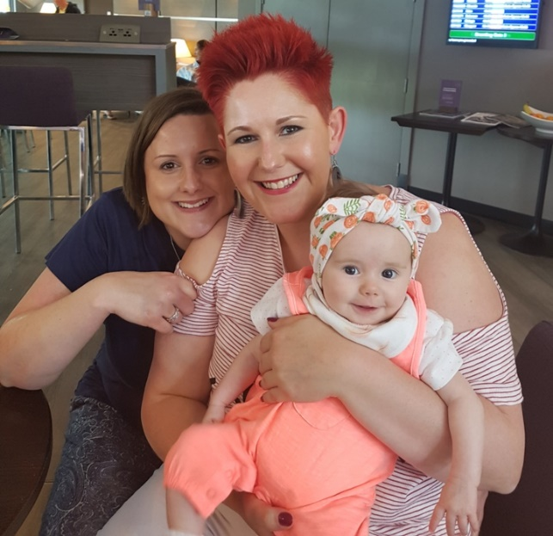
One area where health visitors are playing an important role is supporting new mothers like Kate Clarke, of Nantymoel, with breastfeeding.

Kate Clarke and her partner Megan Davies with their daughter Nettie.

“I really wanted to breast feed but I had a bit of a rocky start after Nettie, who is now four months, was born but now it is like the easiest thing in the world,” she said.

Kate’s health visitor Enfys Lewis pointed her in the direction of breastfeeding clinics held at Bryntirion Clinic and Neath Port Talbot Hospital and a special breastfeeding session at Princess of Wales Hospital.

“It was absolutely brilliant. I am the first person in my family to breastfeed and I have had great support. I didn’t get stressed – they said it would happen and I believed them, and they were right.”

Enfys was also able to give Kate other information including details of a local breastfeeding and new parents’ groups.

“Now we meet up all the time and we can encourage each other with breastfeeding.”

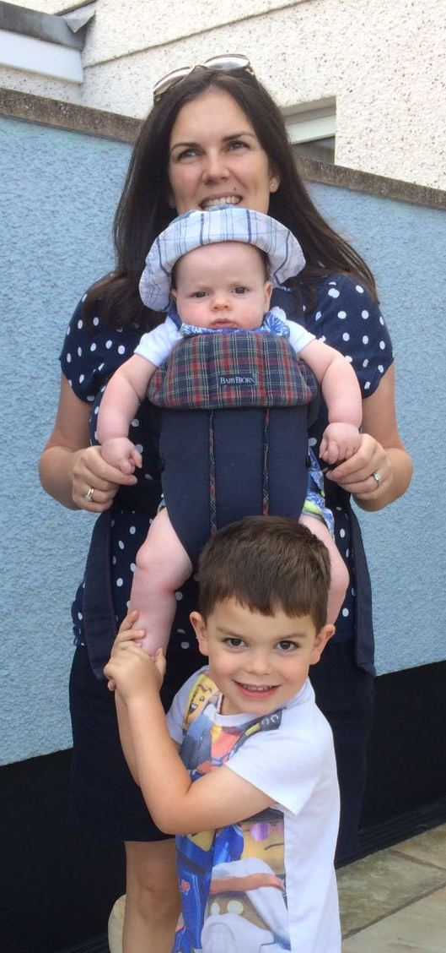
When Rachel Bidder, of Pennard, encountered problems breastfeeding with her younger son Elis she was given expert advice from Clare Shears, one of ABMU’s infant feeding coordinators for the health visiting service.

Rachel Bidder with Elis and his big brother Macsen.

“I had breastfed my son Macsen and I was determined to do the same with Elis but it wasn’t as easy. However as soon as I saw Clare she made me feel like I was doing well and she made me feel comfortable.

“She gave me practical advice and a plan of things I could try with Elis that might help. Just because I had done it before didn’t mean it was the same this time but the support was tremendous. I am very grateful for all she did for me,” she said.

Clare, who along with her colleague Lynne Powell, provides a specialist breastfeeding service across the health board, supporting families with breastfeeding challenges, said: “Breastfeeding isn’t always easy, it’s a skill that mums and babies learn together and sometimes they need a little bit of help to master it.

"We are here to give that support as we really believe breastfeeding will give your baby the healthiest possible start in life.”

Health visitors will be able to answer questions about breastfeeding during a series of special awareness events being held next week.

The sessions will also include baby massage and guidance on diet and immunisation as well as demonstrations of infant CPR techniques. ABMU has one of the few health visiting teams who provide this service universally and the team say it can make a lifesaving difference.

Health visiting lead for Swansea and Public Health lead for health visiting Jane O’Kane added: “Please do come along and take the opportunity to ask the questions you may need about preparing your little one for school with routines or ask us about any health matter you are worried about,” she added.

Events will be taking place between 10am and 3pm on:
Monday 21st August at Gnoll Park Neath
Tuesday, 22nd August, Port Talbot Resource Centre and St Catherine’s Church Hall, Princess Street, Gorseinon
Wednesday 23rd August, Neath Port Talbot Hospital atrium and the outpatients atrium at Morriston Hospital
Thursday, 24th August, 360 Cafe, Mumbles Road, Swansea

Source: Abertawe Bro Morgannwg University Health Board

