Innovative new clinic helps faster cancer diagnosis
Tuesday, 1 August 2017
A new service - believed to be one of the first of its kind in the UK - is being piloted at Neath Port Talbot Hospital offering same-day diagnosis for potential cancer patients who might otherwise slip through the net or face delays getting treatment.
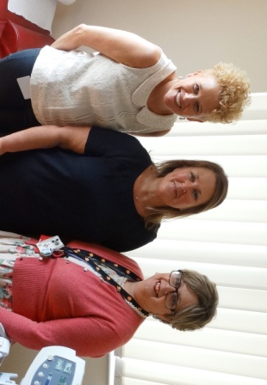
Not everyone with cancer has easily spotted ‘red flag’ symptoms which indicate the disease. As many as one in two might present with vague symptoms, or symptoms which are commonly found in a range of other conditions.

For these patients, the road to a cancer diagnosis can be a long one, as they go from one specialist to another. Their GP may suspect cancer, but getting a firm diagnosis can take time, and that can mean a delay on their treatment starting.

The new fast-track Rapid Diagnosis Centre at Neath Port Talbot Hospital, which opened in June, aims to cut through this. It lets patients know if they have cancer either the same day, or within a week if they need additional tests.

If a patient does have cancer, they are then referred on to a specialist team for treatment. If they are found not to have cancer, but a chronic illness instead, they will again be referred for the right treatment for their condition.

Since the weekly service started, 13 patients have been seen, and three have been diagnosed with cancer.

Clinical lead for the new service, is Briton Ferry GP Dr Heather Wilkes. She became an advocate of the new service after going to Denmark to see a similar one already in action, which was having fantastic results.

She said:

“As GPs, when we see patients with suspected cancer, only 50% will actually present with obvious ‘red flags’ - symptoms like a breast lump, or rectal bleeding, which suggest they might have breast or bowel cancer.

“With these patients, we know which specialist cancer care pathway we need to refer them to for further investigations.

“However, the remaining 50% of patients may have symptoms which are much more vague, and don’t fit into a specific pattern.

“GP gut feeling is quite sensitive, and we often know there’s something wrong but we don’t know quite what. A patient may have a series of vague symptoms which are getting worse, and we might suspect cancer, but the red flags aren’t there.

“With cancer early diagnosis is key. The sooner cancer is diagnosed, the sooner treatment can start and the prognosis is improved.

“If a GP has a feeling the patient has cancer, but there is no clear cancer pathway to refer them to, then a lot of time can be spent referring them to lots of different specialists and tests and waiting for results. While this is going on, time is ticking by and they are not receiving the treatment they might need.

“GPs in the Neath Port Talbot area can now refer this group of patients directly to the new Rapid Diagnosis Centre where they will have a diagnosis that same day, or very soon afterwards.”

If cancer was found, she explained, then patients are referred to the correct specialist cancer service; and with tests and investigations already done at the RDC, patients will be well on their way to getting the treatment they need.

“If cancer is not diagnosed, but another chronic condition like rheumatoid arthritis, COPD or inflammatory bowel disease for example, then we refer them to the correct specialist for their care, and again they will have already undergone many of the tests and investigations already.”

She added:

“What I learned from Denmark is the principle of doing what’s best for the patient in front of you now. It might be more resource intensive at first, but it pays off in the long run as they don’t need repeat scans and tests with different specialists, and treatment can start right away.”

Neath Port Talbot Hospital Director, Claire Birchall, explained that if GPs think they have a suitable patient, blood tests and X-rays are carried out first. If those don’t show anything specific, but the GP is still worried, the patient can be referred to the new service.

She said:

“At the RDC they get a CT scan, which shows up more detail than an X-ray, and their case is explored and managed by a very experienced multi-disciplinary team. They also get rapid access to further tests like an endoscopy, if they need it.

“This saves a lot of time for the patient. Rather than go through three or four different cancer pathways before something is found, our aim is to give them a diagnosis that day, or within a few days if they need an endoscopy.

“This is very much a people-centred approach. Patients arrive at 9am and are here for about four hours. They have access to a lounge with a TV, and we offer them tea and coffee and sandwiches for lunch.”

The development of the RDC has drawn on the expertise of a range of health professionals from across the health board. As well as Dr Wilkes, the RDC team includes Consultant Physician Dr Geraint Jeremiah; Consultant Radiologist Sian Phillips; and Centre Coordination Manager Helen Gray. There is also a healthcare support worker post and moves are underway to add a specialist cancer nurse to the team as well.

The pilot scheme at Neath Port Talbot Hospital is currently available for GP practices in the Neath Port Talbot area only. Currently held once a week, it has the capacity to offer a second weekly session as demand grows.

Funded by ABMU and the Wales Cancer Network, the scheme is expected to help improve the rates of early cancer diagnosis. Macmillan has also lent its support by funding two sessions a week for Dr Wilkes to work on cancer-related issues, allowing her to develop the RDC. Macmillan will also fund the new specialist cancer nurse.

A similar pilot also started a few weeks after this one, in the Cwm Taf University Health Board area. Both pilots are working collaboratively by sharing learning and tracking progress.

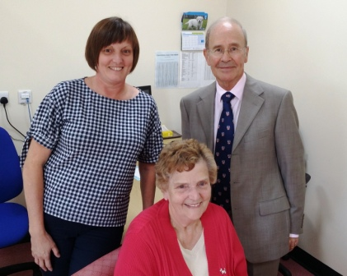
Great grandmother, Joyce Thomas, aged 79, from Pontardawe, was able to have her mind put to rest following a series of tests at the RDC.
She was the 13th patient to use the new service.

“I’ve had blood tests, scans, and a lot of things happening since I arrived at quarter to nine this morning,” she said. “It’s nice to hear straight away and not wait weeks for the outcome.”

Her daughter, Mrs Julie Morgan, said: “It’s been a brilliant service. She has had a lot of tests down throughout the morning and the news has been quite good, so we’re really pleased.”

Picture1: L-r Claire Birchall, Director of Neath Port Talbot Hospital; RDC Clinical lead Dr Heather Wilkes and Consultant Radiologist Sian Phillips.

Picture2: Mrs Joyce Thomas, seated, with her daughter, Mrs Julie Morgan and Consultant Physician Dr Geraint Jeremiah.
Source: Abertawe Bro Morgannwg University Health Board

