Midwives share how research is shaping future care for women
Friday, 11 August 2017
Vaughan Gething has been finding out how midwives are developing and improving maternity care for mums-to-be during a visit to Singleton Hospital.

The Cabinet Secretary for Health was eager to learn more about the work of research midwives who have increased not only the number of clinical trials taking place in ABMU but also the number of pregnant women taking part in them.

These trials are crucial in helping improve outcomes in pregnancy and birth and therefore the experience of mums-to-be and their children.

The team, including the health board’s first research midwife Sharon Jones, was shortlisted in the Promoting Clinical Research and Application to Practice category at last year’s NHS Wales Awards – which brought its work to Mr Gething’s attention.

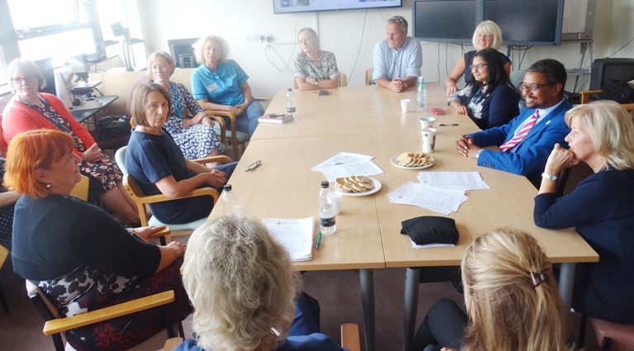
Cabinet Secretary for Health Vaughan Gething meeting members of Maternity Services and senior management at Singleton Hospital along with ABMU non-officer board member Gaynor Richards.

“I like to see the good work that is going on and how shortlisted projects have progressed since the awards,” said Mr Gething who was particularly interested to hear how pregnant women are recruited to take part in the trials.

Sharon explained there are several ongoing research studies into various aspects of pregnancy, and mothers across both the Health Board who might be suitable for inclusion are given the opportunity to take part.

She emphasised that they are never under any pressure but many women are happy to get involved and are very pleased to have been asked.

“We always have to be careful and sensitive but you can never second guess how they are going to feel about it. Also we always try to let people know the results as soon as possible,” she said.

Consultant midwife Sarah Fox said: “We find that the women involved value being asked to be part of the research process.”

She added that the team, which won an ABMU Chairman’s Award in 2015 for its work, was delighted to have received recognition for setting up and coordinating trials.

“We are very proud of what we have done to promote research.
It has been a real team effort but it is a work in progress – it is something that is going to get bigger and bigger.”

Sharon added: “We have a growing reputation for research now and this is assisting us with recruitment.”

During the visit Mr Gething also met members of the team involved in running Singleton’s Antenatal Clinic, where mums-to-be can access specialist advice from consultants as well as receive counselling and advice from midwives, and the Antenatal Day Assessment Unit.

This unit provides outpatient care to women with pregnancy complications who might otherwise need to be admitted for monitoring and care.

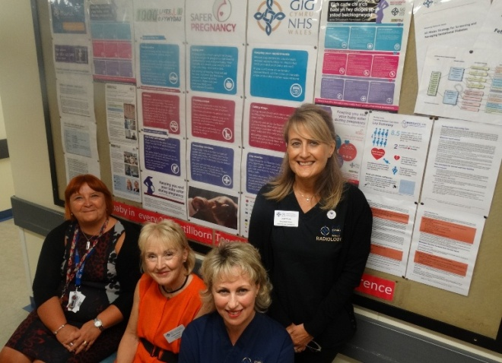
(From left) Singleton Hospital lead midwife Melanie Llewelyn, consultant obstetrician Margery Morgan, sister Vicky Langford and superintendent sonographer Delyth Pirotte with one of the notice boards providing information in the antenatal clinic.

Sister Vicky Langford said clinic staff use every opportunity they can to share healthy messages with mums-to-be and their families.

“We make sure that there is plenty of information at hand to help guide women through their pregnancy. We are always here to give advice about what they can do to keep themselves and their baby safe throughout pregnancy,” she said.

ABMU’s head of midwifery and gynaecology Jane Phillips said: “We believe strongly that all women should receive quality care from our maternity services and we do all that we can to make sure their birth experience is a positive one.

Source: Abertawe Bro Morgannwg University Health Board

