No Bystanders as anti-discrimination campaign launches
Monday, 14 August 2017
Staff across ABMU are signing pledges in support of an anti-discrimination campaign in the workplace.
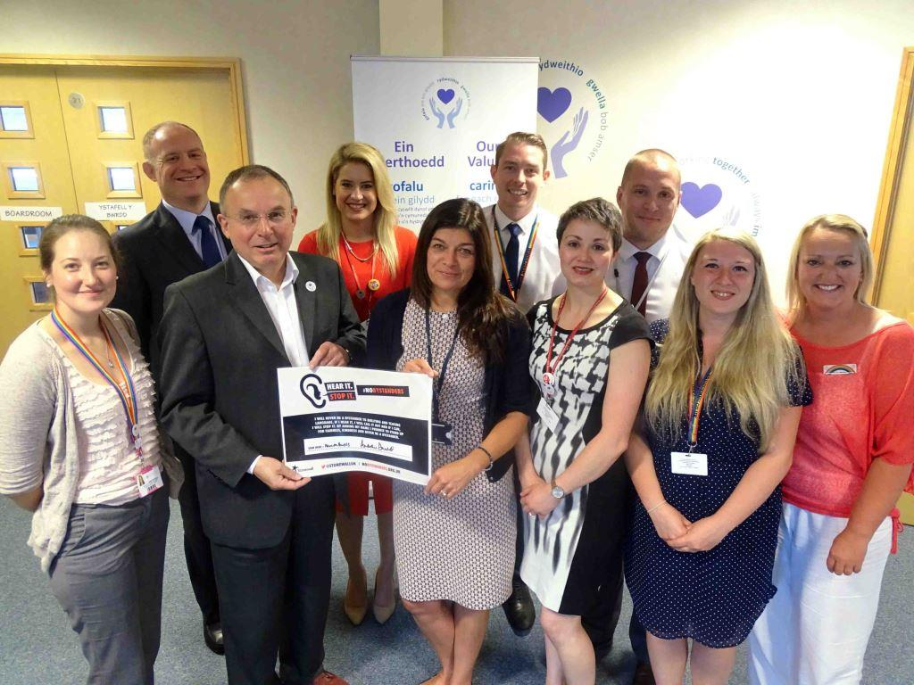
The campaign is being run by Calon, ABMU’s LGBT+ and Allies network, with support from ABMU’s graduate trainee managers and the health board’s full backing.

Chairman Andrew Davies and interim Chief Executive Alex Howells are pictured holding the signed pledge, along with founders of Calon and some of the graduate trainee managers

The organisers say it will contribute to reducing the risk of a bullying culture developing within ABMU.

No Bystanders is the Stonewall* campaign which encourages others to challenge all forms of hateful language and abuse when they can.

It encourages people to be photographed putting their name to the pledge, which states:

“I will never be a bystander to hateful language and abuse. If I hear it, I will call it out and report it, and if I can, I will stop it. By adding my name I promise to stand up for fairness, kindness and never be a bystander.”

Mitchell Jones, one of Calon’s founders, said the network was asking staff to stand up for fairness and kindness by joining the campaign.

He explained Calon had wanted to introduce No Bystanders into the health board for a while. At the same time, trainee managers who joined ABMU’s first Graduate Growth programme were looking for a group project.

Mitchell said: “They decided they would take this on and really they have done all the work around it.

“They came up with the communications plan and they have been out and about, gathering photographs of people signing the pledge.

“This week we will be posting these pictures on Twitter, through Calon. The graduates are based across the health board so they will be capturing people getting on board and signing the pledge too.

“We really want as many staff as possible to sign the pledge. It is something quite simple but it sends out a positive message not just within the health board but to the wider community as well.”

The Graduate Growth programme is for graduates with passion, talent and commitment who want to make a difference to healthcare.
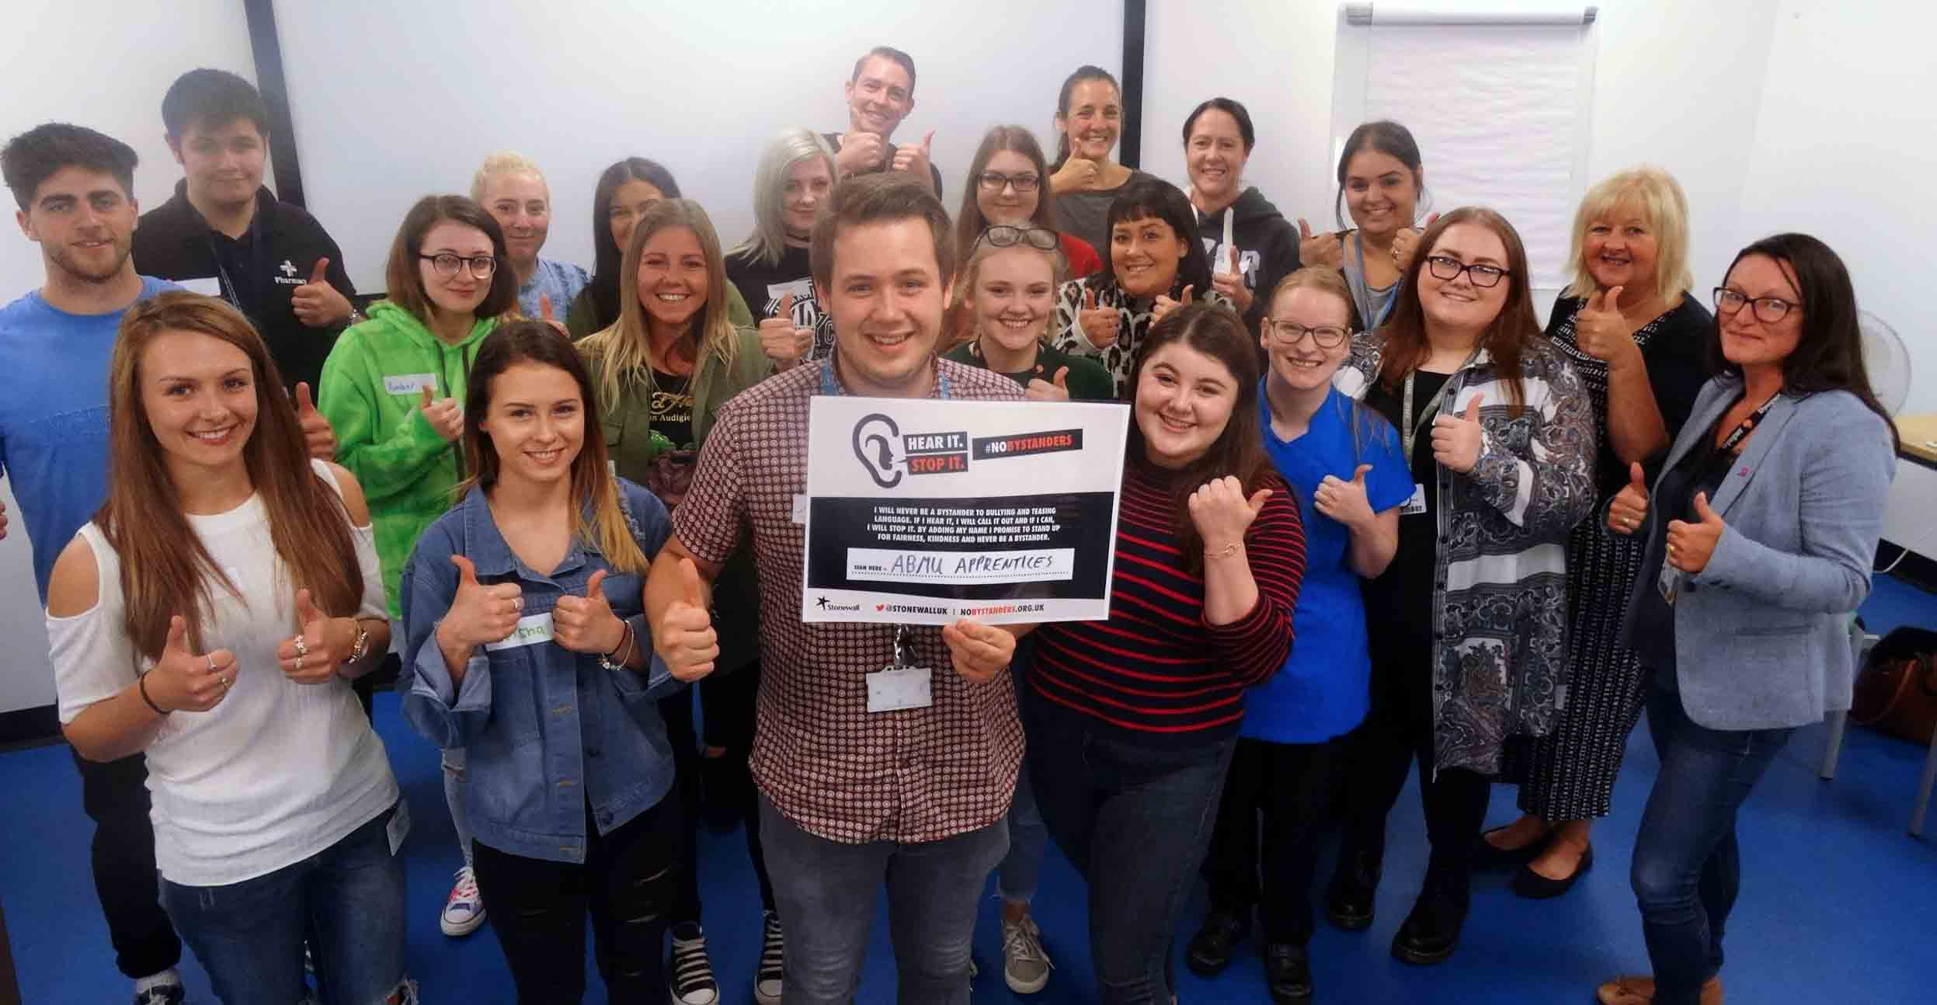
Right: No Bystanders gets the thumbs-up from ABMU apprentices

Over two years they work in different areas across ABMU to help them gain experience and learn new skills.

The first programme started in February and at the end of it, the graduates will be supported to apply for a management role within ABMU.

Their campaign encourages staff to take a stand against any hateful language and bullying – not just through homophobia, biphobia or transphobia but also because of faith, gender, ethnicity, disability, age, nationality or anything else that makes people different.

Graduate trainee manager Meghann Reynolds said: “We want staff within the health board to be aware of the fact that what you say can have an effect on somebody within the room.”

ABMU Chairman Andrew Davies said that, as a rights-respecting organisation, the health board was delighted to support the campaign.

He added: “We are committed to challenging in our workplaces any intolerance and prejudice - whether that is homophobia, biphobia and transphobia – or any other form of discrimination.

“We need everyone to stand with us and pledge their support for our campaign.”

You can follow Calon on Twitter: @AbmuLgbt.

*Stonewall is the lesbian, gay, bisexual and transgender rights charity.

Source: Abertawe Bro Morgannwg University Health Board

