Olivia springs back into action to meet her idol
Friday, 11 August 2017
Gymnastics-mad Olivia Jones has been receiving some expert advice on how she can recover from a broken elbow - from former world champion Beth Tweddle.

But her mum says it was the fantastic care she received from ABMU staff that put her on the road to recovery and made sure she was well enough to meet her sporting idol Beth.
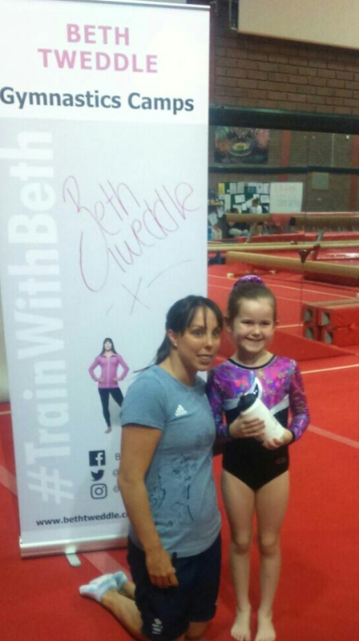
Keen gymnast and dancer Olivia, who has just turned seven, was playing in her grandparents’ garden with her big sister Megan when she fell over a tennis ball.

Olivia meets Beth Tweddle in Cardiff.

She was in such pain that her mum and dad Beth and Barry took her to Neath Port Talbot Hospital’s Minor Injury Unit where she was diagnosed with a type 3 supracondylar facture and told she would need an operation at Morriston Hospital.

Beth, of Maesteg, said: “The care that Olivia received was exceptional and all members of the team we saw were caring, compassionate and professional. She even received two teddies for being so brave.”
After being assessed at A&E and admitted to Oakwood Ward, the following day she was operated on by consultant orthopaedic surgeon Andrew Bebbington and was allowed home that night.

As a squad member of Maesteg Llynfi Valley Gymnastics Club, Olivia normally trains twice a week as well as doing ballet and modern dance.

“Because she is so active Olivia found the first few weeks extremely frustrating.

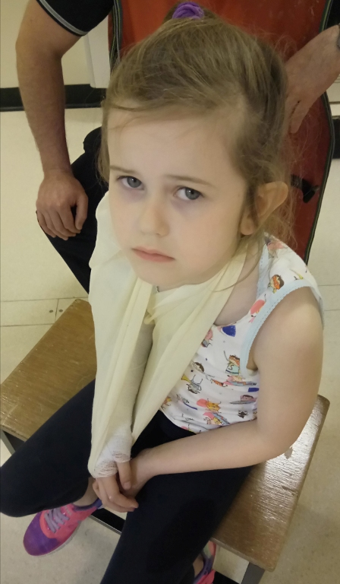
“But when she found out Beth Tweddle would be doing a gymnastics camp in Cardiff as part of a national tour and she would be unable to participate because of her injury she was very upset,” added her mum.

Fortunately Olivia was still able to go along to the Sports Wales National Centre on the day where she met Beth who gave her some useful advice on recovering from injuries.
After having the wires removed from her arm at outpatient clinic Olivia is now back in action, working on her flexibility and fitness and although she is unable to do weight-bearing exercises at the moment, she is expected to make a full recovery.

“We were really worried that her arm might not heal properly. Thankfully due to the great care she received, she is doing fantastically well.

“We are so grateful to all the staff who looked after Olivia,” said student nurse Beth who used to work in HR at Glanrhyd Hospital and in cardiac rehabilitation at Princess of Wales Hospital.

Source: Abertawe Bro Morgannwg University Health Board

